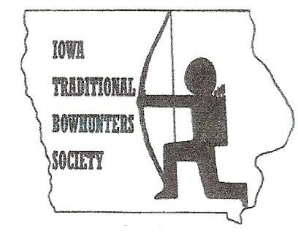**2018 ITBS BANQUET & AUCTION**

**Doors open at 10:00 AM on**

**Saturday, March 31, 2018**

Hosted by: Pine Lake Archers

10:00 – 11:30 Mingle and shoot

11:30 - 12:15 Free Food Provided

12:15 - 12:30 Meeting

12:30 - Auction

Shoot till 3:00 pm coarse closes

**Located in Eldora, IA**:

From US 20: Take exit 181, go on s56 south to 210th Street east

From Eldora: go north on US56 to 210th Street east

# Bring your Bow

We’ll be shooting inside and outdoor stump shooting is encouraged (Weather Permitting) from 10 AM until 3:00 PM. **FREE OF CHARGE**

# Bring your wallet or check book for the auction

Remember the auction is a large part of the clubs money that helps the club run our **ITBS Rendezvous Shoot on May 26 & 27, 2018** and promote the club at outdoor shoots and archery events.

We will have a large variety of items including bows, arrows, apparel, bow and arrow building supplies, and much more! Supplied by traditional archery vendors and members who embrace traditional archery.

**Raffle Bow** will be available from Scott at Best Friends Bows. The Bow drawing and any other raffle items will not be drawn until the Rendezvous. DO NOT have to be present to win

# Please bring pictures and your hunting and fishing stories

The directors and fellow members of the ITBS are wanting to restart the annual that has been lacking the past few years. In order to do this we need your hunting and fishing stories, poems, bow building stories, knapping experiences, pictures, or anything and everything traditional archery related that you want to share with the club. We rely on the members stories throughout the years in order to make this happen.

**FOOD WILL BE PROVIDED FREE OF CHARGE TO ALL ATTENDING.**

We would like it if you could send us an email or give us a quick call to let us know you will be attending. This will make sure we can better provide for the membership. If we receive enough RSVP’s we will enter you all for a door prize that you must be present to win.

cut on line

----------------------------------------------------------------------------------------------------------------------------------------------------------------

I.T.B.S. Membership Application

Name________________________________________________

Street Address_________________________________________

City _______________________State _________Zip___________

Email _______________________________Phone_____________

Please check appropriate box

Please send Dues too: Annual Dues Single - $20.00 ____

ITBS Family - $30.00 ____

1216 Rainbow Drive Life - $200.00 ____

Waterloo, Iowa 50701 Family includes all family members under the age of 18

at date of application

**If You Cannot Attend This Banquet And Would Like To Donate To Support This Organization**

**Please Consider A Cash Donation Of $20 Or More Thank You**