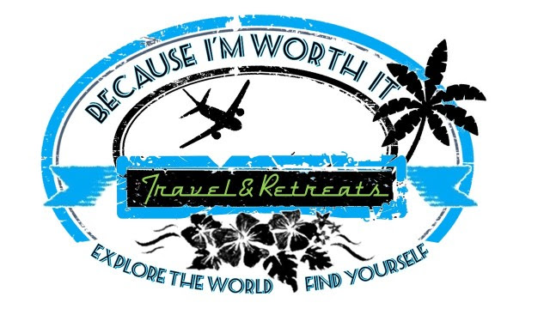

Because I’m Worth It Travel & Retreats

“Gift of Time” Certificate Redemption Instructions

HOW DO I BOOK MY TRAVEL?
- It is simple! Call Cindy Rhoads, Owner of Because I’m Worth It (BIWI) Travel, at (717) 831-8377 or click here to select a time for a virtual call to start planning your trip! She will help to plan and book your vacation or retreat for you.
- Please plan for at least 60 days lead time between the time you contact us and your desired travel dates. This is to ensure availability and best pricing for the entire vacation.
- Your travel advisor will need to verify your unique gift certificate number, password, and the certificate value available to use toward the trip, and your personal identity information. Please have these details ready when calling. Your password is included with your certificate package or email.

HOW WILL MY TRAVEL ADVISOR HELP?
- BIWI Travel will cater to your personal trip preferences, from hotel ratings to airline seating, budget, preferred transportation, and more. Please share all your ideas, likes and dislikes, anything that will ensure your travel advisor can provide options and recommendations that suit your personal taste.
- Your travel agent will research options and offer recommendations for accommodations, activities, tours, and experiences in your destination of choice based on your travel preferences and budget.
- You’ll receive an email invite to download our mobile itinerary app, Travefy, where your full itinerary can be found, including flights & notifications, hotels, transfers, car rentals, cruise schedules, private tours, contact phone numbers, addresses, and the ability to message your personal travel advisor directly.
- You'll have your travel agent's support from the time you leave on your amazing vacation or retreat until you return safely home to solve challenges like flight delays, interruptions, or emergencies.
- Your travel agent will also be available to work with you beyond just your Gift of Time trip, and is available to help you plan any and all vacation and retreat travel throughout the year.
Ready to make your travel or retreat plans? Please contact us at Because I’m Worth It Travel & Retreats at (717) 831-8377 or email Cindy at bcimworthittravel@gmail.com.

FREQUENTLY ASKED QUESTIONS:
What kind of travel can I book? | The certificate may be redeemed for vacation packages, tours, cruises, airline tickets, car rentals, and hotel accommodations, using the extensive network of Nexion, LLC, endorsed suppliers. You may also redeem this certificate for any Retreat offered exclusively by Because I’m Worth It (BIWI) Travel & Retreats.
What is a retreat? | Because I’m Worth It Travel & Retreats also offers unique specialized retreats called “Sister Therapy” for women all over the world! These retreats are for women only and are designed to allow busy women (and friends) the opportunity to step back from their everyday lives for a few days and to relax, reflect and rejuvenate themselves by allowing us to take care of them for a change…see the brochure included in your certificate packet for more information on upcoming retreat opportunities.
Can I exchange my Gift of Time certificate for cash? | No. The Gift of Time certificate can only be used for travel or retreats booked by our BIWI travel advisors.
Can the certificate be transferred to another person? | No, but you can use the Gift of Time certificate to purchase travel for another person traveling with you.
Can a Gift of Time certificate be combined if I have more than one? | Yes! Be sure you keep the passwords and certificate information together if you have the ability to receive more than one so you have all the details readily available when you are ready to combine the values and put them towards your ideal vacation or retreat!
When does the Gift of Time expire? | The expiration date can be found on your Gift of Time certificate but can be extended by contacting us, if necessary. Funds do not lose value over time.
What if the vacation I want to take costs more than my Gift of Time certificate? | You may add your own payment in addition to the certificate amount, should you wish to extend the total value of the vacation. We accept cash, electronic transfer apps, and/or major credit cards for personal vacation and retreat payments.

GIFT OF TIME CERTIFICATE TERMS & CONDITIONS:
- The Gift of Time Certificate may be redeemed for cruise and vacation packages using the extensive network of Nexion, LLC, endorsed suppliers and booked through Because I’m Worth It Travel & Retreats.
- It may not be used for car-only reservations. Prepaid car rentals are only allowed when purchased as part of a package.
- Hotel-only reservations will be accommodated if prepayment is allowed by vendor. Please Note: Not every hotel or accommodation provider worldwide is available for prepayment, however, your travel advisor will make every reasonable effort to accommodate requests or offer alternative options. We do offer certain types of alternate accommodations, such as villas, through our preferred partner network. However, we cannot book home-sharing accommodations such as Airbnb, VRBO, or other privately owned residences.
- Certificate cannot be exchanged for cash, gift cards, or Travelers Cheques.
- Service fees will apply for air-only bookings and travel providers who do not work with travel agencies.
- Certificate is redeemable only for bookings made through a BIWI travel Advisor.
- Recipient may apply the Gift of Time certificate toward the purchase of eligible travel and pay the difference when the total exceeds the value of the certificate.
- The recipient must present assigned password to Travelink prior to redemption.
- Because I’m Worth It Travel & Retreats is not responsible for lost or stolen certificates.
- Certificates are non-refundable and non-transferable.
- Gift of Time certificates are issued in U.S. Dollars.

I’m looking forward to meeting you and helping you plan an awesome trip or sign you up for one of my special retreats….because YOU are worth it!

Enjoy your day!

Cindy Rhoads, Owner
Because I’m Worth It Travel & Retreats

