VENDOR PROCEDURES, REGULATIONS AND RULES
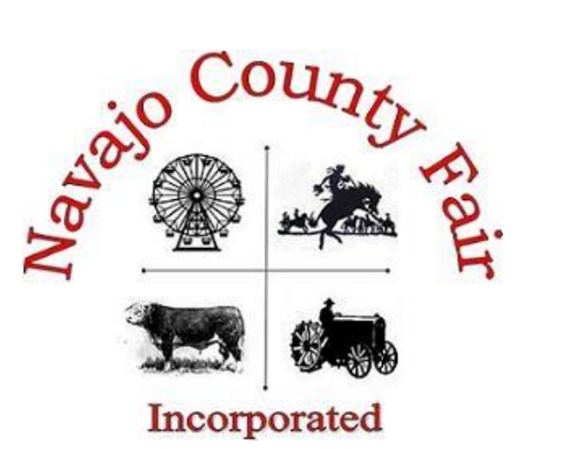

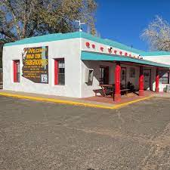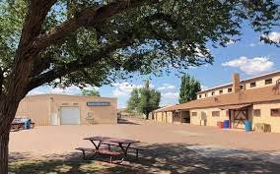
P.O. Box 309
Holbrook, AZ 86025
Phone (928) 524-4757
ncfvendor@yahoo.com

2023 NAVAJO COUNTY FAIR
VENDOR PROCEDURES, REGULATIONS AND RULES

All of our policies are fully outlined in the enclosed Navajo County Fair Vendor Procedures, Regulations and Rules Manual. Please follow all instructions. Any questions please contact us at 928-524-4757 or ncfvendor@yahoo.com. Please read it carefully, sign the last page and return it with the application form.

1. CONTRACTS AND PAYMENTS
- All concession space and utility costs shall be paid in full, according to the terms of the contract. The failure to remit payment when it is due shall be considered a breach of contract and shall be grounds for cancellation of the space assignment.
- Contracts as issued are nontransferable. The contract for each vendor shall be issued only to the owner or lessee of the concession. The subletting of space, misrepresentation of ownership, operation or appearance of any concession shall be considered a breach of contract and grounds for immediate removal. Contracts may not be sublet or shared.
- Vendors shall sell only those items that are listed on the contract. The selling of any item that is not on the contract shall be considered a breach of contract. Only Management or the Vendor Coordinator shall designate any approved changes of additional sale items in an amended contract. Management does not guarantee the exclusive sale of items.
- A separate $150.00 refundable security deposit, in the form of a money order or cashier’s check will be required with your Vendor Application form to guarantee your rental space will remain open, intact and staffed until Saturday, September 16th, 2023, until 10:00 p.m. The fair remains open until midnight on Saturday, you may not dismantle until the fair is closed. Additional time to dismantle will be on Sunday, September 17th, 2023 at 8:00 a.m. Any vendor that dismantles prior to 10:00 p.m. on Saturday, September 16th, will forfeit their security deposit. Deposit refunds will be distributed to vendors by mail to the address on record no later than the first week of October.
- All vendors must be paid in full by Friday, August 25th, 2023, to secure their space. All vendors not paid by this date will forfeit their space, regardless of an approved contract. A non-refundable deposit of 50% of your total contract price must accompany your application by Friday, July 28th, 2023.
- Upon approval of this contract, there will be no refunds of exhibit fees/deposits. All fees/deposits will be refunded to those applicants whose application form has not been approved. (Although the Fair executives and board have the right to discuss individual circumstances that may justify a refund.)
- All approved contracts and payments for such (including deposits), will be directly deposited to our business account immediately upon receipt. All returned checks will be assessed a minimum fee of $25.00.
- All vendor payments must be made in the form of a credit card, debit card, money order or cashier’s check made payable to Navajo County Fair.

2. CREDENTIALS
- Each contract will be issued four (4) complimentary passes with each rental space for the Fair. Additional passes may be purchased at Five Dollars ($5.00) per pass at the Fair Office.
- Note: One person may pick up your credential packet. Additional passes may be purchased at the time of pick-up or with your application. No passes will be mailed to you. You are responsible for distributing credentials (daily admission passes) to your employees. Employees must have a wristband on at all times during the Fair.

- Navajo County Fair is not responsible for lost or stolen credentials.

3. CHECK-IN AND MOVE-IN
- All vendors must check-in with the Vendor Coordinator at the Fair Office, prior to setting up. When you check-in, you will be given a Vendor Packet, which includes credentials and other pertinent information. Vendors will not receive Vendor Packets, credentials or be allowed to set-up until the Fair Office has received your Certificate of Insurance and all charges have been paid. Anyone attempting to set-up without Vendor Coordinator approval will be subject to removal.
- Move-in for all vendors will begin Monday, September 11th, 2023 during the hours of 8:00 a.m. to 5:00 p.m., Tuesday, September 12^{th,} 2023 from 8:00 a.m. to 8:00 p.m. and Wednesday, September 13^{th,} 2023 from 7:00 a.m. to 2:00 p.m. VENDORS shall be in place and ready by 3:00 p.m., Wednesday, September 13th, 2023. The Vendor Coordinator will place all vendors in their assigned space. Every effort shall be made to assist and locate all vendors as quickly as possible, but we ask that you be patient during the process. No one is to locate him or herself. The moving of a concession after placement without prior approval of Fair Management or Vendor Coordinator shall be considered a breach of contract, and shall be grounds for removal from the Fairgrounds with no refund of monies paid.
- ALL VEHICLES MUST BE OUT OF THE FAIRGROUNDS BY 2:00 P.M.
- NOTE: OPENING TIME IS WEDNESDAY, SEPTEMBER 13th, 2023 AT 4:00 P.M.

4. UTILITIES
A. Navajo County Fair will not provide generators, electrical adaptors, water hoses, etc. It is the responsibility of the vendor to make sure that they have the right electrical plug to connect to our electricity. It is also the responsibility of the vendor to supply all of their own water hoses and electrical cords. Please provide a “Y” so that others may connect and have access to the water faucet as well. You will need to include space for your generator in the square footage that you rent from us. All generators MUST have a safety barrier around them and in compliance to a food truck or trailer.

5. RESTOCKING
- Vendors can stock/load booths/areas between 6:00 a.m. and 9:30 a.m. No vehicles including golf carts or any type of ATV’s will be allowed on the grounds after 9:30 a.m. daily.

6. INSURANCE
- ALL Vendors will be required to obtain, at their own expense, no less than One Million Dollars ($1,000,000.00) of liability insurance. Proof required – Certificate of Insurance must be issued and received no less than one week prior to fair.
IMPORTANT: Please provide this language to your insurance company for the additional insured. The certificate of insurance must read exactly as follows: Navajo County Fair Inc., Fair Executives, their directors, officers, employees, agents and representatives, as additionally Insured, 404 E. Hopi Drive, Holbrook, AZ 86025. Please see example at the end of this application.
- Vendors that don’t have their own policy may secure insurance through the fair. For additional information please contact the Fair office at 928-524-4757.
- Vendors will not receive Vendor Packets, credentials or be allowed to set-up until the Fair Office has received your Certificate of Insurance.

7. LIABILITY/LOSS OR DAMAGE
- The Navajo County Fair shall not be liable for any loss or damage to the property of the vendor or of its employees, agents, patrons, or guests due to fire, smoke, water from any source, theft, criminal mischief, accident of any kind or from any other cause whatsoever and will not be liable for injuries to the vendor, his employees, agents, patrons or guests for damages or injuries arising from or in any way connected with the use of occupancy of space. The vendor agrees to indemnify and hold harmless the Navajo County Fair and their employees, against any and all claims of any person whomsoever, arising out of acts or omissions of this vendor, his employees, agents, patrons or guests.
- The Navajo County Fair shall NOT be responsible for any loss or damage suffered by any vendors, patrons, employees or guests from any act of theft, vandalism, accidental injury or act of God.
- For any loss or damage, please refer to the Security section.

8. EXHIBIT SPACE
- NO Vendor will be granted exclusive rights to their product(s).
- The Navajo County Fair provides no special services in connection with setting up or decorating the display. All exhibits, including chairs, tables, furniture, equipment and other display material must be provided and set-up by the vendor.
- The Navajo County Fair will prepare the layout of booths and assign spaces accordingly and also reserves the right to revamp the layout as necessary. Vendors will be placed on a first come first serve basis.
- Vendor may not exhibit or sell any product, commodity or merchandise that has not been listed on the contract and approved by the Navajo County Fair. VENDORS ARE NOT PERMITTED TO SELL LASER LIGHTS, SILLYSTRING OR POPPERS/SNAPS.
- The Navajo County Fair reserves the right to determine whether an item is considered offensive or in poor taste, and to prohibit the sale/display of such an item. The Fair reserves the right to require removal of any object(s), which are, in the opinion of its Management, offensive, hazardous, or adversely affect the Fair’s image.
- The list of products you are requesting to sell/promote must be specific. Words such as “accessories”, “related products”, “etcetera”, and other vague descriptions, are not acceptable, so please be thorough.
- Absolutely NO dumping of oil, product, etc., on Navajo County Fair Property. Any violation will cause the forfeiture of security deposit.
- Displays should not obstruct neighboring displays or project ahead of neighboring booths. Aisles and pedestrian walkways on the Fairgrounds must not be obstructed in any way. No overhangs or awnings will be allowed to protrude/extend outside of your rental area.
- Hand written signs are not allowed at any booth/area. If a hand-written sign is displayed, you will be asked to remove it. Exception: Erasable boards, i.e. chalkboards, will be permitted.
- Storage trailers/trucks with refrigerator/freezer must have contact name and phone number on back door for emergencies. In addition, there will be an additional fee for electric.

- VENDOR HOURS OF OPERATION

WEDNESDAY 4:00 pm – 10:00 pm
THURSDAY 9:30 am – 10:00 pm
FRIDAY 9:30 am – 10:00 pm
SATURDAY 9:30 am – 10:00 pm

9. CODE OF CONDUCT
- All vendors must work within the confines of their booth. NO SOLICTING outside of your space.
- Vendor Space must be kept clean and maintained in a professional manner.
- Vendor agrees to conduct all of its business in an orderly and lawful manner and to obey all rules of Navajo County Fair. Each vendor is expected to deal honestly and fairly with the public and his/her employees. Any attempted fraud or misrepresentation will be considered sufficient cause for revoking the contract and removal from the grounds.
- All vendors are expected to convey a professional behavior and dress appropriately. Vendors not complying will be asked to leave the grounds.
- Any use of promotion, scheme or device involving the award of any prize, gift or privilege determined as a result of any contest or by chance, without prior consent of the Navajo County Fair is prohibited. Promotions shall have written approval by the Navajo County Fair.

10. SECURITY
- Overnight security will be provided Wednesday through Saturday night. The Navajo County Fair will be not be responsible or liable for any loss or thefts. All reports should be filed with the Holbrook Police Department.

11. VENDOR SELECTION PROCEDURE
- Applications must be completely and accurately filled out to be considered. Applications will be reviewed according to:
- Completeness and thoroughness of the application
- Appearance of the booth
- Uniqueness of products
- Fair’s previous experience with the vendor; and
- What is ultimately determined to be in the best interest of the fair.
- If your application is approved and a contract is issued, you will need to be paid in full by Friday, August 25, 2023.
- Fairground layout is subject to change up until the beginning of the fair. Every consideration will be given to booth location requests, but desired placement is not guaranteed. Booth assignments are made by the Fair Staff and are final.

MAIL APPLCATIONS TO: SCAN AND EMAIL APPLICATIONS TO:
Navajo County Fair ncfvendor@yahoo.com
P.O. Box 309
Holbrook, Az. 86025

- HAVE YOU INCLUDED ALL ITEMS?
- INCOMPLETE APPLICATIONS WILL NOT BE CONSIDERED UNLESS FILLED OUT COMPLETELY AND ACCOMPANIED BY A DEPOSIT AND A CURRENT PHOTO OF BOOTH. All fees must be paid by credit card, debit card, cashier’s check, money order or cash. NO PERSONAL CHECKS.

By signing below, I confirm that I have received, read and understood the 2023 Navajo County Fair Rules, Regulations and Procedures. I agree to abide by all Navajo County Fair rules, regulations and procedures explained in the handbook and understand that failure to comply may result in penalty fees and/or removal from the grounds with loss of fees paid. I release Navajo County Fair of any and all liabilities for any loss, injury or damage to persons or property. I understand that Navajo County Fair makes no profit guarantees and does not give refunds.

Applicant Signature:__________________________________________________ Date: __________
Signing above does not guarantee you a space. This is an application that, if accepted by Navajo County Fair, becomes a binding contract. Accepted contracts will receive a confirmation by email or phone call. Rejected applicants will be notified by mail with returned deposit. Contracts accepted by the Fair may be declared null and void if it is discovered that the exhibitor misrepresented himself/herself or his/her company during the application process.

Navajo County Fair Official: ______________________________________Date:__________

