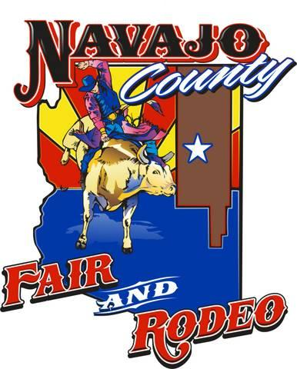
2021

Navajo County Fair & Rodeo

Royalty Application

CONTESTANT:
Name: _________________________________________________ Date of Birth: _______________
Address: ___________________________________________________________________________
City: ________________________________________ State:____________ Zip:_________________
Phone (home) _______________________ (cell) ___________________ (work) _________________
Email: ____________________________________________________________________________
Current Queen Title: _________________________________________________________________

PARENT/LEGAL GUARDIAN: (whom you reside with)
Full Name: ________________________________________ Occupation: ______________________
Relationship: ____________________________________
Address: ___________________________________________________________________________
City: ________________________________________ State:____________ Zip:_________________
Phone (home) _______________________ (cell) ___________________ (work) _________________
Email: ____________________________________________________________________________
Contestant’s Local Newspaper: ______________________________________________

Please provide the following information about you:
Height: __________Weight: __________ Hair Color: ______________ Eye Color: ______________
Pants Size: __________ Waist: __________ Inseam: __________
SIZES: Dress: ____________ Blouse: ____________ T-Shirt: ____________ Jacket: ____________
Hat: ____________ Belt: ____________ Boot: ____________

Please provide the following information using these pages ONLY:

Education: (School, High School, College, Special Training):
__________________________________________________________________________________________________________________________________________________________________________________________________________________________________________________________________________________________________________________________________________________________________________________________________________________________________________________

Scholastic Honors and other Accomplishments: ________________________________________________________________________________________________________________________________________________________________________________________________________________________________________________________________________________________________________________________________________________________________________________________________________________________________________________________________________________________________________________

Hobbies and Sports: ________________________________________________________________________________________________________________________________________________________________________________________________________________________________________________________________________________________________________________________________________________________________________________________________________________________________________________________________________________________________________________

Why I want to be Navajo County Fair & Rodeo Royalty:
**MUST BE WRITTEN IN 3rd PERSON**
Queen, Teen Queen, Little Buckaroo
____________________________________________________________________________________________________________________________________________________________________________________________________________________________________________________________________________________________________________________________________________________________________________________________________________________________________________________________________________________________________________________________________________________________________________________________________________________________________________________________________________________________________________________________________________________________________________________________________________________________________________________________________________________________________________________________________________________________________________________________________________________________________________________________________________________________________________________________________________________________________________________________________________________________________________________________________________________________________________________________________________________________________________________________________________________________________________________________________________________________________________________________________________________________________________________________________________________________________________________________________________

