September 11-14, 2024
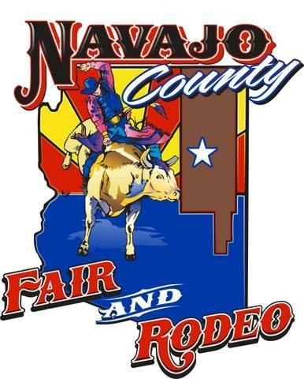
93rdAnnual Navajo County Fair & Rodeo

Welcome to the Navajo County Fair & Rodeo!

Navajo County Fairgrounds, 404 East Hopi Drive, Holbrook AZ. 86025

Phone: 928-524-4757 email - fairmanager@navajocountyfair.net

YEAR-ROUND ADVERTISMENT

Advertise your company year-round. Ready to embrace the charm of rural festivities? Discover what makes your County Fair the heart of local culture. Navajo County Fair, Inc. will be celebrating the 93rd Anniversary of the Navajo County Fair & Rodeo. September 11-14, 2024. Thank you for taking the time to consider the Navajo County Fair & Rodeo for sponsorship. We strive to improve the Navajo County Fair every year. We are a family run event full of family fun. We count on sponsors to help make this event a success! We cannot put on this event without your support. Your sponsorship is essential to the success of the Navajo County Fair & Rodeo. Sponsorship is a great way to advertise your product/service and show your support All Year Long for all the events held at the Navajo County Fairgrounds. We would love to count on your support and involve you in this great event. Here are some sponsor levels available, or we will custom build a sponsorship package to showcase your brand!

Pick-up Men Sponsor - $5,000 - (Only 1 Sponsorship Available)
As the Pick-up Men/Arena Sponsor, the Sponsor will have.
- 1 – Top Level Arena Sign - 1– 4 x 8 sign painted with sponsor name/logo to remain on display for a period of 1 year. (Limited spots please ask for availability)
- Our Pick-up Men will be announced and placed in marketing and media for the Navajo County Fair Rodeo (includes, but not limited to Video Board, Posters, Flyers, Website and Social Media)
- (1) 3min. commercials played on video scoreboard. {Sponsor to supply Commercial}
- Pick-up men Chap Sponsor – {Sponsor to supply 2 – Pair chaps}
- Flag Run – Grand Entry and Grand Finale Sponsor Flag Presentation. {Sponsor to supply flag}
- 3 - Business banners hung throughout the Fairgrounds. {Sponsor to supply banners}
- 2 - Business banner hung in the Carnival area. {Sponsor to supply banners}
- 5 All Access VIP passes for Wednesday night event, Demo Derby and Both Rodeo performances. These passes include exclusive access to the VIP lounge.
- Discount for multi-year commitment.

VIP Sky Box Arena Sign with Media Sponsorship – $3,000.
Our Elevated VIP Sky Box is situated next to the Announcers Booth. Our VIP Sky Box Arena Sign with Media Sponsorship will be announced and placed in some marketing and media for the Navajo County Fair Rodeo (includes, but not limited to Posters, Flyers, Social Media and Website) Limited availability.
- VIP Sky Box Arena Sign – 1 – 4X8 sign painted with sponsor name/logo to remain on display on the VIP sky box for a period of 1 year.
- Flag Run – Grand Entry, Event OR Grand Finale Sponsor Flag Presentation {Sponsor to supply flag}
- 3 VIP passes for both rodeo performances.

Arena Sign with media Sponsorship – $2,000.
Our Arena Sign with Media Sponsors will be announced and placed in some marketing and media for the Navajo County Fair Rodeo (includes, but not limited to Posters, Flyers, Social Media and Website)
- Arena Sign – 1 – 4X8 sign painted with sponsor name/logo to remain on display for a period of 1 year.
- Flag Run – Grand Entry, Event OR Grand Finale Sponsor Flag Presentation {Sponsor to supply flag}
- 2 VIP passes for both rodeo performances.
- Any promotional items.

