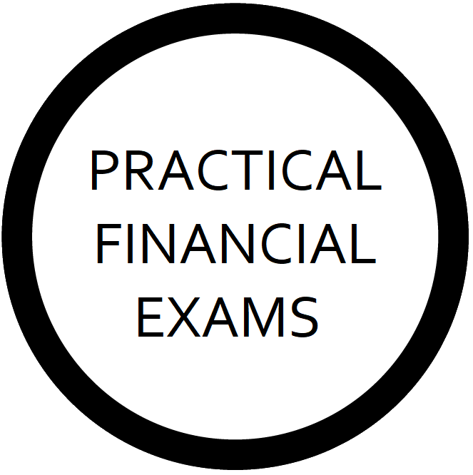

SCQF Level 9

Practical Investment Planning

Client Feedback Questionnaire

Dear Client,

I am currently undertaking a new investment planning qualification, Practical Investment Planning. Part of the assessment involves collating a body of work-based evidence, and your feedback can form part of this.

I would be delighted if you could please take five minutes of your time to help me by providing feedback via the following questionnaire.

There are seven questions in total, covering your experience with me from when we first spoke through to after I presented you with financial advice.

Please answer questions as honestly as possible, and feel free to use the “Additional Information” section at the bottom for any specific feedback or statements. Please note that to prevent any kind of “grey area” in terms of the assessment, answers are binary. Either you agree with the statement or you disagree (unless the statement is not applicable).

Thank you for your continued business and support.

About this Document (for Advisers)

This document forms part of the work-based portfolio of evidence required for the Practical Investment Planning qualification. Fully completed, it provides one (1) piece of evidence for the achievement of Performance Criteria 1.1, 1.2, 1.3, 1.4, 1.5, 1.6, and 3.1.

It is to be completed by clients of assessment candidates who are practicing Financial Advisers. Ideally, clients should be left to complete this questionnaire on their own.

Advisers may answer client questions and/or provide guidance to clients about how to interpret the questions, although they may not influence the client to answer any questions in a particular way or answer for or on behalf of a client.

Where Advisers are found to have unduly influenced, attempted to unduly influence, or answered for or on behalf on a client, this would fall under our Malpractice Policy.

Questionnaire

Performance Criteria | Question | Agree | Disagree | N/A
1.1 | When we initially spoke on the phone to arrange our fact-find meeting, you felt it was effective and professional, including what I was saying and how I was speaking and listening to you.
1.2 | Our meetings were well-controlled and structured.
1.3 | I explained my firm’s disclosure documents to you in a clear, concise, engaging, and comprehensive way. You fully understood them, including our business model and charging structure.
1.4 | Having discussed your SMART financial planning objectives with me, you fully understand what SMART objectives are, and you feel the SMART objectives we established for you are accurate and complete.
1.5 | Having discussed risk profiling with you, you understand the main asset classes, the relationship between risk and reward, and how risk profiles are assessed, sufficiently to put you in an informed position to agree your risk profile with me, and you are confident in the assessment of your risk profile.
1.6 | I explained the main features, advantages, and disadvantages of the main investment strategies to you in a balanced, clear, concise, engaging, and comprehensive way. You fully understand them and were able to make an informed decision as to your preference.
3.1 | You understand the reasons why your advice is suitable, and any disadvantages of the advice, so that you were in a sufficiently informed position to determine whether you wanted to take the advice or not.

Additional Information

Declaration

☐ I declare that the information I have provided in this questionnaire is honest and genuine, and that I was not unduly influenced by my Adviser, or anyone acting on their behalf, to answer in a particular way.

☐ I consent for the details in this document to be provided to and held on file by Practical Financial Exams Limited in accordance with its Data Retention Policy, freely available at: https://practicalfinancialexams.co.uk/scqf-credit-rating

Client Name

Client Signature

Date

