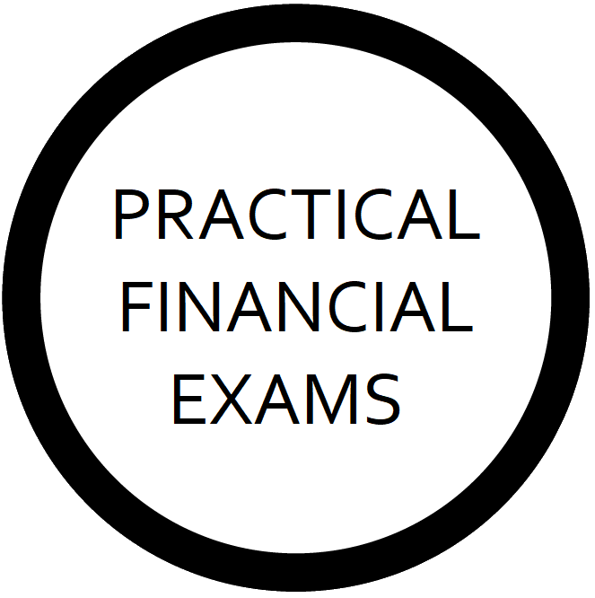

SCQF Level 9

Practical Investment Planning

Assignment 2 Report Template

About this Document

This document is designed to assist SCQF Level 9 Practical Investment Planning Learners when constructing their portfolio of work-based evidence, which is the second coursework assignment.

As per the Qualification Specification, “work-based evidence should be submitted in the form of a written report, perhaps two sides of A4, detailing each Performance Criterion, the evidence submitted, and an explanation of how each piece of evidence evidences the achievement of one or more of the Performance Criteria.”

This document provides a template for this report.

Further information is available in the Qualification Specification, and it is strongly recommended that Learners work closely with the Qualification Specification to ensure their work-based evidence meets our pass-standard requirements.

Assessment candidates are not obliged to use this template, and may instead create their own document, or edit/reformat this document as they see fit, provided it still meets the requirements detailed in the Qualification Specification.

Assessment candidates should be aware that the clearer their report and the easier to navigate their portfolio, the less chance there is of Assessors making errors in their marking such as overlooking pieces of evidence.

Details of the evidence submitted described in the report should clearly correspond to a particular piece of evidence, in whichever format.

Learner Information

Learner Name

Portfolio Summary

General Considerations Checklist

This is for you to confirm to yourself that your evidence meets our General Considerations.

Checklist Requirement | Check | Notes
The evidence is compliant with FCA regulations and UK law
The evidence is compliant with Practical Financial Exams Limited’s policies, processes, and procedures (e.g., no breaches of our Malpractice Policy)
The evidence clearly demonstrates achievement of the relevant Performance Criteria. Assessors should consider in each case: “Would a reasonable person believe, solely on the basis of the evidence provided by the Learner, that they have achieved the relevant Learning Outcomes/Performance Criteria?”
The evidence is comprehensive, demonstrating the achievement of at least one full Criterion, not merely part of a Criterion, unless otherwise stated in the checklist.
Real-life client personal details are redacted/censored.

Work-Based Evidence Summary

Where evidence is provided in the form of audio and/or video recordings, or transcripts thereof, Learners must specify the relevant minutes/timings of the recording, and/or pages of the transcript, which they believe evidence their achievement of the specific Performance Criteria. Audio and/or video recordings, or transcripts thereof, with no minutes/timings, risk being rejected by Assessors.

Performance Criterion | Evidence Submitted |  | How does it evidence the achievement of the Criterion?
1.1 Deliver an effective, compliant, professional, structured telephone pitch meeting | 1
 | 2
 | 3
1.2 Demonstrate the ability to structure and control client meetings effectively | 1
 | 2
 | 3
1.3 Present and explain a set of disclosure documents, including the firm’s business model and how charges work | 1
 | 2
 | 3
1.4 Establish and agree SMART investment planning objectives with the client, including critical assessment of their potential achievability | 1
 | 2
 | 3
1.5 Critically assess and agree the risk profile of a retail client, as a combination of their attitude to risk and capacity for loss | 1
 | 2
 | 3
1.6 Explain to retail clients the main features, advantages, and disadvantages of the main investment strategies | 1
 | 2
 | 3
2.1 Produce a professional, compliant suitability report comprising a piece of innovative investment advice, the client’s objectives, the reasons why the advice is suitable, and any disadvantages of the advice | 1 | This is only required where innovation was not evident in the written assignment.
2.2 Demonstrate the suitability of the advice via deterministic and/or stochastic cashflow models | N/A
3.1 Professionally and compliantly present an innovative investment plan, along with corresponding regulatory supporting documents, answering any client questions, and gaining the client’s agreement to proceed with the advice | 1
 | 2
 | 3

Additional Notes

