

RAKU IZAKAYA
AUTUMN COCKTAILS

PASSIONFRUIT BELLINI $17

Passionfruit. Yuzu umeshu. Prosecco

RAKU BRAMBLE $18

Gin. Yuzu umeshu. Chambord. Lemon juice. Shochu. Sugar.

SAKE KISS $18

Vodka. Sake. Lychee. Raspberry. Rose water.

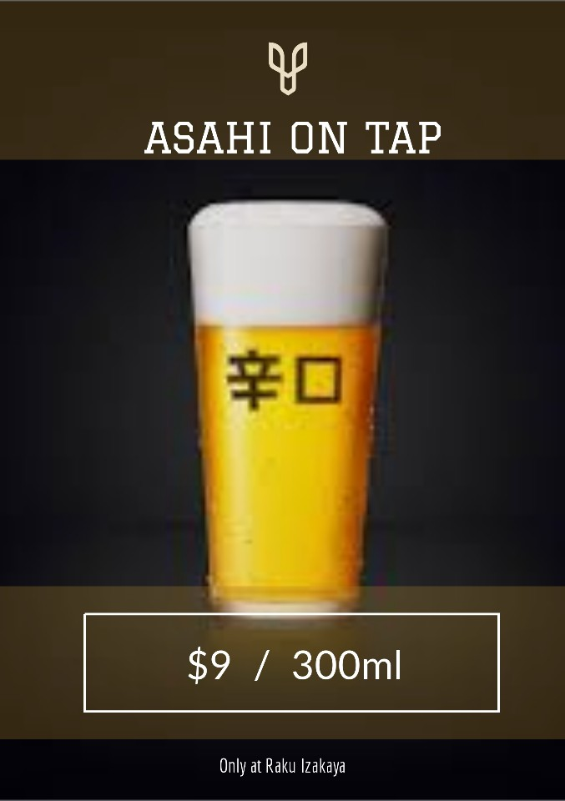

RAKU IZAKAYA
AUTUMN COCKTAILS

PASSIONFRUIT BELLINI $17

Passionfruit. Yuzu umeshu. Prosecco

RAKU BRAMBLE $18

Gin. Yuzu umeshu. Chambord. Lemon juice. Shochu. Sugar.

SAKE KISS $18

Vodka. Sake. Lychee. Raspberry. Rose water.

