Astoria High School
Registration Handbook
2023-2024

Astoria High School
Registration Handbook
2006-2007

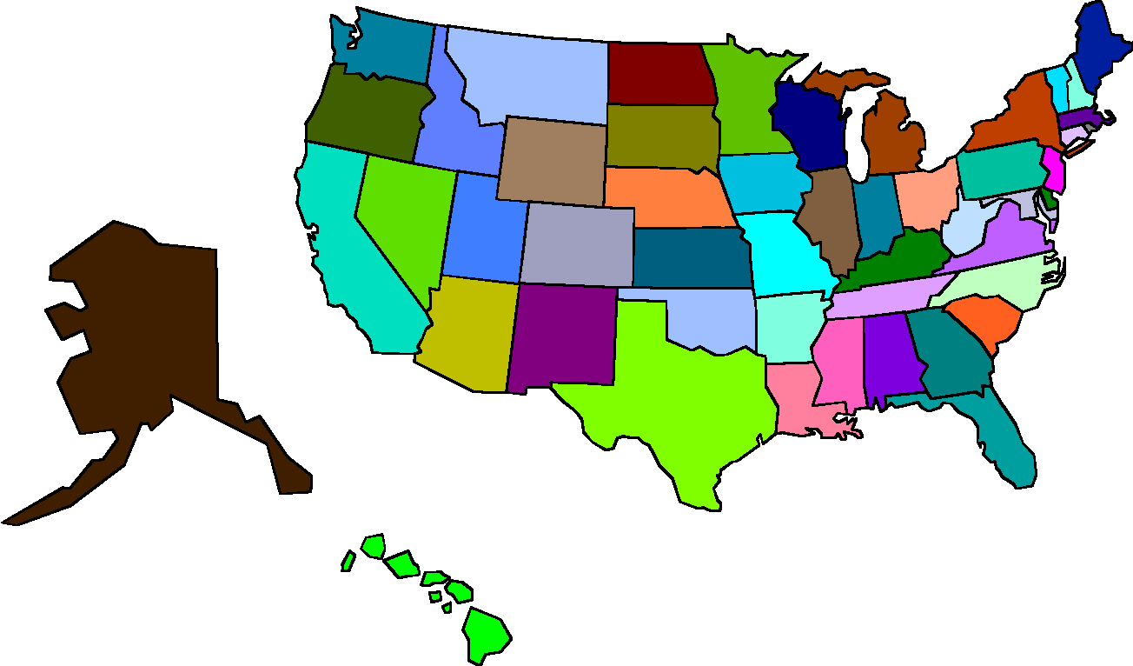
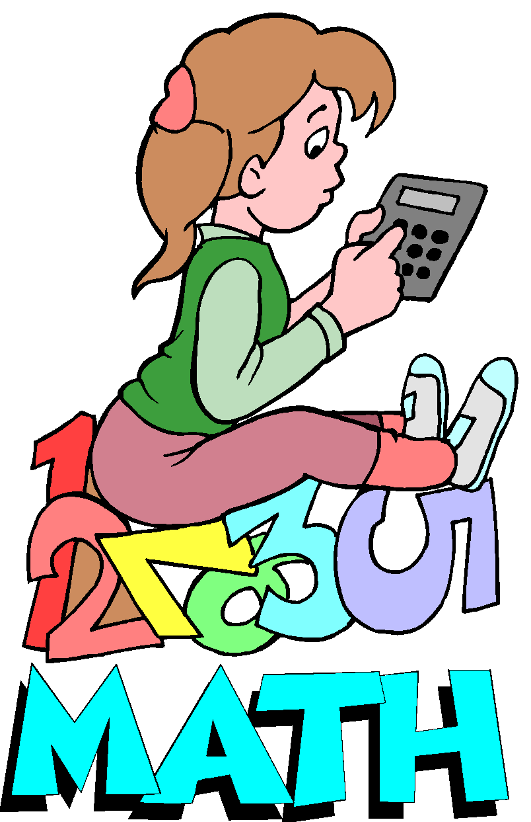
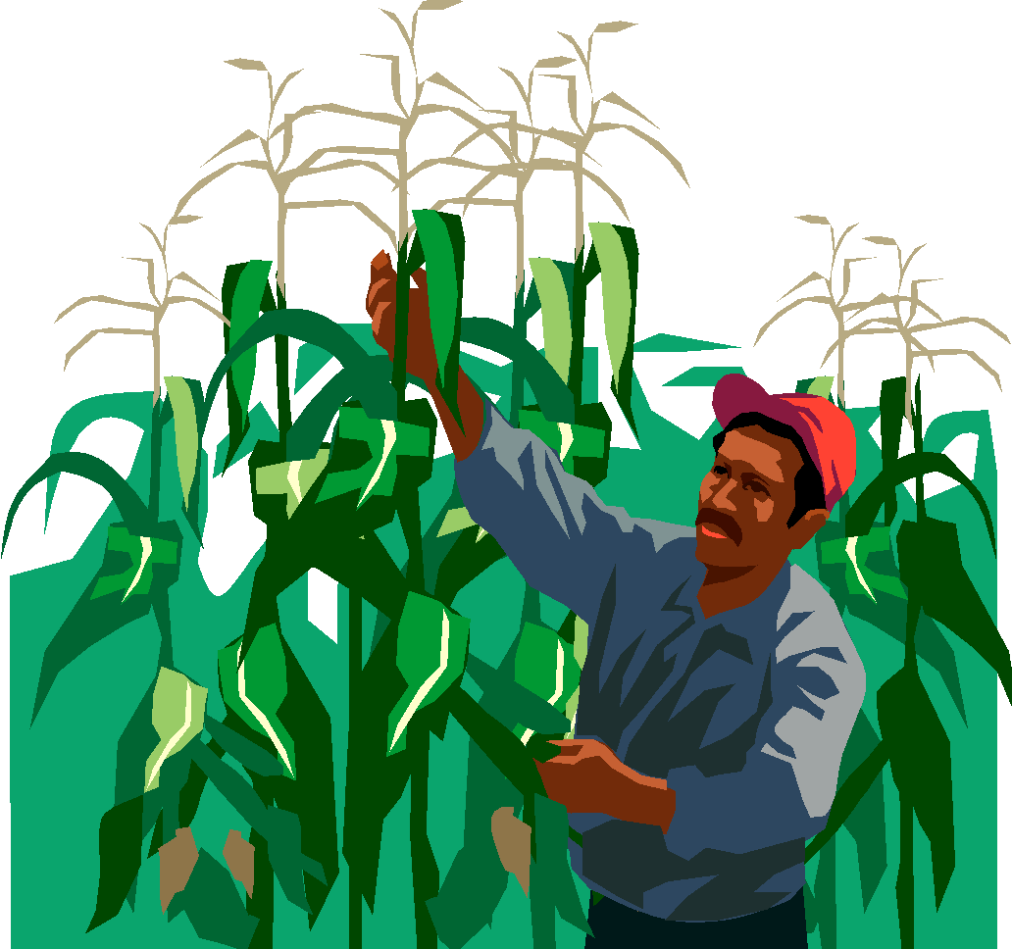
REQUIREMENTS FOR GRADUATION

In order to receive a diploma from Astoria High School, a student must meet the requirements of the State of Illinois and the following requirements established by the Astoria C.U.S.D. # 1 Board of Education:

REQUIRED COURSES or CREDITS

4 credits in English

2 credits in Writing Intensive courses –1 must be an English course

2 credits in Science (Biology I as a Freshman, General Science as a Sophomore)

3 credits in Math

1 credit in U.S. History I (including state and federal constitutions)

1 credit in U.S. History II

1/2 credit in Consumer Education

1/2 credit in Health

1/2 credit in Driver Education (30 clock hours of instruction)

1 credit in Art, Music, Foreign Language or a Vocational Subject

3.5 credits in Physical Education

12 Electives

Total credits needed to graduate: 28
MINIMUM LOAD

Students shall register for a minimum of eight classes per semester. Students who are enrolled for the fifth year in high school may register for the courses and/or credits required for graduation and attend school part-time with administrative approval.

ALTERNATIVE PROGRAMS AND CREDITS

Astoria High School students may earn a maximum of two (2) of the credits that the students will specifically need to graduate through Independent Study, Correspondence Courses, or from Institutions of Higher Education as approved by the building principal. This relates only to students who will otherwise be short credits to graduate or with administrative approval. Successful completion of a two (2) or three (3) hour college course will be accepted as one-half (1/2) credit.

Requirements for Graduation for Students Attending Alternative Education Sites

All students attending Alternative Education Sites will need to meet these requirements in order to graduate. If a student is transferred back to Astoria High School, he or she will be treated as a transfer student and requirements will be adjusted accordingly.

RE-ENROLLMENT

Re-enrollment shall be denied to individuals over the age of 17 who have dropped out of school and who could not earn sufficient credits during the normal school year(s) to graduate before his/her 21st birthday.

A failure in a required class will require that class to be repeated which could result in scheduling difficulties.

DRIVER EDUCATION
A student must have passed at least eight (8) semester classes during the previous two (2) semesters before enrolling in Driver Education.

PROGRAM PLANNING AND COURSE SELECTIONS

Few decisions students make are as important as those concerning their education. Because of this importance, you are encouraged to plan carefully and to involve those who can help you in making course selections. The counselor, teachers and administrators are available to assist you.

Many graduates of Astoria High School continue their education at a community college, a post-secondary vocational training school, or a four-year college or university. The counselor is available to consult with students and parents regarding the requirements for entry into these schools and the appropriate high school courses that prepare students to meet them.

Students who plan to enter a college or university need to be aware of admission policies regarding preparatory courses, testing, and rank-in-class. Students should check the specific entrance requirements of schools they are interested in to be sure to meet those requirements.

In addition to adequate course preparation, some colleges and universities require ACT or SAT test scores for admission. To be considered for the Illinois State Scholar competition, juniors must take the ACT or SAT in April or June of the junior year.

Students who plan to enter a vocational training school or seek work immediately after graduation should strongly consider completing a vocational program in high school.

All students should prepare a 4-year plan of study as they register for high school.

COUNSELING

Counseling services are available for every student in the school. These services include assistance with educational planning, interpretation of test results, occupational information, career information, study helps, help with home, school and or social concerns, or any question the student may feel he/she would like to discuss with the counselor. Information shared with the counselor is confidential.

FOREIGN EXCHANGE STUDENTS

Foreign exchange students should register for a minimum of eight classes including English,. Courses may be taken on pass/fail if the student wishes to receive an honorary diploma. Students who wish to receive a regular diploma must meet all of the requirements for graduation established by Astoria C.U.S.D. # 1

COURSE CHANGES, DROPS, AND INCOMPLETES

The selection of proper courses is the responsibility of students and their parents. We expect that parents will discuss these decisions extensively with their son(s) and/or daughter(s) before courses are selected for the year. Our counselor, teachers and administrators will be happy to answer any questions parents and/or students may have.

Many decisions are affected by student course selections. Such things as final course offerings, purchases of textbooks and materials, class sizes, etc. are determined by the registration process. Therefore, after final registration in the spring, NO class changes will be permitted except with the permission of the counselor and parent based upon sound educational rationale.

Students are strongly discouraged from dropping courses, therefore a student who chooses to drop a course after THE FIRST FIVE DAYS OF A SEMESTER will receive a failing grade ("WF") for the semester unless approved by the principal based upon exceptional circumstances

ADMISSION REQUIREMENTS AT COLLEGES AND UNIVERSITIES

Improving the preparation of students for success in college, increasing the number of potential students who are appropriately prepared for baccalaureate studies, and expanding the choices of programs and majors that are available to college-bound students are major goals for both secondary and postsecondary education in Illinois. In 1985, the Board of Higher Education adopted the following minimum high school subject requirements for admission to public universities and to baccalaureate transfer programs at community colleges:

Four years of English (emphasizing written and oral communications and literature). Three years of social studies (emphasizing history and government). Three years of mathematics (introductory through advanced algebra, geometry, trigonometry, or fundamentals of computer programming). Three years of the sciences (biology, chemistry, 3rd lab science). Two years in foreign language, music, art or vocational classes. These MINIMUM admission requirements, totaling 15 units of high school coursework, went into effect for freshmen entering Illinois public universities and baccalaureate transfer programs at community colleges in the fall of 1993. It should be noted that some universities may introduce their own subject pattern requirements which MAY BE HIGHER than the minimums listed above.

GRADING AND REPORTING

Report cards are issued at the end of each semester grading period. A midterm report will be issued each semester. Letter grades will be given along with the actual percentage grade. The following scale will be followed to compute grade point averages (GPA):
Percentage Grade Grade Point Value
98-100 A+ 4.000
93-97 A 4.000
90-92 A- 4.000
87-89 B+ 3.000
83-86 B 3.000
80-82 B- 3.000
77-79 C+ 2.000
73-76 C 2.000
70-72 C- 2.000
67-69 D+ 1.000
63-66 D 1.000
60-62 D- 1.000
59 & below F 0.000
WF 0.00
D/F notices are mailed to parents of students who are experiencing difficulties in a class. These are normally mailed home between the 4th and 5th week of each grading period, but may be sent at any time by a teacher. Parents must be notified of a possible failure for a mid-term or semester grading period at least two (2) weeks prior to the end of the grading period.

Incompletes are removable, but must be made up within ten school days following the grading period for which they were received. Any incomplete NOT removed during this time becomes a failure ("F") unless the building principal approves of other arrangements in advance.

HONOR ROLL
In order to be listed on the honor rolls, a student must meet the following requirements:
High Honor Roll – All A’s but no more than 1 B
Honor Roll – All A’s & B’s, but no more than 3 B’s
Honorable Mention – “B” average but no grade lower than a C

NATIONAL HONOR SOCIETY
The Astoria High School chapter of the National Honor Society is the Sapian chapter. To be eligible for membership consideration, students must be at least a junior and have a cumulative grade point average (GPA) of 3.65 on a 4.0 scale. Potential members must also meet high standards of leadership, service and character. Students who meet the GPA requirements and are sophomores, juniors or seniors in high school are evaluated by a five-member faculty council appointed by the principal. Those who meet the GPA requirement are given Student Activity Information Forms to fill out in order to assist the faculty council. Selection to the NHS is a high honor and careful consideration is given to each prospective member.

Leadership is based on the student's participation in community or school activities, or work as an officer. To meet the service requirement, the student must have been active in two or more service projects in the school and community. Character is measured in terms of integrity, behavior, ethics, and cooperation with both students and faculty.

DISTRICT STUDENT ASSESSMENT PROGRAM

All Freshman will take the PSAT 8/9 and all Sophomores will take the PSAT 10 as part of the state assessment. The SAT exam will be given to High School Juniors. The SAT is the statewide achievement test for all juniors and is required to graduate. The SAT will test English/Language Arts and Math. Also, all juniors will take the Illinois Science Assessment.

The Armed Services Vocational Aptitude Battery (ASVAB) is administered to all sophomores and to juniors and seniors on a voluntary basis in November or December. This test meets the requirements for vocational testing as mandated by the state at no cost to the school or to the student.

The Preliminary Scholastic Aptitude Test (PSAT/NMSQT) is offered to juniors. This is the National Merit Scholarship Qualifying Test for juniors. Students pay the cost of this test. Fee waivers are available in the counseling office.

The ACCU-PLACER test is offered to seniors who plan to enter a community college after graduation. It is also required for sophomores and juniors wishing to take Dual Credit courses.

FAMILY EDUCATION RIGHTS AND PRIVACY OF RECORDS

Astoria C.U.S.D. #1, Astoria, Illinois, is in full compliance with public law 93-380, Family Educational Rights and Privacy Act of 1975, as amended, as well as the Freedom of Information Act of 1984. All educational records shall be open to inspection and review by parents upon written request to the school principal. A copy of the full policy on the Rights and Privacy of Records may be obtained from the main office during business hours.

STUDENT RECORDS

In compliance with state and federal law, Astoria C.U.S.D. #1 maintains two (2) sets of student records, a permanent record and a temporary record.

1. The permanent record shall include: basic identifying information, academic transcripts, attendance record, accident/health reports, information pertaining to the release of this record, ACT or SAT test scores. No other information shall be placed in the permanent record. The permanent record shall be maintained for at least sixty (60) years after the student has graduated, withdrawn, or transferred from the District.

2. The temporary record may include: family background information, intelligence/aptitude scores, achievement test results, psychological reports, honors/awards, athletics/activities, disciplinary information, teacher anecdotal records, special education files, information pertaining to release of this record, other relevant information not required to be in the permanent record.

Temporary records shall be reviewed at least every four (4) years, or upon a student's change in attendance centers whichever occurs first, to verify entries and correct inaccurate information. Temporary records may be destroyed five (5) years following the graduation or permanent withdrawal of a student from the district. A thirty (30) day notice will be published in the local newspaper, The Astoria South Fulton Argus, prior to the destruction of the temporary record. The students, parents/guardians shall be given an opportunity, within the thirty (30) days to copy the record and information contained in the temporary record.

In the case of the student with a disability who graduates or permanently withdraws from the District, temporary records which may be of continued assistance to the student shall be maintained for five (5) years and be transferred to the student or to the parents/guardians if the student has succeeded to the rights of the parents/guardians. The content of the transferred records may relate to the diagnosis and remediation of the student's handicapping condition. An explanation of the usefulness of the records may be given to the parents/guardians or student by the District's appropriate student personnel services worker.

STUDENT DIRECTORY INFORMATION

Throughout the school year various agencies and organizations request information regarding students. Among those requesting such information are: colleges and universities, scholarship agencies, military services, businesses wishing to offer graduation gifts, award programs.

Student directory information may include the student's: name, address, gender, grade level, birth date and place, parents/guardians' names and addresses, phone numbers, information in relation to school sponsored activities, organizations and athletics, period of attendance in school.

Parents/guardians who wish to have all or a portion of directory information pertaining to their student deleted from the student directory must notify the principal by the first Monday in September.

STUDENT GRIEVANCE PROCEDURE

The Astoria Community Unit School District uses a comprehensive grievance procedure to resolve conflicts related to student concerns regardless of the nature of the conflict. It is the policy of this District that all grievances shall be resolved as quickly as possible and at the lowest step possible.

STEP I:
The student and/or parent/guardian should discuss the matter with the person(s) directly responsible for the grievance.

STEP II:
If the grievance is not resolved at Step I, the grievant shall present the grievance in writing within ten (10) days of the time when the grievant should have known of the occurrence of the event giving rise to the grievance to the principal. The principal shall provide a written response to the grievant within ten (10) days of the receipt of the grievance.

STEP III:
If the grievance is not resolved at Step II, the grievant may refer the grievance to the Superintendent or official designee within ten (10) days after the receipt of the Step II response. A meeting between parties will be held within ten (10) days and a written response shall be provided within ten (10) days of the meeting.

STEP IV:
If the grievant is not satisfied with the disposition of the grievance at Step III, the grievant may submit the grievance to the Board of Education within ten (10) days after receipt of the Superintendent's or official designee's written response. The Board shall allow the grievant to present his/her case to the Board in executive session at the next regularly scheduled Board meeting provided the Board has at least five (5) days notice of the appeal before said regularly scheduled meeting. If the Board has less than five (5) days notice of said appeal, the grievance shall be heard at a Special meeting to be called within fifteen (15) days of the filing of said appeal.

- Failure of a grievant to act on any grievance within the prescribed time limits will bar any further appeal.
- No reprisals shall be taken by the Board or the administration against a grievant because of his/her participation in a grievance.
- All records related to a grievance shall be filed separately from the temporary record file of a student involved.
- If the grievant or representative files any claim or complaint in any forum other than under the grievance procedure, then the Board shall not be required to process the said claim or set of facts through the grievance procedure.

Equal Opportunity: The Astoria School District does not discriminate on the basis of race, color, national origin, sex or disability.
COURSE DESCRIPTIONS

AGRICULTURE

Introduction to the Agricultural Industry 1 credit 1 year
Offered to: 9, 10
Prerequisite: None

This orientation course provides an opportunity for students to learn how the agricultural industry is organized; its major components; the economic influence of agriculture at state, national and international levels; and the scope and types of job opportunities in the agricultural field. Basic concepts in animal science, plant science, soil science, horticulture, natural resources, agribusiness management, agricultural mechanics, agricultural biotechnology, food science technology, environmental science and aquacultural science and technology will be presented. The development of leadership, employability and computer skills will also be taught. Because FFA and Supervised Agricultural Experience Programs (SAEPs) are integral components of this course, students are required to maintain SAEPs and to participate in activities of the FFA organization. Students are evaluated through completion of class projects, homework, participation during labs and field trips, and exams. Students must be able to read a ruler and use fractions.

Agricultural Construction and Technology
Offered to Grades 10, 11 1 credit 1 year
Prerequisite: Minimum of a 75% in Introduction to Agricultural Industry
This advanced course focuses on the knowledge, hands-on skills, and work place skills applicable to construction in the agricultural industry. Major units of instruction include personal safety, hand tools, power tools, blueprint reading, surveying, construction skills in carpentry, plumbing, electricity, concrete, block laying, drywall, and painting. Careers such as agricultural engineers, carpenter, plumber, electrician, concrete and block layers, finishers, safety specialists, and other related occupations will be examined. Improving workplace and computer skills will be a focus. Participation in FFA student organization activities and Supervised Agricultural Experience (SAE) projects is an integral course component for leadership development, career exploration and reinforcement of academic concepts.

Agricultural Business Management
Offered to grades: 11, 12 1 credit 1 year
Prerequisite: Minimum of a 75% in Agricultural Science

This course will develop students' understanding of the agricultural industry relating to the United States and World marketplace. Instructional units include: business ownership types, planning and organizing the agribusiness, financing the agribusiness, keeping and using records in an agribusiness, operating the agribusiness, agricultural law, taxes, and developing employability skills. Student skills will be enhanced in math, reading comprehension, and writing through agribusiness applications. Improving computer and workplace skills will be a focus. Participation in FFA student organization activities and Supervised Agricultural Experience (SAE) projects is an integral course component for leadership development, career exploration and reinforcement of academic concepts.

Agricultural Mechanics and Technology
Offered to Grades: 11 and 12 1 credit 1 year
Prerequisite: Minimum of a 75% in Agricultural Business Management or permission from teacher
This course will concentrate on expanding student’s knowledge and experiences with agricultural mechanics technologies utilized in the agricultural industry. Units of instruction included are: design, construction, fabrication, maintenance, welding, electricity, Engines, hydraulics, and employability skills. Careers of agricultural construction engineer, electrician, plumber, welder, equipment designer, parts manager, safety inspector, welder, and other related occupations will be examined. Improving workplace and computer skills will be a focus.
Agricultural Leadership
Offered to Grades 11 and 12 1 credit 1 year
Prerequisite: minimum of 75% in Ag business Management or permission from teacher
Agricultural Leadership courses help students develop leadership skills with a focus on opportunities in the food, fiber, and natural resources industries. Topics may include but are not limited to human relationships and effective communication, decision-making and problem-solving, leadership qualities and styles, and ensuring successful completion of group activities. Students will learn to lead groups and teams, manage volunteers, exercise leadership ethics, and be able to demonstrate leadership in multicultural settings. Participation in FFA student organization activities and Supervised Agricultural Experience (SAE) projects is an integral course component for leadership development, career exploration and reinforcement of academic concepts.

ART

Intro ART I 1 credit 1 year
Offered to Grades: 9, 10, 11, 12
Prerequisite: None

Basic drawing skills will be studied in the first semester. Composition, shading and perspective will be the major areas of concentration. Pencil and charcoal will be used extensively. In the second semester, watercolor and introduction to acrylics will be the media used. Art History projects will be included in this course. Must pass this class with at least an 80% to take Art 2.

Advanced ART II 1 credit 1 year
Offered to Grades: 10, 11, 12
Prerequisite: at least an 80% in ART I or teacher approval.

Continued shading problems and more advanced drawing compositions will be studied in the first semester. Figure drawing will be introduced. Pen and ink, colored pencil, pastel, some printmaking, and mixed media with emphasis on students having more choices in media and subject matter. In the second semester the painting section will use Acrylics and oils extensively. Students will have more choices in media and subject matter.

Advanced ART III 1 credit 1 year
Offered to Grades: 11, 12
Prerequisite: at least an 80% in ART II or teacher approval.

Continued shading problems and more advanced drawing compositions will be studied in the first semester. Figure drawing will be introduced. Pen and ink, colored pencil, pastel, some printmaking, and mixed media with emphasis on students having more choices in media and subject matter. In the second semester the painting section will use Acrylics and oils extensively. Students will have more choices in media and subject matter.

Advanced ART IV 1 credit 1 year
Offered to Grades: 12
Prerequisite: at least an 80% in ART IV or teacher approval.

Portfolio development course geared towards scholarship applications for college. Students will pick a theme to work with for the year and develop artwork and a portfolio using their theme. Students will be guided in research of their themes and development of an artist's statement.

Intro to Ceramics I 1/2 credit 1 fall semester
Offered to Grades: 10, 11, 12
Prerequisite: None

The focus of this course will be based on hand-building techniques in clay such as coils, pinch pots, and slabs. You do not need to pass ART 1 to take this course!

Advanced Ceramics II 1/2 credit 1 fall semester
Offered to Grades: 11, 12
Prerequisite: at least an 80% in Ceramics I or teacher approval.

Projects in this course will consist mainly of more complex hand built projects and the introduction of the use of the potters wheel.

Advanced Ceramics III 1/2 credit 1 fall semester
Offered to Grades: 12
Prerequisite: at least an 80% in Ceramics II or teacher approval.

Projects in this course will be proposed by the student to create a cohesive collection of ceramic work.

Intro to Sculpture I 1/2 credit 1 spring semester
Offered to Grades: 10, 11, 12
Prerequisite: None

Assemblages, constructions, carvings and relief work will be the areas of concentration in this course. Materials used are cardboard, foam, paster, wire, paper, tape, etc. You do not need to pass ART 1 to take this course!

Advanced Sculpture II 1/2 credit 1 spring semester
Offered to Grades: 11, 12
Prerequisite: at least an 80% in Sculpture I or teacher approval.

Projects in this course will consist mainly of more complex sculpture projects using wax, plaster, wire, cardboard, foam, paper, tape, etc.

Advanced Sculpture III 1/2 credit 1 spring semester
Offered to Grades: 12
Prerequisite: at least an 80% in Sculpture II or teacher approval.

Projects in this course will be proposed by the student or chosen from the list of provided options to create a cohesive collection of sculptures.

Spring Theater 1/2 credit 1 spring semester
Offered to Grades: 9, 10, 11, 12
Prerequisite: Must be in the Spring Play
Theater courses provide students with the opportunity to explore and/or participate in various aspects of theater, including auditioning, singing, acting, and dancing. These courses review the history and evolution of musical theater, its literature and artists, and styles of composition and vocal presentation. Students work collaboratively on performances.

BUSINESS

Introduction to Business 1 credit 1 year
Offered to Grades: 9, 10, 11, 12
Prerequisite: None

Introductory Business courses survey an array of topics and concepts related to the field of business. These courses introduce business concepts such as banking and finance, the role of government in business, consumerism, credit, investment, and management. They usually provide a brief overview of the American economic system and corporate organization. Introductory Business courses may also expose students to the varied opportunities in secretarial, accounting, management, and related fields.

Accounting I 1 credit 1 year
Offered to Grades: 10, 11, 12
Prerequisite: Introduction to Business

Accounting I is a course that assists students pursuing a career in business, marketing, and management. This course includes planned learning experiences that develop initial and basic skills used in systematically computing, classifying, recording, verifying and maintaining numerical data involved in financial and product control records including the paying and receiving of money. Instruction includes information on keeping financial records, summarizing them for convenient interpretation, and analyzing them to provide assistance to management for decision making. Accounting computer applications should be integrated throughout the course where applicable. In addition to stressing basic fundamentals and terminology of accounting, instruction should provide initial understanding of the preparation of budgets and financial reports, operation of related business machines and equipment, and career opportunities in the accounting field. Processing employee benefits may also be included.

Business Communications 1 credit 1 year
Offered to Grades: 10, 11, 12
Prerequisite: Introduction to Business
Business Communications courses help students to develop an understanding and appreciation for effective communication in business situations and environments. Emphasis is placed on all phases of communication: speaking, listening, thinking, responding, reading, writing, communicating nonverbally, and utilizing technology for communication. Business communication functions, processes, and applications in the context of business may be practiced through problem-based projects and real world application.

Business Computer Applications
Offered to Grades: 9, 10, 11, 12 1 credit 1 year
Prerequisite: None

In Business Computer Applications courses, students expand their knowledge of and experience in the proper and efficient use of previously written software packages, particularly those used in business. Generally, these courses explore a wide range of applications including (but not limited to) word processing, spreadsheet, presentation, graphics, and database programs, and they may also cover topics such as electronic mail, desktop publishing, and telecommunications. Advanced topics may include integrated software applications, including printed, electronic, and Web publications; computer maintenance activities; and Website development.

Keyboarding
Offered to Grades: 9, 10, 11, 12 1 credit 1 year
Prerequisite: None

Keyboarding courses provide students with an introduction to the keyboard (letters, numbers, and symbols), basic machine operation, and proper keystroke technique. As students progress, they improve their speed and accuracy and produce increasingly complex documents. Such courses help students develop keyboard proficiency, document production skills, and problem-solving skills.

Social Media Marketing
Offered to Grades: 9, 10, 11, 12 1 credit 1 year
Prerequisite: None
This is a course designed to serve as an introduction to the basic principles of digital & social media marketing, practices, and the application of these practices. Each student will develop leadership and problem-solving skills, understand the importance of making ethical decisions, develop public speaking and presentation skills, proper social and business etiquette, analyze possible solutions to specific business problems, develop business leadership skills, and develop an increased understanding of the business world. This course is conducted through lectures, engaging activities, group-paced instruction, hands-on practice, and discussion.

Office Technology 1/2 credit 1 semester
Offered to: 12
Prerequisite: On track to graduate and 2.5 GPA or higher

This skill level course would prepare students for employment upon graduation. Emphasis is placed on office etiquette; proper business behavior; maintaining office equipment; performing clerical duties; organizing and planning; processing mail; receiving visitors, or clients; coordinating and performing activities for the employer; telephone techniques; filing materials manually; maintaining office supplies and forms; performing telecommunications activities; preparing written communications; supervising and training; and office equipment applications, as well as a review of grammar, punctuation, and business mathematics. Previously learned skills will be integrated with new skills by completing a series of realistic office assignments.

Business Concepts (Consumer Education) 1/2 credit 1 semester
Offered to Grades: 12
Prerequisite: None Required for Graduation

The purpose of this course is to provide students with an understanding of the functioning of our private enterprise system and how it affects individuals as workers, consumers, and citizens. Consumer decisions must be based upon factual knowledge and the application of basic economic principles as well as one's own values and goals. Business communication concepts taught will focus on the students’ abilities to read and interpret information as it applies to effective reading and writing skills needed in business procedures. Students will develop skills in business computations including keeping checkbooks, calculating salaries, taxes, investments, and related business and personal financial transactions. Helping students to become informed consumers and to understand their rights and responsibilities as consumers in society are among the goals of this course.

COMPUTER SCIENCE

Beginning Digital Graphics
Offered to Grades: 9, 10, 11, 12 1/2 credit 1 Fall Semester
Prerequisite: None
Digital Graphics course provides students with the opportunity to use the computer to produce visual imagery and to apply graphic techniques to various fields, such as advertising, TV/video, and architecture. Course topics include modeling, simulation, animation, and image retouching.

Computer Gaming and Design
Offered to Grades: 9, 10, 11, 12 1/2 credit 1 Spring Semester
Prerequisite: None

Computer Gaming and Design courses prepare students to design computer games by studying design, animation, artistic concepts, digital imaging, coding, scripting, multimedia production, and game play strategies. Advanced course topics include, but are not limited to, level design, environment and 3D modeling, scene and set design, motion capture, and texture mapping

Computer Science Principles (Previously known as Coding)
Offered to Grades: 9, 10, 11, 12 1 credit 1 year
Prerequisite: None

This introductory course to coding is designed to present the basic principles of programming. Students will engage in various programming interactivities that will reinforce their learning and understanding. This course also guides students as they are introduced to writing and testing their own code.

Cybersecurity
Offered to Grades: 10, 11, 12 1 credit 1 year
Prerequisite: Computer Science Principles (Coding)

Cybersecurity courses introduce students to the concepts of cybersecurity. These courses provide students with the knowledge and skills to assess cyber risks to computers, networks, and software programs. Students will learn how to create solutions to mitigate cybersecurity risks. These courses may also cover the legal environment and ethical computing behavior related to cybersecurity.

Java Programming
Offered to Grades: 10, 11, 12 1 credit 1 year
Prerequisite: Computer Science Principles (Coding)
Java Programming courses provide students with the opportunity to gain expertise in computer programs using the Java language. As with more general computer programming courses, the emphasis is on how to structure and document computer programs, using problem-solving techniques. Topics covered in the course include syntax, I/O classes, string manipulation, and recursion.

Database Applications
Offered to Grades: 10, 11, 12 ½ credit 1 semester
Prerequisite: Computer Science Principles (Coding)
Database Application courses provide students with an understanding of database development, modeling, design, and normalization. These courses typically cover such topics as SELECT statements, data definition, manipulation, control languages, records, and tables. In these courses, students may use Oracle WebDB, SQL, PL/SQL, SPSS, and SAS and may prepare for certification.

Mobile Apps
Offered to Grades: 10, 11, 12 1/2 credit 1 semester
Prerequisite: Computer Science Principles (Coding)
Mobile Applications courses provide students with opportunities to create applications for mobile devices using a variety of commercial and open source software. These courses typically address the installation and modification of these applications, as well as customer service skills to handle user issues.

Web Development
Offered to Grades: 10, 11, 12 1 credit 1 year
Prerequisite: Computer Science Principles (Coding)
Web Page and Interactive Media Development I is a skill-level course designed to prepare students to plan, design, create and maintain web pages and sites. Students will learn the fundamentals of web page design using HTML, HTML editors, and graphic editors as well as programming tools such as JavaScript. Students will work in a project-based environment to create a working website. Students will learn to create pages, add hyperlinks, make tables and frames, create forms, integrate images, and set styles. Students will use image- editing programs to manipulate scanned images, computer graphics, and original artwork. Instruction will include creating graphical headers, interactive menus and buttons, and visually appealing backgrounds. Students will use hardware and software to capture, edit, create, and compress audio and video clips.

DRIVER EDUCATION
Driver Education 1/2 credit 1 semester
Offered to grades 9
Prerequisite: As below Required for Graduation

Student must have passed at least eight (8) full credit courses during the previous two (2) semesters before enrolling in Driver Education
This course is an introduction to driving with the end goal being to obtain an Illinois Driver's License. Concepts of the safe driving task.

ENGLISH
English I 1 credit 1 year
Offered to Grades: 9
Prerequisite: None Required for Graduation

Students will increase their skills in literature, grammar/usage mechanics, language, composition and reading. The course includes units on novels, basic grammar, spelling, learning to write organized, coherent paragraphs, essays, and independent reading.

English II 1 credit 1 year
Offered to Grades: 10
Prerequisite: English I Required for Graduation

Students should increase their skills in literature, grammar/usage mechanics, language, composition and reading. The course includes units on the library, on reading improvement, basic grammar, learning to write organized coherent paragraphs and independent reading

English III 1 credit 1 year
Offered to Grades: 11
Prerequisite: English II (or administrative approval) One English III is Required for Graduation

English III consists of a survey of American literature focusing on poetry, short stories, and plays as well as a brief review of grammar and writing program.

College English III 1 credit 1 year
Offered to Grades: 11
Prerequisite: English II (or administrative approval) One English III is Required for Graduation

College English III consists of a survey of American literature focusing on poetry, short stories, and plays as well as a brief review of grammar and writing programs. College English III follows the curriculum of regular English III but at a faster rate with more difficult selections and enrichment activities. This course is strongly recommended for students planning on attending a community college or a four year university program.

English IV 1 credit 1 year
Offered to Grades: 12
Prerequisite: English III One English IV is Required for Graduation

This course consists of a writing program which builds the student to writing several basic essays and a MLA and an APA research paper as well as an English literature survey of various literary forms such as the epic, parable, drama, the sonnet and other poetry forms, the short story and the novel.

College English IV 1 credit 1 year
Offered to Grades: 12
Prerequisite: English III One English IV is Required for Graduation

This course consists of a writing program which builds the student to writing several basic essays and MLA research papers as well as a survey of British literature focusing on various literary forms such as the epic, parable, drama, the sonnet and other poetry forms, the short story and the novel. Follows the curriculum of regular curriculum of English IV but at a faster rate with more difficult selections and enrichment activities. This course is strongly recommended for students planning on attending a community college or a four year university program.

Journalism/Advanced Journalism 1 credit 1 year
Offered to: 11, 12
Prerequisite: Passed English II with at least a C average.

A combination class dealing with communications, business English, journalism, and professional journalistic writing all involving computer applications. Designing and producing the yearbook and writing monthly articles for the Argus as well as other publications are the main focus of the class. Designing and producing the yearbook includes financial decision making and responsibility, ad sales and other fundraising, designing a cover, theme, and basic template, choosing colors and fonts, photography, and content choices. Students will be responsible for individual pages and spreads in the yearbook. Writing for the Argus includes study of journalistic history and ethics as well as finding, researching, interviewing, and writing monthly news stories, understanding the financial and business aspects of the newspaper business and exploring modern career opportunities involving journalism. Although the class involves lecture, the majority of the class is spent working on individual projects with one-on-one teacher guidance. Students may take a second year of journalism. This course will be identified as Advanced Journalism.

Literature/Advanced Literature 1/2 credit 1 Semester
Offered to 10,11,12
Prerequisite: none

Literature course offer the opportunity for students to study and reflect upon the themes presented in the body of literature being presented. Students improve their critical-thinking skills as they determine the underlying assumptions and values within the reading selection and as they understand how the work reflects society’s problems and culture. Oral discussion is an integral part of literature courses, and written compositions are often required. Literature courses may survey representative works, reflect a particular genre or a specific theme, or survey works of a particular time or people. Students may take a second year of literature if they pass literature with an 85% or higher. This course will be identified as Advanced Literature.

American Film 1/2 credit 1 semester
Offered to: 10, 11, 12
*Cannot take this course if you have had Drama; it is the same course with a new title
Prerequisite: English I

In this course, students study the development of the American and Classical film as an art form and a social phenomenon. The course surveys classical and contemporary genres, eras, trends, directors, studios and influential people in the industry. Students will focus on the techniques of acting as they apply to the electronic and film media. Class work will focus on class discussion and criticism of various films.

FAMILY AND CONSUMER SCIENCES
Foods and Nutrition H210/211 1 credit 1 year
Offered to Grades: 9, 10, 11, 12
Prerequisite: None

This course includes both classroom and laboratory experiences needed to develop knowledge and understanding of food principles and applied nutrition for all ages. During the first semester (Foods I), the course content focuses on the tools and equipment used in cooking, safety and sanitation, food facts and fallacies, buying and storing food, and weight control and daily food needs. The second semester (Foods II) course content focuses on setting a table, nutrition, individual food groups, and foods around the world.

Food Services and Management H311 1 credit 1 year
Offered to Grades: 10, 11, 12
Prerequisite: Foods and Nutrition

This course is designed to introduce students to the planning, purchasing, preparing and serving of food in quantity. Opportunities will be provided for students to practice a variety of preparation and serving techniques. Course content focuses on safety and sanitation, quality control, nutrition, commercial terminology, menu planning and the techniques of preparing food in quantity. Arrangements for serving some of the foods produced by the class to groups are included in the plans.

Clothing and Textiles I H230/231 1 credit 1 year
Offered to Grades: 9, 10, 11, 12
Prerequisite: None
Fee: Must purchase required materials including sewing supplies, fabric, polyester fiber-fill, etc.

This course includes both classroom and laboratory experiences needed to develop knowledge and understanding of clothing and textile principles and techniques. The laboratory course content focuses on sewing safety, terms, tools and equipment, parts and functions of a sewing machine, understanding how to read and follow a pattern envelope and guide sheet, and basic sewing construction techniques. The classroom course content focuses on fibers, yarns, fabrics, finishes, caring for clothing, garment styles, labeling, color tones, and consumer rights and responsibilities in the clothing and textiles area.

Fashion Merchandising I H390 1 credit 1 year
Offered to Grades: 10, 11, 12
Prerequisite: Passed Clothing I with at least an 80%
Fee: Must purchase required materials including sewing supplies, fabric, polyester fiber-fill, etc.

This course includes both classroom and laboratory experiences. A great deal more sewing techniques will be applied as many projects will be constructed. Students enrolled will be thoroughly trained on the use of an Embroidery machine and be required to do the work as orders come in. Students will develop skills in: owning and operating a small business, customer service techniques, preparing visual displays, performing sales related activities, and fabric and textile knowledge.

Human Growth and Development H240/241 1 credit 1 year
(Child Development and Parenting)
Offered to Grades: 9, 10, 11, 12
Prerequisite: None

This course is a combination course. The first semester being child development and the second semester being parenting. This course emphasizes learning experiences, which help students gain knowledge and understanding of the intellectual, physical, social, and emotional development of children from conception through adolescence. Course content focuses on conception, contraception, prenatal care, delivery and postnatal care of the baby and mother, health and safety of children, and exceptional children. The responsibilities and the skills needed to be a quality parent are also stressed throughout this course.

Adult Living H320/340 1 credit 1 year
Offered to Grades: 11,12
Prerequisite: None

This course focuses on skills for living. Decision making skills will be emphasized along with the ability to recognize and accept the consequences of decisions. Financial resources, insurance, housing, relationships, parenthood, healthy lifestyles and career preparation will be addressed along with informing students of their rights and responsibilities as consumers.

FOREIGN LANGUAGE
Spanish I 1 credit 1 year
Offered to Grades: 9, 10, 11, 12
Prerequisite: None

Students in this course will develop reading, writing, listening and speaking skills in the target language, at a beginner’s level. Spanish I emphasizes basic, conversational Spanish, as well as basic vocabulary and grammatical elements that support effective communication. A video series will be incorporated to help students explore cultural elements associated with the language. Students are active participants in the class through conversation, partner/group work, as well as individual projects.

Spanish II 1 credit 1 year
Offered to Grades: 10, 11, 12
Prerequisite: Grade of C or better in Spanish I

Students in this course will strengthen the four aspects of language acquisition that were introduced in Spanish I. Cultural exploration and comparison will continue and be enhanced through a video series. Class is conducted in Spanish and English.
Spanish III 1 credit 1 year
Offered to Grades: 11, 12
Prerequisite: Grade of C or better in Spanish II

Spanish III provides opportunity for a more in depth development of the four basic skills with a focus on highly structured grammatical aspects and descriptive vocabulary. Intensive practice in oral expression and conversation is required through in-class participation. Hands-on activities, such as teaching Spanish to elementary students and various cultural projects, are some highlights to this level of Spanish. Class is conducted in Spanish.
Spanish IV 1 credit 1 year

Offered to Grades: 12
Prerequisite: Grade of C or better in Spanish III

Spanish IV is an introduction to critical analysis of authentic media (text and audio) in the target language. . Several grammatical structures from Spanish I, II, and III will be reviewed as students continue to advance their communicative abilities in Spanish . The teaching of elementary students is also continued. Class is conducted in Spanish.

HEALTH and PHYSICAL EDUCATION

Health 1/2 credit 1 semester
Offered to Grades: 9, 10
Prerequisite: None Required for Graduation

Introduction to health concepts in the following topic areas: Personal Health (diseases, reproduction, alcohol, drugs, first aid, nutrition) and Public Health (disease control, pollution, ecology, consumer health, public health problems).

Physical Education 1 credit 1 year
Offered to Grades: 9, 10, 11, 12
Prerequisite: None Required : Students are required 3 ½ credits in PE to graduate

Participation which includes dressing out, participating, and passing tests in this class. All students are required to take PE unless a current medical excuse or PE waiver is on file in the high school office. PE waivers may be granted to Seniors on a semester basis in accordance with the laws of the state of Illinois.

MATHEMATICS
Integrated Math I 1 credit 1 year
Offered to Grades: 9
Prerequisite: None

Integrated Math I covers the same concepts as Algebra and Geometry, but in a combined approach. Students are involved in explorations and activities using technology to help students make cross-curricular and real-life connections. This is the first of a two-year course sequence. The course will be equivalent to an Algebra credit.

Integrated Math II 1 credit 1 year
Offered to Grades: 10
Prerequisite: Integrated Math I

Integrated Math II continues topics covered in Integrated Math I. Students will further investigate Algebra and Geometry concepts and their connections plus the beginnings of Algebra II and statistics. This course is equivalent to a Geometry credit.

Integrated Math III 1 credit 1 year
Offered to Grades: 11, 12
Prerequisite: 2 years High School Math

This course concentrates on strengthening and building on Algebra and Geometry skills. Designed to prepare students for College Algebra, standardized tests and entrance exams to assessment will be both subjective and objective. Primary textbook is used by Spoon River College in its developmental math courses. Additional supplemental texts will also be used.

Algebra I 1 credit 1 year
Offered to Grades: 9
Prerequisite: None

Algebra I courses include the study of properties and operations of the real number system; evaluating rational algebraic expressions; solving and graphing first degree equations and inequalities; translating word problems into equations; operations with and factoring of polynomials; and solving simple quadratic equations.

Geometry 1 credit 1 year
Offered to Grades: 10
Prerequisite: Algebra I

Geometry is the study of points, lines, plane figures and their relationship in 2 and 3 dimensions. Connection to and application in the real world are seen throughout the course. Logical reasoning from basic definitions and axioms to more complex theorems is emphasized.

Algebra II 1 credit 1 year
Offered to Grades: 10, 11, 12
Prerequisite: Geometry or Integrated Math II

Algebra II is an advanced course in Algebra. Many topics covered in Algebra I are covered here in more detail. New topics include quadratic equations with non rational solutions, exponential, complex numbers, and radical equations. Algebra II prepares the student for more advanced study in Analytic Geometry/Trigonometry and/or college.

Analytic Geometry 1/2 credit 1 semester
Offered to Grades: 11, 12
Prerequisites: Algebra II

This class will primarily focus on analytic geometry functions, higher degree polynomials, and logarithms. This course is recommended for students planning to attend college.

Trigonometry 1/2 credit 1 semester
Offered to Grades: 11, 12
Prerequisites: Algebra II

This class covers trigonometry and other topics in algebra as time allows. This course is recommended for students planning to attend college.

Statistics 1/2 credit 1 semester
Offered to Grades: 12
Prerequisites: Completion of three years of mathematics with a “B” average or above.

The text has been selected to prepare students for college level statistics. Topics include sampling techniques, mean and standard deviation for a set of data and for grouped data, binomial probability, normal distributions, the Central Limit Theorem, and linear regression. The required curriculum for many college majors ( business, agriculture, public health careers, etc) include a statistics course.

Calculus 1 credit 1 year
Offered to Grades: 12
Prerequisites: Analytic Geometry, Trigonometry (may be taken concurrently)

A college level text is used to prepare students for college calculus. Topics covered include limits, derivatives, and integrals. All science, math and business majors will need to take calculus in college.

MUSIC

Band 1 credit 1 year
Offered to Grades: 9, 10, 11, 12
Prerequisite: Enjoy music and willingness to participate. Previous experience in Jr. High band is preferred but not required.

This course will help improve the development of group and individual capabilities. Band at the high school level is geared toward performance. The high school band performs at football games, basketball games, Prairieland Band Festival, and the Winter and Spring Concerts. Participation in the State Solo and Ensemble Contest and ILMEA Festival is also available.

Chorus 1 credit 1 year
Offered to Grades: 9, 10, 11, 12
Prerequisite: Enjoy music and a willingness to participate.

This course will help improve the development of group and individual capabilities. Chorus at the high school level is geared toward performance. The chorus performs at the Winter and Spring Concert, and the Prairieland Choral Festival. Participation in the State Solo and Ensemble Contest and ILMEA Festival is available.

SCIENCE
General Science 1 credit 1 year
Offered to Grades: 10
Prerequisite: None Required for graduation
General scientific concepts are explored with an emphasis on earth and space science, as are the principles underlying the scientific method and experimentation techniques. In this course students typically learn about space science in the first semester and earth science in the second semester. There will be an emphasis on the physical and chemical sciences as they apply to the topics covered.

Biology I 1 credit 1 year
Offered to Grades: 9
Prerequisite: None Required for graduation

Biology I is a required introductory course dealing with all living forms of life. The course is designed to provide information regarding the fundamental concepts of life and life processes. Students will be guided through topics in a storyline format which will require students to apply their knowledge to real-world phenomena. .

Biology II 1 credit 1 year
Offered to Grade: 11, 12
Alternates years with Anatomy and Physiology--offered in 2022-2023, 2024-2025
Prerequisite: Biology I
Taken after a comprehensive initial study of biology (Biology I), Biology II covers biological systems in more detail. Topics that may be explored include cell organization, function, and reproduction; energy transformation; and the evolution and adaptation of organisms. Students will be engaged in labs, writing lab reports, and conducting research to better prepare them for college level biology courses. .

Chemistry I 1 credit 1 year
Offered to Grades: 10, 11, 12
Prerequisite: none

Chemistry is a college-prep course that includes lab work and technical writing. Students gain knowledge that would be useful for such areas as health care occupations, agriculture, science and engineering occupations, and consumer resources.

AP Chemistry (Chemistry II) 1 credit 1 year
Offered to Grade: 11,12
Prerequisite: Chemistry I

This course is taught as a parallel to a college general inorganic chemistry course, and has been approved by the College Board as an advanced placement course. Topics include: Atomic Theory, Bonding, Stoichiometry, Kinetic Theory, Solutions, Rates of Reactions and Acid-Base Theory. The course will introduce the basic terminology and structure of organic chemistry.

Physics 1 credit 1 year
Offered to Grades: 11, 12
Prerequisite: Algebra II or Integrated III (May be concurrent)

Physics is the study of energy and motion. The course covers a variety of topics including laws of motion, thermodynamics, optics, electricity, radioactivity and electronics. The course is considered college-prep, and students need to have a solid grasp of algebraic problem solving.

Anatomy and Physiology 1 credit 1 year
Offered to: 11, 12
Alternates years with Biology II--offered in 2023-2024; 2025-2026
Prerequisite: Biology I

Usually taken after a comprehensive initial study of biology, Anatomy and Physiology courses present the human body and biological systems in more detail. In order to understand the structure of the human body and its functions, students learn anatomical terminology, study cells and tissues, explore functional systems (skeletal, muscular, circulatory, respiratory, digestive, reproductive, nervous, and so on), and utilize dissection methods and microscopes to observe various materials.

Biological Science Applications in Agriculture (Animal Science)

Offered to Grades 10, 11, 12 1/2 credit 1 semester
Prerequisite: Biology I

Biological Science Applications in Agriculture- Animal Science is a course designed to reinforce and extend students’ understanding of science by associating scientific principles and concepts with relevant applications in agriculture. Students will examine major phases of animal agriculture and specific biological science concepts that govern management decisions in the animal industry. This one-semester course will deepen your understanding of science as content and as a process through the use of numerous laboratory exercises and experiments. Because the FFA and SAE are integral components of this course, students are encouraged to maintain SAEPs and participate in activities of the FFA organization. Grades will be based on assignments, lab reports, other projects, quizzes and tests.

Biological Science Applications in Agriculture (Plant Science)
Offered to Grades: 10, 11,12 1/2 credit 1 semester
Prerequisite: Biology I

Biological Science Applications in Agriculture- Plant Science is a course designed to reinforce and
extend student’s understanding of science by associating basic scientific principles and concepts with
relevant applications in agriculture. Students will examine major phases of plant growth and management
in agriculture and the specific biological science concepts that govern management decisions. This one
semester course will deepen your understanding of science as content and as a process through the
use of numerous laboratory exercises and experiments. Because FFA and SAE are integral components of
this course, students are encouraged to maintain SAEPs and participate in activities of the FFA
organization. Grades will be based on assignments, lab reports, other projects, quizzes and tests.

SOCIAL SCIENCE
World Geography 1 credit 1 year
Offered to Grades: 9, 10, 11, 12
Prerequisite: None

World Geography is an elective course that focuses on global cultures and humans’ interaction with natural resources and environments. World Geography will be so much more than places on a map. This class is designed to introduce you to the seven continents of the world. Along the way, we will focus on studying people and their culture, which will give you a general idea of how people live. We will analyze current issues that people are facing, past events that continue to shape the world, and how using geography can help you understand that a lot of things just come down to location, location, location! We will learn countries, people, places, interesting places that you didn’t even know existed…we will watch videos of culture and exciting foreign destinations that will make you want to book the next plane ticket out of the US! We will have fun along the way as we take “tours” of each country in the world.

Ancient and Medieval History 1 credit 1 year
Offered to Grades: 9, 10, 11, 12
Prerequisite: None
Ancient and Medieval History combines a study of ancient civilizations and Medieval Europe, beginning with the civilizations of the ancient Middle East and continuing through the late Middle Ages in Europe. This class will study the formation and contributions of civilizations from around the globe from multiple time periods. Topics that will be covered include but are not limited to ancient Mesopotamia, Egypt, China, India, Greece, Rome, the Arab World, Medieval Europe, and a few examples of Sub-Saharan Africa.

Modern World History 1 credit 1 year
Offered to Grades: 9, 10, 11, 12
Prerequisite: None

Modern World History will provide an overview of the history of human society in the past few centuries from the Renaissance, or later, to the contemporary period exploring political, economic, social, religious, military, scientific, and cultural developments. This class will focus on the changes the world will undergo as civilizations evolve and develop in the modern age. Topics that will be covered include but are not limited to the Age of Exploration, European colonization of North America, Africa, and Asia, Age of Revolutions(Focusing on the America/French Revolutions), the Industrial Revolution, the World Wars, the Cold War, and the evolution of the world to present day.

US History I – American Government- CIVICS 1 credit 1 year
Offered to Grades: 11
Prerequisite: None Required for Graduation

US History I is designed to introduce the student to American history and government. Content will include American History from its beginnings to 1865, as well as an in-depth study on the birth of America and American Government, the Constitution, and the Declaration of Independence. The course will inform students about who they are as citizens of the United States, the basic framework of the Illinois and United States Constitution, and their role as citizens of such. The class will provide material necessary to passing the Illinois Constitution Test and the U.S. Constitution Test. This course will also draw from current events. This is Part I of a two-part class – upon completion, students will learn American History 1865-current in US History II their senior year.

US History II 1 credit 1 year
Offered to Grades: 12
Prerequisite: US History I Required for Graduation

This course continues where US History I concludes and covers American History from 1865 to 2012. It offers an in-depth, guided analysis through major events in American history that continue to shape our modern-day events. A major part of the class is spent on 20th Century history, which featured a myriad of events that directly or indirectly shape our present day. By the time students are done with this course, they will have a greater understanding of the underpinnings of many of today’s happenings, as well as a greater respect and appreciation for the United States of America.

Sociology 1/2 credit 1 semester
Offered to Grades: 10, 11, 12
Prerequisite: None

Sociology is an elective course. It examines the role that society plays in the shaping of an individual’s tastes, customs, traditions, and activities. It examines pertinent questions, such as: How is society constructed? What major institutions, like education, religion, and government, are present? How does society take on new trends and ideas? How does society shape who you are today? This course features a wide variety of fascinating readings on selected topics, discussions, and simulations that help students understand the big picture of sociology.

Film History 1/2 Credit 1 semester
Offered to Grades: 10, 11, 12
Prerequisite: None

In this class we will watch films that show important time periods in history. The purpose of this class is to use the medium of film with its relatable characters and situations to make history come alive, and provide a connection to times and people long past that may be hard to acquire when studying these events. Prior to each film we will complete a short unit time period or event that will be shown. During and after each film the class will discuss why these events came to pass, and the long term consequences of the choices made at the time. We will also go over the differences between historical fact and the adjustments made by Hollywood.

Psychology 1 credit 1 year
Offered to: 11, 12

This psychology course introduces students to the study of individual human behavior. Course content typically includes (but is not limited to) an overview of the field of psychology, topics in human growth and development, personality and behavior, and abnormal psychology. The first semester will cover the history of psychology, personality, and development. The second semester will introduce the various fields of psychology, cover aspects of development, and focus on abnormal psychology.

EXPANDED CURRICULAR OFFERINGS

Online/Dual Credit Courses
Spoon River College/ Carl Sandburg College 1/2 Credit 1 Semester
Online and Dual Credit courses are available through Spoon River College and Carl Sandburg College. Students taking Dual Credit Courses will receive High School and College credit upon successful completion. Students are responsible for the expenses of these courses. A list of courses will be made available to those who are interested and qualify.

IVS (Illinois Virtual High School)/Edgenuity 1/2 Credit 1 Semester
Students also may take online courses through IVHS or Edgenuity. These courses are intended to be an extension of the current curriculum. In most cases the district will cover the expenses for these courses. A list of courses will be made available to those who are interested and qualify.

Work Program ½ Credit 1 Semester

Seniors who are on track to graduate and have sought out a place of employment willing to work with Astoria CUSD1 can work during the afternoon school hours (periods 7,8, and 9) and receive credit while doing so.

SPECIAL EDUCATION COURSE OFFERINGS
The following courses are offered only to students who have been found eligible for special education as a result of a full-case study and are determined to need an alternative learning environment in accordance with an IEP.
English 1, 2, 3, 4
Math 1, 2, 3
Science 1, 2
Life Skills 1, 2, 3, 4
American History 1
American History 2 (will contain the necessary constitution tests for graduation)
Health - R
Consumer Ed - R
Working Life Skills 4

