# INFORMATION SHEET FOR CHILDREN (6-10 YEARS)

# Chief Investigator: Professor Francesco Muntoni

Recording information on the management of your Spinal Muscular Atrophy in the UK

– SMA REACH UK Database in association with the Neuromuscular Clinical UK Network

Please go through this leaflet with your parent or guardian.

**Hello!** You are being asked to be in a research study.

**What is a research study?**

Research studies help us learn new things. We can test new ideas. First, we ask a question. Then we try to find the answer.

This patient information leaflet talks about our research and the choice that you have to take part in it. We want you to ask us any questions that you have. You can ask questions at any time.

**Important things to know …**

• You get to decide if you want to take part in this study.

• You can say ”No” or you can say ”Yes”.

• No one will be upset if you say ”No”.

• If you say ”Yes” now, you can always say “No” later.

• You can say ”No” at any time, even if your parent(s) or guardian(s) say ”Yes”.

• We will still take good care of you no matter what you decide.

• Your parent(s) or guardian(s) know that we are asking you to be a part of the study.

• If you decide to be a part of the study, your parent(s) or guardian(s) will also need to give their permission.

**Why are we doing this study?**

We are doing this research study as we would like to collect and record information which will help us to improve the care for all children with SMA in the UK. We would like to look at how SMA changes over time and keep a record in a database.

A database is like a filing cabinet where we can keep a lot of information all in one place. The database is called the SMA REACH UK Database. All children with SMA who attend clinics at Great Ormond Street Hospital in London and in Newcastle will also be invited to take part. Instead, all other UK sites open to SMA-REACH will have the opportunity to invite children with SMA to take part in the study.

The SMA REACH Network is also part of an international SMA Consortium (ISMAC) group working with two Networks: the PNCRN in the United States and the Italian SMA Network. We will ask you to allow us to collect fully anonymised information about you (which means all your personal details, like your name and date of birth, will be taken out) to be shared on a separate database. Other pharmaceuticals companies like Biogen and universities can look at this information to see how your SMA changes over time and the effect of different SMA medicines. This information will only be collected upon consent (signing a form to allow us to collect this information). If you choose not to share your information as part of this partnership (or are taking part in clinical trials with drugs), then you can still be a part of SMA-REACH database but your information will not be shared with others.

**Additional information for those taking part in the nusinersen (SPINRAZA®) Managed Access Agreement (MAA)**

If you are taking part in the nusinersen (SPINRAZA®) MAA then as well as providing consent for the SMA REACH database, your parents or guardian will also need to sign up to the managed access patient agreement. Your doctor will provide you with this.

People taking part in the MAA will have their personal pseudo-anonymised (not recognisable/identifiable) data from the SMA REACH database shared with the following companies:

* NHS England- To check patients treatment over time.
* The National Institute of Health and Care Excellence (NICE)- To make sure information is correctly collected and completed
* University of Strathclyde- To match different types of information collected
* Biogen (the company that makes SPINRAZA®)- to see if the drug is working and present information to NICE

This is not a complete list and it may be necessary during the course of the MAA to share your data with other institutions but your data will always be pseudo-anonymised before it is shared.

**Do I have to take part?**No, it is up to you to decide if you want take part. We will still look after you even if you say no.

**What will I be asked to do if I take part?**You and your parents will fill out some forms to say you want to take part. You will be asked to come to hospital every 6 months as you do for your normal clinic appointments.

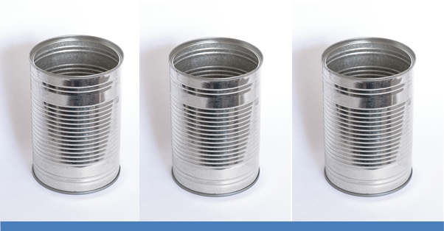The only difference is that when you come to physio, it may take a little longer than usual as we will be doing a few more things and we would like ask for your permission to video you. You can still be put on the database if you do not want to be videoed.

We would like to collect and save information each time you are seen in clinic. The project will last for 2 years. You and your parents/carer may also be invited to one or two group meetings to talk about your SMA assessments if you would like to. At some point you might be asked to do an interview, together with your parents, to give us your point of view about how the management and time may have affected you.

**Will joining in with this help me?**It may not help you but may help improve the care of children with SMA in the future.

**Will my medical details be kept private if I take part? Will anyone else know I'm doing this?**We will only tell the people who need to know like the doctors taking care of you. We will only put information on the database or share it once your name and address has been removed.

**How can I find out more?**You can talk to your parents about the project and ask them any questions that you have. If they don’t know the answer you can ask your doctor, or your parents can ask your doctor for you.

