|  |  |
| --- | --- |
|  |  |

# INFORMATION SHEET FOR PARTICIPANTS AGED 18+ YEARS

# Chief Investigator: Professor Francesco Muntoni

Recording information on the management of your Spinal Muscular Atrophy in the UK – SMA REACH UK Database

in association with the Neuromuscular Clinical UK Network

You require the expert care of medical and therapy teams for the long-term management of your Spinal Muscular Atrophy. We would like to collect and record information, which will help us to deliver the best care to all adults with SMA in the UK.

This leaflet explains why we are asking your permission to record clinical information into a database; the SMA REACH UK Database.



What is the SMA REACH UK Network?

The SMA REACH UK Network is a national and international partnership between doctors and therapists involved in the care of children and adults with Spinal Muscular Atrophy. This network issupported by SMA UK.

**What is SMA REACH UK Database?**

The SMA REACH UK Databaseis an internet based system which can save information about your diagnosis, assessment and management of SMA. Into this new database we aim to put clinical and genetic data from two existing databases (SMARTnet and the SMA registry). The data collected would be jointly managed by the Dubowitz Neuromuscular Centre and MRC Neuromuscular Centres in London and Newcastle.

The SMA REACH Network is also part of an international SMA Consortium (ISMAC) in partnership with two prestigious Networks: the PNCRN in the United States and the Italian SMA Network. All these networks work closely in clinical and research projects aligning data collection. One of the main initiatives of ISMAC is to share strictly anonymised patients’ data on a third IT platform which will be accessible to Biogen and can be shared with third parties (pharmaceuticals and academic institutes) in a strictly anonymised form, to obtain information about both the natural history of the disease and the effect of different SMA specific drug treatments. This information will only be collected upon patient consent. If patients choose not to share data as part of this collaboration (or are participating in clinical trials), then they can still be a part of SMA-REACH and data will not be shared with third parties.

**Why have I been invited to take part?**

You have been invited to take part in this research study because you have SMA and we would like to study how your condition changes over time. All adults with SMA who attend clinics in neuromuscular UK sites open to SMA-REACH will have the opportunity to invite Adults with SMA to participate in the study.

**Do I have to take part?**

No, it is entirely up to you to decide. If you do decide to take part, your doctor or physio will ask you to sign a consent form. By signing the form you are agreeing to take part in the study. You are free to stop taking part at any time during the research without giving a reason. If you decide to stop, this will not affect the care you receive in any way.

**What will happen to me if I take part? What will I be asked to do?**

We would like to collect and save information each time you are assessed in clinic. You will be asked to come to hospital every 6 months as you do for your routine clinic appointments. The only difference will be that some of your physiotherapy assessments may be a little longer. The study will last for 2 years but may be extended in the future.

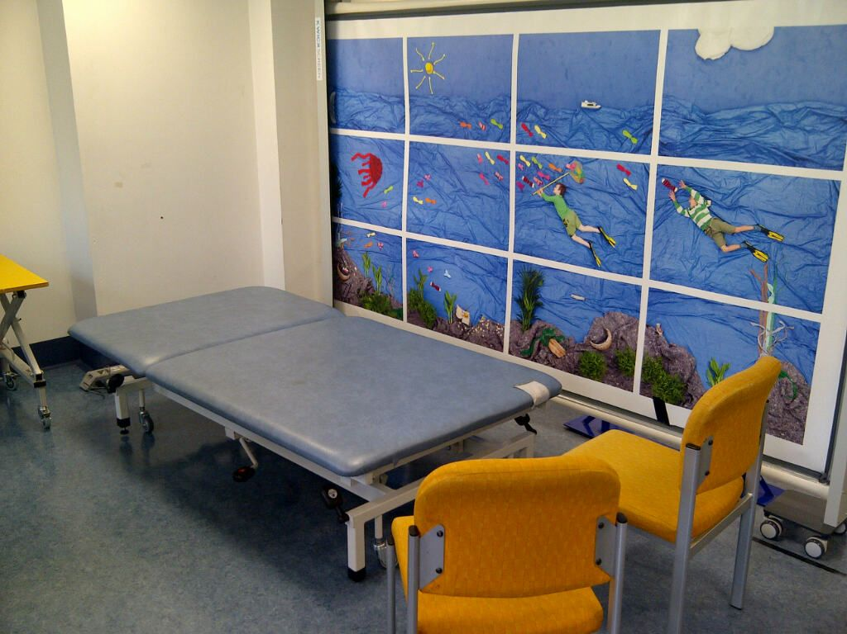

**What information will we collect?**

We would like to record:

* Your NHS number
* Name and date of birth
* General information about your condition for example your age at diagnosis, any results of gene testing, and problems resulting from SMA Results of muscle, heart, breathing, growth and general health testing from medical assessments
* Your medical history and additional medical information will be recorded as part of the initiative with ISMAC (only applicable for patients who consent to take part in this initiative)
* Some extra physiotherapy assessment measures including some as part of the initiative with ISMAC (upon consent).
* If you consent, we may contact you by phone for short interviews/surveys on SMA (only at GOSH)

We will also ask you for your permission to videotape/take photos of you while the physical assessments are carried out. The photos will be used to make the instructions that physiotherapists use to do your physical assessment. The videos will be used to help teach other physiotherapists to do the correct assessments for SMA. They will also be used to test that the physiotherapists are scoring properly - these are known as reliability studies. Some of the results from the reliability studies may form part of a MSc project.



You can still be registered on the database if you do not wish to be videotaped/photographed.

**Why are we collecting this information?**

We will use the information we collect to help us:

* Collect accurate details about SMA and how it changes over time
* Monitor medical and therapy care to make sure it is always up to date.
* Plan and develop services for better management of SMA
* Try out new assessment tools with the aim to develop more sensitive SMA specific scales.



* Undertake reviews/audits and produce reports that will improve our knowledge of the natural history of SMA
* Improve and monitor the standards of care
* Start to prepare for clinical trials.
* Compare information on SMA from this database

with data from other international sites

**Who collects the information?**

The hospital staff at the clinic will collect this information. This will usually be your doctor, physiotherapist or nurse or may be one of the designated research team: a doctor, physiotherapist or study coordinator. A designated database manager may also help with recording information.

**When and how will you collect the information?**

The information will be collected and updated at every clinic visit. We will collect the information from the medical and therapy records.

We will also invite you and your parents/carer (as required) to be involved in one or two group sessions in the coming months. These sessions will allow you, your parents/carer, researchers and doctors to discuss the most useful assessment tools for families.

**Who will see the information?**

Only the NHS staff who care for you will see all the details. There are strict regulations controlling access to personal information like your name, date of birth or NHS number. By law, everyone who works for the NHS must keep all personal information confidential and the trust has strict confidentiality and security procedures in line with GDPR. Only anonymised data will be shared with other institutions (SMA Registry, MRC database, ISMAC IT Platform).

**What is the consent procedure?**

If you are happy for your details to be stored on the database and used for clinical care and research purposes please give your permission on the consent form. A signed copy of your consent form and a copy of this information sheet will be given to you for your information. Please talk to your doctor if you would like to withdraw your consent for providing data to SMA Reach.

**Additional information for those enrolling onto the nusinersen (SPINRAZA®) Managed Access Agreement (MAA)**

If you are enrolling onto the nusinersen (SPINRAZA®) MAA then in addition to providing consent for the SMA REACH database you will also need to sign up to the managed access patient agreement. Your doctor will provide you with this.

People enrolled in the MAA will have their personal pseudo-anonymised data from the SMA REACH database shared with the following institutions:

* NHS England- To monitor patients treatment start and stop criteria as per the terms of the managed access agreement. To monitor case ascertainment in the SMA REACH database.
* The National Institute of Health and Care Excellence- To ensure compliance with the data collection terms of the managed access agreement i.e. to monitor data completeness of mandatory data fields. To monitor case ascertainment in the SMA REACH database.
* University of Strathclyde- To allow matching of clinical and PROMS data.
* Biogen (the company that makes SPINRAZA®)- To enable the company to analyse the clinical and cost effectiveness of the technology and present a submission of the evidence to NICE for a health technology appraisal.

This is not an exhaustive list and it may be necessary during the course of the MAA to share your data with other institutions but your data will always be pseudo-anonymised before it is shared.

Pseudonymised personal data means replacing characteristics of personal data with a pseudonym, a value that does not allow the person to be directly identified without the use of additional information, provided that (a) such additional information is kept separately, and (b) it is subject to technical and organisational measures to ensure that the personal data cannot be attributed to an identified or identifiable individual.

**Can I see the records on the database?**

**Yes**, you can get a copy of the information we have about you. To do this, please ask the doctor in charge.

**Are there any benefits or disadvantages?**

You may not directly benefit from the database system; however it might help to improve the standards of care for SMA in clinics in the UK and may benefit children and adults with SMA in the future. This research could also help to prepare for and design clinical trials for SMA in the future.

**What if there is a problem?**

You may contact one of the study team by email or telephone using the contact details at the end of this leaflet. If you are not happy about your treatment and you wish to complain, you should contact the PALS service at <insert details here> By phone: <insert details here> or by email: <insert details here> so that they can advise you about the steps to take as well as being able to give you the contact details for the appropriate people in the hospital.

**Who is organising and funding the research?**

This study is funded by the SMA UK and MDUK.

**Who has reviewed the study?**

Before any research is allowed to happen, all research in the NHS is looked at by an independent group of people, called a Research Ethics Committee, to protect your interests. This study has been reviewed and given favorable opinion by the London- Bromley Research Ethics Committee.

**How can I find out more about it?**



Please talk to the doctor in clinic if you:

* Need more information
* Have any questions or concerns

Or contact one of the study team by email or telephone:

<insert details here>

Or visit our website http://www.smareachuk.org/