West Point-Army Men’s Rugby Program

A FIRST TEAM LEGACY

Establishing the Brotherhood

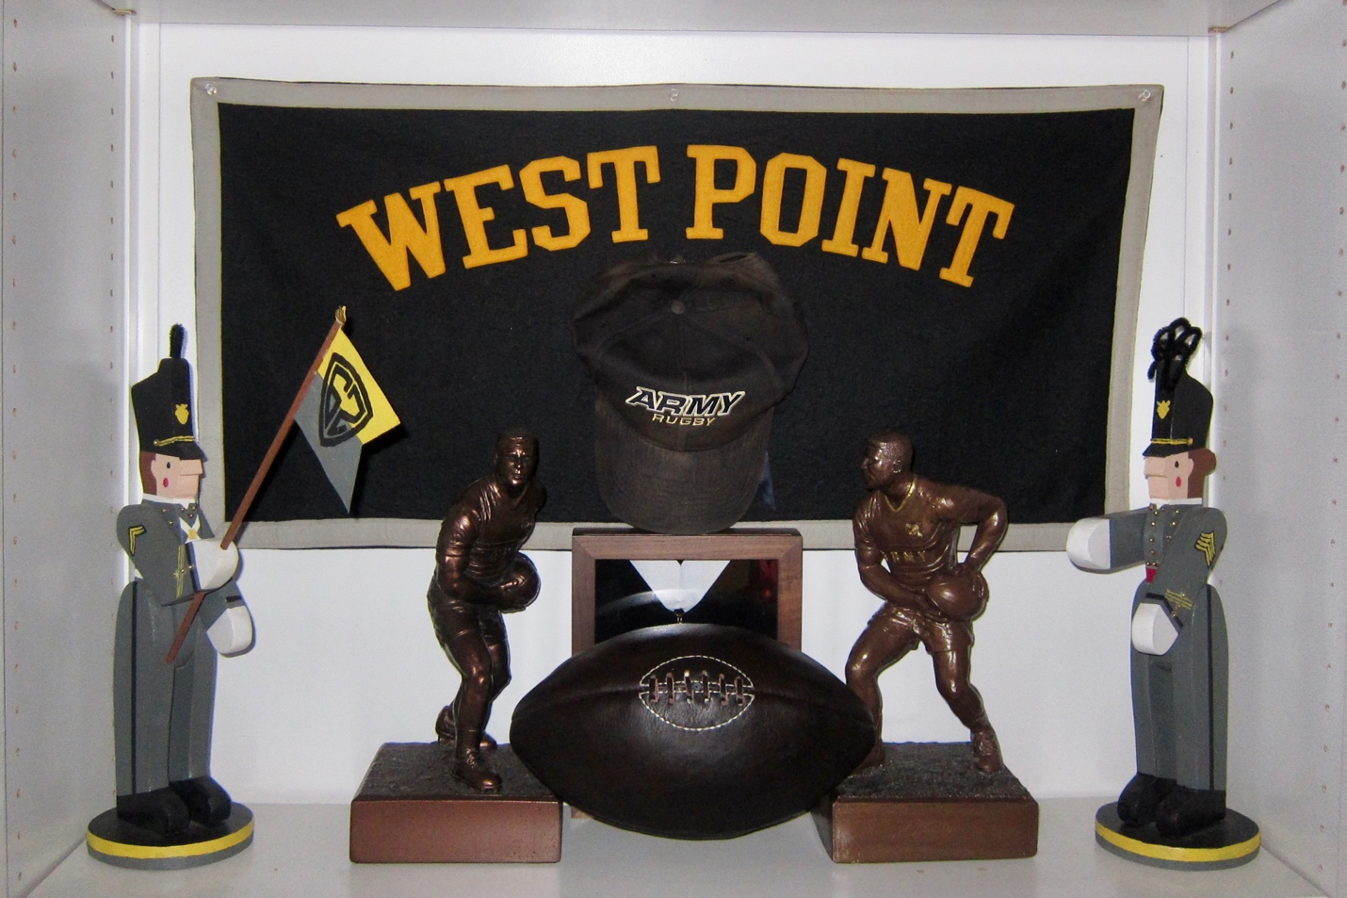

PART I: Army Rugby’s Early Years
PART II: Recalling the Experience
PART III: Fostering the Will to Win

Dedication
This compilation of Army Men’s Rugby First Team History is dedicated to the efforts and memory of Michael George Schredl ’62. Mike was the starting West Point Rugby football Club Left Prop during the team’s initial 1961-2 seasons of play. His love of the sport and his dedication to team and teammates carried on well into his retirement. Mike became the First Team Historian, keeping in touch with those who played, researching their play, competition, and achievements.
Mike in addition developed articles and web postings, and conducted research essential to promoting Rugby within the Academy. His efforts were evident in a 2003 article, The Early Years, a piece he wrote for the Association of Graduates Assembly Magazine. This was done at a time the Academy was starting to seek donors who would help build a rugby complex at West Point with locker and meeting rooms, offices and regulation-size playing fields. That dream was fulfilled with the 2009 completion of the state-of-the-art Anderson Rugby Complex (ARC).

Forward
Since mid 2016 I had been working closely with Mike Schredl on a number of First Team commemorative and team history initiatives. In the process Mike shared with me his files and articles that we could mutually begin to use in developing a single source First Team History. Our vision was to compile a document that would gather all relevant First Team data and memories, and then render a product that could be shared and used into the future by the Army Rugby Program and Athletic Department. Our objective was to make it easily accessible on the web or in hard copy, enabling those who were to follow to benefit from our example and in doing so to appreciate their “roots”.
Mike left us on 17 October 2019, departing for the big pitch in the sky, but leaving with us a wealth of information allowing us to develop a single all-inclusive First Team History. Most of this work to date has been of Mike’s doing. While working towards completion the First Team History was subject to a First Team peer review. Through this process new insights and recollections were received that further enriched and memorialized the First Team Legacy.
Thanks to all who participated.

Bill Kosco ’62, Editor
(h) 717-243-1024
(e) billkosco@aol.com

Table of Contents:

A FIRST TEAM LEGACY
 | TITLE |  |  | Page #
 | INTRODUCTION
 |  | Cover |  | Intro-1
 |  | Dedication |  | Intro-2
 |  | Forward |  | Intro-3
 |  | Table of Contents |  | Intro-4 & 5
 | PART I: ARMY RUGBY’S EARLY YEARS |  |  | I-1
 |  | - The Beginning of Rugby in America |  | I-2
 |  | - The Founding of Army Men’s Rugby FC |  | I-4
 |  | - Initial Coordination, Training, and Play |  | I-6
 |  | - The Second Season and Success |  | I-10
 |  | - In looking Back |  | I-15
 |  | - The Perpetual Rugby Baton |  | I-16
 | PART II: RECALLING THE EXPERIENCE |  |  | II-1
 |  | A. The First Team Photograph |  | II-2
 |  | B. First Team Members Recall the Early Years |  | II-4
 |  | C. No Man Left Behind |  | II-21
 |  | D. A Record of Achievement-The Rest of the Story |  | II-23
 |  | E. An Address by Gen. Dennis L. Reimer, USA (Ret) |  | II-24
 | PART III: FOSTERING THE WILL WIN |  |  | III-1
 |  | - Commemorating the Past |  | III-2
 |  | - Remarks by the Army Rugby Founder |  | III-3
 |  | First Perspectives of Rugby |  | III-3
 |  | The First Ball and the Library Display |  | III-3
 |  | The Interest Survey |  | III-4
 |  | Approval by the Supe |  | III-5
 |  | Finding the First Coach and OIC |  | III-6
 |  | The Beginning of Our Brotherhood |  | III-7
 |  | The Uniforms |  | III-7
 |  | Joining the Manhattan Rugby League |  | III-8
 |  | Injuries and Safety |  | III-9
 |  | The First Team’s Final Match |  | III-10
 |  | Establishing a Legacy |  | III-11
 |  | - Remarks by Army Rugby’s First Coach |  | III-12
 |  | My Youth and the Grange School |  | III-12
 |  | Appling to West Point |  | III-13
 |  | Adjusting to Cadet Life |  | III-13
 |  | My Selection as the First Rugby Coach |  | III-14
 |  | Initial Practice and Placement |  | III-14
 |  | Teaching the Basics |  | III-15
 |  | Mounting injuries |  | III-15
 |  | Our Initial Season of Development |  | III-16
 |  | Entering Full League Play |  | III-16
 |  | Our Last Game |  | III-16
 |  | Recognizing Coach Matthew Sherman |  | III-17
 |  | - Presentation of a Commemorative Plaque |  | III-18
 |  | First Team Presentation Photo |  | III-18
 |  | The Plaque |  | III-19
 |  | - Recollections by BG Peter Dawkins |  | III-19
 |  | Pete Dawkins’ E-Mail |  | III-19
 |  | Recollections of my Introduction to Rugby |  | III-20
 |  | - Announcing Plans to Endow an Award |  | III-23
 |  | - Taking Pride in the Future |  | III-23
 |  | - Introduction |  | III-23
 |  | - Chronology of Events |  | III-23
 |  | - Presentation of Initial Brotherhood Award |  | III-25
 |  | - Brotherhood Award Criteria and Details |  | III-26
 |  | Award Purpose |  | III-26
 |  | Award Criteria |  | III-26
 |  | Award Name |  | III-27
 |  | Award Venue |  | III-27
 |  | Award Sculpture |  | III-27
 |  | Forms of Recognition |  | III-27

