PART I
West Point-Army Men’s Rugby Program

ARMY RUGBY’S EARLY YEARS

Through Teamwork Came Success

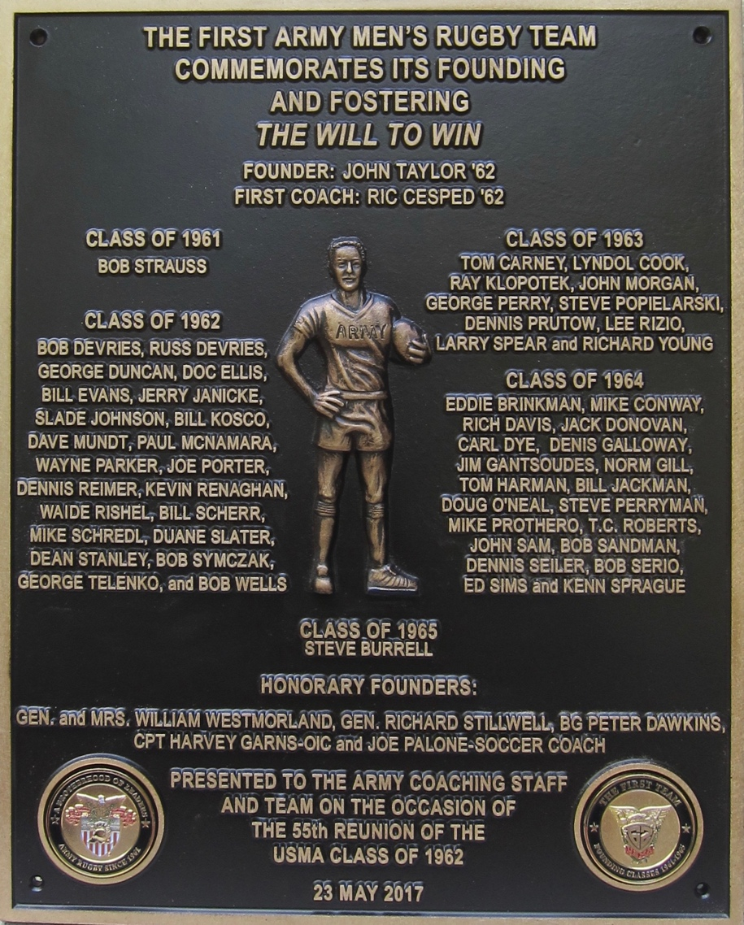

Establishing the First Team

PART I—ARMY RUGBY’S EARLY YEARS

- The Beginning of Rugby in America

The first recorded rugby match in the United States was between the Harvard Crimson and McGill (Canada) Redman on 14 May 1878 in Cambridge, Massachusetts. The match was played in three periods and ended in a scoreless tie.

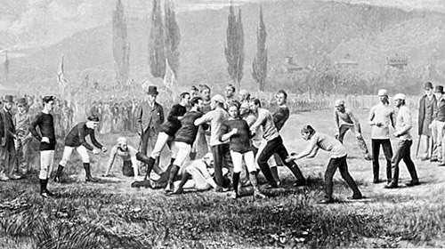
Harvard verses McGill

American football in the early 1900s had become increasingly violent. Typically, the ball carrier would be pushed and pulled up the field by his own players in massive formations that often resulted in serious injuries. In 1905 there were 18 deaths, and 159 serious injuries reported.
President Theodore Roosevelt, concerned about the game, called a meeting of school presidents to discuss reform or abolition of the game. Despite the resulting planned changes, a number of universities banned the sport, including Columbia, NYU, and Northwestern. Also, on the West Coast schools led by California and Stanford, who had played American football from 1892 to 1905, replaced the sport with rugby. Other schools that made the switch included Nevada, St. Mary's, Santa Clara, and USC.
Stanford played twelve seasons of rugby, during which it played other college teams, club teams from the United States, Canada and Australia, as well as the New Zealand and Australian national teams. However, without a nationwide movement, the available pool of rugby teams to play remained small. Despite the sport’s initial success, it became clear that other schools were not adopting rugby in large numbers. However, the annual game between Stanford and California continued as rugby, with the winner invited to a tournament in Vancouver over the Christmas holidays. But after rival California returned to football in 1915, and after a year of playing neither sport, Stanford returned to American football in 1919.

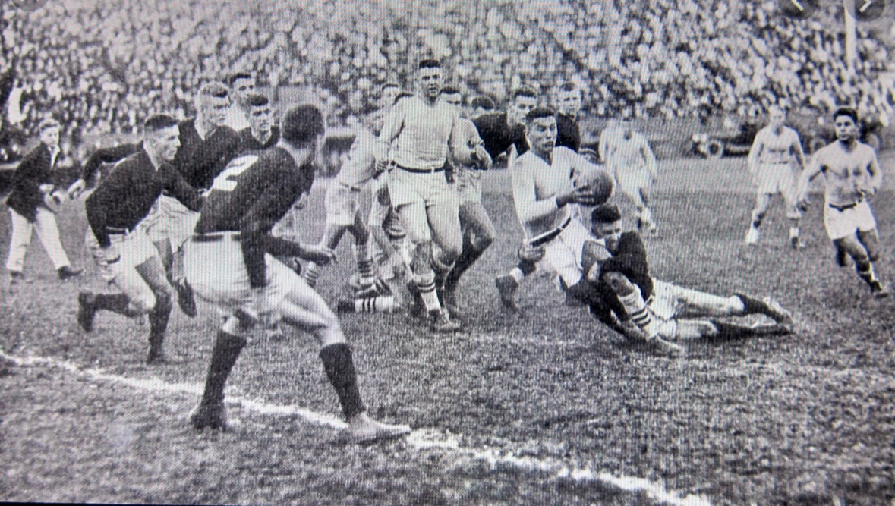
Stanford Rules: 1906-17

Rugby was an Olympic sport and Stanford supplied most of the players to the US Olympic rugby teams, along with Santa Clara University and the University of California. Both US National Teams, in 1920 and 1924 won the Gold medal. After the 1924 Olympic Games rugby was removed from Olympic competition making the USA the defending Olympic Champions until rugby was re-introduced, in the 2016 Summer Olympic Games.

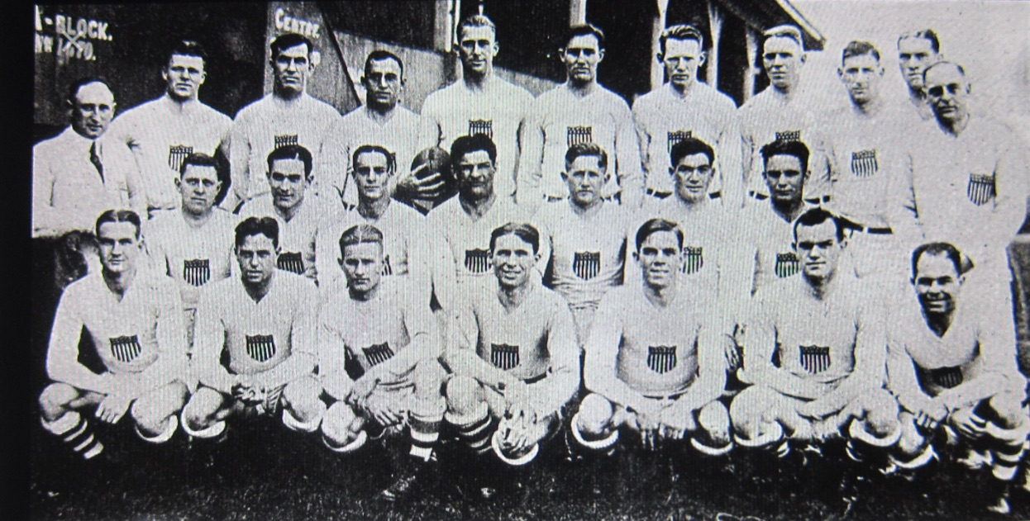
The 1924 USA Gold Medal Rugby Team

In 1934, there was only one official rugby body in the United States, the Eastern Rugby Union, with a total of 9-member teams. By 1950, there were 30 clubs in the US, existing in small pockets on the East and West Coasts.
Rugby began its revival in the United States in the 1960s and 1970s, as many colleges started club rugby teams. By the mid-1960s rugby re-appeared with regular fixtures and competitions. Its basic appeal was that it required minimal costs for the individual, the style of the game provided constant action, and there was an emphasis on enjoyment rather than winning. This was primarily because rugby was not part of the institutionalized and restrictive National Collegiate Athletic Association (NCAA) system that American Universities had developed. USA Rugby, the body that governs rugby in the U.S., was founded in 1975. On 31 January 1976, the US National Team played Australia—in its first official match since the 1924 Olympics—before 8,000 fans at Glover Field in Anaheim, California. Australia won the match 24–12.

- The Founding of the Army Men’s Rugby Football Club.

The Army Rugby Football Club was founded in 1961 and since then the Army Black Knights have been a leader in USA Collegiate Rugby. Today Army Ruggers continue the tradition of being one of West Point's most winning teams.
By the time Rugby started at West Point, it was played in the United States mainly in Ivy League schools, on the West Coast at Stanford and Cal, and by Clubs formed mostly by immigrant enthusiasts from traditional rugby countries like England, Ireland, France, Australia and South Africa. The Rugby Clubs, as opposed to university teams, were the best teams in America at that time, and were known for having the best opponent camaraderie and post-game social traditions in American sport circles.
Army Rugby began with the foresight that John Leslie Taylor ’62 demonstrated at a time when rugby was just starting to emerge again as a collegiate sport. This renders John in a small and elite group of leaders in this sport. In 1961 Notre Dame establish a rugby program, Columbia was doing the same, and the Manhattan Rugby League (MRL) through its New York Rugby Club (NYRC) was aggressively trying to help schools along the east coast to establish rugby teams. There were 13 new college rugby teams founded in 1961, with 11 being only clubs, as most colleges, including Army, classified their rugby programs as club sports rather than varsity sports. The NYRC took an active role in organizing the Columbia University Rugby Club, later to Army’s initial chagrin. Their club, like many, was not limited to currently enrolled students--a limitation placed on the West Point program. Columbia fielded alum, donors, graduate students, faculty, and members of its football team!
John Taylor was intent in bringing the game of rugby-football to West Point. He knew that once started it would spread like wildfire that could add to the long tradition of learning to win by competing in the fields of friendly strife. He faced a tough challenge. He had limited support from organized sports at the Academy, having no funds, no experienced players, no coach, no uniforms, no equipment, and no field to call home. John, to his credit persisted against all these odds.
Peter Dawkins ’59 was John Taylor’s and the First Team’s inspiration. He was King of the Beasts and then the First Captain during the Class of 1962’s plebe year. Dawkins was also an academic Star Man, class president and captain of the Army football team. Upon graduation he received a three-year Rhodes Scholarship to Brasenose College in Oxford to study philosophy, politics, and economics. But, while at Oxford he also found time to play rugby and for all three years his team won the championship. Dawkins during his play at Oxford introduced a number of innovations based on his American football experience which made quite an impression in England, as reported in the American media.
The effort and time required to establish a rugby team at West Point was immeasurable and all Ruggers at West Point, regardless of the year which they played, recognize this achievement was realized primarily through the efforts of our Founder.

- Initial Coordination, Training, and Play.

The first team as initially formed in the spring of 1961 consisted of players from the classes of 1961, 1962, 1963, and 1964. 1962 had the most players followed by solid contingents from 1963 and 1964. Initial leadership and direction were provided by the Class of 1962. John Taylor ’62, the club founder and president, and Ric Cesped ’62, the team coach for the first two seasons, were key in this regard. Members of the other founding classes were essential to our development as a team, especially in providing players to form competitive teams and to conduct meaningful practices. Furthermore, upon 1962’s graduation it was the class of 1963 and again later the class of 1964 that accepted the challenge of leadership, provided coaching and management skills that kept Army Rugby virtually alive before it was later able to receive additional sustaining support from the Academy’s bureaucracy.

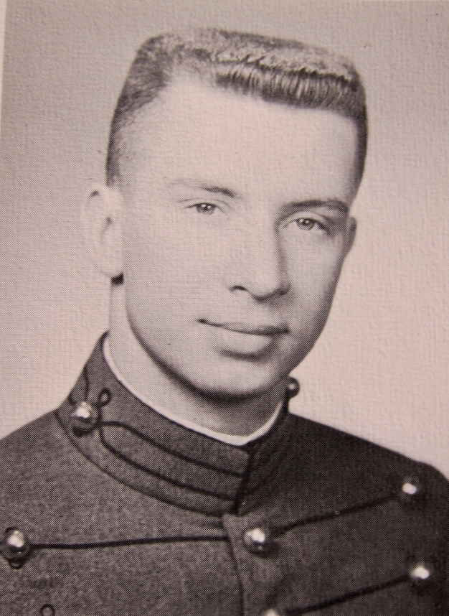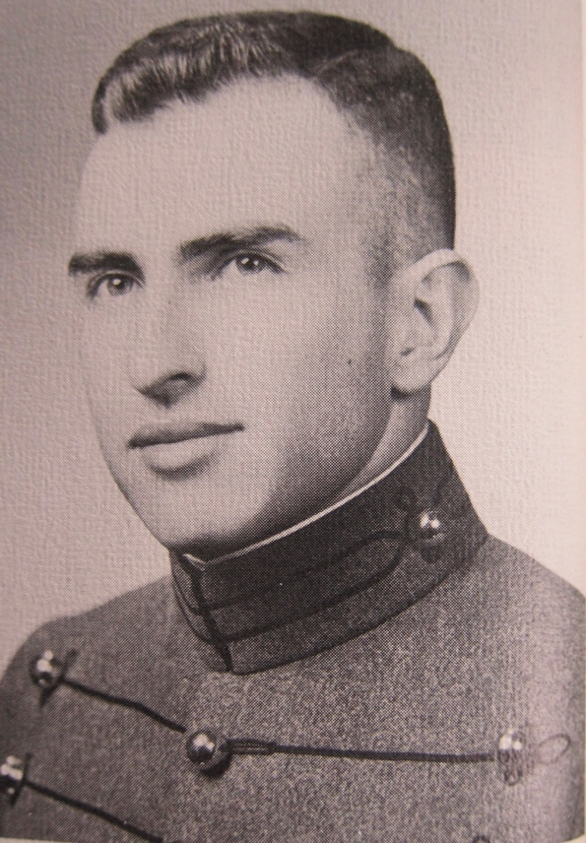
Club Founder: John L. Taylor ’62 First Team Coach: Ric Cesped ‘62
Having responded to John Taylor’s previous October/November query of potential interest 40 cadets gathered at our lonely and distant playing field on a cold March day in 1961 to organize and begin practice as a club sport. Their backgrounds were varied; B Squad football, 150 lb. football, soccer, ice hockey, track, and intramural sports. Not one of the prospective players knew what rugby was essentially about. Within minutes John and Ric realized that creating a creditable Army Rugby Team would be a bigger challenge than they ever imagined, especially doing so safely and without serious injury. Learning the basics of how to tackle (not block), how to use your feet (after all, the game is called “rugby football” because the feet play an important part in winning the game), how to constantly pass the ball to your teammates (and not hang-on to the ball while trying to gain as many yards as possible), how to play without rest in 45- minute halves, how to form loose scrums to retain control of the ball, etc., would all be the key to the team’s success.

The team started with the basics, but the volunteers wanted to “play” the game, and so, we started playing a little at a time, with the one practice ball it had, selecting in the process an A and a B team. This was done without regards to class or standing, in an upward mobility process, and without losing focus of the need to master the basics. Everyone learned at the same time, not only how to play the game but how to do a better job of coaching and administering the emerging organization.
Ric took charge and outlined his first training period that included safe tackling, not head butting or head in stomach tackling. Whereas, in American Football, these were the best means to tackle your opponent’s, given players had protective head and body pads.
The MRL’s New York Rugby Club (NYRC) was the oldest rugby club in the United States and served as Army’s mentor during the team’s formation process. The NYRC fielded highly competitive Division I Men's, Premier Women's, U-19 Boy's and Girl’s teams, as well as an Old Boy's side. It was founded to continue a tradition of excellence, sportsmanship and fun, on and off the field, that dates back to the formation of the New York Rugby-Football Club (NYRFC) in 1929. The NYRC valued its ties to a large alumni network as much as it strived to focus on the development of youth, high school, and collegiate rugby players in the greater New York metropolitan area. It also worked to develop its active playing members, numbering well over 200 men and women of all ages, and to give all levels of players and fans the opportunity to enjoy the best of what the game can offer.
In the process of inviting Army to participate in organized play the Manhattan Rugby League (MRL) invited Captain Garn, the team Officer-in-Charge (OIC), and John Taylor to a meeting of officials at the home of the Club President in the Spring of 1961. Also, in attendance was a sizeable contingent of NYRC representatives. John presented a summary of the recent organization and formulation of Army’s club. The MRL, consisted of four sides (or teams) and was comprised mainly of middle-aged men who played with finesse, but not endurance. Initially, during this placement process Army was designated Side C, as a Division III Team. The NYRC was Side A. Later John Taylor found out that Side B and D were actual rugby clubs, but rarely participated as such—rather their members formed composite teams, took part in scrimmages or filled the ranks of other clubs.
Upon being accepted into the MRL the team was asked to provide the league with a list of dates when it would be available to play. John Taylor was ready to indicate that any weekend was open for on-and off-campus matches, but Captain Garn had to temper his enthusiasm. Captain Garn requested that the MRL send him their proposed schedule of matches, since he would have to coordinate the entire Army games schedule with the Director of Cadet Affairs to approve civilian clubs to visit West Point and of our playing off-campus, which including arranging for military buses. These off-campus matches, were basically different. Captain Garn had the team assemble in an area near the hospital to await a trip inspection by the FOD and board the buses. The drivers already knew where to go, when to be there, and to drive us back to the Academy. To the team this was the magic of West Point.
By late April 1961 the team was ready to try its new skills, against its mentor and one of the best rugby clubs in the East — the New York Rugby Club. The NYRC, being very supportive of new and developing rugby teams, was willing to play a practice game with us, or rather, to put on a rugby clinic at Army’s expense. It was, however, a valuable learning experience. Army lost, but did so with its head held high. Although losing the score was very close and, in the process, we gained confidence and we became a better team. In addition, we surprised our mentors, since we physically outran and overran them.
Since the team had not yet gained rugby “finesse” it initially lost more scrimmages and matches than it won, most of which were played against MRL composite teams. However, Army players were younger, stronger and faster—and played enthusiastically and with vigor and rugby had now become part of life at West Point.

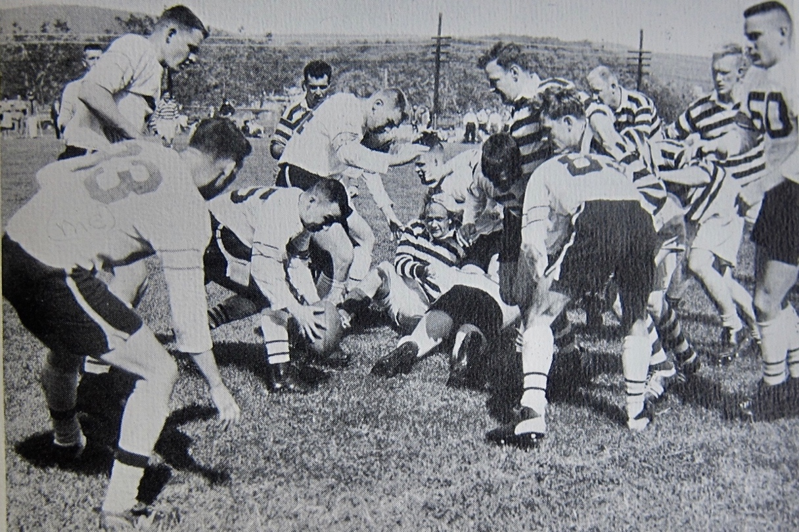
Initial League Play: Jerry Janicke fields the ball, Wayne Parker is
ready to receive.

Army Rugby did not officially practice and play in the fall of 1961. Rugby at that time was not in season and most players were otherwise engaged in competing at the corps squad level or coaching and playing intramural sports. There were, however, a few reported “friendlies”—a match against Dartmouth on the B Squad football practice field and a scrimmage against another MRL Team/Side.
It must be acknowledged that many of Army’s matches, especially in the Spring of 1962, were outside the specific context of matches against the MRL’s competitive sides, as they had been in the Spring of 1961. By this time Army was still in the MRL, but a member of the Eastern Rugby Union. CPT Garn must be credited with coordinating the scheduling of games with other clubs and college teams. Although John Taylor was not directly in-the-loop in the scheduling clubs Army would play he was, however, instrumental in the implementation of the schedule. Sometimes this resulted in John not knowing when teams arrived on post until they showed up the Cadet Gym to change clothes. However, in most cases the MP guard at the Thayer Gate called John on his CIC red phone to alert him of a visiting team’s arrival. In both scenarios he was in a tail spin to notify everyone he could and to instruct them to tell others to report to Target Field. Game on! Amazingly, the technique worked and John’s conditioning improved in the process.

- The Second Season and Success

It must be acknowledged that many of Army’s matches, especially in the Spring of 1962, were outside the general context of matches against the MRL’s competitive sides, as they had been in the Spring of 1961. By this time Army was still in the MRL, but a member of the Eastern Rugby Union. Now in Army’s second year of rugby the team continued to focus on the basics and improving teamwork, and in the process the First Team was ready to compete. Captain Garn had coordinated a full schedule of 6 or 8 matches for our A Team, ending the season with a match against our teachers and mentors, the NYRC. Army had now obtained increased respect within the MRL, which was attributed primarily to its speed in learning game and the coaching ability of Ric Cesped.
The team now had about 50 club members. General Westmoreland and his wife had a special interest in the club, and it received continued support, including a medic and an ambulance at our practices in case of serious injury. Often, the General and his wife would show up during practice and encourage us on.
Army soon became a very creditable team, even with its serious lack of weight and size in the forward line. It was, however, blessed with an abundance of enthusiasm, lots of energy and speed, fearless low tackling, and an incredible "Can Do" attitude. In addition, it did not need to be coached in having a good time together--or in socializing in New York City after away games.
On-campus matches would become relatively easy, however, off-campus matches tended to be difficult administratively due to need to inform the cadet players in advance, so that academic deficiency, punishment tours, and confinements were accommodated. Additionally, for those who could not make the trips, volunteers from the B and C Teams were recruited. Without exception there were ample volunteers. CPT Garn’s effective coordination with the Office of Cadet Affairs, ensured military buses were always available and on time, waiting for the team to be inspected by the FOD, and still arrive at destination fields on time. Sometimes, these games were scheduled with a team that was composed of a mix of players from the other teams in the league.
In trying to create an account of our First Team accomplishments on the rugby pitch in the Spring of 1962 it must be recognized we did not have even a nook or file cabinet at our disposal in those early days to promote a process of documentation. Our coach or manager/founder might at one point have kept working files, but they are no longer to be found. Without copies of rosters, schedules, results, notes, and articles it is very difficult to state with a high degree of accuracy what we achieved. Members of the First Team have had difficulty at this point in recalling the specific names of opponents and the seasons of competition. The fact that many members of the First Team subsequently played on the Second Team (1962-3) and the Third team (1963-4) made the verifying of matches played during only the Spring of 1962 problematic. What members of the First Team did recall were some individual memorable matches, their particular injuries, the beer and girls after the game, and the friendship and camaraderie on and off the field within ours ranks and with opponents after the game (win or lose). There are conflicting memories of who we played, where, and when. However, what was vivid in everyone’s memory was that our experience provided an incredible life lesson that great things can be accomplished with limited resources given an abundance of teamwork, coaching, and dedication. It can be stated with certainty that the consensus is the combined records of the A and B Teams resulted in a very successful 1962 spring season.
A specific case in point regarding the working with limited resources and with an economy of effort would be that of our one official game and practice ball. The only regulation rugby ball the First Team had during its entire 15 months of play was the ball John Taylor purchased from the MRL official for $50 in the Fall of 1960. It was a leather ball with laces. Early on, upon our founding of the program, the MRL gave the club two whistles and four practice balls. However, the practice balls being noticeable smaller and narrower than our official ball were not held in high regard and eventually ended up in the dumpster behind John’s I-2 Barracks.
The First Team entered into the Spring of 1962 Season of Play under rules that are unfamiliar today. Matches were played under straight 45-minute halves, with no time outs, no substitutions, and 3-point Trys. Occasionally during scrimmage play we would seek a mutually agreeable relaxation of the substitution rule to primarily allow more players to gain game experience.
An early match in the 1962 Spring season that was recalled by Army ruggers was an A-Team match played against the Westchester Rugby Club on its home field in New Rochelle. The weather was raw, chilly and sunny and Westchester had an outstanding Irish scrum half that kept Army on the defensive with an excellent kicking game. Westchester reportedly either tied or won the match on a 62-yard field goal. This kick was a record for both football and rugby and it was reported to be written up in the New York Times and also receiving a short write-up in the back section of Sports Illustrated, under Record Performances.
Also recalled was an early Spring match against Manhattan College in Van Cortlandt Park. Before the match began, with what resulted in a winning 30-0 effort, the field first had to be policed by all hands to remove broken bottles and glass.
Other matches that were suggested by some, but could not be further substantiated, were possible games against Harvard, Yale, Princeton, and Notre Dame. More verifiable recollections were games against the City College of New York and Fordham University.

However, the one game remembered by many and documented in the 29 April 1962 edition of the New York Times was the First Team’s last away game played against the Columbia University Teams—the A Team “Old Blues” and its B Team.
As the teams prepared to board the bus for the Columbia game in New York, they ran into a hiccup. John Taylor was the designated trip commander. The bus was already there, but the FOD was late. When he did arrive, he asked for the trip commander. John stepped forward and the FOD looked at him from top to bottom. When he inspected his low-quarters, he determined his “spit-shine” was not as good as his and told John to find another trip commander. John said, “Yes, Sir”, saluted, and immediately told Mike Schredl to take over. John gave Mike all his paperwork and instructions and then told him to get everyone on the bus and move out, as they were already late in departing.

However, the discrepancy in the team’s military appearance had been reported up the chain of command, resulting in the team bus being stopped at the Post Main Gate by the Military Police, at the request of the Superintendent, General Westmoreland. Mike was instructed to have the bus return to the departure point at Washington Hall. In Mike's words:

“I knew something was up and had a feeling it might not be good. I told the team members to put on and zip up their gray uniform jackets. Upon our return General Westmoreland was waiting for us in front of Washington Hall with a group of other officers, including the no nonsense B-1 Tactical Officer, Major Earl Craig Betts '49. The team disembarked and fell in for inspection. General Westmoreland then personally inspected each one of us. Every cadet, except me, was cited for some minor uniform infraction and sent back to the barracks to make corrections. I had the distinct feeling that he was not pleased! “

After being released for travel Mike continued, "General Westmoreland directed me to call him at his quarters immediately upon our return to the Academy.”

The next challenge was to now play Columbia. It was recalled that many members of the Columbia Ivy League Championship football team played on the university’s rugby teams, as the Ivy League did not allow teams to conduct Spring Practice. The Columbia “Old Blue” Club, consisted of an interesting group of Columbia grads, including Dick Donelli a former quarterback and Bill Campbell the football team captain. The A Team game played on Columbia’s Baker Field became a game of attrition. The Army A Team was favoured to win, but with 8 minutes to Play Donelli scored a try to put Columbia ahead 11-10 and then scored again with 2 minutes to play. By this time Army was only holding on and then handed a loss with only 12 players left on the field. The team, from this experience, learned that in the future they would have to play smarter and avoid game ending injuries. As a result of this win over the Army’s First Team Columbia earned a berth in the Eastern Rugby Union’s Division III play-offs.

Others on the Columbia game trip section have better memories of the experience. Jerry Janicki ’62 remembers being the B Team scrum half in beating the Columbia B Team 19-0, in a game played after the A Team match.

Mike Schredl in reporting back to the Supe after the teams return recalled thinking:

“ To make matters worse we lost to Columbia in a squeaker of game-won primarily by its football team. I felt that I would be in big trouble. When I called the General at home that Sunday evening and told him that we lost, I was expecting disciplinary action. I had visions of a 15&15 or more, and possibly a delayed graduation. Completely opposite of the tact taken when inspecting us, he expressed his sorrow over our loss and then complemented us for a good season to date. I am sure that he sensed the anxiety in my voice. He then commended me for sitting at the front of the bus and explained that good leaders lead by example and are highly visible but, at the same time, are always aware of what the troops in the back are doing. I found General Westmoreland to be a warm, caring, and compassionate man. He then told me that there would be no further disciplinary actions taken, and consequently, none of the players were written up".

Before the end of the 1962 Spring Season Army played a home game against a new Fordham University Team. Fordham requested to play our B Team, a team as defined as having with no Army seniors. The game ended badly for Fordham with its team being attrited heavily through injuries. Reportedly Fordham learned through the experience and returned the next year to defeat Army.

The First Team’s second season was a winning experience for West Point Rugby by the time we played our final game. That was on Saturday, May 12, 1962 and we were again scheduled to play the NYRC, the perennial Eastern Rugby Union power. That same day General Douglas MacArthur would make his famous trip to West Point to deliver his last speech to the Corps of Cadets. This would be just minutes before the team’s last game of the season and for many, the last time they would play rugby. Portions of General McArthur’s speech brought tears to the eyes of many cadets, and have remained in their memory to this day. This included:

“…..Yours is the profession of arms, the will to win, the sure knowledge that in war there is no substitute for victory, that if you lose, the Nation will be destroyed, that the very obsession of your public service must be duty, honor, country. Today marks my final roll call with you. But I want you to know that when I cross the river, my last conscious thoughts will be of the Corps, and the Corps, and the Corps. I bid you farewell.”
No doubt, MacArthur’s speech had a profound impact on all of us. Maybe it was just what West Point is all about. On that day, the Army Rugby-Football team would play and go on to victory. With additional experiences collegiately, as well as against other New York clubs hard lessons were learned and Army, with BG Stillwell dressed in his blues in attendance, came from behind and won its final game against the "Best Club in the League, the Manhattan New York Rugby Club”. As a final tribute to our progress and play MRL officials called the First Team to the sideline after the game and told us we had been moved up in the league bracket to Side B, just behind the NYRC.
- In Looking Back

In looking back, team members could relate that the experience of being on the Army Rugby Team developed a unique and keen awareness of teamwork, trust in one another, and the importance of a concern for teammates. The degree and intensity of these characteristics were developed on the rugby pitch more so than in any other warrior sport. It was obvious that our responsibilities and conduct on the field led directly to our attitude and execution of future responsibilities in service to our country and in life.
As the team turned in its equipment and uniforms for the last time Denny Reimer remembered:
“We on the other hand didn't have a lot of talent (at least I didn't) or tradition, but we were good enough to get Rugby at USMA off the ground and gave it a chance to be all it could be without changing the culture. I am proud of that”
In recapping the season, the team was reminded that success on the rugby pitch requires total commitment to teamwork and rarely one player alone is called upon to make the difference--perhaps with one exception - the fullback. The fullback is the last line of defence, the one person who must "stop the hordes at the gate" and Army was recognized has having the best fullback in the Eastern Rugby Union, Lee Rizio '63. Lee knew no fear and kept the opponents from scoring in numerous occasions. He would be selected to the All Eastern Rugby Union Team along with Wayne Parker ‘62 to play against the All Canadian Rugby Team.

A few weeks later on June 6, 1962 the senior members of the Rugby Club’s First Team, the Class of 1962, graduated and bid farewell to some of the best friends we made while at the Academy, our Rugby-Football teammates, some of whom unfortunately we would never see again.

Together the First Team had established the beginning of a legacy that would be carried forward by cadets managing the administration of the Club and filling the coaching position. After 15 months Army Rugby had arrived and the leadership role was passed to the Class of 1963.

In the Spring of 1963 after the graduation of the Class of 1962 the team was coached by Steve Popielarski '63. Assisting Steve was Dennis Prutow '63, who performed in vital positions as the player-manager and club president. Steve remembers the influence Ric Cesped’s coaching and his reading of the rule book had on being able to coach a good team into a great team by season’s end.

Thereafter the 1963-4 coaching responsibilities were put in the able hands of another Founder, Kenn Sprauge ’64.

The baton had been passed.

- The Perpetual Rugby Baton

Mike Schredl, appreciating the symbolism associated with the passing of the baton to future Army Rugby Teams and players, crafted a unique baton in his California workshop. It was presented to Coach Rich Pohlidal, his coaches and players who gathered for a moment of comradeship during the Class of 1962’s visit to the Anderson Rugby Complex (ARC) on the occasion of its 50th Reunion in May 2012.

The baton not only recognized the contributions made by the First Team, but also serves to challenge future teams to carry on and pursue excellence through character, leadership, teamwork, and an unfaltering brotherhood.

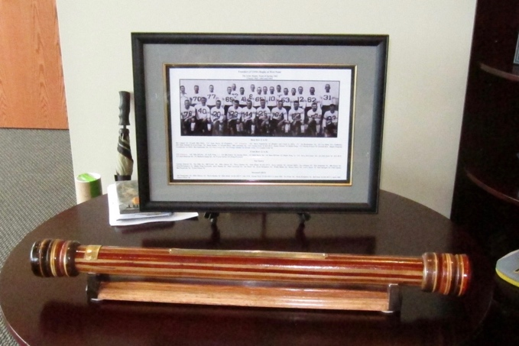

The Rugby Baton and Team Photograph presented to the
the Army Men’s Rugby Program on 22 May 2012

