PART III

West Point-Army Men’s Rugby Program

FOSTERING THE WILL TO WIN

Together Building a Legacy

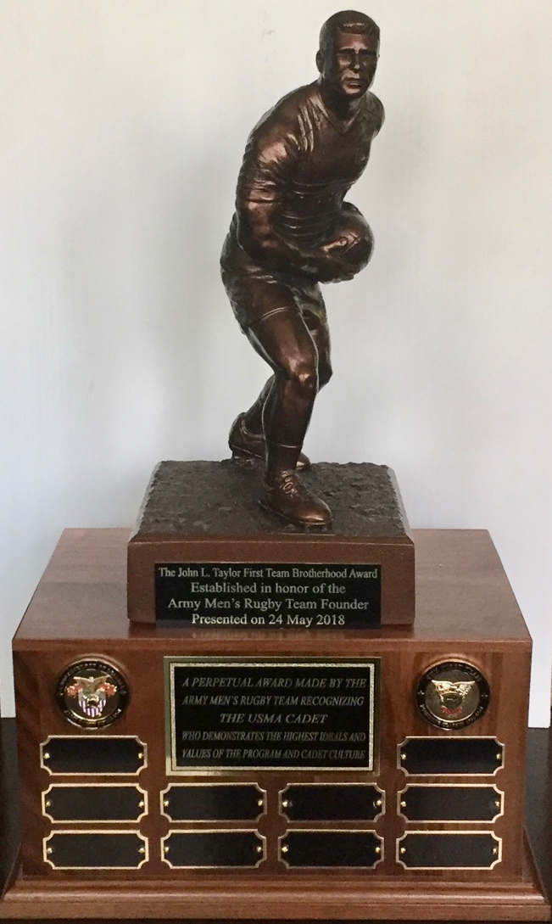

III. FOSTERING THE WILL TO WIN

- Commemorating the Past

In the Fall of 2016 the Army Rugby Founders’ Legacy Working Group (WG) led by Ric Cesped (First Coach), John Taylor (Founder), Dennis Reimer, Mike Schredl, and George Telenko decided to reinvigorate the pursuit of an initiative to recognize and memorialize the efforts of the program founders on the occasion of the Class of 1962’s 55th Reunion. At that time Bill Kosco and Bill Scherr joined the committee and Bill Kosco was appointed Project Manager to coordinate and execute a plan to present a suitable form of recognition to the program and to put into motion the creation of a Founders’ Endowed Annual Perpetual Award. Committee members participated in subsequent in-progress reviews and contributed to the funding of a bronze plaque and challenge coins that were selected for presentation.
On May 23, 2017, ten Class of 1962 ruggers and their guests were transported to the Anderson Rugby Complex (ARC) after the Alumni Luncheon to participate in the presentation of the challenge coins and a plaque commemorating the founding of the program. These gifts were accepted and were then distributed and displayed independently by the program to recognize those members of the First Team responsible for establishing Army Men’s Rugby.

Features of the associated Presentation Ceremony included:
- Remarks by the Program Founder, John Taylor, see Pages III-3 to 11
- Remarks by the First Coach, Ric Cesped, see Pages III-11 to 16
- The Presentation to the program of the Commemorative Coins and Plaque, see Pages III-17 and 18
- A reading of a message from a Program’s Honorary Founder, Peter Dawkins, see Pages III-19 to 21
- An Announcement of the intent to create an Endowed Annual Perpetual Award, see Page III-21

- Remarks by the Army Rugby Founder

THE FOUNDING DAYS OF WEST POINT RUGBY
A SHORT STORY
by

PROGRAM FOUNDER, JOHN L. TAYLOR ’62

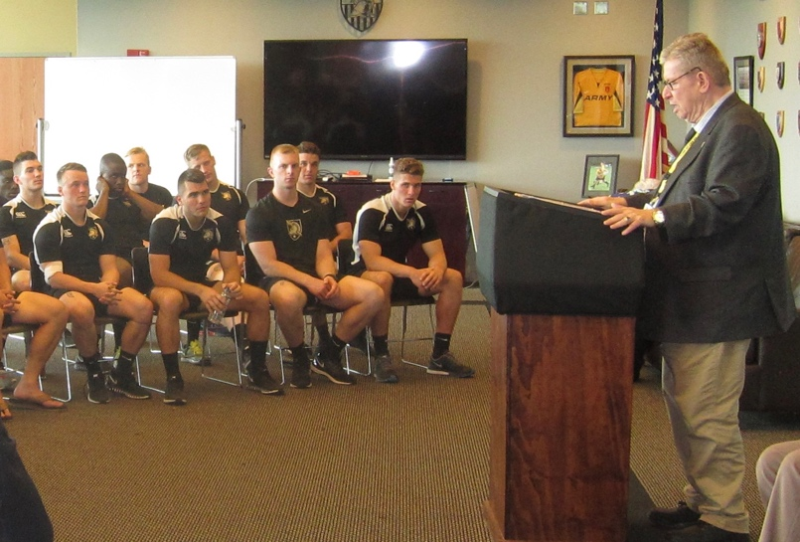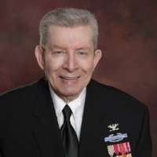

May 2017: John L. Taylor, Army Rugby’s John L. Taylor
Founder Recalls the Early Days

First Perspectives of Rugby
During my Cow summer of 1960 I observed a Rugby Game on Earl Blake Field played by outside teams. Thoughts: Rough and tumble, no Rules. However, it seemed to me Rugby was a game many cadets could play and enjoy. After the game I talked to an official from Manhattan Rugby League who gave me his phone number. Shortly after, I purchased from my personal cadet account the First Ball from that Manhattan League official.

The First Ball and the Library Display
I took the ball to the Chief Librarian at the Cadet Library and discussed ways to create an interest among the Corps of Cadets. Upon seeing my rugby ball, she immediately recalled a Life Magazine spread on 2LT Peter Dawkins’ Rugby experience at Oxford, including a two-page picture of Pete running with a rugby ball as he prepared to pitch it to the rear to another player.
She designed an attractive display case near the entrance of the Library: red velvet cloth around sides of the case, rugby ball at the top center and Dawkins’ picture in the lower center of the case. I visited the Library frequently to ask the level of interest in the display. Always the same answer, “Much! Great!”

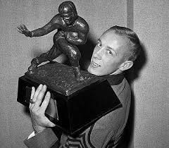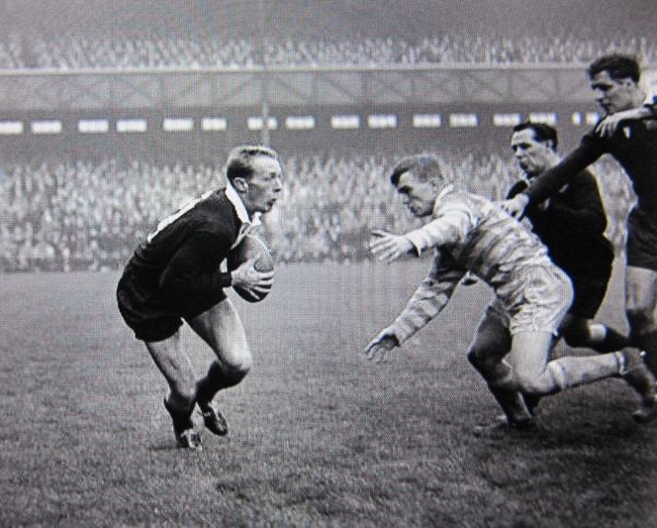
First Captain Pete Dawkins with Pete Dawkins in action--the Oxford
his 1958 Heisman Trophy - Cambridge Match, 6 December 1960

The Interest Survey
During the beginning of my Cow academic year, I started to think of ways to finally determine the actual interest level among the Corps of Cadets. I decided to go the route of a survey to be distributed to each company in both regiments.
In addition to helping me stay academically proficient in all subjects, allowing me to pursue my idea of creating a Rugby Team, my roommate, Ted Stroup, also helped me draft a survey questionnaire. I took it to the Chief Librarian who made a few corrections and printed sufficient copies for each class in each of the twenty-four cadet companies. The main thrust of the survey, in addition to finding those cadets who were interested in organizing a rugby team, was to determine if any cadets had previously played Rugby Football.
I delivered the survey packets to each cadet company and class with a note that told the CQ how to distribute them. I indicated that I would return 7 days later. Survey results showed 45 cadets were interested. These responses, by members of the Classes of 1961-64, initially covered the gamut from varsity teams and intramural sports. None had had any rugby experience except one—a foreign cadet.

Approval by The Supe
Again, Ted helped me by drafting a military letter addressed to the Supe. I took this draft to the Chief Librarian. She liked the content, but suggested a softer, informal business style letter format. I asked her if she thought having a supportive letter would be helpful from now 1st LT Peter Dawkins. She agreed and typed my letter to Peter, including his Oxford mailing address. I mailed it to him the next day after SAMI. My letter was “air-mailed” to Oxford, and “Saint Pete” wrote back within a few days with a very supportive statement, urging the Supe and the Commandant to approve the fielding of a Rugby Team at West Point.
I mailed my letter directly to the Supe, with 1st LT Dawkins’ statement attached, and received a direct reply via mail from him. Allegedly, this might have been the first time in the history of West Point a Cadet directly sent anything to the Supe and he directly replied to the Cadet. The returned response was approval by the Commandant, BG Richard Stillwell, and the “WCW” initials indicated approval by the Supe. Officially the Supe authorized forming the team as a “Class B Competitive Club”. General William Westmoreland added a note that I should find an OIC for the Rugby Team from possibly among professors in the Social Sciences Department.

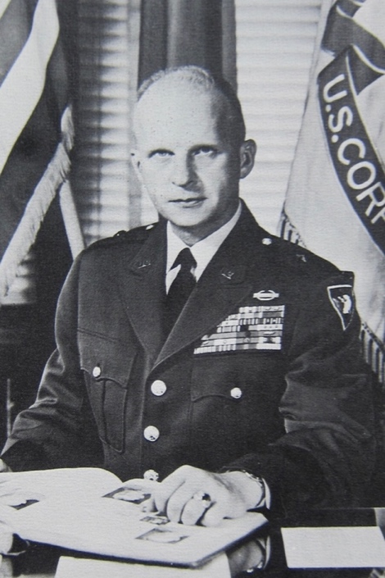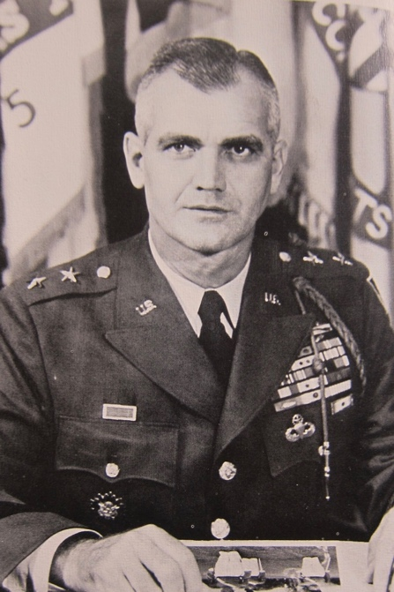
BG Richard Stillwell MG William Westmoreland

Finding the First Coach and OIC
Yes, we needed an OIC; but more importantly we needed a Cadet Coach. I again searched through the 45 responses, and found my man—Ric Cesped, a foreign cadet from Chile. So, one Sunday after Chapel, I went to his cadet company and found his room. With a forceful knock, I entered the room of three Cows. All three came to attention; I asked “Who is Cesped?” Ric replied, “Sir, I am.” I told them to relax, since I was their classmate. I then militarily suggested that Ric be our coach. He said “Why me, I have never coached anything… are you kidding?” I said, “No, I am not kidding, you are the First Coach.”
Now we had the First Coach and the First Ball, but where and when do we play games and practice? An OIC was needed to answer these questions. I found CPT Harvey Garn ’55 in the Social Sciences Department and asked him to be our OIC. He accepted and we could not have done any better. As a cadet, he was assigned to company I-1 and was the B-Squad QB. As a Firstie he was promoted to Cadet Captain and was given command of the Third Battalion in the First Regiment. He chose armor as his combat branch and upon graduation, was one of four members of the class to receive a Rhodes Scholarship, studying in England where he learned to play, or at least appreciate, rugby.

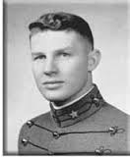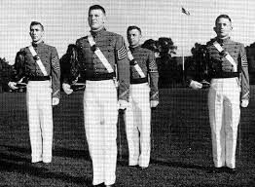
Cadet Harvey Garn ’55 Cadet Battalion Commander Harvey Garn

The Beginning of Our Brotherhood
Our OIC, CPT Garn, located a practice field through the Office of Cadet Affairs. The only field available was in the “mud and mire” at the end of the Target Field, down by the railroad tracks and the Hudson River. This location is now the home of the Anderson Rugby Complex (ARC). The question of “when” to have practices and games was still TBD and TBA. I called a meeting of our team in the hallway of the Cadet Gym one night after “release from quarters” at 9 pm and told our members of our First Team that: We had the authority from General Westmoreland and BG Stillwell to organize a team and play rugby, the newest sport at West Point. Ric Cesped, holding the First Ball, explained the invention of Rugby Football by soccer players at the Rugby School in the UK and also about the rugby rules and the related safety precautions. Then the next afternoon we marched toward Target Field until we were well beyond Shea Stadium. I then gave “Route Step” to the group and my directive resulted in a gaggle of enthusiastic and joking cadets, led by Bill Scherr and George Telenko. Upon reaching the field, Ric took charge and outlined his first training period, which included safe tackling--not head butting or head in stomach tackling. Realizing, that in American Football, these techniques were the best means to tackle an opponent given football players had protective head and body pads. This was far from the case in rugby!

The Uniforms
Once we had a playing field (pitch) and a game schedule we were still wearing our cadet PT uniforms and/or sweats. As a consequence, our PT uniforms eventually became torn, ragged, and disreputable. Some of us were written up by the FOD and awarded three demerits for our ad hoc rugby practice attire.
Thus, as cadet in charge (CIC), I undertook finding better uniforms for all team members as a priority. My research indicated only ones possibly available were old soccer uniforms. I then went to the athletic uniform storage room on the 1st floor of the Cadet Gym and I spoke to a civilian who said that I needed to get approval from Coach Palone, the famed Army Soccer Coach. I asked for an appointment and he departed. When he returned he said that Coach Palone would see me that afternoon at 1500 hours.

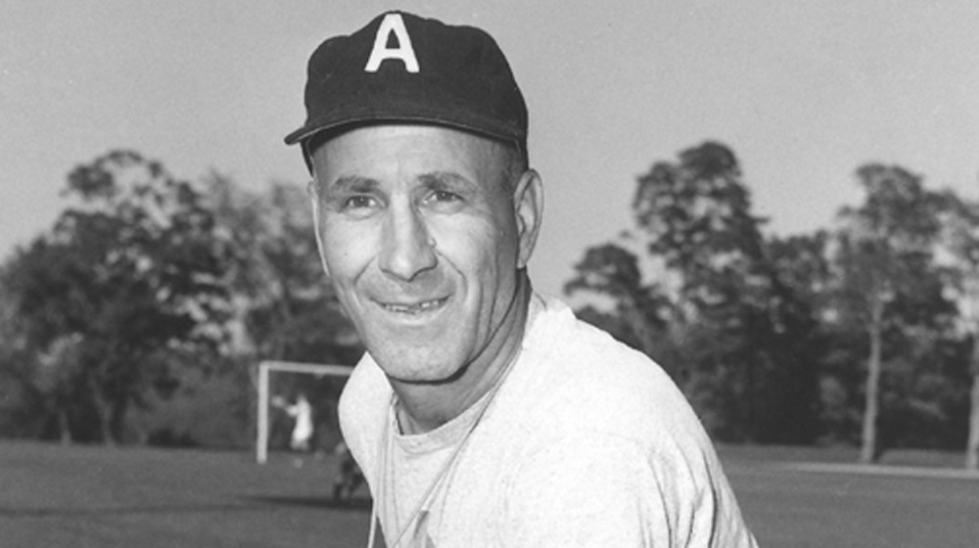
Coach Joe Palone
I was there in the uniform room on time and Coach Palone was there to meet me. I introduced myself. Coach Palone said he remembered me from Plebe boxing and intramural wrestling. He already knew about Rugby as a Club Team Sport and was receptive to my request. In front of me were row on row of soccer shirts, shorts, and even rubber spiked shoes of all sizes. Coach Palone said to have my players come in and pick up three sets of uniforms and one pair of shoes over the next three days. Then I went to Target Field and told the team about Coach Palone’s offer. They were particularly excited about not being further targets of the Tactical Department and not having to practice any longer in their cadet basketball shoes. We continued then on to use soccer uniforms and shoes with cleats. Later, as we needed uniforms for our games, we acquired additional equipment from the B-Squad Football Team

Joining the Manhattan Rugby League
We practiced, scrimmaged and played games without pads or protection. Since we had not gained the “finesse” of Rugby Techniques, we initially lost a lot of scrimmages and matches. However, we were younger, stronger and faster; and, we played enthusiastically and with vigor. We surprised our mentors, namely the New York Rugby Club, since we physically outran and overran them. Such semi-professional teams were composed of professional British businessmen with an average age of 35, who did not practice together often, but knew the game and were great supporters of Rugby in America.
By later in the Spring of 1961, our developing skill and momentum became more appreciated. One night during study hall, CPT Garn called me on my CIC phone and told me that we were invited on that Saturday to a meeting with the leadership of the Manhattan Rugby League. I was frightened to death. “What do I do and say”? On the drive to the meeting, held in a large mansion in a wooded area near NYC, CPT Garn clarified the terms of our attendance. He explained that we were attending only to hear what Manhattan Rugby League had to say and that even due to our enthusiasm and theirs, we still could not support too many games on or off campus. He also strongly suggested that I relax and be less “cadetish”. Although, I was in uniform and probably the “most spooniest” I had been in 3 years. Upon our arrival we received a warm welcome and entered a room without chairs and sat on the floor. I think this was a way to make the meeting more casual. We were offered liquor, beer, wine and soda to drink with a selection of snacks. CPT Garn had a glass of wine and couple of sandwiches. I asked for a cold Coke Cola and took advantage of numerous sandwiches. Subsequently, they asked me how I received permission to organize a Rugby Team. In three minutes, I told them my story. When I finished they got up and started pounding their feet on the floor in excitement. CPT Garn whispered that he thought they liked my approach, as they were in the process of thanking me. The Chief of the group then invited our rugby team to join the Manhattan League in C Division, two divisions behind A Division, but ahead of the long-established D Division. They asked me to approve their invitation. I glanced at the my OIC. He smiled and nodded “yes”. So I, in a command voice, said,“Yes”. This time they both clapped and pounded their feet. We, then, had a social hour with more food and drink.
During these final minutes of our meeting the question of scheduling games was addressed by the Manhattan Rugby League representative. CPT Garn stated that it was probably best for the League to send him a schedule of their teams’ availability. On-campus matches would be easy, however; off-campus matches would be difficult to schedule due to the need for bus transportation and time to inform the cadet players in advance; so that academic deficiency, punishment tours, and confinements, were accommodated and return trip to West Point was made on-time. Additionally, for those who could not make the trips, members from the B and C Teams volunteered and filled in the gaps. CPT Garn’s skillful coordination with the Office of Cadet Affairs ensured the military buses were always funded and on time. They were there as we were inspected by the FOD and then delivered us to a NY Rugby Club field as scheduled. Sometimes, our games were scheduled with a team that was composed of a mix of players from the other teams in the league. We normally returned to West Point in the early evening with CPT Garn in praise of our play. It was satisfying for me to know that we were in an actual Rugby League and had a pre-planned schedule.

Injuries and Safety
We became more attentive to Ric Cesped’s coaching. However, due to our increased enthusiasm, particularly during practices, injuries began to build.
General and Mrs. Westmoreland visited our games in order to learn the game and to see how and why injuries were occurring. The Cadet Hospital Administrator had threatened that he was going to suggest to the Supe that Rugby as a Club Sport be eliminated as our injury rate was high. At one point it reached 40%! This situation prompted all players to execute Ric’s safety coaching more closely.
Apparently, at a social event, Mrs. Westmoreland overheard the Hospital Administrator saying that Rugby should be eliminated. She approached him and asked to speak with him privately. Allegedly, she encouraged him to support the team with an on-site ambulance, a medic, medical supplies and wraps to deal with injuries on the spot. Thereafter, we did not have injuries that required evacuation, and the overall reportable injury rate greatly dropped.
I conclude that our own increased sense of safety from Ric’s coaching and Mrs. Westmoreland’s actions saved “WHAT WE DID” 58 years ago.

The First Team’s Final Match
May 12, 1962 was the day General Douglas MacArthur gave his Farewell Address to the Corps and also the day the First Team played its final season game with NY Rugby Club. The game was hard fought and close, but we defeated our “teachers”. Shortly, after the game, we were called to the sidelines, and in the presence of our mentors, told that our team had moved from the next to last position in the Manhattan Rugby League to second place behind the first place team--the NY Club we just defeated. This quantum leap in just two seasons was due to our motivation, synergy, sense of urgency, and our achieving a level of finesse and understanding of the game.

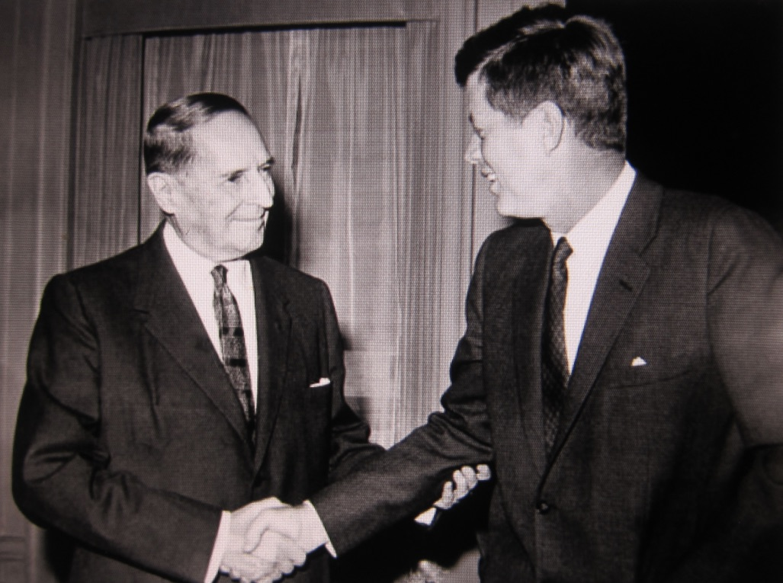
Circa 1962: General of the Army Douglas MacArthur with
the soon to be Class of 1962 Graduation Speaker,
President John F. Kennedy

Establishing a Legacy
After 58 years, the First Team stands proud of WHAT WE DID. We are dedicated to the Academy and to the Army Rugby Program--both the men’s and women’s teams. We will continue to demonstrate in our daily lives that we are a Brotherhood of Leaders who understand what “Learning Leadership on the Move” means and we will display the values of West Point “DUTY, HONOR, COUNTRY,”.
John L Taylor ‘62
Founder and Author

2. Remarks by Army Rugby’s First Coach

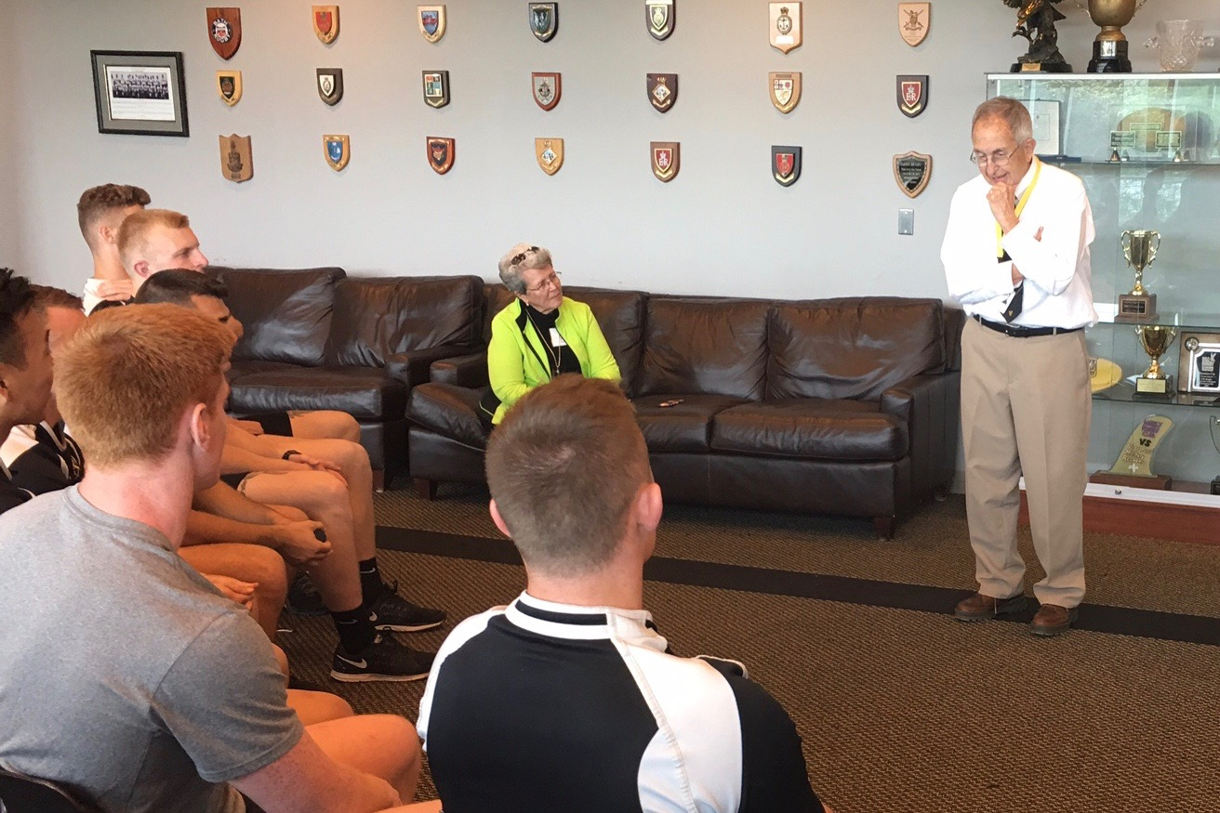
Ric Cesped, First Army Rugby-Football Coach
Recalling Coaching the First Army Rugby Team
23 May 2017

Remarks by Ric Cesped,

On Being Army’s First Rugby-Football Coach

My youth and the Grange School
I was born and raised to and early age in a nitrate mining town located in the middle of the Atacama Desert in Northern Chile. My Dad was chief Engineer and later General Manager of the local mining company. I credit my father with teaching me a very valuable lesson in life--that a respectful and caring relationship with your team were key to the success in any endeavor.
At the age of ten I was sent as a boarding student to Santiago’s Grange School, an English School that was established by Mr. John A. S. Jackson and a group of British Army officers and their wives who had migrated to Chile and Argentina between the First and Second World Wars. The Grange was run like an English School and was recognized as an excellent private school.
When I reached age of 14 the Grange’s sport program included swimming, soccer (football), cricket, rugby, and athletics. Learning to play rugby was a fun experience which led, after several months, to playing it in intra-mural games with 3 other "colors". During the last two years of schooling at The Grange (11th and 12th grade school years) we played against other schools including: the French School, Jewish School, Old Grangeonian teams, and others. I became a member of the First XV and played a variety of positions both as a forward and as a member of 3/4 line. I never played full back. I very much enjoyed the game and the English Coaches, including Mr Balfour, were very good. I graduated, with honors, from The Grange in early 1958.

Applying to West Point
During my last year at The Grange Colonel Leland Drake USMA ‘36 , was on assignment to the American Embassy in Santiago. In the process of his duties he became aware that US laws allowed for the admittance of up to 3 foreign cadets, from a long list of countries, to any of the US Military Academies. Upon being informed by Colonel Drake of this opportunity I applied to West Point.
Not expecting to be accepted to West Point I started school at the University of Chile, School of Civil Engineering. Then, one day in early May 1958, I was invited to attend a ceremony to honor my Dad. Upon entering a Board Room, a large tall gentleman sprang to his feet and came to meet me shouting to all to hear, "Welcome Ricardo!, I am pleased to inform you that you have been accepted to the United States Military Academy as the first Chilean to attend West Point. You are to report at West Point on July 1, 1958". I froze in place thinking what am I going to tell my friends and how is this going to change my life.

Adjusting to Cadet Life
As a cadet I initially had difficulty adjusting to American English and to the many requirements of life at West Point. At the end of the first month of academics I had the dubious honor of ranking last in English. I was in shock! My spelling and sentence composition were killing me!
Gradually I adjusted to West Point, played lots of soccer, joined the plebe swimming team, and so on. I started to like life at the Academy, and I had two great roommates who became friends for life. Life was good.

My Selection as the First Rugby Coach
Unknown to me I had a classmate, John Taylor, who at the beginning of our Cow year became enamored with rugby and wanted to bring it to the Academy. However, in responding to his Corps wide interest survey I was on his radar. Soon after, John burst into my room one afternoon in the Spring of 1961 asking, “Who is Ricardo Cesped?”. I raised my hand and he promptly declared, "Great! You are now the Army Rugby Coach." My two roommates looked at each other and smiled. I was stunned, for I felt that I was not qualified for such a mission, but was anyone else?

Initial Practice and Placement
A few days later I would go to one of the furthest-most, coldest, and muddiest locations on campus where I organized the cadets who had expressed interest in playing rugby. In short order, I determined I had inherited a team with zero rugby experience. My plan was simple, teach them the basics and show them how much fun is Rugby to play. We went through a lot of trial and error and John and I sorted through who should play what position and learned how to referee the game from our single rule book.
Subsequently, I then began the initial practice by asking the team to line up by height tallest first, smallest last. I had 40 frozen cadets anxious to "do something..."
John and I picked the tallest cadets present as props and then a smaller happy guy from Philadelphia to be our "Hooker”. For the second row we selected two shorter guys who looked like weight lifters. After manning two sets of forwards we still had a bunch of other cadets frozen and hoping to be placed, which we did by manning the 3/4 line and the lonely fullback positions.
Some positions were easy to fill with ’62 Founders. Dennis Reimer and Mike Schredl, our “biggest” players at 195 pounds each and with the right fighting spirit would become the first team props. George “Tank” Telenko, the perfect choice for scrum lock, strong as a bull, Tank would “hold us together”. Bill Scherr’s and Jerry Janicke, both quick, with good leadership skills and excellent ball handling became our two scrum halves. Russ Devries and his twin brother Bob, were a fast and quick duo fresh from the 150 Pound Football Team, and when given the opportunity they could fly with the ball becoming key to our offense. Bill Kosco, our last line of defense and kicker, showed some initial promise, Bill Evans and Dave Mundt, experienced the rigors of playing in the second row of the scrum. Key positions were filled with other volunteers, regardless of class or cadet rank.
We repeated the process establishing a second team. Thereafter, John initially took the 3/4 lines and the full backs under his wing and I took the forward groups during the initial days of practice, all conducted initially with only one rugby ball!

Teaching the Basics
I started with the basics including that the ball can be moved forward by carrying or kicking it, a forward pass is a “foul”, resulting in the loss of the ball to the opposition in doing so. The forward pass penalty would take a long time to drill into the minds of the First Team. I stressed that one should forget about tackling the same way as in-American Football, as one or both players could be seriously hurt. We practiced tackling and bring the opponent down rapidly. I repeated this drill many times to on order to avoid injuries and to keep control of the ball. I continued to emphasize the need to be untamed in tackling your opponent’s low and in running with this odd-looking ball across the goal line and touching it to the ground. We started with passing on the run and tackling the opposing runner low to bring him down fast before he can pass the ball to another team-mate. This was totally in opposition to what American football promoted.

Mounting Injuries
Originally, in spite of my instructions we had many injuries requiring treatment at the Cadet Hospital. This almost threatened to end the rugby experiment at West Point. Mrs. Westmoreland, the Superintendent’s wife, noted this increase in injuries while working at the West Point hospital and came to our help by successfully suggesting that an ambulance and a medic be assigned to our remote field. In the process she encouraged her husband to join her at several of our rugby practices. We got the message that we were on notice and worked hard to address the problem. Gradually the team of founding players grew in skill and the injury rate subsided.

Our Initial Season of Development
We made it a point to play all our volunteer founders, as much as possible. This was a key to our future success. The enthusiasm to learn the game and play as a team was awesome! Attendance at practice was high in spite of our remote muddy field, now the site of the Anderson Rugby Complex (ARC). Happy talk was everywhere.
In our first season of play, the Spring of 1961, we had few games outside of our own development program. We did play some teams from the New York area. These teams were made up of mostly immigrants from rugby playing countries such as the UK, France, Australia, etc. We had some success, but with one notable loss to the NY Rugby Club (NYRC), which was the best East Coast rugby team.
Games against local clubs that Spring were very important in our development, but I do not recall many victories. Most of our matches were what I called Scrimmage-Games among our A Team and B Team or the A or B Teams against the C Team. A few times, the NYRC, our teachers/mentors, came on their own to give us instructional scrimmages with our A Team. Sometimes, these scrimmages-matches were conducted against a mixture of the NYRC and other clubs in the Manhattan Rugby League (MRL). The intra-team practice games were fun and our ruggers learned fast.
Although we did not train as a team in the Fall of 1961 we had a few weekend matches—one was a losing effort against Dartmouth.

Entering Full League Play
By the Spring of 1962, we were ready to fully engage in league play. We played six teams from the Region and we did quite well. Considering that our season extended from March to the end of May and our games were mostly in April and May we were quite active for a “new” rugby program. We had more enthusiasm, speed, and energy than any of these teams. During away games, we played hard both on and off the field. We lost a close match to Columbia, but had an overall winning record.

Our Last Game
Our last game was one to remember for the rest of our lives. On that day, May 12, 1962 General of the Armies, Douglas McArthur, came to West Point to deliver his famous “Duty, Honor, Country” farewell speech to the Corp of Cadets. You could feel the excitement surrounding such a memorable event. By coincidence also on that occasion, the First Team played its last match against the New York Rugby Club, our teachers of a year earlier, who once again were ranked first in the East. On that day, the First Team in dramatic fashion came from behind and beat their mentors with the Commandant, General Stilwell, in attendance.
At the end of the season Army Rugby was ranked second in the Manhattan Rugby League, second only to The New York Rugby Club, a team with one loss—to Army! We had learned a valuable lesson—that if we believed in ourselves we could beat any opponent! Our founding team of West Point ruggers was the greatest group of guys I’ve known, and it was my honor to have been their coach and to have partnered with John Taylor to fulfill his dream of establishing an Army Rugby team.
As the First Team left the pitch for the last time we could look back with pride for having started rugby at West Point and for fostering the Will to Win.”

Recognizing Coach Matthew Sherman
After Ric made his presentation he asked Army Coach Matt Sherman, to join him in front of the assemblage of young cadet players, ’62 Rugby Founders, and their family members. After shaking hands with the coach, Ric said, “the ’62 Founders of Rugby at West Point want to thank you, from the bottom of our hearts, for taking the assignment to be the Army Rugby Coach and Manager of the Army Rugby Program. I learned of your assignment shortly after you accepted this challenge. Later, I would also learn, that you had other tempting offers such as coaching the USA Rugby Team, yet, you chose to come to West Point to give Army Rugby, a chance to achieve greatness. Our visit to the Anderson Rugby Complex, at your invitation, is a wonderful way to remember the start of Army Rugby, more than 55 years ago and to recognize all those cadets and officers who made this possible.”

Ricardo E. Cesped ‘62
Army’s First Rugby Coach

- Presentation of a Commemorative Bronze Plaque to the Army Men’s Rugby Team at the Anderson Rugby Complex by members of the Class of 1962 First Team.
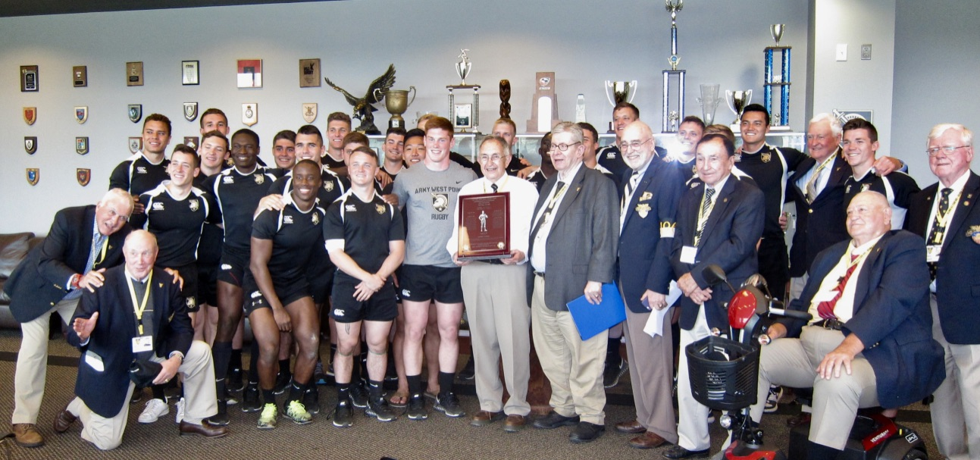

Class of 1962 First Team Ruggers participating in the presentation of the commemorative coins and bronze plaque:
Far Left:
Bill Evans
Bill Scherr
Center:
Ric Cesped (holding plaque)
To Ric’s Left: Back Row:
John Taylor 3rd in from the Right—Dennis Reimer
Bill Kosco Far Right—Dave Mundt
Jerry Janicke
Mike Schredl

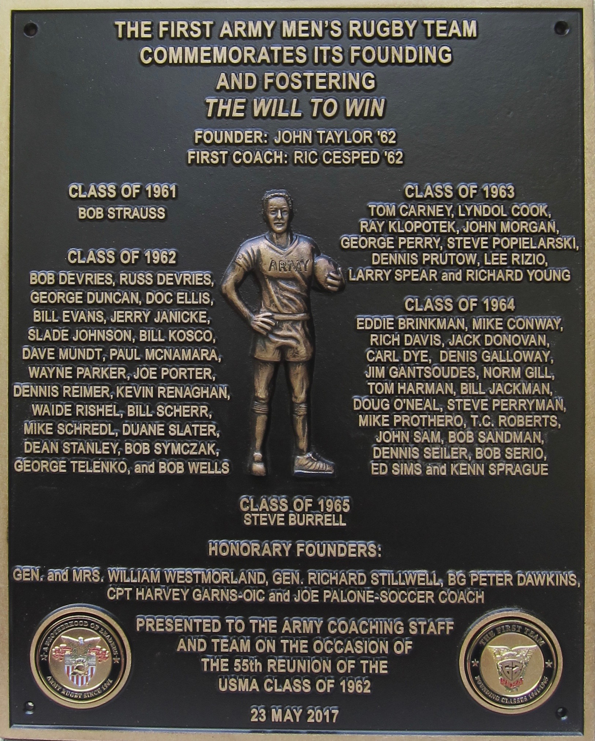

The Commemorative Bronze Plaque crafted and produced by 12HourAwards, of Jacksonville, Florida
- Recollections by BG Peter Dawkins, an Honorary Program Founder

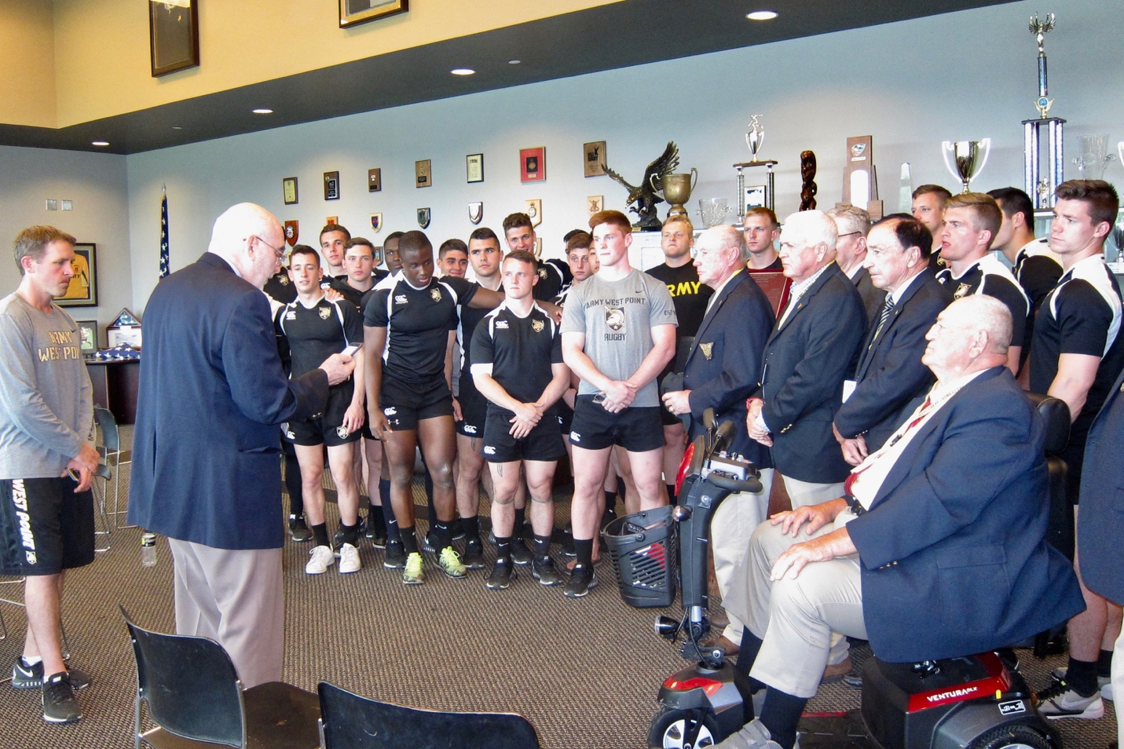
Recollections received from BG Peter Dawkins, an Honorary Program Founder, read to assembled ruggers-past and present.

E-mail message sent to Bill Kosco:
Bill, I know you're looking forward to your 55th Class Reunion and, as a part of it, your recognition of John Taylor and of Rugby at West Point, more broadly.
The Plaque is handsome, and a fitting tribute to all who have, through the years, contributed to making Rugby at the Military Academy such a proud and vital program.
Please pass along my congratulations and best wishes to all!
Beat Navy!
Pete

Recollections of my introduction to the game of Rugby
by
BG Peter Dawkins USA (Retired)
I arrived at Brasenose College, Oxford, knowing virtually nothing about Rugby and, in fact, having never seen a rugby match. That said, I was definitely keen to learn. It was my great good fortune that a small cadre of University zealots immediately took me under their wing – teaching me the rules and trying, as best they could, to help me grasp the essence of the sport.
I confess that I was not a particularly attentive pupil, and enjoyed the robustness of rugby more than immediately mastering its many subtleties. As an example, I quickly adopted a penchant for what they called “Crash Tackling”. That is, rather than using my opponent’s momentum to bring him to the ground (the customary technique, as you know), I would attack directly at my opposite number and tackle him, as violently as possible, by driving my shoulder through his chest. As I was, at that time in my youth, reasonably fit and quite a bit larger than most of the opposing backs I was matched up against, I found that it took only a few of those encounters to discourage their enthusiasm. From that point on, they seemed to spend a good deal of their attention on making new sure they had passed the ball off before I met up with them.

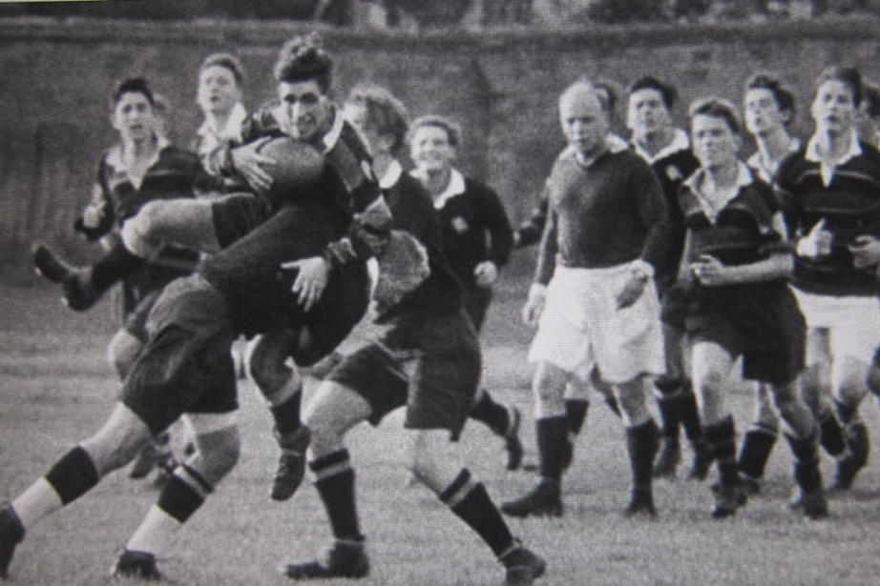
Pete executes a “Crash Tackle”
After a few months, however, I did in fact learn both the rules, and a good deal of the subtlety of that thoroughly enjoyable sport. I graduated quite quickly to the Oxford University side, and had the delight of playing 3 seasons with them. Among my most treasured memories are playing, in successive years, against the two best sides in the sport: first, the New Zealand “All Blacks” and, a year later, against the South African “Springboks”. (We lost the first but, to the astonishment of many, won the second!)
There is also the tale of what came to be referred to as “The Yank’s ‘Torpedo Pass’”. I’ll leave it to you, however, should you choose to share that bit of Rugby “lore”…

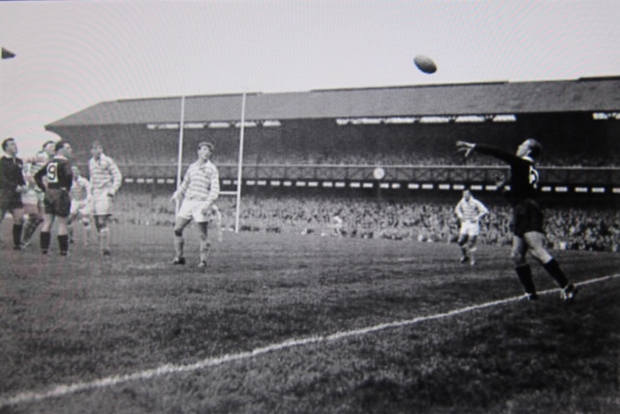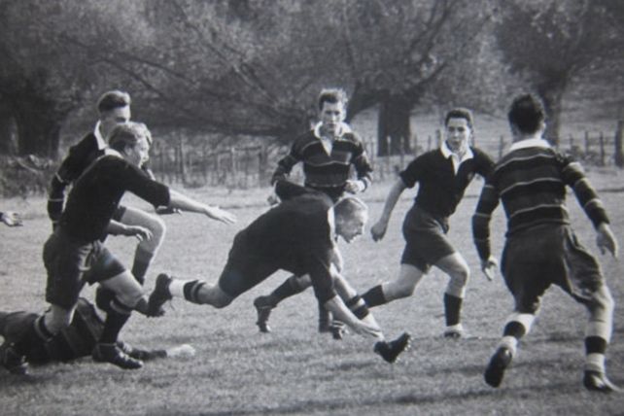
The Yank’s “Torpedo Pass”. Pete drives forward.
Being just random bits of “related trivia”, I mention all this simply as backdrop for your celebration of the introduction – and, over a very brief period of time, the rapid rise to respected excellence – of the sport of Rugby at the Military Academy. You have built a proud tradition, and a lasting legacy. Well done. I salute you.

- Announcing the First team’s plans to endow an Annual Perpetual Award.

Before leaving the Anderson Rugby Complex to participate in further 55th Reunion activities the ’62 members of the First Team announced the intent to create an endowed annual perpetual award, once it received approval of its formal request made to the Academy.
The award became a reality and the first presentation was made on 24 May 2018. Details follow.

- Taking Pride in the Future

- Introduction
In July 2016 the Class of 1962 Founders’ Legacy Working Group (WG) initially requested Academy approval to present a Founders Commemorative Plaque, recognizing those cadets, officers, and coaches who were instrumental in creating Army Men’s First Rugby Team in 1961. Also, an aspect of the proposal was a commitment to add $100,000 to the Army Men’s Rugby Endowment for the purpose of creating a perpetual cadet annual award. The vision to present a Founder’s Commemorative bronze plaque to the Army Men’s Rugby Program was realized during the Class of 1962’s 55th Reunion, as detailed above in Paragraph A. Within the next year the WG formalized and executed its plans to establish a “naming opportunity” award, with endowed funds, to promote the First Team legacy, provide a means to support program activities, and to promote the team’s future brotherhood and cohesion. This effort resulted in the establishment of the John L. Taylor First Team Brotherhood Award. This First Team Perpetual Award was presented to the program at its annual awards banquet on 24 May 2018. Details follow.

- Chronology of Events
In September 2016, the WG appointed Bill Kosco as project manager with an object of pursuing the basic initiative. Thus, began discussions regarding the terms of a proposal with ODIA—in accordance with Academy guidelines. In the proposal, the Class WG first suggested “gifting” a bronze plaque recognizing the legacy of the initial Army Men’s Rugby Team Founders, to be made at its 55th Reunion. It also requested permission to create a $100,000 “naming opportunity” endowment for the purpose of establishing a perpetual annual cadet award. This concept was given development approval in late 2016. As a result, the bronze plaque and commemorative coins were gifted, without stipulation on 23 May 2017 at the Anderson Rugby Complex on the occasion of the class reunion. The plaque and commemorative coins were funded by the Class of 1962 WG and the award endowment of $100,000 was raised by members of the First Team (a donor pool of approximately 50 ruggers, of which 25 initially contributed). The development of the perpetual award and related fund-raising activities, were subjected to an accelerated schedule and completed by early 2018.
On 8 October 2017 the WG was notified that the Academy Superintendent, LTG Robert L. Caslen, approved its request to establish a First Team Perpetual Award. This approval eventually allowed the WG to begin the simultaneous development of the award and the initiation of fund-raising activities to establish a $100,000 endowment. The immediate objective to be able to complete all requirements and stipulations allowing for the first award to be made during Graduation Week 2018. This approval was based on the details of a 3 May 2017 requesting memo seeking approval of the perpetual award, drafted by ODIA with WG input. On 22 February 2018 ODIA approved the suggested changes to the requesting memo that related to the name, purpose and award criteria of the First Team Perpetual Award.
On 27 March 2018 ODIA upon verifying the award’s wooden base and sculpture were completed and all funds had been raised, authorized the WG Project Manager to initiate actions to pass the award trophy and individual sculptures to Coach Sherman for an initial presentation and award in conjunction with 2018 Graduation Week activities. Details were further coordinated with Captain David Geib and the Rugby Program allowing these presentations to be made at the Team’s Annual Awards Banquet on 24 May 2018.
At the 24 May 2018 Annual Men’s Rugby Team Awards Banquet members of the Class of 1962 represented the First Team in making the initial presentation of the John L. Taylor First Team Brotherhood Award to the Program for permanent display in the Anderson Rugby Complex and facilitated the award to the first annual recipient.

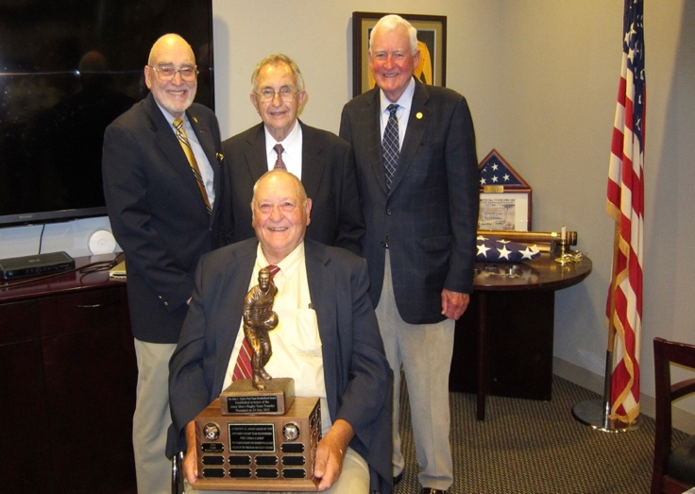
Class of 1962 First Team representatives: Top L to R: Bill Kosco, Ric Cesped, and Dennis Reimer and Front with trophy: Mike Schredl

- Presentation of Initial Brotherhood Award

The Banquet Master of Ceremonies was Cadet Andrew Finken ’19. Bill Kosco orchestrated the First Team Perpetual Award portion of evening’s program. BG Doc Bahnsen ’56 and Gen Dennis Reimer (Class of 1962 and 33rd Army C of S) provided remarks relating to the leadership and character benefits of participating in one of the Academy’s most successful warrior sports—Rugby. Individual rugby sculptures were presented in appreciation to John Taylor (Program Founder in absentia), Ric Cesped (First Coach), Dennis Reimer (for Program Support), and Cadet Alec Smith’18 (for exemplifying the image of an Army Rugby player). The final award was made by the team to the 2018 Brother of the Year, Cadet Hayden Cross ’18, and first recipient of the John L. Taylor First Team Brotherhood Award.

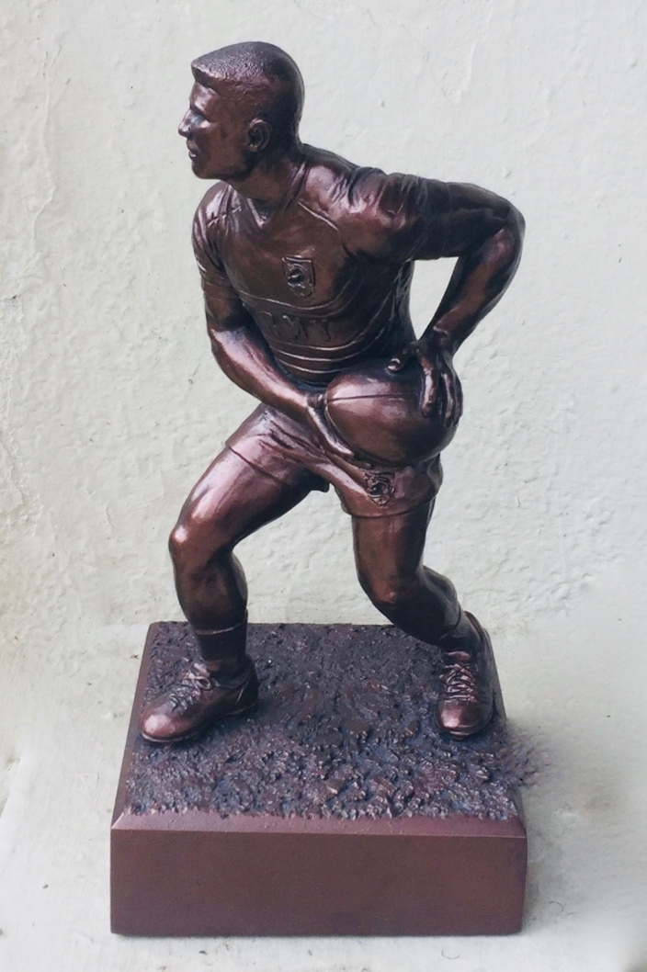

The initial recipient of the John L. Taylor First Team Brotherhood Award was Cadet Hayden Cross ’18

- Brotherhood Award Criteria and Details

During the award approval process the following was officially recognized and established regarding the First Team Perpetual Award:

Award Purpose: The purpose of the award is to promote the legacy of the Founders of Army’s Men’s First Team through a naming opportunity and the recognition of a brotherhood that has existed from 1961 to the present. The award’s criteria allow the opportunity to present it to a cadet in any significantly contributing role directly associated with the program and its success.

Award Criteria: The Award is an annual perpetual award made by the Army Men’s Rugby Team, under the guidance of the Head Coach, that recognizes the cadet who each year demonstrates the highest ideals and values of the Army Men’s Rugby Program and USMA Cadet culture. Selection is based on contributions and attributes that include honor, academics, leadership, support, devotion, promotion of team cohesion, and/or team play that significantly enhanced program success.

Award Name: The John L. Taylor First Team Brotherhood Award. (Note: John L. Taylor’62 is the Founder of Army’s First Men’s Rugby Team.)

Award Venue: The Men’s Rugby Team Annual Banquet during Graduation Week.

Award Sculpture: The WG Project Manager was given ODIA permission to pursue a unique award--a sculpture trophy featuring an Army Rugby Player in action. This trophy has been developed by Victory Awards and Trophies through West Art. These are the same vendors that provide the Army Lacrosse Team with its generic annual awards. The rugby award is specific in detail to Army Rugby, but is of the same relative size, composition, craftsmanship, and finish as the traditional Army Lacrosse trophies. Alec Smith’18, a team co-captain, was recruited to be the sculpture model.
It must be noted that an extensive search was made worldwide to find a suitable off the shelf sculpture. None existed. Army players are unique in attire and grooming.
Note: The original sculptor of the trophy statue, Nate Aderman, may be relied upon to produce additional sculptures for the program. He may be contacted at
(c ) 267-644-8024 and/or (e) naderman1009@gmail.com

Forms of recognition: The First Team Perpetual Award consists of a wooden base designed to contain the names of the first 26 award recipients and is an integral part of the permanent statue on display at the Anderson Rugby Center. Annual individual awards will be presented to that year’s awardee and will consist of the sculpture only containing an inscribed plate with the award year, name of the award, and the awardee’s name.

Note: It is the First Team’s intent that the unique Army Rugby Sculpture, when appropriately inscribed for an occasion, could also be used in the recognition of individuals associated with other established achievements and contributions made by Army Rugby Program participants, supporters, and alumni.

