Dear Sponsors & Contributor,

**EBO TOWN COMMUNITY NURSERY SCHOOL – CHRISTMAS NEWS UPDATE.**

Well the Christmas season is upon us all, as we head towards a busy week of Christmas preparations.

I thought I would send you all a quick news update to end the year, and fill you in on our latest trip over and all the amazing doors that are opening.

**CHRISTMAS PARTY AT EBO**

What an amazing day we had with the children. Staff embraced the party, and made party hats, decorated the classrooms with balloons, and worked so hard with the children, teaching them new songs. Martina our Butterfly teacher excelled, she formed a choir with our older children who then led the rest of the school into chorus. Father Christmas and his elf where in attendance, and each child and teacher received gifts, it is at this point I personally would like to thank Julie Lewis and her team of helpers in Cardiff, for gathering, making, wrapping and paying for excess baggage to get the gifts to the school. Amazing work and thank you. Thanks too goes to Father Christmas, who was overheating in his Santa outfit in a 36 degree heat, the children loved you so much. We finished the party off with bags of popcorn and cartons of Juice for the children to take home with them, and the smiles were in abundance, the children looked so smart in their party clothes, these are moments to treasure.

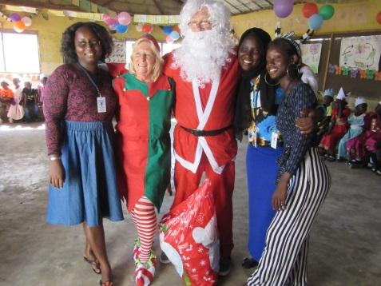 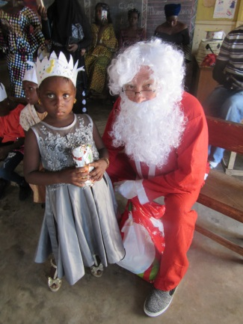 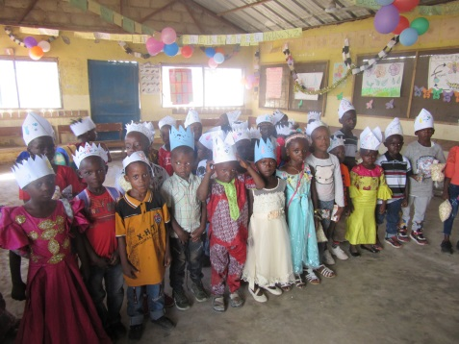

**EXTENSION GRANTED.**

We had meetings with the Head Master and his governing bodies, and appealed for an extension on our lease as our school build is still under way. The Headmaster is delighted with the work we do with our children and in the community, and have granted us 1 more year on our lease.

**MEDICAL CENTRE**

A new medical centre has opened, a classroom within the government school has been turned into a medical centre. These little medical centres are part of a scheme being opened up, and are dotted around The Gambia. This scheme is to help Grade 1 and above children in education with medical cover at heavily discounted rates, teachers at Tallinding can be a part of the scheme to. With a big tongue in cheek, I asked if our nursery school children and staff be included onto the scheme, and when we move in 1 years’ time, if we could still continue, to be told YES our children could be enrolled onto it.

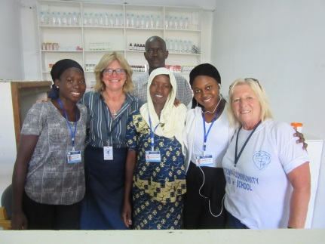 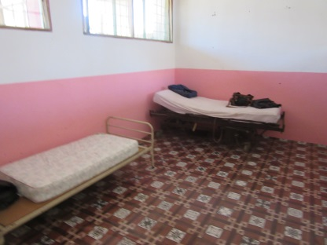 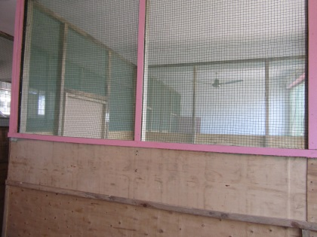

So what does this mean: For £3.50 a year, a child can receive FREE medical consultations and medicine including antibiotics & malaria medication. Whilst the team were on the ground, we put out a social media appeal and raised enough money to cover 29 children and got them enrolled whilst we were there. The children/parents received their medical card, it’s at times like this that I personally would love you to see the smiles and hear the gratitude off the parents, it really does mean so much to them. We are still collecting money on our return to get ALL children covered under this scheme, we have a Virgin Money page set up, whereby donations can be done, or we can accept a bacs/cash or cheque payment. If you would like to donate to this scheme to give a child a free years medical cover please contact us, £3.50 is all it takes a year. Paula and the team personally gave out some medical supplies we had stored at the school, and in return ALL OUR STAFF have been covered for FREE for one year. New doors opening what an opportunity.

Link for the Virgin Giving Page - <https://uk.virginmoneygiving.com/charity-web/charity/displayCharityCampaignPage.action?charityCampaignUrl=medicalaccess&fbclid=IwAR34ej-OOIye-txKlWyGMWksdNVg4uhWUgUvOLFEspF375BTVIQJO7a6DBw>

**NEW SCHOOL BUILD**

The visit to the build site, took the teams breath away. To see bricks and mortar, and to see how far we have come, to see the size of the classrooms x 3 which are huge, to see the toilet blocks, living quarters, staff room/kitchen, and office, was humbling. Now thanks to Concord College and the students in the library for recycling books for £5.00 each, they have recently given us a huge cheque of £3800 towards the build, which is perfectly timed, plus Yvonne and Roger (sponsors) who make and sell their talents giving us a donation of £1000, has allowed us to send over £4800 just before team November 2019 left, this money we have been assured is enough to complete and put on the roof. Meetings with our builder, have been had, and we have been told that the final figure to complete the build to a high standard, painted and ready to move into is now £11,100. This figure bought Paula and her husband Dave to tears, as it is so achievable and this dream back in June 2017, is becoming a reality. Trustees can’t thank all who have worked so hard during 2019, (you know who you are) enough for believing in us, and seeking to help and improve more lives in this poverty stricken area of The Gambia. We are PLANTING SEEDS FOR THE FUTURE, and very soon, we will have an extra classroom to help another 40 plus children and their families. Thank you so much to special people who continue to fundraise, we CAN DO THIS, thank you, thank you thank you.

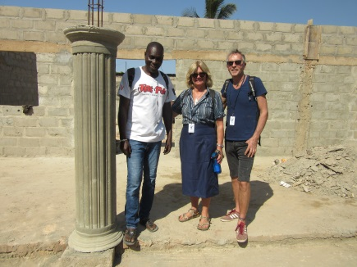 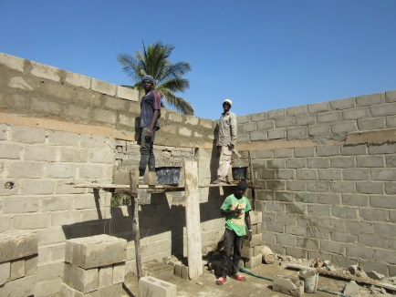 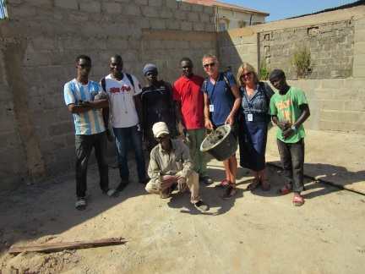

**THIS IS VERY MUCH A COMMUNITY PROJECT. ALL WORKFORCE ARE EBO TOWN BASED.**

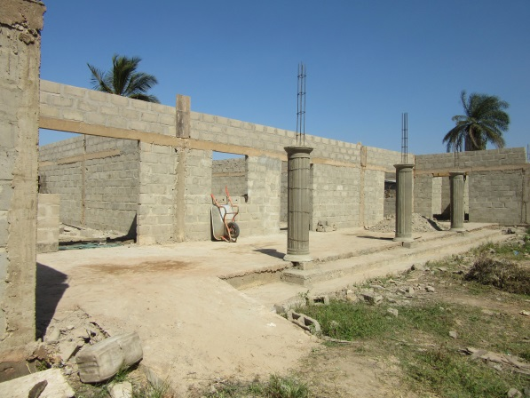 **ROOF IS GOING ON NOW**

**RICE/MOZZIE NETS/CLEANING PACKS**

Words can’t thank enough those who give extra to supply their sponsored children and families, rice and aid twice a year. Kaylee (Trustee), has sent round emails recently of your children receiving their much needed aid. We gave out over 2000kg of Rice this trip, plus 29 mozzie nets, and plenty of cleaning packs. The aid this trip was amazing. Parents came, the team got hugs and so much thanks, but it’s you the sponsor that should be having those hugs and thanks not us. A kind donation was received from a kind couple in Bewdley, who paid for rice for each staff member for Christmas, plus gave extra towards the build. Thank you to you all, I am really overwhelmed at the generosity of you all.

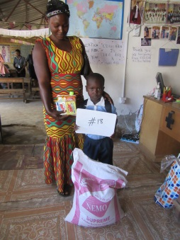 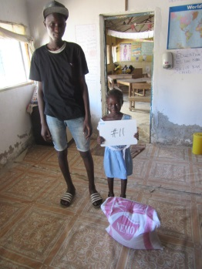 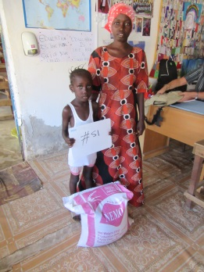 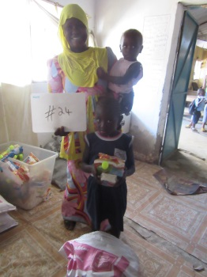

**CHRISTINE (STAFF)**

Christine our teacher has given birth on the 19th November 2019, to a beautiful baby boy, named Robert Jarja. Unfortunately baby Robert, is very sick and has been diagnosed with a very rare condition called Prune Belly Syndrome. I visited Christine at Banjul hospital a few days after giving birth, Christine asks for your prayers during this very difficult time, she is home with baby Robert at present but the outlook is unfortunately not good, baby is under the care of the Medical Research Centre and Banjul baby unit.

**THE CHILDREN**

To say the children are happy is an understatement. They are so well behaved, they are writing well and being well stimulated by our teachers and so full of love and hugs. The time I spent with them was so precious, to spend time having one to one and talking and sharing plus sitting in classrooms and helping the slower learners was fantastic. Its moments like this that makes everything so worthwhile, just this week I had a video call at break time and I waved and sang with the children from home. They are all adorable, thank you for sponsoring and contributing and allowing this to happen.

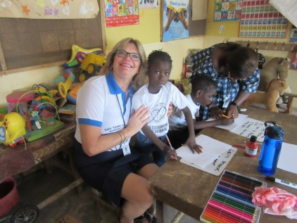 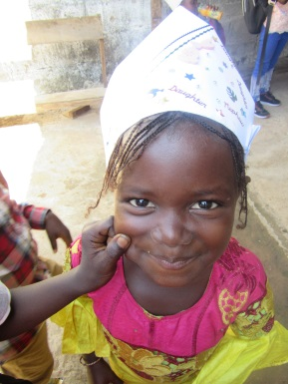 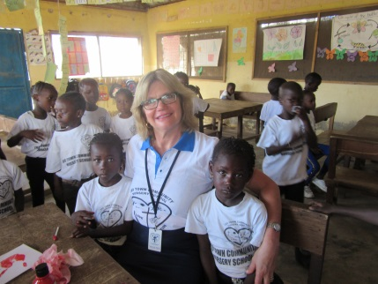

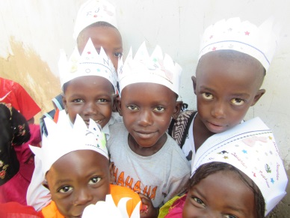 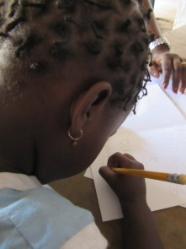 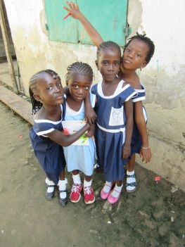 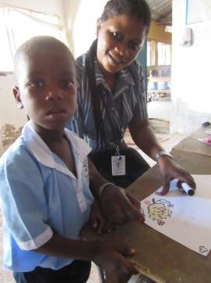

**ENROLLMENTS**

Whilst on the ground in November 2019, the team had a mission to enrol a few children. We enrolled 4 new children to Butterfly class. It was challenging as we needed children that could write, and had an understanding of a classroom atmosphere. The children enrolled started school whilst the team were there, it was amazing to see a little boy come to school in his normal clothes, be given a uniform, go home and return fully dressed for school with a bag. Moments that will stick with us, this is what makes what we do so worthwhile.

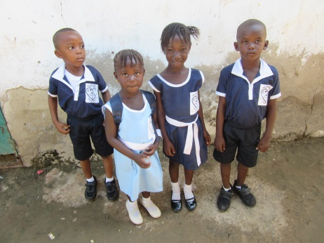 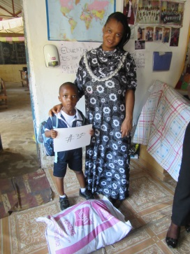

Newly enrolled children.

CHRISTMAS CARDS

Whilst on are trip the team and staff worked with children, to make some very special Christmas cards. On our return home Carol Murray and her team of helpers have decorated and completed them fully. They are professionally printed inside and on the back cover, and comes in a plastic sleeve to protect them. We are selling these cards for £1 per card, to raise money for our build funds. Every single penny goes directly to the school. Please get in touch if you wish to order a few even at this late stage, and we will get them to you quickly. We think we are safe to say that people who have ordered cards are very happy with their purchase.

To end this little update, we Trustees would like to thank you all for your support and love in 2019, every single penny goes to the school and the children, we Trustees self-fund our trips over, and work with love, as our passion is to help and reach out to those a little less fortunate than ourselves, and ease lives a little.

For now may we wish you and your loved ones a fantastic Christmas, and may 2020 bring you all peace, love, health and happiness.

Our love and thanks

Paula and the team of Trustees.