NEWS UPDATES FROM EBO SCHOOL.
OCTOBER 2019

- Staff
Our Teaching Assistant in Butterfly class, has not returned after the monsoon season, as she is heavily pregnant, and has gone on maternity leave. She will resume her position on 1st April 2020, we all wish Christine well, as we await news of the safe arrival of her baby. The team going in November 2019, will look forward to baby cuddles when Christine comes into see us. We have employed a lady named Joella, who has just finished her degree, and is about to become a qualified teacher. Joella has heard of the wonderful work we do at our school, and offered to work on a temporary contract, which she says in her own words “gain valuable experience in the work place” whilst wanting to continue further in her studies. We welcome Joella to our team and look forward to meeting her next month.

- Team November
After the sad news of Thomas Cook the team have rebooked flights. Rick and Sue will fly on Air Morocco, taking 13 hours to arrive in Banjul, and Paula is flying via Brussels taking 12 hours to arrive in The Gambia. Both flights leaving on 19th November 2019, and returning on 3rd December 2019.

- Aid Appeal
Now that a team has a confirmed booking and leave on the 19th November 2019, we are asking if you the sponsor would like to support your family with aid this Christmas season. The pricing is:
- Small Bag Rice £12.50
- Large Bag Rice £25.00
- Mosquito Net £ 5.00
- Clean pack £ 2.00
Please do not think you have to support your family in this way, but we do realise that some sponsors like to help a little further. Our deadline for aid orders is latest 10th November 2019, as we need to put in the order for mosquito nets to be made in time. Can I personally thank those that go the extra mile and put smiles on faces. Thank you. Anyone who pays via monthly standing order to include aid or has already confirmed additional funds for aid – we have you on the list, BUT if you are unsure and would like to check that we have included you please feel free to email and Kaylee can confirm.

- Christmas cards.

The team will be very busy working with our children making Christmas Cards on this trip. 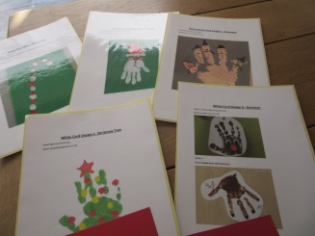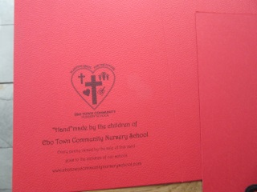
The cost will be £1.00 a card, plus P&P, and will be in a plastic sleeve. We are taking orders, therefore please bear in mind when buying your cards this year, and think of how special it would be to have a handmade card from Ebo Town. Can you imagine the children enjoying
A days art. 100% all proceeds will go towards our School Build Project.

- Christmas Party

It was decided at our Committee meeting, that we will be holding a Christmas party. We can confirm that we have more than enough presents to give each child a gift, and Santa will be in attendance. It will be a day of fun and games, singing and laughter.

- Build project.

We trustees would like to thank Concord College Library Students, who support us and our dream for there hard work. On 13th November 2019, Paula and Kaylee (Trustees) will be visiting the college to receive a cheque for £3500.00. This money is URGENTLY needed and will allow us to put the roof onto our build.
Another very special lady Yvonne Dixon, works so hard, she paints pet portraits, knits jumpers, makes cards, and then sells her items at Craft fayres. Yvonne has raised £1000.00 and Trustees can’t thank her for all her love and continued support. Thanks Yvonne.
(If anyone wishes to have their pet portrait done or would like to commission knitware
Please contact us via Ebo’s email for more information).
We have got a runner in the London Marathon in April 2020, named Julie Lewis. She has a virgin money page, and is busy raising funds and gaining support already. All proceeds will be spent on our school build. Thank you Julie for your hard work already. If you would like to find out more about supporting Julie in the months prior, please get in touch with us and we will link you up to her.

- Children

The children have settled down very well, we still have 6 children to offer a place at our school, as extra children moved to Grade 1, unexpectedly. Paula and the team will assess the situation on the trip over, and enrol children that are required. What an opportunity for these children and families, it will be lovely to see our classes full and children thriving.

- Annual General Meeting.

This meeting was held, and was extremely productive. Thank you to all who attended. We sadly say goodbye to one Trustee Nicole Owen, but the team would like to thank her for all the input and support she gave, and still gives to our project, she will be sadly missed. We are happy to welcome Sue Rogers as a Trustee, Sue has been out to the school, and has seen the work we do first hand, and can offer good constructive support and advice. Sue has already been an asset to us, and we look forward to moving forward as a team in the future. Welcome on board Sue.

- Chairperson

We would like to wish our Chairlady, Amy Taras all the best for the future, as she gets
Married on Friday 1st November 2019.

Finally, I will endeavour to send an email round to you all, when I am at the school, with a few random photos of all the children. Wifi is always difficult, so please bear with me, I will do my best. To follow us please visit our facebook page : @ebotowncommunitynurseryschool and we will post photos and videos daily if possible. Words still can’t thank you all enough for all your support, without you we wouldn’t be able to do what we do, and change and ease lives. Thank you for believing in us and helping us to achieve our dreams of having our own school, with an extra classroom, to help more. Still every penny goes to the children, we still self-fund our trips, and work as volunteers.

So for now, I will close and will be in touch very soon.

With a grateful and thankful heart.

My best wishes

Paula Howells
Founder.

