NEWS UPDATES FROM EBO SCHOOL
Dear sponsor/supporter.
Can all involved with the running of the school, including our wonderful staff in The Gambia, wish you and your loved ones a Happy New Year 2020.

With Christmas behind us, I guess we are all planning out our year and getting ideas for how we foresee the year mapping out for us. We too have just held a Committee meeting this week, and are very excited about this coming year at our school in Ebo Town, The Gambia.

THE BUILD

As I am typing this the roof is being completed, and the builder has sent us a few photos of how its looking. The builder has given us a report that the community of Ebo Town are taking a walk to the school build site, and walking onto the land, in awe of the new school that is being built in their area. We are hearing that it is causing much excitement in the community as parents are hoping to see their children being educated in the much needed school in the not too distant future. How exciting is this. We can report, that we have saved enough money to send over a little more, which we hope will be able to seal the build, by putting in the windows and doors, we are just awaiting a costing to see if we have enough finances in place to be able to do this. So its all happening and so exciting, we only need £10,000 to complete the build fully, which is a dream come true.

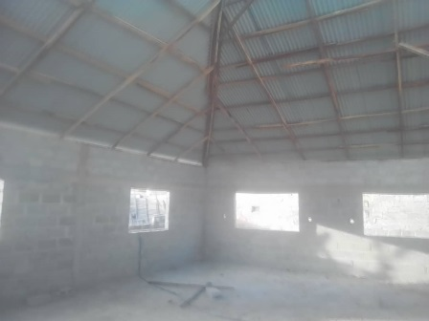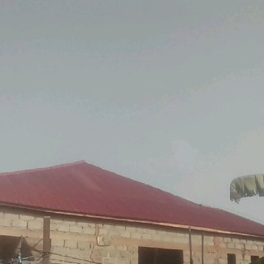

CHILDRENS HEALTH

This week we can report, that we have managed to gather enough money to be able to get every child and member of staff, fully covered with medical expenses for 1 year. Yesterday the money was sent across to be able to get all medical forms completed to enable the children to receive their medical cards. A very kind and generous sponsor donated £73.50 to allow this to happen. Thank you to all who have donated £3.50 a year to cover a child.
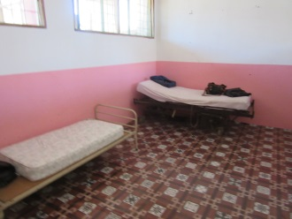

NEXT TRIP OVER AID APPEAL

We appreciate its very soon after the last aid appeal as the trips over to the school are quite close this time, due to the fact Easter falls in the middle of April 2020 and the school would be closed. So our next trip over is on 11th March 2020 to 25th March 2020. Paula and Trustee Kaylee (whom you all speak to regarding the sponsorship programme,) will be going to work. Our main mission will be to enrol 27 new children whom will join our school in September 2020, we too are in the process of setting up meetings with the education ministry and have lots to follow up to get things in place for the smooth running of the school. Both Kaylee and myself fund our own trips over, as we still believe every single penny must go to the children and the project.

We do have quite a few sponsors signed up on a standing order to cover their sponsorship fees and aid twice a year, but if you are not on this scheme and would like to supply your childs family with some much needed rice etc, please we would love to hear from you.

50kg Rice bag is £25.00, 25kg Rice bag £12.50, Mosquito net £5.00, cleaning packs £2.50.

If only you could see the gratitude of the families and how they appreciate this help, the smiles that it puts on faces, and how much it takes the pressure off, even for a small time. Please email : ebotowncommunitynurseryschool@outlook.com to place your order, and we will get back to you. If you wish to call Paula my number is 07738022397.

Below are a few photos of families receiving rice in November/December 2019.

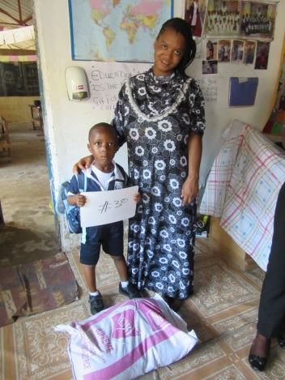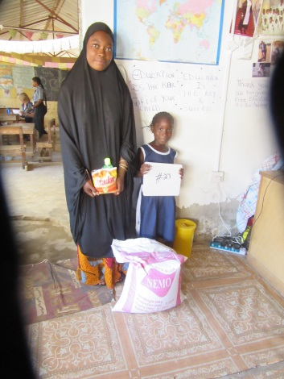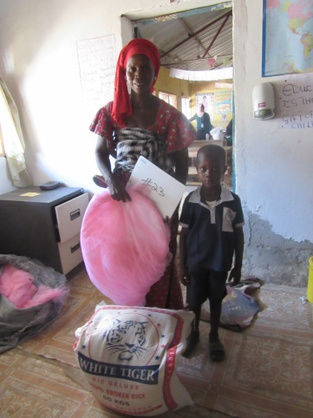
So please if you can help at all, this will be the last appeal for aid until mid September 2020, ready for our next team trip out in November 2020.

We are so excited, the staff are working amazing, the children are so happy, we Trustees are working hard and in unity with a goal and that is to PLANT SEEDS FOR THE FUTURE.

Thanks for your continued love and massive support, you are making this happen.

Thank you so much.

Paula and the team
Ebo Town Community Nursery School.

PS: JUST A SHORT UPDATE OF THE VERY LATEST WITH AID APPEAL. SORRY TO BE ASKING AGAIN SO QUICKLY.

