The Coastal Peacekeepers
Luxury Deep Cleaning Checklist

Standard Tier
• Dust all surfaces
• Vacuum carpets and rugs
• Mop hard floors
• Clean mirrors and glass surfaces
• Sanitize high-touch areas (doorknobs, switches)

Premium Tier
• All Standard services
• Clean inside microwave and oven
• Wipe down baseboards
• Detail bathroom fixtures
• Clean under furniture

Elite Tier
• All Premium services
• Clean inside cabinets and drawers
• Wash walls and doors
• Deep clean upholstery
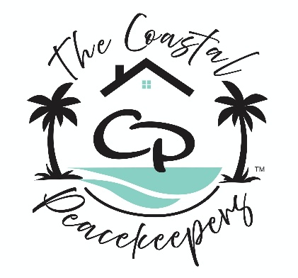
• Organize closets and storage areas

