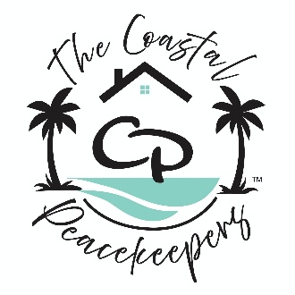
🧼 General House Cleaning Checklist
🏠 Whole House
- ☐ Dust all surfaces (furniture, shelves, décor)
- ☐ Vacuum carpets and rugs
- ☐ Sweep and mop hard floors
- ☐ Clean mirrors and glass surfaces
- ☐ Wipe down light switches and door handles
- ☐ Empty trash bins and replace liners
- ☐ Check and replace air filters if needed
- ☐ Tidy up clutter (magazines, shoes, mail)

🛋️ Living Room
- ☐ Dust electronics and TV screen
- ☐ Fluff and rotate cushions
- ☐ Wipe coffee tables and side tables
- ☐ Organize remote controls and accessories

🍽️ Kitchen
- ☐ Wipe countertops and backsplash
- ☐ Clean sink and faucet
- ☐ Sanitize cutting boards
- ☐ Wipe down appliances (fridge, oven, microwave)
- ☐ Clean inside microwave
- ☐ Empty and clean trash/recycling bins
- ☐ Sweep and mop floor
- ☐ Check pantry for expired items
🚽 Bathroom(s)
- ☐ Scrub toilet, tub, and shower
- ☐ Clean sink and countertop
- ☐ Wipe mirrors
- ☐ Replace towels and restock toilet paper
- ☐ Empty trash bin
- ☐ Mop floor
- ☐ Disinfect high-touch areas

🛏️ Bedrooms
- ☐ Change bed linens
- ☐ Dust furniture and lamps
- ☐ Vacuum or sweep floors
- ☐ Organize nightstands and dressers
- ☐ Declutter closet (seasonal rotation if needed)

🧺 Laundry Area
- ☐ Wipe down washer and dryer
- ☐ Sweep and mop floor
- ☐ Organize detergents and supplies
- ☐ Empty lint trap

🌬️ Extras (Optional Deep Clean)
- ☐ Wash windows inside and out
- ☐ Clean baseboards and crown molding
- ☐ Dust ceiling fans and light fixtures
- ☐ Shampoo carpets or upholstery
- ☐ Clean behind/under furniture
- ☐ Organize drawers and cabinets

🖋️ Service Agreement & Signature
I acknowledge that house cleaning services have been performed by The Coastal Peacekeepers in accordance with the agreed scope of work. Any concerns or special requests have been communicated and documented.

Client Name: ___________________________________________
Service Address: _________________________________________
Date of Service: __________________________________________
Client Signature: _________________________________________
Printed Name: ___________________________________________

Service Provider Name: ___________________________________
Company: The Coastal Peacekeepers
Signature: ______________________________________________
Date: _________________________________________________

⚠️ Disclaimer
The Coastal Peacekeepers provides professional house cleaning services focused on surface-level sanitation, organization, and aesthetic upkeep. These services do not include deep restoration, mold remediation, pest control, or any tasks requiring licensed contractors unless specified in a separate agreement.
While every effort is made to ensure thoroughness and care, The Coastal Peacekeepers shall not be held liable for pre-existing conditions, structural issues, or damage resulting from unforeseen circumstances beyond the scope of cleaning services. Clients are responsible for securing valuables and notifying the provider of any sensitive areas or items requiring special attention.

