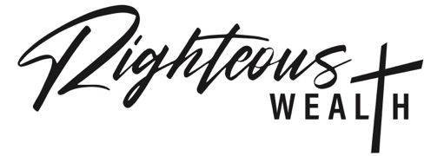

Thank you for your interest in joining the Righteous Wealth network.

Righteous Wealth is an online community that connects customers with trusted businesses that share values that align with the unchanging Word of God and represent Godly principles with a strong biblical foundation.

Core Values include:

* Renouncing ungodliness and worldly passions and principles according to Titus 2:12
* Guided by the Holy Spirit as described by Colossians 2:8-10
* Conduct business as holy and blameless before our Father as in Ephesians 1:3-4
* Stand as instruments of righteousness referenced in Romans 6:12-14

In an era where many businesses have compromised their missions and agendas, this organization seeks to remain steadfast to the Bible and the principles used by the Founding Fathers of the United States to establish the framework of this great nation, under God.

Matthew 6:33 states “But seek first the kingdom of God and his righteousness, and all these things will be added unto you.”

Individuals wanting to give their life to Jesus Christ can start by believing in their heart and repeating the prayer of salvation, as a seed.

*Dear Jesus,*

*I realize I need You. I believe You died for my sins and I believe You rose again. I ask You to come into my heart. Be my Lord and be my Savior. I repent of my sins and I put You in first place. Thank You for saving me. Amen.*

**Business Standards & Requirements:**

* Company exhibits an operational excellence and integrity
* Strive to set an example and commit to higher principles; cultivating Godly habits, modeling integrity and remaining teachable
* Consistently involved in promoting the Kingdom of God
* Supports the vision, mission and culture of Righteous Wealth

Yearly fee of $400

Disclaimer: Business can be removed for misconduct without refund.

**Benefits**

* Marketing services provided by Righteous Wealth that include creating and sending email campaigns, segmenting an email list, and tracking the performance of your emails. We help our clients create effective email campaigns that drive engagement and conversions.
* Quarterly networking sessions with Righteous Wealth affiliates

**Application Process**

1. Submit the attached application with an jpeg image of your company logo to [contact@righteouswealth.org](mailto:contact@righteouswealth.org)
2. You will be contacted for a scheduled call or zoom interview
3. Company information will be evaluated
4. Application response will be sent within 7 – 10 business days
5. If approved, you will be contacted with a link to submit payment