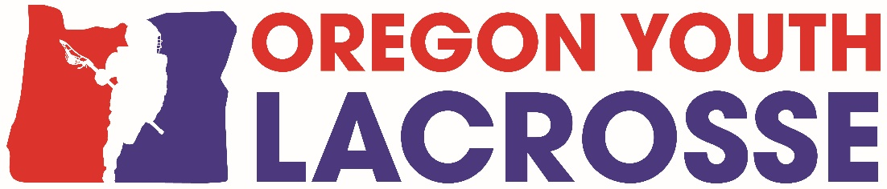
INVOICE
2021 Season OYL Dues
Please fill out form and submit with your payment

Club:___________________________________________

Contact Name & email:_____________________________________________
Contact Address: _________________________________________________

Please list number of teams and players and what division if known: (Premier, D1, D2, D3)
Boys 7/8 # of Teams______ # of Players_______ Division____________________
Boys 5/6 # of Teams______ # of Players_______ Division_____________________
Boys 3/4 # of Teams______ # of Players_______ Division_____________________
Boys 1/2 (full pads) # of Teams______ # of Players_______ Division_____________________

TOTAL Number of Teams________ TOTAL Number of Players_____________

2021 - OYL DUES ARE AS FOLLOWS:
1 – 2 Teams = $ 100.00
3 – 4 Teams = $ 175.00
5 – 9 Teams = $ 250.00
10+ Teams = $ 350.00

Total Dues for 2021 Regular Season $______________

AMOUNT PAID
Make check out to: OREGON YOUTH LACROSSE

Mail check to: Oregon Youth Lacrosse (No Longer OYLA)
c/o Lisa Hockman
7255 SW Alpine Dr
Beaverton, OR 97008

Please mail this form and your check along with Certificate of Insurance for your club.

Initial:
______ Our Club (identified above) has requisite insurance coverage for no less than $1,000,000.00 of general liability coverage as evidence by the Certificate of Insurance submitted herewith and Oregon Youth Lacrosse as additional insured.
______ Our Club’s officials are also properly insured or endorsed with coverage protecting them in their capacity as lacrosse officials and have been trained by OYL at one of our clinics.

You must have your dues check and insurance certificate submitted to OYL by April 1st.
You will not be able to schedule games without your forms turned in and dues paid in full.
For any questions, please email lisahockman@comcast.net. Tax ID#83-2771715. Non-Profit

