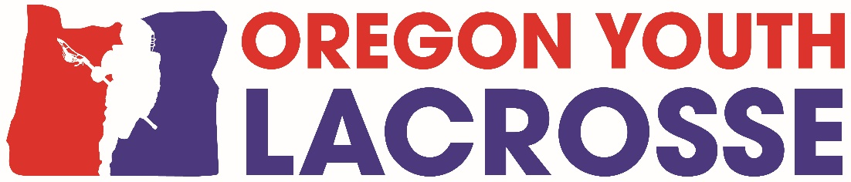

**INVOICE**

**2022 Season OYL Dues**

Please fill out form and submit with your payment

**Club:_________________________________­­­­­­­­­­­__________**

**Contact Name & email:_____________________________________________**

**Contact Address: _________________________________________________**

Please list number of teams and players and what division if known: (Premier, D1, D2, D3)

Boys 7/8 # of Teams______ # of Players_______ Division____________________

Boys 5/6 # of Teams______ # of Players_______ Division_____________________

Boys 3/4 (max 15) # of Teams______ # of Players_______ Division_____________________

Boys 1/2 (full pads) # of Teams______ # of Players_______ Division_____________________

**TOTAL Number of Teams________** TOTAL Number of Players_____________

**2022 - OYL DUES ARE AS FOLLOWS:**

**1 – 2 Teams = $ 100.00**

**3 – 4 Teams = $ 175.00**

**5 – 9 Teams = $ 250.00**

**10+ Teams = $ 350.00**

**Total Dues for 2022 Regular Season $______________**

**AMOUNT PAID**

**Make check out to: OREGON YOUTH LACROSSE**

**c/o Lisa Hockman**

**7255 SW Alpine Dr, Beaverton OR 97008**

You may also pay on Melio via bank account or debit card (no fee) or credit card (with small fee) at: **https://melio.me/oregonyouthlacrosse** (go to this link to pay via Melio, for businesses only)

Please use your club’s name as invoice# and attach this completed document as your invoice

If you need an invoice from Oregon Youth Lacrosse, please email [oregonyouthlacrosse@gmail.com](mailto:oregonyouthlacrosse@gmail.com)

Please mail this form and your check along with Certificate of Insurance for your club.

**Initial:**

______ Our Club (identified above) has requisite insurance coverage for no less than $2,000,000.00 of general liability coverage as evidence by the Certificate of Insurance submitted herewith.

______ Our Club’s officials are insured by US Lacrosse as a junior official and have been trained online by OYL and mentored by an OYL Trainer. You must complete all 3 tasks to be certified by OYL.

**You must have your dues check and insurance certificate submitted to OYL by March 15th.**

You will not be able to schedule games without your forms turned in and dues paid in full.

For any questions, please email [oregonyouthlacrosse@gmail.com](mailto:oregonyouthlacrosse@gmail.com) Tax ID#83-2771715. Non-Profit