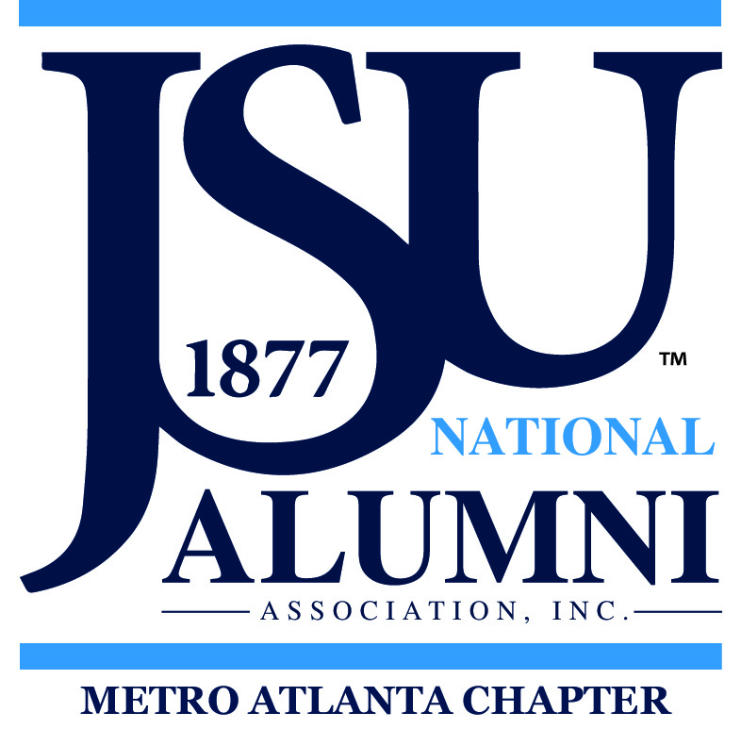
METRO ATLANTA CHAPTER, INC.
Jackson State University National Alumni Association, Inc.

P. O. Box 57122

Atlanta, GA 30343
Tiger Hotline: 404.266.7933 Website: http://www.jsumac.org/about.html

Zoom
JSUMAC Executive Board Meeting
Secretary’s Report October 13, 2020

Call to Order – President Deborah Taylor officially called the meeting to order at 6:32 PM.

Invocation – David Kennebrew provided the opening prayer.

Parliamentary Procedures – William Buchanan reviewed the parliamentary procedures and provided rules to making a motion. The meeting will follow the newly revised Robert’s Rules of Order. Committee heads are reminded to be mindful of a 2-minute limit.

Roll Call – President – Deborah Taylor, 1st Vice President – Debbie Lowe, 2nd Vice President – Keith Adams, Secretary – Renee’ Slaughter, Assistant Secretary - Jerome Jones, Treasurer – Sylvester Taylor (excused absence), Financial Secretary – Dylester Scott, Chaplain – David Kennebrew, Parliamentarian – William Buchanan, Immediate Past President – Kenneth Archer
Approval of Agenda – The agenda for the meeting was reviewed. The motion was moved by Keith Adams and seconded by Jerome Jones to accept the agenda as printed.

Secretary’s October Executive 2020 Report - The minutes from September Executive 2020 meeting minutes were read silently by the members. The recap was done by the Secretary. The reporting was based on Roberts Rules of Order, stating facts and voted on decisions. The motion was made by Renee Slaughter and seconded by Jerome Jones to accept the report with the noted corrections.

Secretary’s October Chapter 2020 Report - The minutes from September 2020 Chapter meeting minutes were read silently by the members. The recap was done by the Secretary. The reporting was based on Roberts Rules of Order, stating facts and voted on decisions. The motion was made by Renee Slaughter and seconded by Jerome Jones to accept the report with the noted corrections.

October 2020 Treasurer Report – Dylester Scott reported the September 2020 Opening Bank balance was $7,157.34. September total income was $778.85. Total expenses for September were $389.29. Net Income for September was $389.56. The September ending balance as of September 30 was $7,546.90. The JSUMAC Scholarship fund available balance was $3,100.00 and the adjusted total balance for the month of September was $4,4446.90. The Treasurer’s Report for September was presented for information purposes only and subject to audit.

IHL Report – Ken Archer reported that IHL is in the process of filling the permanent position for president of Jackson State University.

Fall Council Meeting – Deborah Taylor reported JSUNAA Fall Council meeting is scheduled via Zoom Saturday, October 24, 2020.

1st Vice President’s Report – Debbie Lowe reported that Savannah State graduate, Janelle is looking for HBCU graduates to interview for an upcoming documentary on HBCU schools. She would like to interview members of the Metro Atlanta Chapter. She can be contacted at 601-4935-5483 to schedule an interview.

HBCU Alliance – Keith Adams reported that the HBCU Alliance has partnered with the HBCU Homecoming Movement, Once Voice One Vote, and other various movements. Keith Adams has agreed to run for Vice President of the HBCU Alliance.

Membership –Deborah Taylor reported that JSUNAA Metro Atlanta Chapter elections will be held next year and to be eligible to vote, membership dues must be paid by December, 31, 2020.

Community Service – Debbie Lowe reported that JSUNAA MAC scheduled a campaign with the Red Cross to donate blood at your local Red Cross donation center. The campaign will be held during the week of 10/12 – 10/17.

Fundraiser - Jerome Jones, the fundraiser chair gave a report on the fundraiser to sell JSU merchandise. The fundraiser will allow the chapter members to sell JSU merchandise (hoodie, cap, chapter polo shirt and t-shirt). A portion of the proceeds from the items sold will go the chapter. The vendor is an approved licensed vendor

Meeting adjourned @ 7:46 PM and Released by the President

