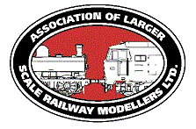
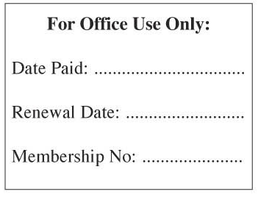

www.alsrm.org.uk

MEMBERSHIP APPLICATION

Full Name: ……………………………………………………..

Address: ……………………………………………………..

……………………………………………………..

……………………………………………………..

……………………………………………………..

Post Code: ……………………

Telephone
Home: ……………………………..

Mobile: ……………………………..

Email: ……………………………………………………..

Interests Scale/Gauge Please indicate
‘0’ □ ‘1’ □ ‘G’ □ ‘2’ □ ‘3’ □ Other(s) Please Specify …..…….
DC□ DCC□ R/C□ Live Steam□ Other(s) Please Specify …..…….

Period(S) ………………………...

Can you help? At a show □ Contribute to the Journal □

The above data is collected and stored for membership purposes only.

Signature: ………………………………………………………………

The Association of Larger Scale Railway Modellers is a company limited by guarantee formed to promote the hobby of railway modelling in the scales of S, 0, 1, G, 2, 3 up to 7¼”

The Associations annual show at Reading in May is free to members (current entry £9 to non-members) you will also receive by newsletter or on occasion magazine dependant on the availability of articles summited.

Members also receive a discount, currently 10%, on purchases over £5 from Slaters, MSC also offer a discount to our members. There is also a discount for entry to the Leeds Model Railway Society in October. We shall advise members of any other discounts as and when they become available.

Annual Subscription £14 (Overseas £24)

Please enclose a cheque made payable to The Association of Larger Scale Modellers Ltd (ALSRM Ltd)
Together with an A5 sized stamped and addressed envelope to

Mark Sanders, 1 Heath Road, Hockering, Norfolk, NR20 3HT

Registered Office: 8 Ffolkes Place, Runcton Holme, Kings Lynn, Norfolk, PE33 0AH
Tel: 01553 810673 Registered in England No. 04123660

