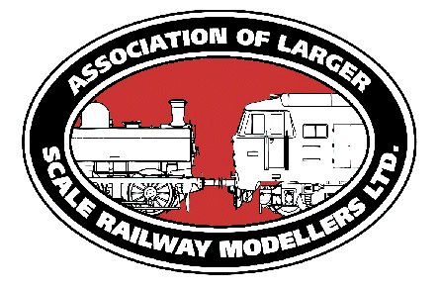**HIGH WYCOMBE LARGER SCALE SHOW 2022**

**TRADE BOOKING FORM**

**High Wycombe Leisure Centre**

**Sunday 8 May 2022 10am – 4pm**

|  |  |  |  |
| --- | --- | --- | --- |
| **Stand Name** |  | **Contact Name** |  |
| **Email** |  | **Phone (mobile)** |  |
| **Address** |  | | |

**Your trade unit**

Trading units –5ft depth allows for one table deep stand. For two tables behind each other a depth 7ft or 8ft will be required. If you require tables, stand length must be in 6ft multiples. A minimum length of 6ft (with or without tables)must be booked. Please indicate how many chairs and tables you require – if none, please insert a zero. If this is left blank, then none will be provided.

|  |  |  |  |  |  |
| --- | --- | --- | --- | --- | --- |
|  | **A: Standard unit**  **6ft x 5ft:**  Pre 28 Feb2022: £46/6ft  1 Mar 2022 onwards: £50/6ft | **B: Non standard unit:**  Pre 28 Feb2022: £1.54/sq ft  1 Mar 2022 onwards: £1.67/sq ft | **C: Tables**  **Cost: £7 each** | **D:**  **Chairs**  **Cost: £3 each** | **Power required?**  **Y/N** |
| **Number required** |  | Size required: |  |  | **Wattage:** |
| **COST** |  |  |  |  | **£0** |

|  |  |  |  |  |
| --- | --- | --- | --- | --- |
| **TOTAL COST**  **(A or B)+C+D =** |  | **Deposit** (min 25% required with booking) | **£** | **Paid by**  **BACS / Cq / Cash** |

**On the day details:** Please note, arrival times will be needed to manage the hall access and unloading.

|  |  |  |  |
| --- | --- | --- | --- |
| **Type of vehicle used**  **(large van, car etc)** |  | **No of badges required**  (note – 2 per 6ft stand, max 4 per stand) |  |

|  |  |  |  |  |  |  |  |  |
| --- | --- | --- | --- | --- | --- | --- | --- | --- |
| **Arrival time (Sat)** | 4pm | 4.30pm | 5pm | 5.30pm | 6pm | 6.30pm | 7pm | 7.30pm |
| **Arrival time (Sun)** | 7am | 7.30am | 8am | 8.30am | 9am | NO ARRIVALS FROM 9.30 onwards | | |

**Do you have any special requirements?**

|  |
| --- |
|  |

**Please refer to the terms and conditions**

DECLARATION: I wish to apply for a trade space at the above event I have read & understand the conditions. I understand that any money paid is non-returnable should I cancel my application after the form is received by the Association of Larger Scale Railway Modellers (ALSRM) or fail to attend the above event for any reason. Applications are subject to acceptance by ALSRM who reserve the right to withdraw an invitation at any time should their declared terms not have been complied with.

Name………………………………………………… Date………………………………………

**Return this form with deposit** to: Liz Marsden (ALSRM Trade),Email: [trade.alsrm@gmail.com](mailto:trade.alsrm@gmail.com) or Address:Kings Road Lock House, Foxholes Lane, Altofts, West Yorkshire, WF6 2PE.

Make cheques payable to **The Association of Larger Scale Railway Modellers Ltd** or **ALSRM Ltd**

Or pay by Direct Transfer to: Sort code **30-92-99** Account No. **00942505** with trading name as reference