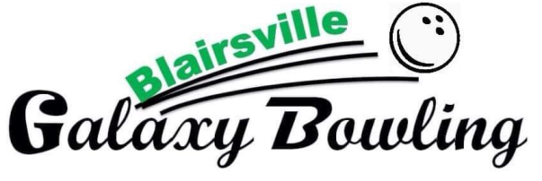

104 Backyard Lane

Blairsville, GA 30512

**706-745-4444**

[www.galaxybowling.net](http://www.galaxybowling.net)

**PARTY/EVENTS GENERAL TERMS & CONDITIONS POLICY AGREEMENT**

The Following terms and conditions govern your purchase of event and services from the bowling facility (“facilities”, “we” or “us”). You agree as follows:

1. Please note the following: Your request for event to be held on specified day and time is being reserved by us. Your time slot is for two hours which includes your set up time should you wish to set the table yourself.
2. A $30.00 deposit is required and will be applied to final bill. You, however remain responsible for all costs incurred during the event including 10% gratuityadded to total of bill.
3. You agree to pay us as sums are due hereunder, including any costs for damage caused by you or your guests. You may cancel this event at any time by calling 706-745-4444, or email us at galabowl@gmail.com. Deposits are non-refundable on cancellations 5 or less days from day of event. To reschedule contact us at 706-745-4444.
4. Party Package starts **at $150.00** and covers 1-8 attendees who bowl on your (2) reserved lane(s). Your party includes: two hours in party room, two pizza’s (cheese/pepperoni), two pitchers of drinks (coke products) and table set up (tablecloth, plates, cups, napkins, & sporks) and one game of bowling and shoe rental for attendees. You may also bring your own decorations and/or set your own table when your time slot begins. Lane location will be selected at the sole discretion of the facility.
5. ONLY birthday cakes/cupcakes/cookie-cakes, and ice-cream allowed in party room. No outside food or beverages allowed, please let your guests know. All other food and beverages must be purchased from us.
6. Event involves physical activity. You and your guests represent that you are in proper health to participate in such activities. You assume risks arising therefrom. Children must be chaperoned. We reserve the right to refuse service and remove anyone from the facility which we reasonably believe threatens the safety of personnel or guests or causes damage to our facilities, including activity that violates federal, state, provincial or local lows. Other local restrictions and facility house rules may apply.
7. You are responsible for any and all damages, losses, claims and liability arising out of or related to you or your guests’ use of the event facilities, equipment and services, or related to your event, including property damage or personal injury arising therefrom, and will release, indemnity and hold us harmless from damages, losses, claims and liability resulting therefrom (other than claims caused by our gross negligence or willful misconduct).
8. By signing this contract, the signer is attesting that he/she is authorized to sign this contract and herby authorizes, if any, the credit card charges noted herein.
9. Our services and facilities are provided “as is” without any warranty or representation express or implied. WE ARE NOT LIABLE for any consequential, indirect, punitive, special, general, exemplary, economic damages arising fro this contract or our services. Our liability, if any, in all cases shall be limited to amounts paid to us under this agreement.
10. By submitting the request form to us, or by making any other manual or electronic signature now or later which either incorporates or references these terms, you agree and acknowledge that such action constitutes your signature which applies to an evidences your agreement to these term.