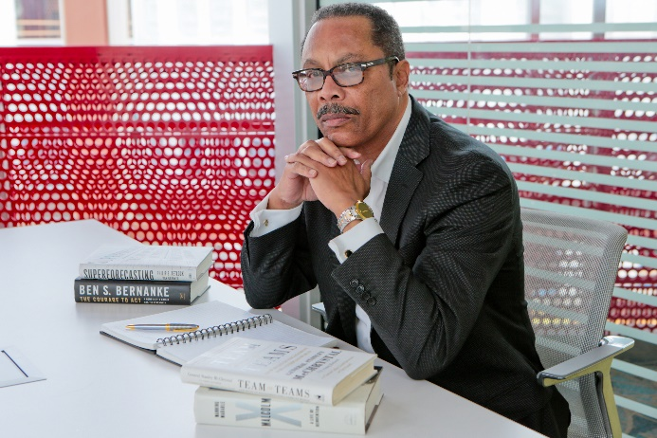 **20/20 Vision by Harry D. Sewell**

**The end of the beginning**

**December 20, 2020**

**T**he year 2019 was marked by ceremonies on both sides of the Atlantic commemorating 400 years since the arrival of the first enslaved Africans in the English colony of Virginia. And it was especially poignant that the current Lt. Governor of Virginia, Justin Fairfax, with the manumission papers of one of his forbearers in his pocket, spoke of it being the end of the first 400 years and the beginning of the next.

And so 2020 has been the end of the beginning. And what a beginning to the next 400 it has been. If anything, 2020 was “the red pill” from The Matrix. It was the opening of our country’s eyes to the legacy of injustices of the past, and the continuing inequalities of the present. More importantly, however, is what it may signal about the future.

The rush of events this year may have felt like an avalanche, but it was more like an earthquake. After a big storm, the melting snow reveals a landscape largely unchanged. But with an earthquake, while the immediate damage is apparent, the resulting cracks and fissures may take years to cause seemingly undamaged buildings to crumble. Like the major events of this year, the coronavirus and the presidential election.

**The new utility**

COVID has been an accelerant, quickening changes that were already underway. In the last few years we have begun to talk about Industry 4.0; the era after automation. COVID moved everything to the internet, from schools, to work, to shopping. This is also the first year I attended several live-streamed funerals. Access to broadband became the new “utility”, as necessary as electricity, but not as ubiquitous. And its unavailability further exacerbated inequality in education and the workplace.

“Big tech” has brought the problem of disinformation to the forefront, although there is no consensus yet on how to solve it. Merely eliminating Section 230 won’t be sufficient to change how social media has come to dominate the way most Americans consume their content. And going after TikToc is the most inane administration action of all. The Russian hack of the entire government is another wake-up call.

**Creeping authoritarianism**

The 2020 presidential election, and refusal of the incumbent to concede, has revealed the fragility of our democracy. Creeping authoritarianism is perhaps the greatest threat yet. Suggestions that the president declare martial law to throw out election results in “swing states”, the states he lost, and hold new elections at gunpoint is at least sedition, if not treason. Yet one of our major political parties has mostly remained silent as this assault is carried out.

The fusion of politics and religion is a dangerous trend, with that same party claiming its leader is ordained by God, along with the rise of “Christian nationalism.” We’ve seen this emerge in the Middle East (Hezbollah literally means Party of God) and how political Islam led to radical Islam.

Every “interest” or “identity” group in the other party is demanding representation in the president-elect’s cabinet. As if being black, or native, or gay, or young is a qualification for office. None of these is a substitute for expertise and “content of character.”

When Jim Clyburn, congressman from South Carolina, was asked about comments by Representative AOC that congressional leadership was too old, his retort was, “Would you rather have a young Clarence Thomas or an old Thurgood Marshal?”

**The next 400**

Even though we may not yet have all the answers, we see clearly what needs our attention. We have to fix education before we lose a whole generation of young people. We have to fix health care before we lose a whole generation of old people. No one should be hungry, or without a roof over their heads, in the supposed “richest country in the history of the world.”

A recent article by writer and film maker Cyril Christo put it succinctly: “Will we be an inclusive country of possibility, or a crippled giant that has outworn its usefulness?” His prescription, “America, and humanity, needs to find balance, vision, justice and healing.”

Amen.

**H**