**Cedar Lake Conservation Club | Water Quality Committee**

**2018 Year in Review**

**Kathy Jonsrud, Water Quality Committee Chair** [**kjonsrud@yahoo.com**](mailto:kjonsrud@yahoo.com)

**2018 Water Quality Values Continue to be Outstanding | Meet Project Goals**

The results are in! Samples are regularly taken from our lake during the summer months by the Clearwater River Watershed District. Analysis is done by a laboratory.

We again had outstanding water quality values on Cedar in 2018. Many commented on how clear the water was this year. Clearly, our Clearwater River Watershed District project implemented in 2006--and with recent enhancements-- is delivering results, even with several years of multiple inch rain events.

Here’s a summary of our 2018 values:

→ The gold standard for monitoring lake water quality is the phosphorus level. A good lake is considered to have a level less than 40ug/l. The average 2018 phosphorus level in Cedar was 19.5 ug/L meets our project goal of 20 ug/L.

→ The secchi depth (clarity) reading was an average of 9.1 feet. This is a bit lower than last year and certainly within expected year to year variations.

→ The chlorophyll was 6.2 ug/L which indicates limited algae blooms.

***We should take delight that all our stewardship has manifested in significant improvement in water quality. Each of our individual actions is important; from financial support for projects to***

***mindful enjoyment of our beautiful lake.***

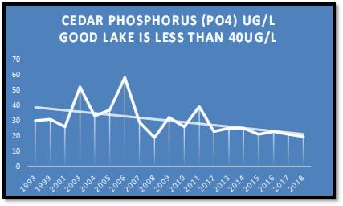

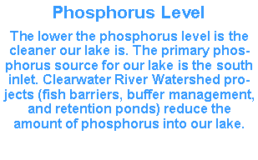

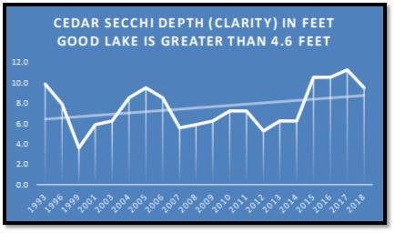

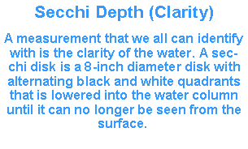

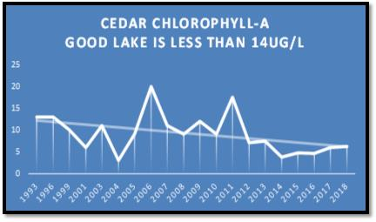

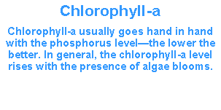

**CRWD PO6 Project Implemented**

**CRWD PO6 Project Implemented**

**2018 Treatment of Curly Leaf Pondweed and Eurasian Water Milfoil**

The Water Quality Committee, with oversight by the CLCC Board of Directors, had a successful season controlling curly leaf pondweed (CLP) and eurasian water milfoil (EWM). Both treatments yielded excellent results. Here is a summary of CLP and EWM 2018 treatment.

**2018 Treatment**

**Red Areas | CLP 11.2 acres**

**Yellow Areas | EWM 8.2 acres**

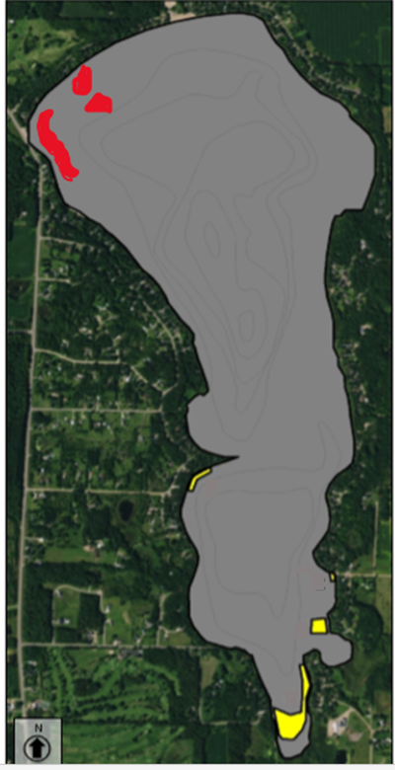**Curly Leaf Pondweed**

→ Treatment of 11.2 acres on May 23rd.

→ We received a $1,100 grant from Wright County for CLP treatment.

→ Mapping/delineations (pre and post treatment) were completed. Treatment and delineation expense is paid from our Clearwater River Watershed District PO6 Project—this year’s total for CLP was $10,673.

**Eurasian Water Milfoil**

→ Treatment of 8.2 acres on July 12th.

→ Post treatment mapping/delineation was completed in September.

→ Treatment and delineation expense is paid from our Clearwater River Watershed District AIS Project—this year’s total for EWM was $4,659.

**Zebra Mussels Discovered on Cedar in 2018 | No Starry Stonewort Found**

As part of our on-going monitoring of the zebra mussel infestation on Cedar, a formal search was conducted with Blue Water Science on September 27th, 2018. We also searched for the newest invasive foe—starry stonewort.

***GOOD NEWS***

No starry stonewort was found on Cedar. Starry stonewort (SSW) is one of the newest aquatic invaders and is particularly problematic with thick matting and exceptionally invasive characteristics.

**Areas on Cedar where zebra mussels have been found.**

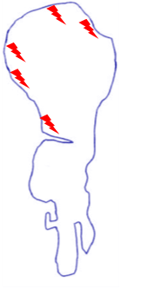***SAD NEWS***

More zebra mussels were discovered at multiple locations on the lake. Given the lake wide infestation, with current chemical treatment strategies, we are not a candidate for treatment. Most of the zebra mussels were found on docks and lifts, though some have been discovered on monitoring devices.

Most of the zebra mussels were 1/4” to 1/2” in size—about 1 to 2 years in age.

In a comparable search on Sugar Lake this fall, a similar zebra mussel infestation was identified.

***WHAT TO EXPECT***

The zebra mussel infestation on Cedar will continue to grow. How fast? Only time will tell. Zebra mussels disrupt the ecological food chain and the long-term impact to lakes is difficult to predict. Given Cedar’s lower phosphorus level (food for zebra mussels) the infestation will more than likely take three to five years to fully understand. Thereafter, the infestation may move into an ebb and flow pattern.

We can expect the phosphorus level in our lake to decrease, and water clarity will more than likely increase. The increasing water clarity can promote native vegetation. Invasive aquatic vegetation seems to take particularly quick advantage of increased water clarity, so our management practices of curly leaf pondweed and eurasian water milfoil must remain vigilant.

***STEWARDSHIP PRACTICES AND HOPE***

Now that we face this infestation, here are some important stewardship practices we all must do and remain eyes-forward for new science.

✓ Zebra mussels are attracted to darker, quiet areas; docks, lifts, and sea-legs tend to be favorite spots. **If you sell your equipment, seriously consider doing so only after it has over-wintered. *The one sure method for killing zebra mussels is freezing.*** If you need to sell equipment in the summer months, it must (by Minnesota law) be out of the water for 21 days before installing in a new lake. Plan to do a high-pressure hot water decontamination at the free service at the Wright Regional Watercraft Inspection site at 1300 Business Blvd, Annandale, MN (April to October).

✓ If your watercraft is “resident” to Cedar Lake (e.g. in the lake all summer) there is a good chance it will have zebra mussels. Given this knowledge, and the difficulty and time for a complete decontamination, **consider not visiting other lakes with your watercraft.**

✓ New zebra mussel management strategies are emerging from the Minnesota Aquatic Invasive Research Center (www.maisrc.umn.edu). New studies of “spot” treatment for heavily infested zebra mussel areas are being researched.

**Manned AIS Inspections on Cedar**

As serious lake people know, there is not a magic bullet to prevent aquatic invasive species from entering our lake. Education is the key! In 2018, over 1,600 inspections were done on Cedar (CTY RD 6, Schroeder Park). Along with the DNR and Wright County inspections on CTY RD 6, CLCC funded an additional 840 hours of inspections at an expense of $16,000.

**Wright County AIS Prevention Aid**

The Minnesota Legislature allocates $10 million per year directly to Minnesota counties to help fight the spread of aquatic invasive species. Wright County received $228,000 in 2018. Wright Soil & Water Conservation District (WSWCD) is charged with leading this local effort. 2018 areas of focus for the AIS Prevention Aid in Wright County included:

* AIS treatment assistance to lake associations. Cedar received $1,100 in grant monies from Wright County this year.
* Manned inspections at lake accesses.
* Decontamination program
* Rapid response protocol for early zebra mussel infestation.

**Water Quality Committee Responsibilities**

The Water Quality Committee is a very active CLCC committee. The committee is responsible for:

* managing aquatic invasive species treatment
* monitoring water quality
* engaging with government entities to preserve and improve water quality
* providing lake community education.

**CRWD PO6 Project Implemented**

**CRWD PO6 Project Implemented**

**CRWD PO6 Project Implemented**