Stage

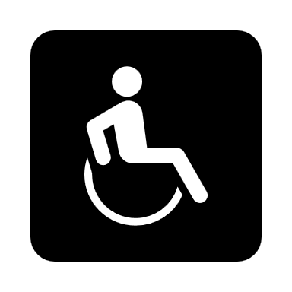

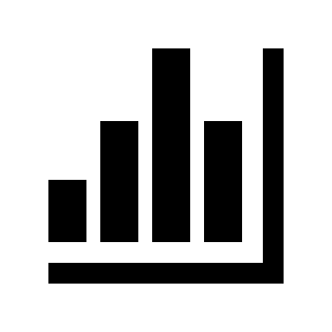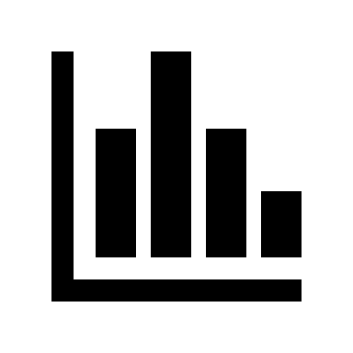

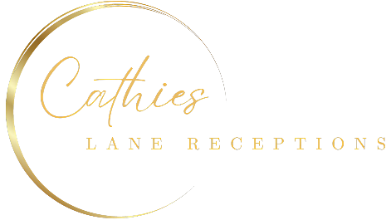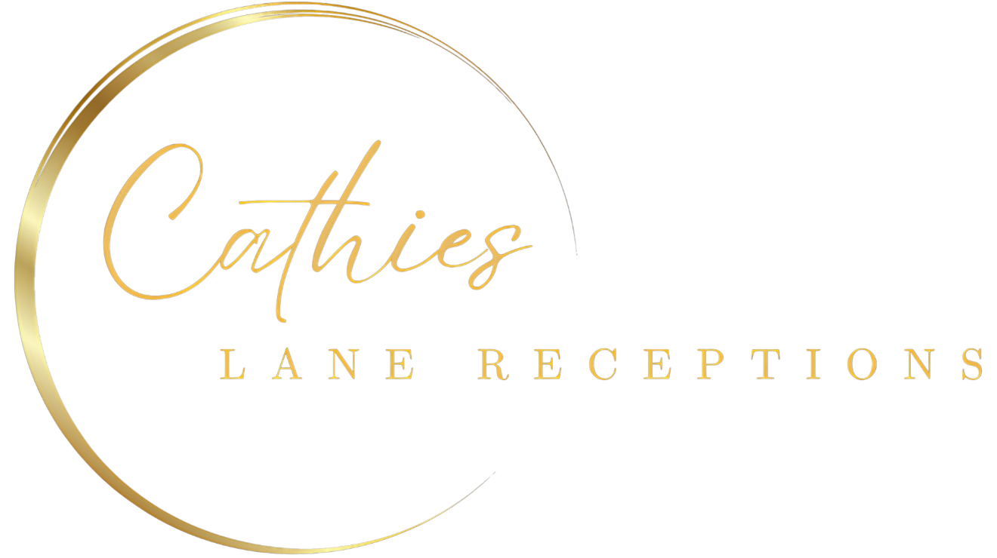

Please note we can do a maximum of

12 per table

**Total numbers: 600**

24 meters

32 meters

**27**

10

Photobooth

Bar

Tea Station

Kitchen

**28**

10

Buffet 2

Buffet 1

Sides

8 meters

22 meters

**22**

10

**26**

10

**25**

10

**24**

10

**20**

10

**29**

10

**33**

10

**30**

10

**31**

10

**35**

10

**34**

10

**37**

10

**36**

10

**23**

10

**21**

10

**19**

10

**13**

10

**38**

10

**32**

10

**17**

10

**16**

10

**18**

10

**14**

10

**15**

10

**07**

10

**40**

10

**50**

10

**39**

10

**11**

10

**12**

10

**10**

10

**42**

10

**08**

10

**09**

10

**45**

10

**05**

10

**06**

10

**46**

10

**47**

10

**44**

10

**02**

10

**03**

10

**49**

10

**41**

10

**48**

10

**43**

10

**04**

10

**01**

10