Stage

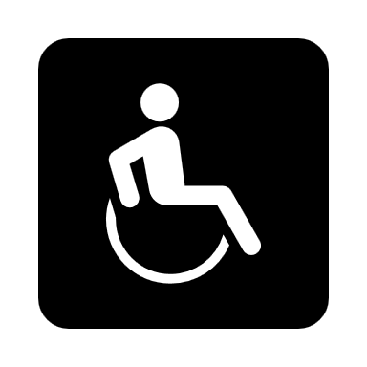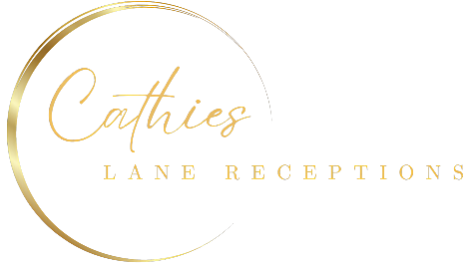

22 meters

24 meters

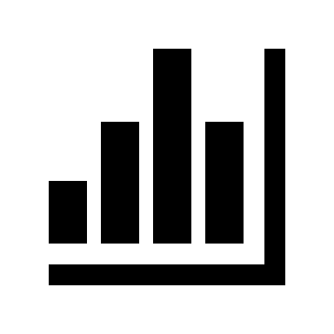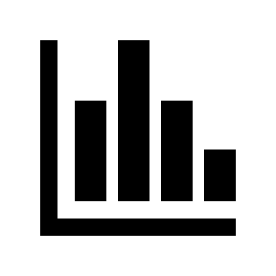

Please note we can do a maximum of

12 per table

**Total numbers: 600**

**30**

12

**34**

12

**38**

12

**32**

12

**32**

12

**36**

12

**28**

12

**27**

12

**26**

12

**22**

12

Photobooth

Bar

Tea Station

Kitchen

8 meters

**25**

12

**24**

12

**20**

12

**29**

12

**33**

12

**31**

12

**35**

12

**23**

12

**21**

12

**19**

12

**13**

12

**17**

12

**16**

12

**18**

12

**12**

12

**15**

12

**07**

12

**40**

12

**50**

12

**39**

12

**11**

12

**12**

10

**10**

12

**42**

12

**08**

12

**09**

12

**45**

12

**05**

12

**06**

12

**46**

12

**42**

12

**44**

12

**02**

12

**03**

12

32 meters

**49**

12

**41**

12

**48**

12

**43**

12

**04**

12

**01**

12