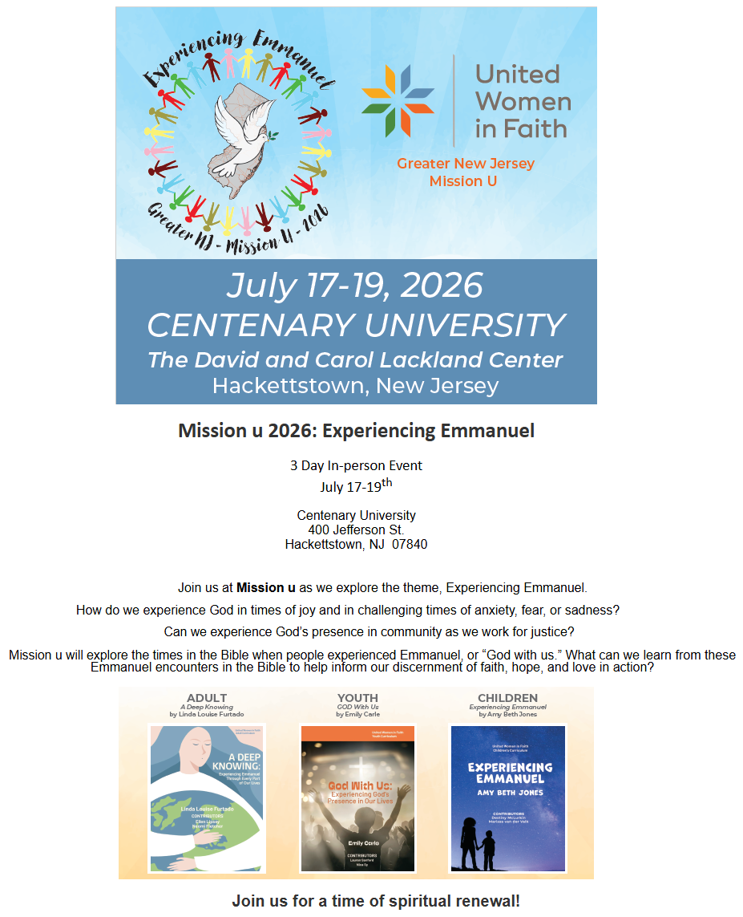

https://na.eventscloud.com/876780.

