**GNJ United Women in Faith Calendar of Events 2022-2023**

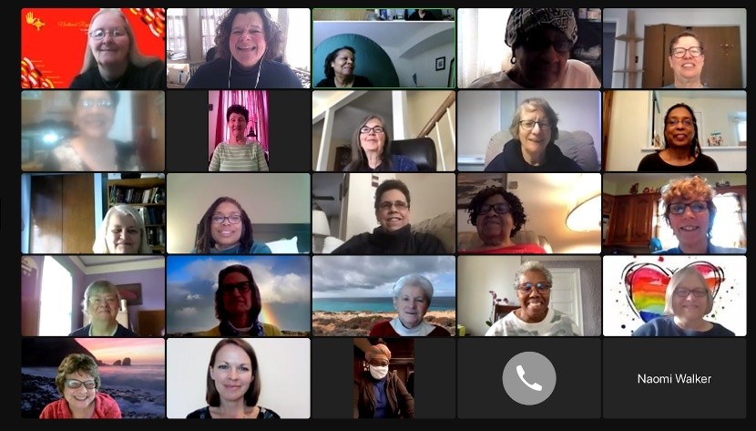

2023

January 11 Tech Rehearsal for Breakout Rooms for Jan. 14th

7-7:30pm

January 14 Leadership Development and Charter for Racial Justice

9:30am- 2pm “**Day of Action”**  followed by Leadership Team meeting   
Flyer: <https://tinyurl.com/LDActionFlyer>

Zoom link: <https://tinyurl.com/LD-ActionEvent>

January 19-21 National Leadership Development Days, “On Towards the Goal,” Philippians 3:12-16   
Virtual for conf & dist pres, conf VP, conf & dist MNO  
Thur 7pm, Fri & Sat noon-7pm

February 11 Day of Action & Love, Congressional Outreach

Noon-1pm

March 11 Leadership Team, 9:30-11:30

April 1 Leadership Development

10-11:30am

2023

April 15 Spring Celebration

May 6 Leadership Team

May 10 Finance Comm., Wed., 7pm

August 26 Treasurers’ Meeting, 9:30am, followed by LT

October 14 Annual Meeting

November 15 Planning meeting, Wednesday, 7-8:30pm