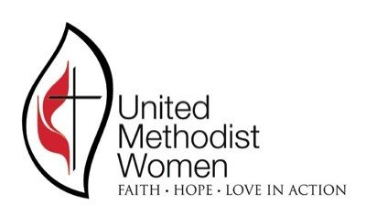

September 15, 2021

Dear Contact Person for the UMW Unit,

***Calling all UMW Units in the Gateway South District of the Greater New Jersey Annual Conference!!!***

“Friends Helping Friends Day” will be Wednesday, October 20, 2021. This is the annual promotion sponsored by the chain of Boscov’s Department Stores. All UMW Units are requested to be responsible for ten (10) passes. Share the passes with friends in your church! They will receive from 10% to 25% off regular and sales merchandise when they purchase a pass for $5.00 and shop on October 20, 2021.

The Neighborhood Center in Camden will benefit from each pass that is sold. The more passes sold, the larger the dollar amount that will be generated for the Center. You may request additional passes as you need them. Here is the procedure to follow:

Special Instructions:

**First:** Please spread the word to your congregation.

**Second:** Thank you for your service of being the contact person for your church. Your service is most valuable as you are the vehicle of communication to share information on your church events and to receive messages from the Leadership Team that may be of interest to the members of your church.

**Third:** Send all funds to the attention of the Gateway South District Treasurer, Barbara Talton at 60 Matlock Drive, Voorhees, NJ 08043. Ensure that your church’s name is on the check, and make the check payable to Gateway South District UMW earmarked for the Neighborhood Center. Mrs. Talton will forward the funds directly to the Neighborhood Center at the end of the promotion. A report of the success will be shared with all.

We are anticipating 100% participation. This is a very easy way for all of our churches to support the Neighborhood Center of Camden. Thank you, in advance, for your cooperation, support and financial assistance.

Sincerely,

Sharyn Bailey

18 West Madison Street

Collingswood, NJ  08108

[sharyn8888@gmail.com](mailto:sharyn8888@gmail.com)

**P.S.** During these troubling times, The Neighborhood Center in Camden has continued to operate without interruption as a place of hope and promise for children, teenagers, and folks suffering from food insecurity. We can only continue our mission with both your prayers and financial support. I do hope that you will continue to support us with Boscov’s “Friends Helping Friends Day.” The Center depends on the financial gifts from our Methodist Conference of Churches and United Methodist Women Units throughout the State of New Jersey.