The Daily Prayer Guide and themed monthly Program Resource is available for orders at UWFaith website “[Resources](https://uwfaithresources.org/prodlist.cfm?catID=2526&utm_source=United+Women+in+Faith&utm_campaign=45d5d8bdae-EMAIL_CAMPAIGN_2023_12_21_09_21_COPY_01&utm_medium=email&utm_term=0_-d3ec2511f0-617679050&mc_cid=45d5d8bdae&mc_eid=5e2cedf479)” page.

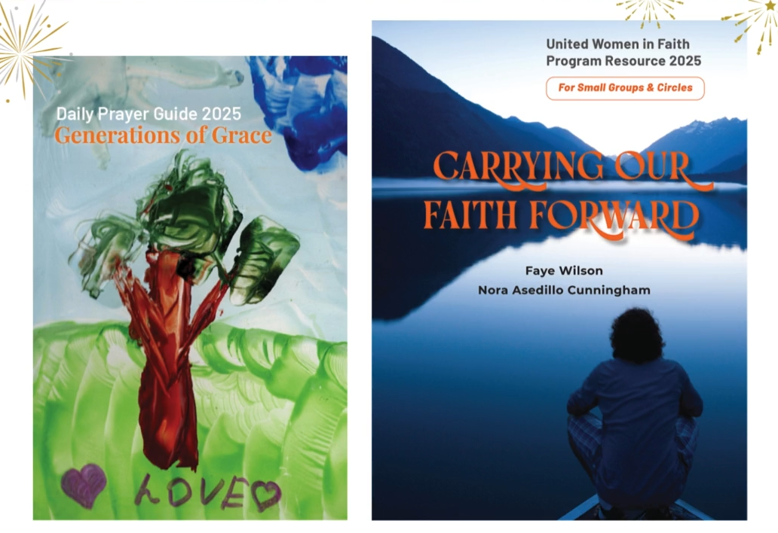

|  |
| --- |
|  |

|  |  |
| --- | --- |
| |  | | --- | | [A group of books on a white surface  Description automatically generated](https://uwfaith.us6.list-manage.com/track/click?u=29c7c08b73c632ded44fb9935&id=6779a7e127&e=5e2cedf479) | |

|  |  |
| --- | --- |
| |  | | --- | | [**Order your resources today!**](https://uwfaith.us6.list-manage.com/track/click?u=29c7c08b73c632ded44fb9935&id=7f16af770c&e=5e2cedf479) | |

12/18/24