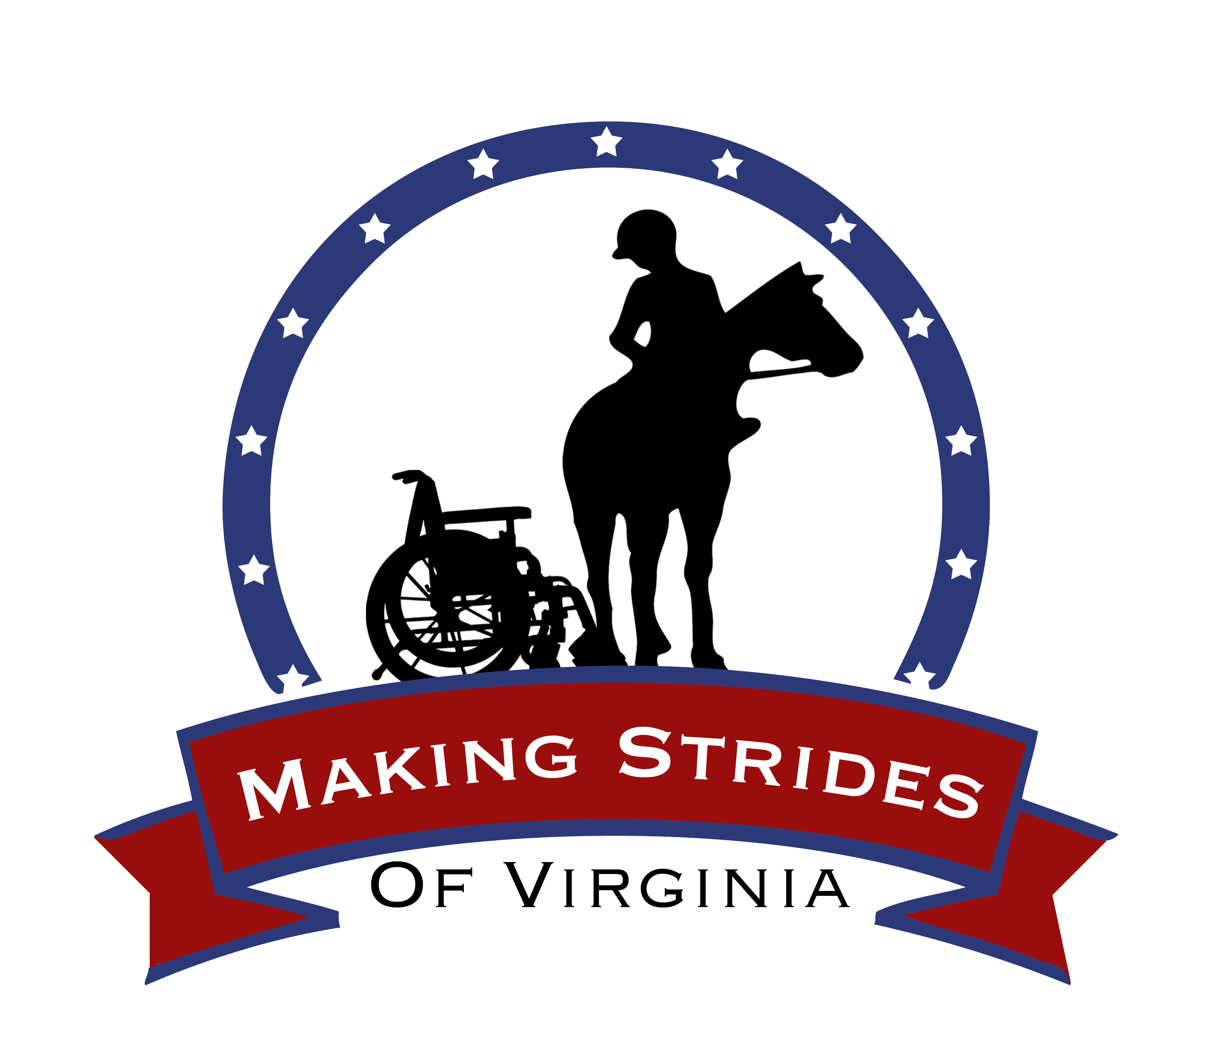

Confidentiality Agreement

IMPORTANT: Please read all sections. If you have any questions, please ask before signing.

- Confidentiality of Patient Information:
I understand and acknowledge that: (i) services provided to patients are private and confidential; (ii) to enable such services to be performed, patients provide personal information with the expectation that it will be kept confidential and used only by authorized persons as necessary; (iii) all personally identifiable information provided by patients or regarding medical services provided by patients, in whatever form such information may exist, including oral, written, printed, photographic and electronic formats (collectively, the “Confidential Information”) is strictly confidential and is protected by federal and state laws and regulations that prohibit its unauthorized use or disclosure; and (iv) in the course of my employment/affiliation with Brandywine Valley Consultants, Inc. d.b.a. Making Strides, Making Strides Therapeutic Services d.b.a Making Strides of Virginia, I may be given access to certain Confidential Information.

- Disclosure, Use and Access
I agree that, except as authorized in connection with my assigned duties, I will not at any time use, access or disclose any Confidential Information to any person (including but not limited to co-workers, friends, and family members). I understand that this obligation remains in full force during the entire term of my employment/affiliation and continues in effect after such employment/affiliation terminates.

- Confidentiality Policy
I agree that I will comply with confidentiality policies that apply to me as a result of my employment/affiliation.

- Return of Confidentiality Information
Upon the termination of my employment/affiliation for any reason, or at any other time upon request, I agree to promptly return to Brandywine Valley Consultants, Inc. d.b.a. Making Strides, Making Strides Therapeutic Services d.b.a. Making Strides of Virginia, or my employer all copies of business, administrative, and patient confidential information that is individually identifiable in my possession or control (including all printed and electronic copies), unless retention is specifically required by law, regulation or for special issues as outlined in the Making Strides Confidentiality Policy.

- Periodic Certification
I understand that I may be required to periodically certify that I have complied in all respects with the Agreement, and I agree to so certify when requested.

- Remedies
II understand and acknowledge that: (i) the restrictions and obligations I have accepted under this Agreement are reasonable and necessary in order to protect the interests of patients, Making Strides and my employer (if different from Brandywine Valley Consultants, Inc. d.b.a. Making Strides, Making Strides Therapeutic Services d.b.a Making Strides of Virginia,); and (ii) my failure to comply with this Agreement in any respect could cause irreparable harm to patients, Making Strides and my employer for which there may be no adequate legal remedy. I therefore understand that Brandywine Valley Consultants, Inc. d.b.a. Making Strides, Making Strides Therapeutic Services, Inc. d.b.a. Making Strides of Virginia, or my employer may prevent me from violating the Agreement by any legal means available, in addition to disciplinary measures, which may result in sanctions in accordance with applicable policies and collective bargaining agreements.

Signature: Date:

Printed Name:

