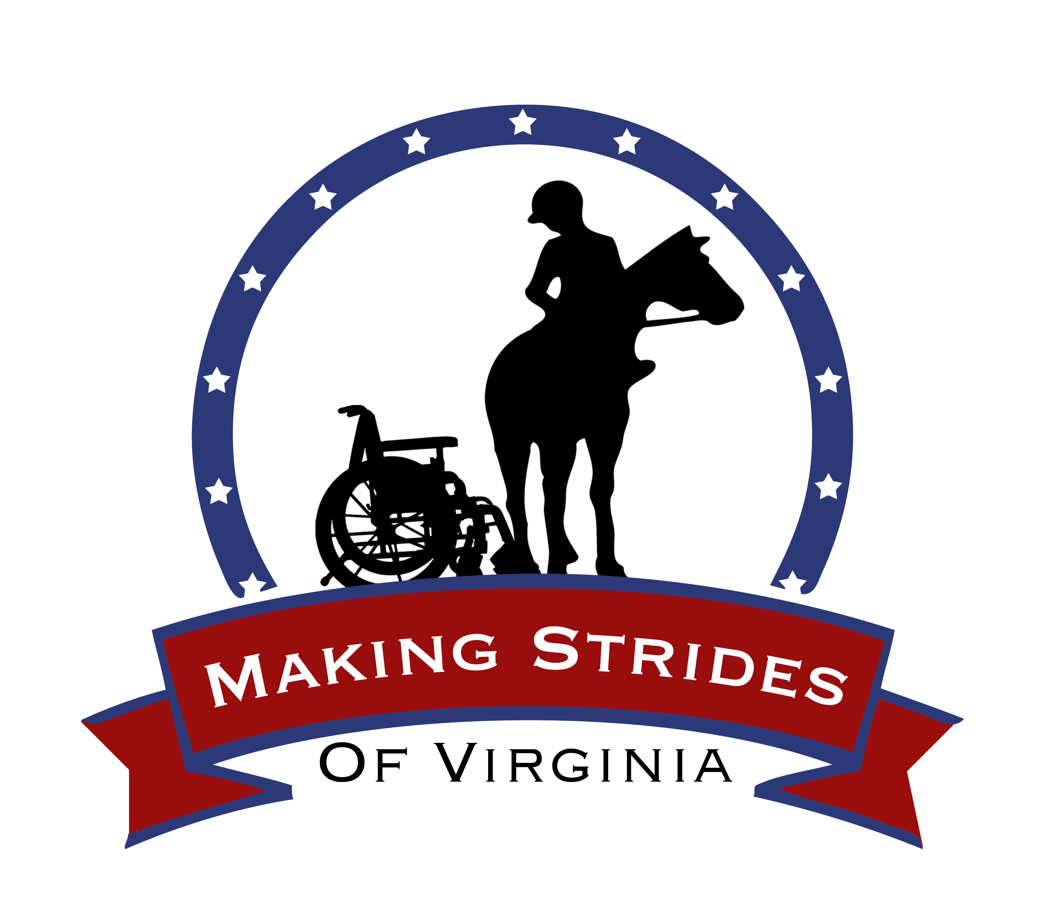

PLEASE RETURN THIS PAGE ONLY, KEEP THE OTHERS FOR YOUR RECORDS

Horse Competency Acknowledgement

By signing this document, I acknowledge that I have read, understand, and agree to the above Horse Competency provided to me by Making Strides of Virginia.

____________________________________________ _________
Signature Date

