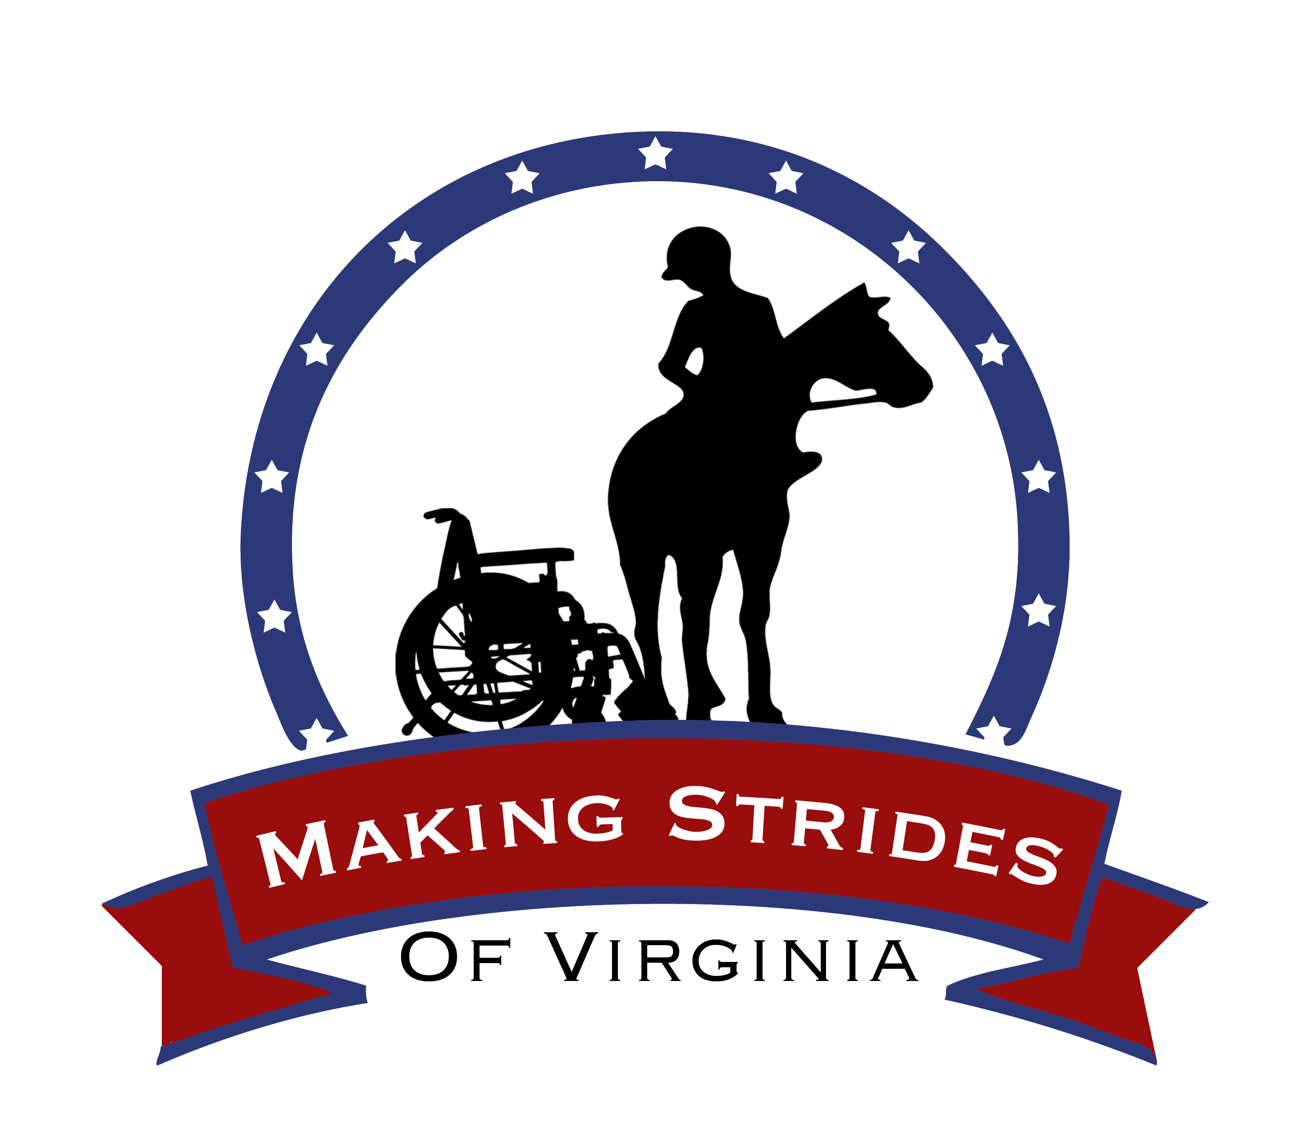

COMPETENCY:
The Horse

LESSON PLAN: PARTS AND TYPES OF HORSES

PURPOSE OF LESSON
The purpose of this lesson is to teach the riders the different types of horses (mare, gelding, stallion, colt, etc.) and different parts of their bodies (muzzle, withers, etc.).
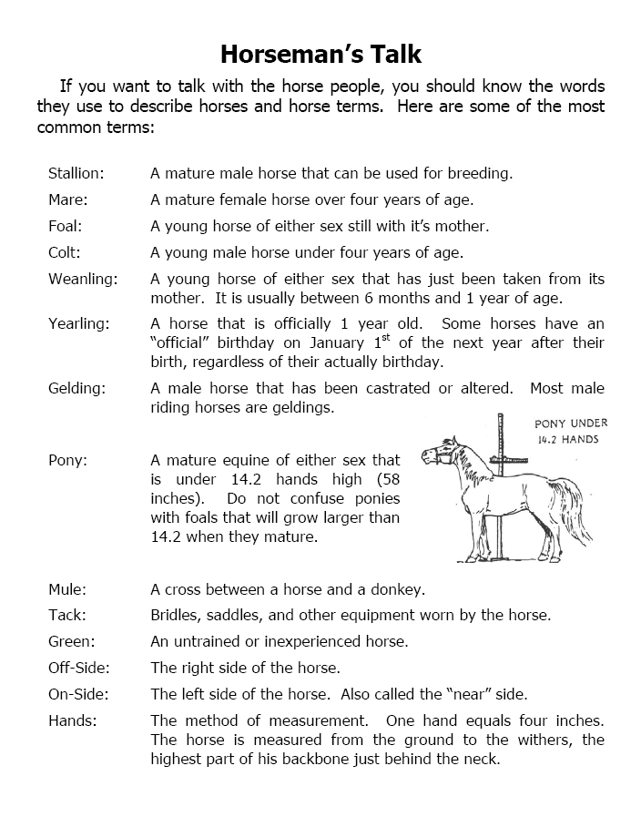
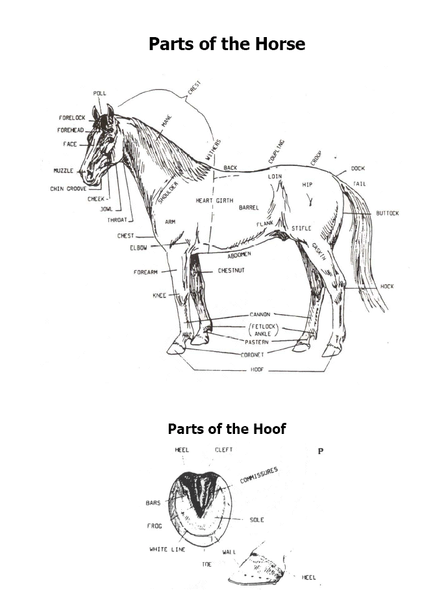
QUIZ 1: TYPES OF HORSES

NAME: ____________________________________________________

DIRECTIONS: For questions 1-8, decide if the statement is TRUE or
FALSE or Circle the correct answer.

1) A male horse is called a mare.
a) True b) False
2) A pony is a baby horse.
a) True b) False
3) A filly is a young, female horse
a) True b) False
4) A baby horse is called a foal.
a) True b) False
5) Male horses are called geldings or stallions.
a) True b) False
6) A mare is a ________________.
a) Female Horse b) Male Horse
7) A ___________ is a young, female horse.
a) Foal b) Filly
8) A colt is a _______________ horse.
a) Male b) Old

PARTS OF THE HORSE
DIRECTIONS: For questions 1-4, decide if the statement is TRUE or
FALSE. Circle the correct answer.

1) A muzzle is a horse’s nose.
a) True b) False
2) The height of a horse is measured from the ground to the horse’s tail.
a) True b) False
3) A frog is a part of the horse’s hoof
a) True b) False
4) A horse’s mane is the hair between the horses eyes.
a) True b) False
LESSON PLAN: FITTING THE HELMET

PURPOSE OF THE LESSON
This lesson was designed to teaching the rider how to choose and fit a helmet properly.

SELECTING AND FITTING THE HELMET
STEPS TO FOLLOW
1) Select a helmet that looks like it will fit the rider comfortably.
2) Hold the rider’s head still and gently rock the helmet back and forth.
a) Do the rider’s eyebrows move up and down when you rock the
helmet?
b) If the rider’s eyebrows don’t move when you rock the helmet, the
helmet might be too loose. Try a smaller sized helmet.
3) If the rider cannot clip the throat strap, offer to help him or her.
a) Check that the throat strap is not too tight by trying to insert one
finger between the strap and the rider’s throat

THINGS TO REMEMBER
1. Helmets usually come in three sizes including Small (S), Medium
(M) and Large (L)
2. The helmet should be level, not tilted forward or backward on the
rider’s head
3. The helmet should be centered on the rider’s head

QUIZ 2: SELECTING AND FITTING THE HELMET

NAME: ____________________________________________________

DIRECTIONS: For questions 1- 5, decide whether the statement is
TRUE or FALSE. Circle the correct answer. For questions 6-8, choose the
best answer to the question and circle it.

1) The riding helmet should be level, not tilted forward or backward on the rider’s head.
a) True b) False
2) The riding helmet should be leaning to one side of the rider’s head not centered.
a) True b) False
3) The throat strap should fit tightly under the rider’s chin and you should be able to insert one
finger between the strap and the rider’s throat
a) True b) False
4) The rider should always have his helmet on when he/she is on the horse.
a) True b) False
5) Helmets only come in one size.
a) True b) False

6) What is one way to tell if the helmet fits the rider well?
a) When you hold the rider’s head still and gently rock the helmet back and forth, the rider’s eyebrows move up and down
b) Ask the rider if the helmet fits him/her well
7) What do you do if the helmet is too loose on the rider’s head?
a) Choose a larger helmet
b) Choose a smaller helmet
c) Don’t worry about it. A loose helmet is better than no helmet.
8) If you try a medium (M) helmet on a rider and it is too tight, what size should you try on the rider next?
a) Small
b) Large

LESSON PLAN: SAFETY

PURPOSE OF LESSON
To explain to the riders why the stables, the riding ring, their school and
work places have safety rules in place. In addition, to learn safety rules they have to follow in the stables and riding ring to keep themselves and the horses safe.

HOW TO BE SAFE AROUND HORSES
Horses are large animals and sometimes they can become frightened easily. Follow these simple rules so that you and your horse will be safe.

RULES TO REMEMBER
- Speak SOFTLY when you approach any horse
- Approach your horse SLOWLY
- Touch your horse GENTLY
- Avoid walking or standing directly BEHIND your horse
- Don’t RUN when you are in the riding ring
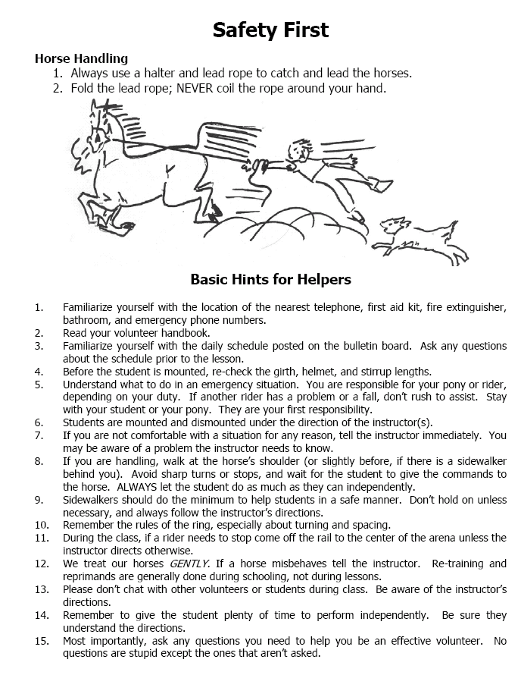
QUIZ 3: SAFETY

NAME: __________________________________________________

DIRECTIONS: For questions 1 to 7, choose the correct word from the
WORD BANK and write it on the line.

WORD BANK
Softly Boots Behind Slowly Run Gently Helmet

1) I should avoid walking or standing ________________ any horse.
2) It is important to speak ____________ when I am near any horse.
3) When I am on the horse, I need to wear a ___________ to protect
my head.
4) When I am in the riding ring, I should never _______________ unless given permission by the instructor.
5) It is important to protect my feet when I am in the ring. The best things to wear on my feet are ________________.
6) When I approach any horse, I need to walk _________________.
7) When I touch the horse, I need to do it _______________.

DIRECTIONS: For questions 1-6, choose the best answer to each question and circle it.

1) When I approach any horse, I need to walk _______________.
a) Slowly b) Quickly
2) When I am in the ring, I never _____________________.
a) Talk b) Yell
3) When I touch my horse, I pat his shoulder _____________.
a) Gently b) Roughly
4) When I come riding, I need to wear ___________ to protect my feet.
a) Sneakers or Boots b) Slippers or Sandals
5) When I am riding my horse, I need to wear a _________ to protect my head
a) Scarf b) Helmet
6) When I am around any horse, I should avoid walking or standing
____________ the horse.
a) Behind b) Near

LESSON PLAN: RECOGNIZING HORSE MOODS

PURPOSE OF LESSON
To explain how horses and people express themselves. We want riders to be able to understand how the horses are feeling based on certain signs the horses are giving. We also want the riders to understand how people communicate how they are feeling by using body language.

EXPLANATION OF HORSES BODY LANGUAGE
- horses can’t talk, they communicate through body language
- horses rely a great deal on the use of their tail, ears, eyes, and body position to express how they feel:

EARS/EYES: The horse’s ears and eyes are very expressive and the position and movement of the horse’s ears tell a lot about what they are feeling:
- Relaxed-Ears following sounds/face relaxed
- Annoyed/upset-Ears pinned back, whites of eyes showing
- Alert/watchful- Ears pricked forward/Eyes bright
- Bored/tired-Ears drooping

TAIL: The horse’s tail also shows how the horse is feeling:
- Tail pressed against his buttocks, he might be nervous or afraid of something
- When the tail is relaxed and swinging from side to side, the horse is probably relaxes and happy each student is expressing

QUIZ 4: RECOGNIZING HORSE MOODS

NAME: __________________________________________________

DIRECTIONS: For questions 1-5, decide if the statement is TRUE or
FALSE. Circle the best answer.

1) The horse’s ears are turned back but relaxed. He is probably listening to
the rider.
a) True b) False
2) The horse’s ears are droopy. He is probably scared of something.
a) True b) False
3) Since horse’s can’t talk, they communicate through body language.
a) True b) False
4) If the horse’s tail is pressed against his rump, he is happy and ready to
work.
a) True b) False
5) Which body parts do horses use to help them express how they are feeling?
Circle all the items that apply. a) Ears b) Eyes c) Tail
LESSON PLAN: GROOMING THE HORSE

PURPOSE OF LESSON
The purpose of this lesson is to teach the rider the importance of keeping the horses clean and the proper way to use the grooming tools.

TOOLS FOR GROOMING YOUR HORSE
- A CURRY COMB is used to loosen caked mud and dirt from the horse. The curry comb is also used to clean dirt from the body brush. Move the curry comb in circles around the horse’s neck, back, rump, stomach and under his stomach where the girth goes to loosen dirt and hair
- A BODY BRUSH is used to remove loose hair and dirt from your horses’s coat. Use the body brush in a sweeping motion to remove hair and dirt loosened with the curry comb
- A HOOF PICK is used to clean dirt from the horse’s hooves. Use the pointy end of the hoof pick to gently loosen dirt stuck in the horse’s hooves. You will use the brush end to remove the excess dirt you cleaned out with the pick.

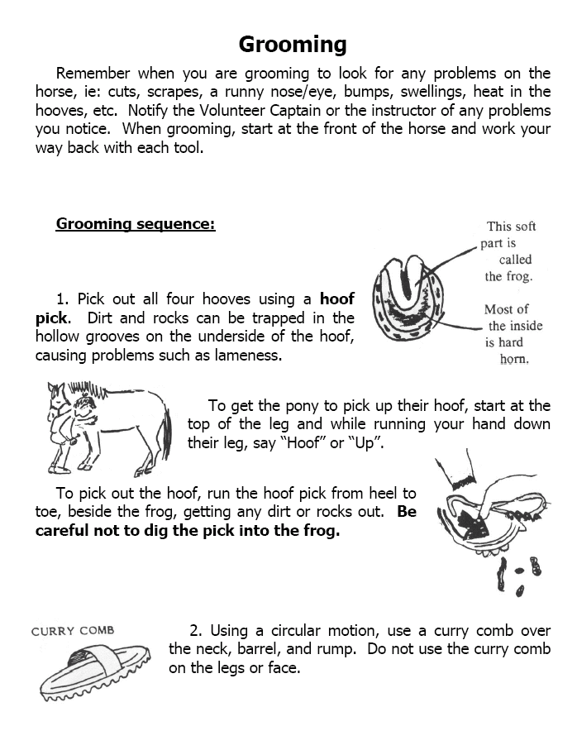
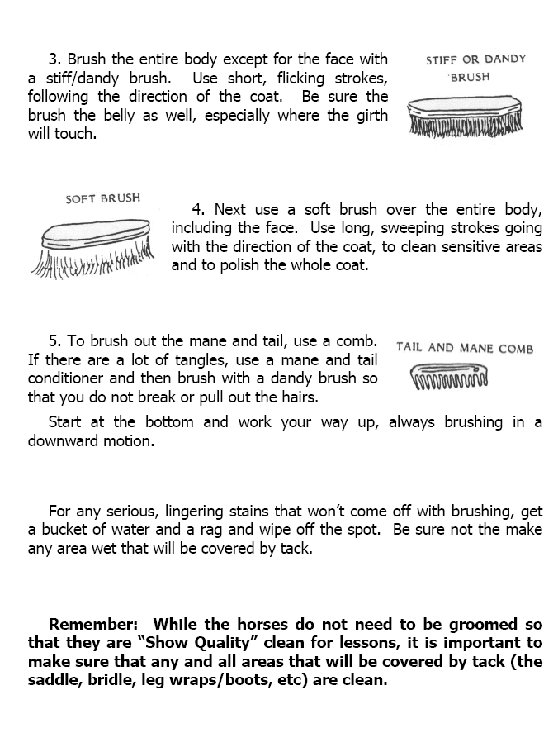
QUIZ 5: GROOMING THE HORSE

NAME: ____________________________________________________

DIRECTIONS: For questions 1 - 8, read each statement and decide if the statement is TRUE or FALSE. Circle your answer.

1) I use the body brush to clean hair and dirt off of the horse.
a) True b) False
2) I use the hoof pick to clean out dirt that is stuck in the horse’s hooves.
a) True b) False
3) The brush on the end of the hoof pick is used to brush dirt off the horse’s neck.
a) True b) False
4) When I am using the curry comb, I need to move it in a circular motion on the horse’s neck and back to loosen dirt and hair.
a) True b) False
5) I only have to groom my horse once a month.
a) True b) False
6) When cleaning the horse’s hooves, it is ok for me to sit on the floor.
a) True b) False

7) It is important to brush the horse carefully on his back where the saddle goes so that the horse does not develop sores.
a) True b) False
8) When brushing the horse’s rump, I should never stand behind the horse.
a) True b) False

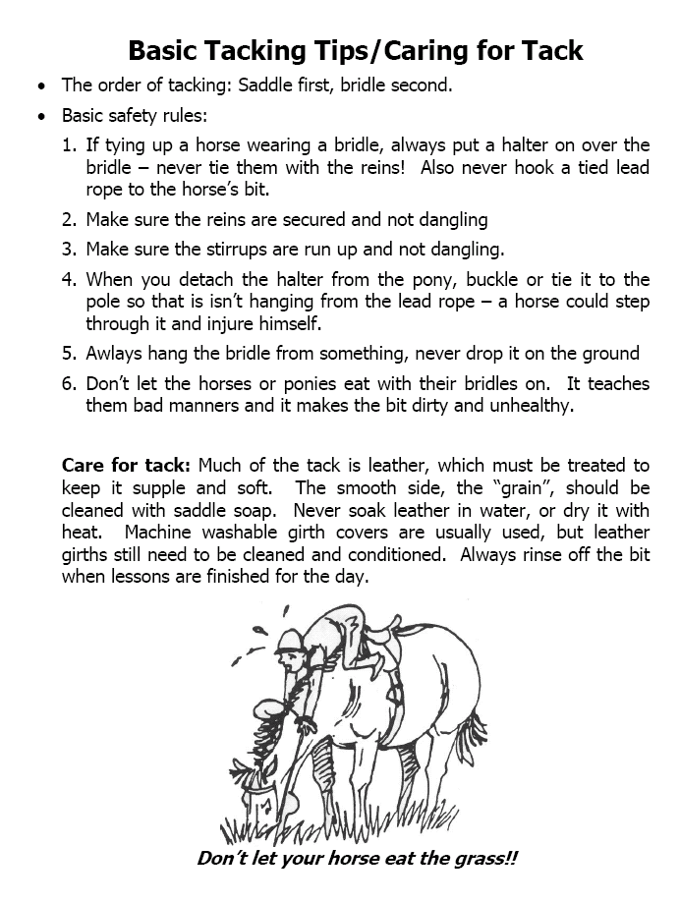
LESSON PLAN: TACKING UP—PUTTING ON AN ENGLISH SADDLE

PURPOSE OF LESSON
This lesson focuses on following specific steps to put on the saddle so that the rider and the horse are safe and comfortable.

STEPS TO PUTTING ON AN ENGLISH SADDLE
Groom the horse/pony to remove all dirt before tacking your horse. The saddle blanket (pad) protects the horse’s back and absorbs the horses sweat. The saddle is placed on the saddle blanket (pad). You sit on the saddle. You put your foot in the stirrup. The stirrup holds your foot in place and is attached to the saddle. Both stirrups should be adjusted before riding to make sure they are the right length. The saddle is attached to the horse with the girth strap. The girth strap attaches to the billet. Before riding the horse, make sure to tighten the girth strap to keep the saddle from slipping. The front of the saddle is called the pommel and the back of the saddle is called a cantle.

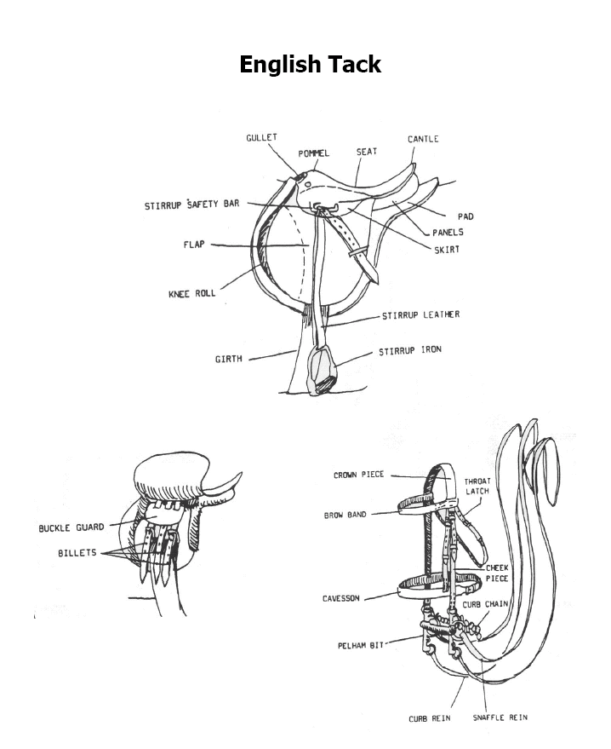
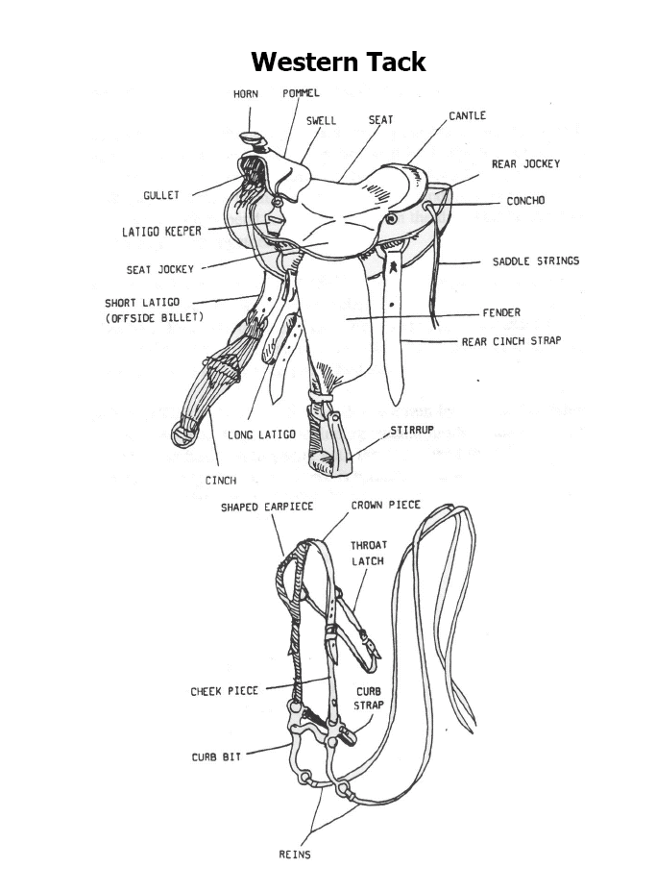
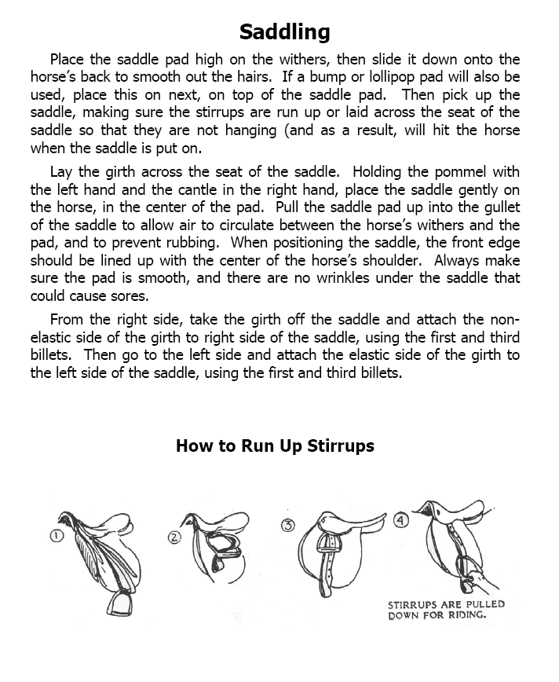
QUIZ 6: TACKING

NAME: _______________________________________________________

DIRECTIONS: For questions 1 to 4, choose the correct word from the
WORD BANK and write it on the line.

WORD BANK
Brush Saddle Stirrup Iron Saddle Pad

1) You sit on this when you are on the horse. This is called a __________.
2) You use this tool to clean the horse before you put the saddle on the horse. This is called a _________.
3) You put this on the horse before you put the saddle on. It helps keep the horse comfortable. This is called a _______________.
4) You put your foot in this when you are sitting on your horse. This is called a __________.

DIRECTIONS: For questions 1-7, decide whether the statement is TRUE or
FALSE and circle the correct answer

1) A saddle pad is another name for a saddle blanket.
a) True b) False
2) A saddle pad absorbs the horse’s sweat and protects the horse.
a) True b) False
3) The girth strap is attached to the billet.
a) True b) False
4) When tacking up your horse, you always put the saddle on the horse
before putting on the saddle blanket (pad).
a) True b) False
5) The girth strap holds the saddle on the horse.
a) True b) False
6) You only need to groom your horse once a month.
a) True b) False
7) The pommel is the front of the saddle.
a) True b) False

LESSON PLAN - BRIDLING

PURPOSE OF LESSON
The purpose of this lesson is to teach each student how to put a bridle on a horse so that he/she and the horse are both safe.

NEAR SIDE (LEFT SIDE)/ OFF SIDE (RIGHT SIDE)
• You put on the bridle while standing on the horse’s near side
• You mount your horse from the near side
• You dismount from your horse on the near side
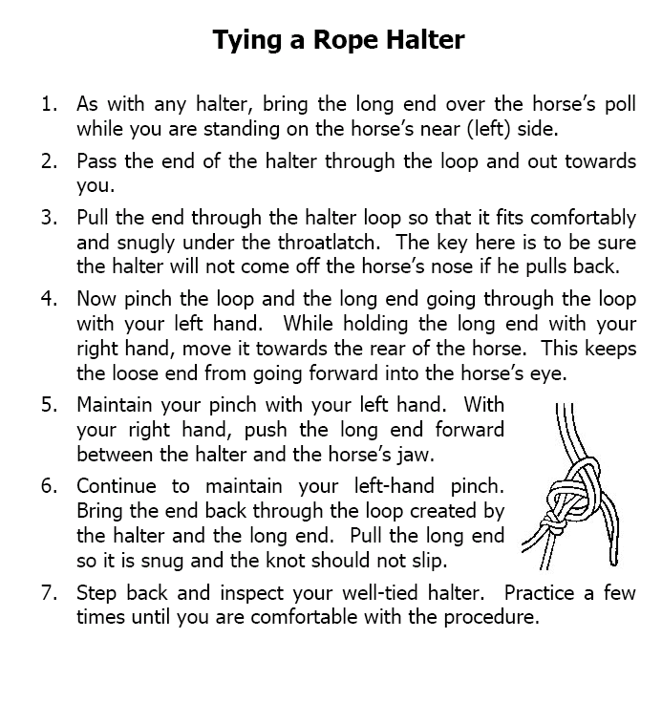
• When you lead the horse you stand on the near side

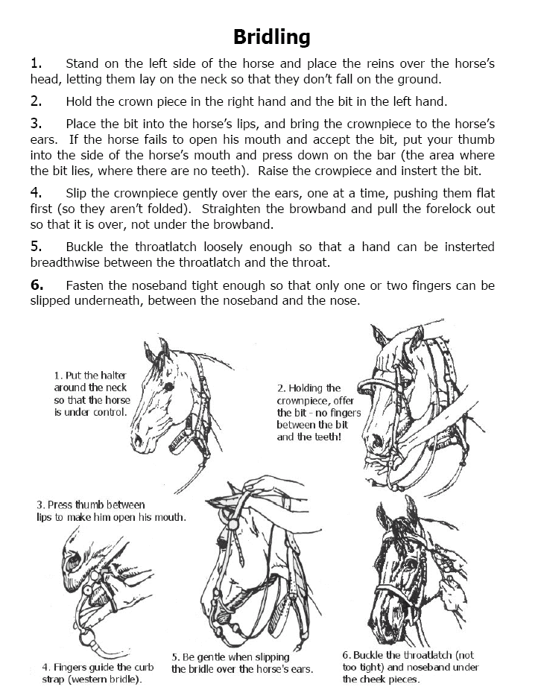

QUIZ 7: BASICS ABOUT BRIDLING

NAME: _______________________________________________________

DIRECTIONS: For questions 1-7, decide whether the statement TRUE or
FALSE and circle the correct answer

1) You should stand on the off side/right side to put on a horse’s bridle.
a) True b) False
2) The bit is placed between the horse’s lips.
a) True b) False
3) The brow band is pulled over the horse’s ears.
a) True b) False
4) Make sure the throat latch is snug on the horse’s throat when latched. You should not be able to get any fingers between the throat latch and the horse’s neck.
a) True b) False
5 The reins attach to the cheek pieces of the bridle
a) True b) False
6) You may need to reach into the horse’s mouth and push down on the bars to open the horses mouth to put the bit in place.
a) True b) False
7) The forelock should remain under the browband to prevent it from flying around when riding.
a) True b) False

LESSON PLAN: STABLE CARE

PURPOSE OF LESSON
The purpose of this lesson is to teach each student the importance of keeping
the stable and the stall clean and safe

STABLE CARE
FOLLOW THESE STEPS TO KEEP THE HORSE’S STALL AND
THE STABLE CLEAN:
1) Have someone help you remove the horse from the stall and secure him nearby.
2) Use a mucking fork or a shovel to remove manure from the stall.
3) Use the pitchfork to separate the clean straw from the dirty straw or shavings. Keep the tines pointed toward the floor at all times.
4) Put the manure and dirty straw into a wheelbarrow or a muck tub.
5) Use the mucking fork to put clean straw in the horse’s stall.
6) Sweep the floor outside each of the stalls.

Don’t forget to clean your tools and put them away in the proper
place when you are finished cleaning out the stall.

QUIZ 8: STABLE CARE

NAME: _______________________________________________________

DIRECTIONS: For questions 1-5, choose the best answer to each question and circle your answer. For questions 6-7, decide if the statement is TRUE or
FALSE and circle the best answer.

1) After removing the horse from his stall, what is the first step you should take when cleaning out his stall?
a) Sort through the straw or shavings with a pitch fork and separate the clean straw or shavings from the dirty ones.
b) Pick up the manure with a shovel or mucking fork and put it in the wheelbarrow.
c) Put down clean hay.
2) Circle all the tools that are used to clean out the horse’s stall.
a) Shovel
b) Pitch fork
c) Wheelbarrow
d) Hoof Pick
3) How often should you clean out the horse’s stall and put down new straw or shavings?
a) Once a week
b) Once a day
c) Never
4) How often should you give the horse clean water?
a) Once a day
b) Once a week
c) Never
5) When you are finished cleaning out the stall, what do you do with the tools?
a) Leave them in the stall
b) Clean them and return them to the tack room
c) Leave them in the hall outside the horse’s stall
6) When working with a pitch fork it is important to keep the pointed end
(tines) pointing down toward the floor at all times.
a) True b) False

LESSON PLAN: FEEDING THE HORSE

PURPOSE OF LESSON
The purpose of this lesson is to teach the rider the importance of proper nutrition for the horses..

WHAT DO HORSES EAT?
- BEET PELLETS must be soaked in water before feeding them to your horse. Once they are soaked in water, they are called BEET PULP.
- BEET PULP looks like oatmeal after it is soaked in water. Beet Pulp is important for horses because it fills them up, gives them energy and water.
- PELLETS can be made of different grains like oats, corn or hay and contain fiber, vitamins and minerals.
- Horses are fed HAY two times a day.
- WATER is very important for the horses. There is fresh water for them in their stalls.

QUIZ 9: WHAT DO HORSES EAT?

NAME: ______________________________________________________

DIRECTIONS: For questions 1 to 8, circle the best answer to complete the question.

1) _________ need to be soaked in water before you feed them to your horse.
a) Hay b) Beet Pellets
2) Why is it important to store the food for the horses in bins?
a) The food stays dry b) The food won’t get stolen
3) Beet Pulp looks like ______________ after it is soaked in water.
a) Applesauce b) Oatmeal
4) Pellets can be made of different foods including ___________________,
_________________ and ___________________.
a) Oats, Corn and Hay b) Carrots, Apples and Pears
5) How much you feed your horse depends on what things? Circle all the correct items.
a) What color he is
b) How hard he works
c) How old he is
d) How big he is

6) A horse is a ________________.
a) Herbivore b) Carnivore
7) A herbivore only eats _______________.
a) Meat b) Plants
8) ______________ should always be available in the horse’s stall.
a) Water b) Apples

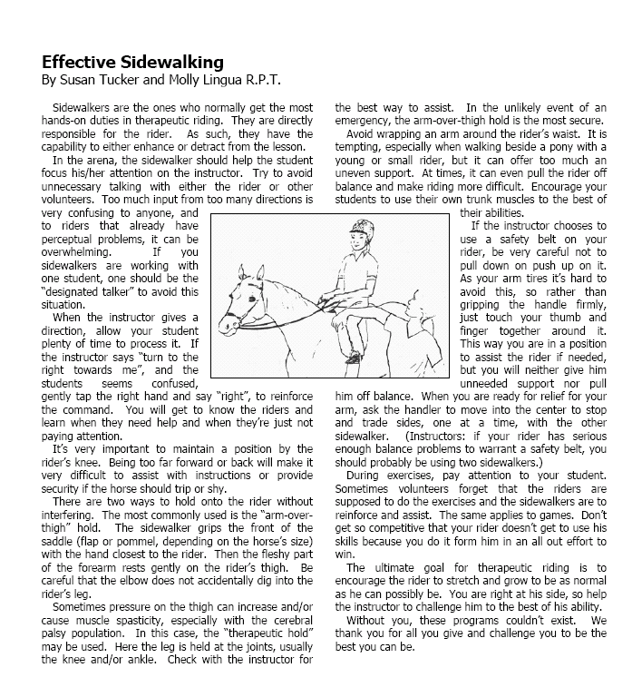

QUIZ10: SIDEWALKING

NAME: ________________________________________________________
DIRECTIONS: For questions 1-7, decide whether the statement is TRUE or
FALSE. Circle the correct answer. For question 8, choose the best answer and
circle it

1) When the rider is mounting his/her horse, the sidewalker needs to be standing on the off side of the horse to make sure the rider puts his/her foot in the stirrup.
a) True b) False
2) The sidewalker should watch the rider at all times to make sure he/she is safe.
a) True b) False
3) The sidewalker is allowed to leave the rider alone on the horse.
a) True b) False
4) The sidewalker needs to be sure the rider’s foot is out of the stirrup before the rider dismounts.
a) True b) False
5) The sidewalker needs to let the leader or instructor know if he/she is concerned about his/her safety or the safety of the rider.
a) True b) False
6) It is important to let the rider try to complete each task on his/her own
before offering any help.
a) True b) False
7) The sidewalker should make sure that the rider is always holding the reins or
the strap.
a) True b) False
8) If you need to tie your shoe while you are sidewalking, what should you do?
a) Just stop where you are and tie your shoe
b) Tell the instructor or the person leading the horse that you need to stop for a minute to tie your shoe so that someone else can take your place as the sidewalker

LESSON PLAN: LEADING THE HORSE

PURPOSE OF LESSON
This lesson is going to help us to determine if the rider have the basic skills needed to lead the horses. They will need to understand and follow safety regulations, listen to directions given by the instructor and be able to work as part of a team.

SAFETY TIPS FOR LEADING THE HORSE

IMPORTANT SAFETY TIPS
- Never loop the excess lead rope around your hand, arm or any
other part of your body
- The horse should always walk next to you not in front or behind you
- Protect your fingers. Keep them away from the horse’s mouth
- When turning the horse, make wide turns so that the sidewalker has room to walk
- Keep a safe distance from the horse in front of you

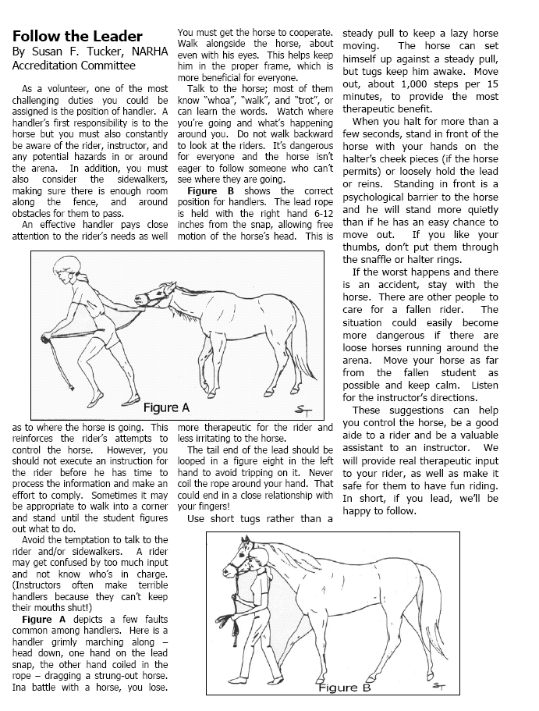
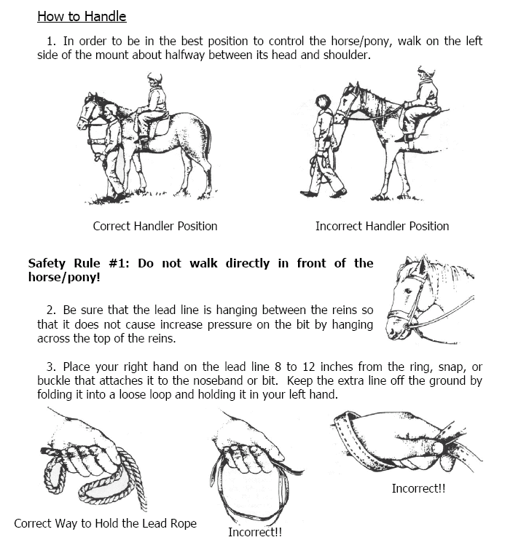
QUIZ 11: LEADING THE HORSE

NAME: ___________________________________________________

DIRECTIONS: For questions 1-7, decide if the statement is TRUE or
FALSE. Circle the best answer.

1) When leading the horse it is important to look up and straight ahead.
a) True b) False
2) When either the rider or the instructor says WHOA, the leader of the horse
needs to walk faster.
a) True b) False
3) When leading the horse, it is important to keep a safe distance from the
horse in front of you.
a) True b) False
4) When asked to WALK ON by the student or the instructor, the leader will
prompt the horse to stop.
a) True b) False
5) The leader will follow all directions given by the instructor during group
lessons.
a) True b) False
6) When leading the horse, it is important to pay attention to the sidewalkers
and give them space to walk.
a) True b) False
7) Never loop the lead rope around any part of your body.
a) True b) False

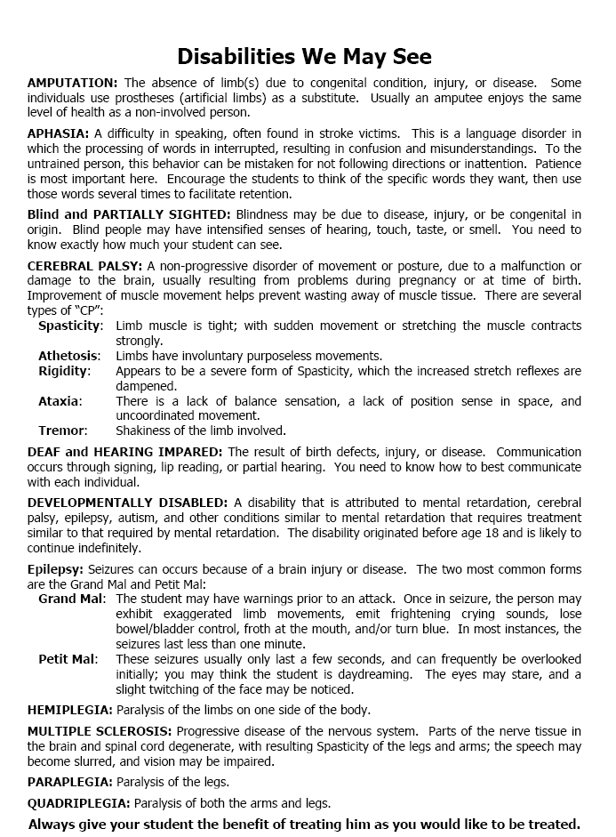
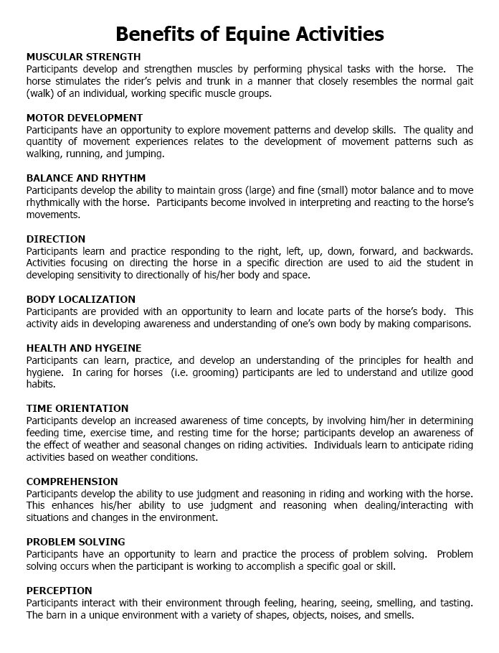
EQUINE ACTIVITY LIABILITY RELEASE, WAIVER OF RIGHT TO SUE
AND ASSUMPTION OF ALL RISKS
Under Virginia law, an equine activity sponsor or equine professional is not liable for an injury to or the death of a participant in equine activities resulting exclusively from the inherent risks of equine activities.

CODE OF VIRGINIA TITLE 3.2. AGRICULTURE, ANIMAL CARE, AND FOOD. SUBTITLE V. DOMESTIC ANIMALS. CHAPTER 62. EQUINE ACTIVITY LIABILITY. VA. Code Ann. § 3.2-6200 – 6302 (2008).

1. I, _______________________________________, the undersigned have read and understand, and freely and voluntarily enter into this Release and Hold Harmless Agreement with Brandywine Valley Consultants, Inc. d.b.a. Making Strides, Making Strides Therapeutic Services/Making Strides of Virginia, including its owners (Paul and Robin Langerhans), their family, agents, equine professionals, sponsors, employees, and/or staff, Suits-Us Farm, LLC and property owners whose properties are adjacent to 7600 and 7726 Applewhite Lane, Chesterfield VA 23838 understanding that this Release and Hold Harmless Agreement is a waiver of any and all liability(ies). I do so on behalf of myself or my minor child: _________________________________________________________________, as applicable.

2. I have read and fully understand the “WARNING” posted above.

3. I understand the potential dangers that I or my minor child could incur in mounting, riding, driving, walking, boarding, feeding horses; including, but not limited to, any interactions with other horses. Understanding those risks I hereby release Brandywine Valley Consultants, Inc. d.b.a. Making Strides, Making Strides Therapeutic Services/Making Strides of Virginia, it’s owners, family, employees and anyone else directly or indirectly connected with that Business from any liability whatsoever in the event of injury or damage of any nature (or perhaps even death) to me, my minor child or anyone else caused by or incidental to my electing to mount and ride a horse owned or operated by Brandywine Valley Consultants, Inc. d.b.a. Making Strides, Making Strides Therapeutic Services/Making Strides of Virginia, I have read and been given a copy of the EQUINE ACTIVITY LIABILITY ACT, VA. Code Ann. § 3.2-6200 – 6302 (2008).

4. I understand and recognize and warrant that this Release and Hold Harmless Agreement is being voluntarily and intentionally signed and agreed to, and that in signing this Release and Hold Harmless Agreement I know and understand that this Release and Hold Harmless Agreement may further limit the liability of equine professionals
beyond that statutorily provided by the above referenced EALA; to include any activity, whatsoever, involving an equine, including death, personal injury and/or damage to property.

5. I also freely and voluntarily enter into the following Mediation and Arbitration Agreement concerning any equine activity incidents relating to or allegedly involving with Brandywine Valley Consultants, Inc. d.b.a. Making Strides, Making Strides Therapeutic Services/Making Strides of Virginia, including its owners, Paul and Robin Langerhans.

Mediation with Arbitration if Necessary:
The parties shall endeavor to resolve any dispute arising out of or relating to this AGREEMENT by mediation under the then current Mediation Rules and Procedures of the Equine Dispute Resolution Service (EDRS). The parties agree to select a Mediator from the EDRS Panel of Mediators. Any controversy or claim relating to this contract or
breach, termination or validity thereof, which remains unresolved for 45 days after the appointment of the EDRS Mediator, shall be settled by arbitration by an EDRS appointed Arbitrator in accordance with the then current EDRS Arbitration Rules and Procedures, and judgment upon the award rendered by the EDRS Arbitrator may be entered
by any court having jurisdiction thereof.

NOTICE: Wearing an ASTM/SEI approved hard hat is REQUIRED while riding or driving.

Person voluntarily entering into this Release and Hold Harmless Agreement: If minor, signature should be person
representing himself/herself to the lawful Guardian under this Release and Hold Harmless Agreement:

Printed Name of Rider:
Signature:
Date:
(or Guardian Signature if rider is under 18)

Printed Name of Guardian:
Printed name of Witness:
Witness Signature:
Date:

CODE OF VIRGINIA
TITLE 3.2. AGRICULTURE, ANIMAL CARE, AND FOOD. SUBTITLE V. DOMESTIC ANIMALS.
CHAPTER 62. EQUINE ACTIVITY LIABILITY
VA. Code Ann. § 3.2-6200 – 6302 (2008)

§ 3.2-6200. Definitions

As used in this chapter, unless the context requires a different meaning:

"Engages in an equine activity" means: (i) any person, whether mounted or unmounted, who rides, handles, trains, drives, assists in providing medical or therapeutic treatment of, or is a passenger upon an equine; (ii) any person who
participates in an equine activity but does not necessarily ride, handle, train, drive, or ride as a passenger upon an equine; (iii) any person visiting, touring or utilizing an equine facility as part of an event or activity; or (iv) any person who assists a participant or equine activity sponsor or management in an equine activity. The term "engages in an equine activity" does not include being a spectator at an equine activity, except in cases where the spectator places himself in an unauthorized area and in immediate proximity to an equine or equine activity.

"Equine" means a horse, pony, mule, donkey, or hinny.

"Equine activity" means: (i) equine shows, fairs, competitions, performances, or parades that involve any or all breeds of equines and any of the equine disciplines, including dressage, hunter and jumper horse shows, grand prix jumping, three-day events, combined training, rodeos, driving, pulling, cutting, polo, steeple chasing, endurance trail riding and western games, and hunting; (ii) equine training or teaching activities; (iii) boarding equines; (iv) riding, inspecting, or evaluating an equine belonging to another whether or not the owner has received some monetary
consideration or other thing of value for the use of the equine or is permitting a prospective purchaser of the equine to ride, inspect, or evaluate the equine; (v) rides, trips, hunts, or other equine activities of any type however informal
or impromptu that are sponsored by an equine activity sponsor; (vi) conducting general hoofcare, including placing or replacing horseshoes or hoof trimming of an equine; and (vii) providing or assisting in breeding or therapeutic veterinary treatment.

"Equine activity sponsor" means any person or his agent who, for profit or not for profit, sponsors, organizes, or provides the facilities for an equine activity, including pony clubs, 4-H clubs, hunt clubs, riding clubs, school-and
college-sponsored classes and programs, therapeutic riding programs, and operators, instructors, and promoters of equine facilities, including stables, clubhouses, ponyride strings, fairs, and arenas where the activity is held.

"Equine professional" means a person or his agent engaged for compensation in: (i) instructing a participant or renting to a participant an equine for the purpose of riding, driving, or being a passenger upon an equine; or (ii) renting equipment or tack to a participant.

"Intrinsic dangers of equine activities" means those dangers or conditions that are an integral part of equine activities, including: (i) the propensity of equines to behave in ways that may result in injury, harm, or death to persons on or around them; (ii) the unpredictability of an equine's reaction to such things as sounds, sudden movement, and unfamiliar objects, persons, or other animals; (iii) certain hazards such as surface and subsurface conditions; (iv) collisions with other animals or objects; and (v) the potential of a participant acting in a negligent
manner that may contribute to injury to the participant or others, such as failing to maintain control over the equine or not acting within the participant's ability.

"Participant" means any person, whether amateur or professional, who engages in an equine activity, whether or not
a fee is paid to participate in the equine activity.

§ 3.2-6201. Horse racing excluded
The provisions of this chapter shall not apply to horse racing, as that term is defined by § 59.1-365.

§ 3.2-6202. Liability limited; liability actions prohibited

A. Except as provided in § 3.2-6203, an equine activity sponsor, an equine professional, or any other person, which
shall include a corporation, partnership, or limited liability company, shall not be liable for an injury to or death of a
participant resulting from the intrinsic dangers of equine activities and, except as provided in § 3.2-6203, no
participant nor any participant's parent, guardian, or representative shall have or make any claim against or recover
from any equine activity sponsor, equine professional, or any other person for injury, loss, damage, or death of the
participant resulting from any of the intrinsic dangers of equine activities.

B. Except as provided in § 3.2-6203, no participant or parent or guardian of a participant who has knowingly
executed a waiver of his rights to sue or agrees to assume all risks specifically enumerated under this subsection may
maintain an action against or recover from an equine activity sponsor or an equine professional for an injury to or
the death of a participant engaged in an equine activity. The waiver shall give notice to the participant of the
intrinsic dangers of equine activities. The waiver shall remain valid unless expressly revoked in writing by the
participant or parent or guardian of a minor.

§ 3.2-6203. Liability of equine activity sponsors, equine professionals

No provision of this chapter shall prevent or limit the liability of an equine activity sponsor or equine professional or
any other person who:

1. Intentionally injures the participant;

2. Commits an act or omission that constitutes negligence for the safety of the participant and such act or omission
caused the injury, unless such participant, parent or guardian has expressly assumed the risk causing the injury in
accordance with subsection B of § 3.2-6202; or

3. Knowingly provides faulty equipment or tack and such equipment or tack was faulty to the extent that it did cause
the injury or death of the participant.

Acts 2008, c. 860, eff. Oct. 1, 2008.

Derivation: Acts 1994, c. 404; § 3.1-796.136.

ANSWER KEY
QUIZ 1
- b 2) b 3) a 4) a 5) a 6) a 7) b 8) a

- a 2) b 3) a 4) b

QUIZ 2
- a 2) b 3) a 4) a 5) b 6) a 7) b 8) b

QUIZ 3
- Behind
- Softly
- Helmet
- Run
- Boots
- Slowly
- Gently

- a 2) b 3) a 4) a 5) b 6) a

QUIZ 4
- a 2) b 3) a 4) b 5) a,b,c

QUIZ 5
- a 2) a 3) b 4) a 5) b 6) b 7) a 8) a

QUIZ 6
- Saddle
- Brush
- Saddle Pad
- Stirrup Iron

- b 2) a 3) a 4) b 5) a 6) b 7) a

QUIZ 7
- b 2) a 3) a 4) b 5) b 6) a 7) b

QUIZ 8
- b 2) a,b,c 3) b 4) a 5) b 6) a

QUIZ 9
- b 2) a 3) b 4) a 5) b,c,d 6) a 7) b 8) a

QUIZ 10
- a 2) a 3) b 4) a 5) a 6) a 7) a 8) b

QUIZ 11
- a 2) b 3) a 4) b 5) a 6) a 7) a

PLEASE RETURN THIS PAGE ONLY, KEEP THE OTHERS FOR YOUR RECORDS

Horse Competency Acknowledgement

By signing this document, I acknowledge that I have read, understand, and agree to the above Horse Competency provided to me by Making Strides of Virginia.

____________________________________________ _________
Signature Date

