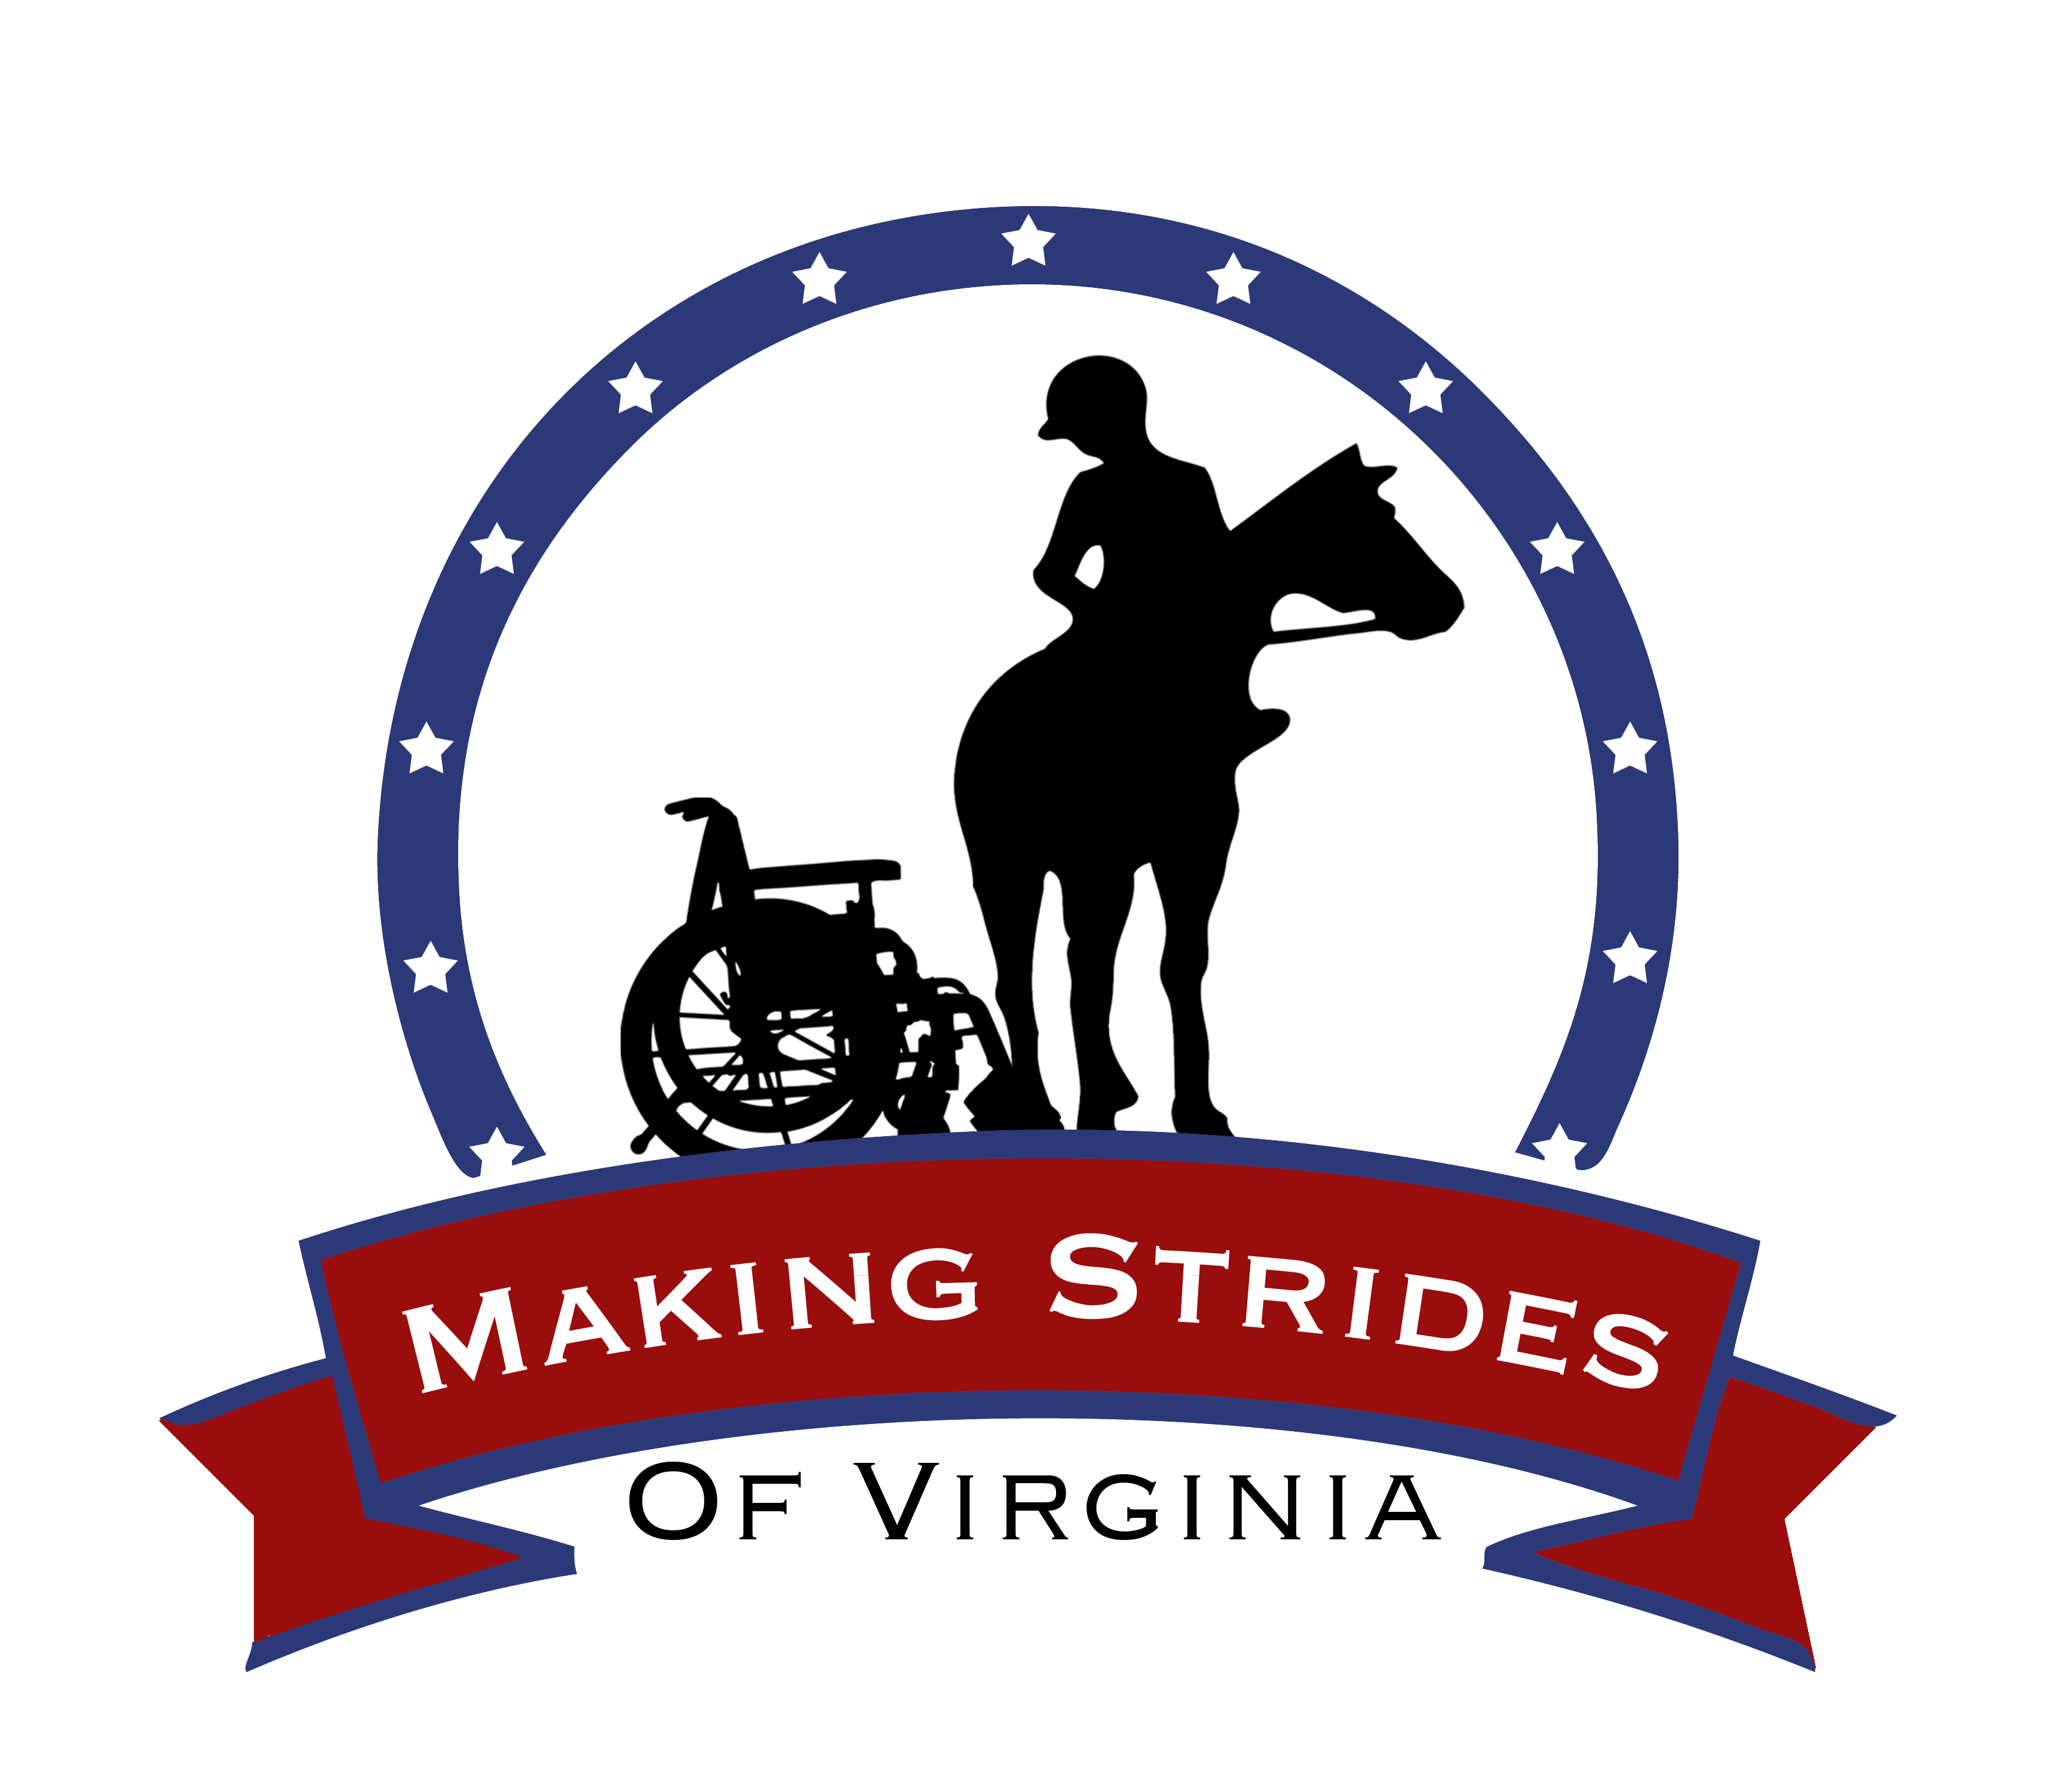

PLEASE RETURN THIS PAGE ONLY, KEEP THE OTHERS FOR YOUR RECORDS

Volunteer Handbook Acknowledgement

By signing this document, I acknowledge that I have read, understand, and agree to the above Volunteer Handbook provided to me by Making Strides of Virginia.

____________________________________________ _________
Signature _______________________________ Date __________

