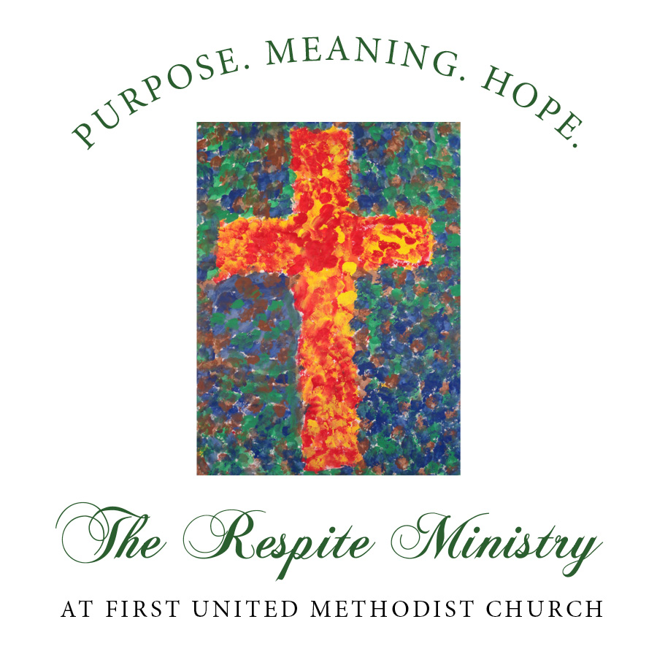

2416 W. Cloverdale Park | Montgomery, AL 36106 | 334.834.8990 | fumcmontgomery.org/respite

**Community Partners**

**Christ Church XP**

Montgomery, Alabama

**Church of the Ascension**

Montgomery, Alabama

**First Baptist Church**

Montgomery, Alabama

**First United Methodist Church**

Montgomery, Alabama

**St. John’s Episcopal Church**

Montgomery, Alabama

**Temple Beth Or**

Montgomery, Alabama

**Trinity Presbyterian Church**

Montgomery, Alabama

Text here.