2010 Camaro 2SS/RS
Motor: L99 (LS3)
LS-Series Gen IV Small-Block V-8 Cast-Aluminum with Six-Bolt, Cross-Bolted Main Caps
376ci (6.2L) 4.065'' x 3.622'', 10.4:1 Compression Ratio, Internal Balanced
Nodular Iron Crankshaft, Nodular Iron Connecting Rods, Hypereutectic Aluminum Pistons
Hydraulic Roller Camshaft, .500'' Intake / .492'' Exhaust Lift, 195° Intake / 201° Duration @.050 in
Aluminum Heads L92-Style Port; ''as cast'' w/ 68cc Chambers, 2.165'' Intake / 1.590'' Exhaust Valve Size
Investment-Cast, Roller Trunnion Rocker Arms, 1.7:1 Ratio
Transmission:
Hydra-Matic 6L80 6 Speed Automatic w/Sport Mode & Manual Paddle Shift
Supercharger: (2010 Camaro SS Stage II Intercooled System)
Procharger D-1SC 8 Rib Satin Supercharger, 3 Core 825HP Intercooler, Proflow Surge System
Procharger 4.63” & 4.38 Upper Pulley, 7.65” Crank Pulley w/ Crank Balancer Pin Drill Kit
Procharger PCV System, Air Inlet System, Drain Kit
Suspension:
FE-3 Performance Fully Independent Front & Rear Suspension
Rack & Pinion Steering, Coil Over Front & Rear Shocks
StabiliTrak, Traction Control, Anti-Lock Active Braking

Wheels/Tires
20x8 Front, 20x9 Rear Polished Aluminum Wheels
245/45R20 Front Sumitomo 103W M+S, 275/40ZR20 Rear Pirelli P Zero Tires
Rear:
Limited Slip IRS w/ 3.27 Final Gear Ratio, 30 mm Left Halfshaft, 40 mm Right Halfshaft
Exhaust:
Stainless Works Headers w/ 4" Stainless Exhaust (no cats).
Brakes:
Front Brembo 355 mm x 32 mm Vented Rotors w/ Four-Piston Aluminum Calipers
Rear Brembo 365 mm x 28 mm Vented Rotors w/ Four-Piston Aluminum Calipers
Semi-Metallic Brake Linings

Upgrades & Tuning:
Custom Tuned (Direct Flashed to ECM) by Redline Motorsports
Howard Tanner howard@redline-motorsports.net
http://www.redline-motorsports.net/

Custom Heat Extractor Hood, Custom Body Kit
Heated Power Leather Seats, Heated Power Auto Dim Mirrors, Power Windows & Door Locks,
Air Conditioning, Boston Acoustic Premium 9 Speaker Audio System, Cruise, Tilt & Telescoping,
Paddle Shift, Traction Control, ABS, Active Braking, 4 Wheel Disc Brakes, Full Gauge Package,
Satellite Radio, Hands Free Phone Connect, Blue Tooth, USB & Charging Ports, On Star, Auto Start,
much more...

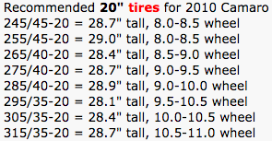
If you widen the front wheels you must use an adapter.
If you widen the rear wheel to 10.75" and use a 305 tire you are good.
If you widen to 10.75" and use a 315 you may have to use a 1/4" spacer.
If you widen to 11" you will need a spacer for 305 or 315 tires.

If you widen to 10.5 you can run a 315 with no spacer or rubbing

Mobile 1 SAE 5W-30

L99 6.2L TECH SPECS
• Engine Type: LS-Series Gen IV Small-Block V-8
• Displacement: 376ci (6.2L)
• Bore x Stroke: 4.065'' x 3.622'' (103.25 x 92mm)
• Block: Cast-aluminum with six-bolt, cross-bolted main caps
• Crankshaft: Nodular iron
• Connecting Rods: Nodular iron
• Pistons: Hypereutectic aluminum
• Camshaft Type: Hydraulic roller
• Valve Lift: .500'' intake / .492'' exhaust
• Camshaft Duration (@.050 in.): 195° intake / 201° exhaust
• Cylinder Heads: Aluminum L92-style port; ''as cast'' with 68cc chambers
• Valve Size: 2.165'' intake / 1.590'' exhaust
• Compression Ratio: 10.4:1
• Rocker Arms: Investment-cast, roller trunnion
• Rocker Arm Ratio: 1.7:1
• Recommended Fuel: 92 octane
• Maximum Recommended rpm: 6600
• Reluctor Wheel: 58X
• Balanced: Internal

Spark Plugs

OEM: AC Delco Iridium Spark Plugs 12621258 (ACDelco-41-110) .040
Red Line: BR7EF (NGK-3346) 0.22 – 0.25
Installed: TR6 (NGK-4177) 0.35

ProCharger 1GT202-SCI 2010 LS3/L99 SS Camaro HO Intercooled Supercharger Tuner Kit
Upgraded w/ D-1SC 8 Rib Satin Supercharger

(A Procharger P-1SC at 7 PSI on a bone stock 2010 Camaro SS 6.2L makes 600+ Flywheel HP)
I have a D-1SC at 9 PSI on a non stock application and it makes 700+ HP

High Output and Stage II supercharger kits available: 575+ HP to over 1000+ HP
When it comes to adding big, reliable power to late-model LS engines, ProCharger simply dominates. With the largest, most reliable power gains on pump gas, ProCharger-powered 2015-10 Camaros dominate both on the street and on the strip. ProCharger was the first to offer a supercharger system for power-hungry 2010 Camaro owners, was the first to add 200+ HP to otherwise stock LS3 Camaros, and was also the first to power a 2010 Camaro SS into the 9’s.
Backed by the strength and support of the industry leader, ProCharger offers you the greatest power potential and most choices for your 2015-10 Camaro SS.

The L99 is derived from the LS3 with reduced output but adds Active Fuel Management (formerly called Displacement on Demand) and variable valve timing, which allows it to run on only four cylinders during light load conditions. Applications: 2010–2015 Chevrolet Camaro SS (Automatic Transmission).
400 HP @ 5900 RPM 420 TQ @ 4600 RPM, 10.4:1 Compression

The 90-degree V-8 includes an aluminum block (with cast iron cylinder liners) and aluminum cylinder heads. The bottom end of the engine includes a new structural cast aluminum oil pan, with an oil capacity of 8.9 quarts (8.5 liters), while the two-valve cylinder head design is based on race-proven airflow dynamics. The intake valves measure 2.16 inches (55 mm) and exhaust valves are 1.60 inches (40.5 mm) in diameter.

The 6.2L engines also use a roller lifter-style camshaft with 5-percent greater intake-side valve lift than the Corvette's LS3. It manages airflow that is channeled through an acoustically tuned intake manifold with a composite design that reduces runner-to-runner variation. The throttle bore diameter is 90 mm.

The highest-capacity automatic ever in a GM passenger car, the Hydra-Matic 6L80 six-speed automatic, is matched with the L99 engine. It includes driver shift control, with the driver taking control via paddle shifts located on the steering wheel after selecting the "M" mode on the console-mounted shifter. It also features driver shift control and PAS. Performance Algorithm Shifting (PAS) lets the electronic transmission controller override the automatic gear selection during high lateral acceleration maneuvers.
The final drive ratio on all automatic-equipped Camaro models is 3.27:1.

All Camaro models include a four-channel StabiliTrak electronic stability control system that incorporates anti-lock braking, traction control and an active braking system to control wheel slip, optimize traction and enhance stability in wet, snow-covered or icy roads.

2010 Chevrolet Camaro
Item# 272678495913
I built this car and hate to sell it but being in New York, I've only put 1500 miles on the last 2 summers so it just sits in the garage. I have about 90000 invested. It also has a body kit and a new hood. The inside is practically brand new. The back seat has never been sat in and nobody has ever smoked in it. Tires are new. I just went from 7lb boost to 9lb and had it tuned while I was in Florida last week. I also had front brakes and rotors done and wires put on.

Pro charger supercharger, headers, stainless steel works 4" exhaust front to back. Only 27000 miles barely broken in. Inside is practically new. Over 700hp. Trades considered
Bought From:
Philip Cote, 27 Maple Drive, Queensbury NY, 12804
honda-78@hotmail.com

2010 Chevrolet Camaro Ss2
VIN#: 2G1FK1EJ8A9141734

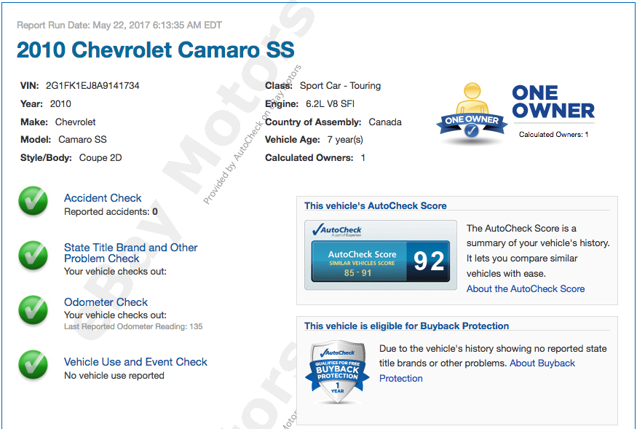
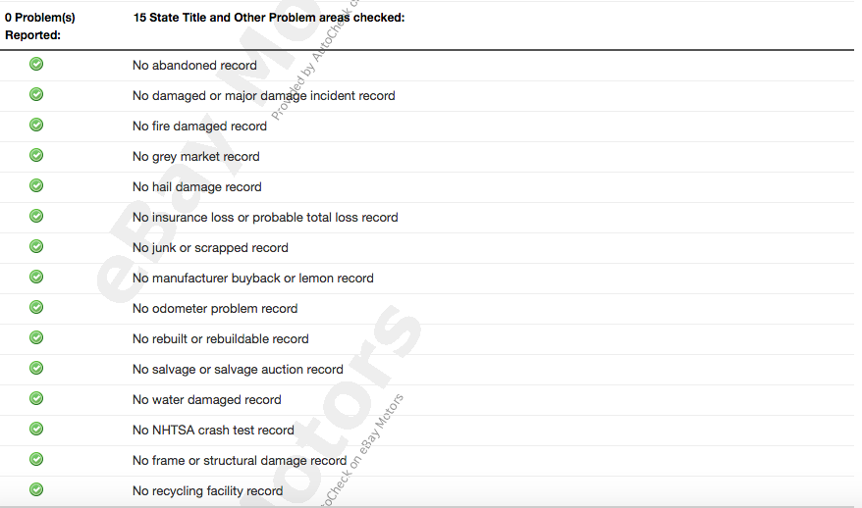
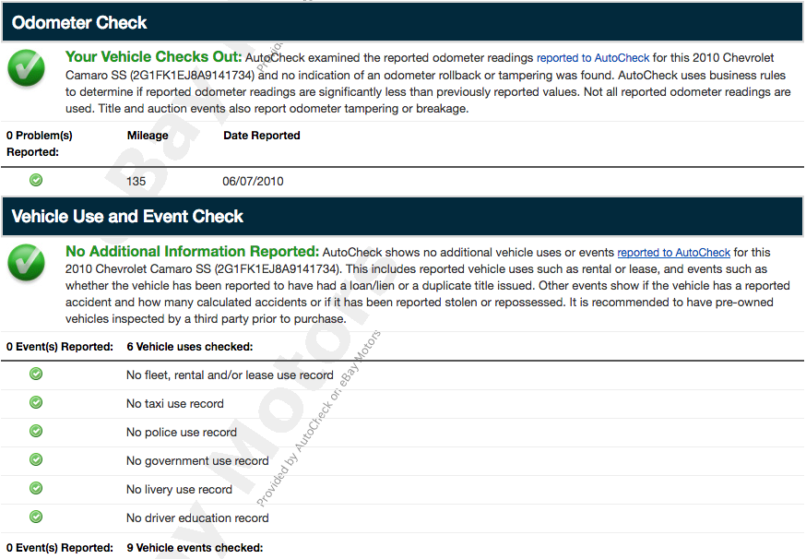
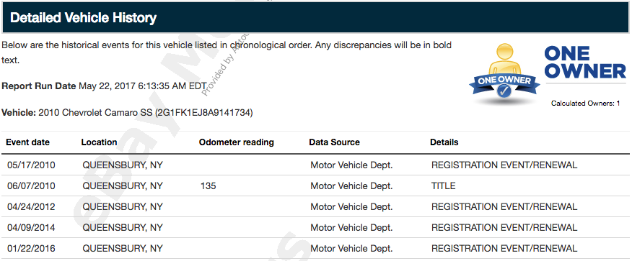

(5) Lightnings
(1) 93 Lightning, 351W Kenne Bell
(1) 99 Lightning 5.4L Kenne Bell 2.6
(1) 00 Lightning 5.4L 2.3 Whipple
(1) 01 Lightning 2.3 Kenne Bell
(1) 02 Lightning 1.7 Magnum Powers
(1) 99 Mustang GT P1SC Procharger
(1) 03 Mustang Terminator 2.8H Kenne Bell
(1) 07 ROUSH NITEMARE Eaton
(1) 90 Sierra 871 Dual Quad
(1) Mustang Mach P1SC Procharger
(1) 10 Camaro 2SS/RS D1SC Procharger
-----
11

Sold 3-9-19
$16,600.00
Jack Johnson
125 Mckinney Hollow Road
Roan Mountain, TN 37687
United States
Buyer:
jacksnapa
Email: jack1086@live.com
Phone number: 423 772 3866

