1991 GMC Syclone
1991 GMC Sonoma
VIN#: 1GDCT14Z8M8801071
The truck has been extensively modified: the fuel system, turbocharger, intercooler, torque converter, transmission, intake, and exhaust, have all been updated to street/strip racing specs

- Unique - one of a kind Johnny Lightning paint scheme
- Less than 100 miles on: GNNW OEM Spec 4.3 Longblock
- Less than 100 miles on: GNNW Fully Built 700R4 Transmission
- 3600 RPM Stall Convertor
- Less than 100 miles on: NOS OEM Front Diff & Axle Assemblies
- RARE Dequick A2A Intercooler
- Upgraded Garrett Turbo A/R .60 M24
- External gate downpipe
- Full Performance Exhaust
- McCoy Motorsports Cold Air Induction
- Hallman Pro Boost Controller with remote, in cab mount
- 50lb injectors
- 48mm twin bore throttle body from a 5.7 L
- Accufab adjustable FPR
- Racetronix Fuel Pump + Hotwire Kit
- MSD 6AL Ignition Box
- Custom Tuning by Jason of GNNW (GN NORTHWEST)
- Battery Box (relocated to bed)
- Remote Cut Off Switch
- R compound tires
- Fiberglass Cowl Hood (original hood goes with truck as well)
- AC delete - Standard Heater Box
- All original cladding
- All Stock Gauges
- Added Gauges (Boost, Fuel Press, A/F, Oil Press, Trans Temp, Motor Temp)

Stock Specs
3526 lbs
280 HP / 350 TQ (was really 330HP but they showed 280HP for Insurance reasons)
0-60 mph in 4.3 seconds
13.6 ¼ mile @ 93 mph
#905 out of 2995 made
Built 3/21/91

Stock Turbo
Mitsubishi TD06-17C 8 cm² Turbocharger

MY Turbo
A/R .60 M24 Garrett

Stock Wheels/Tires
16x8 Wheels
255/45R16 (25.65 x 9.65)
5x120.65 mm / 5 x 4.75
TOYO TQ Drag Radials 275/45R16 (25.74 x 10.83) on Stock Wheels (Polished)
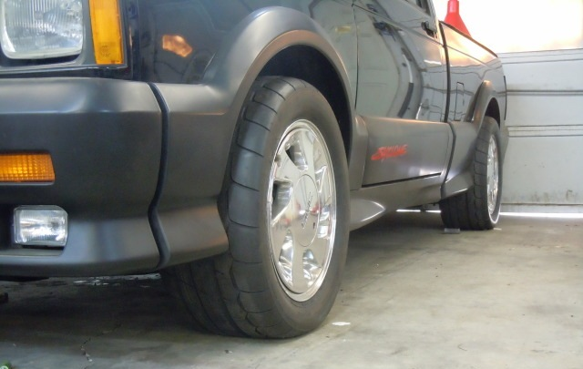
You can also fit these on the Stock Wheels
255/45R16 (25.04 x 10.04)
255/50R16 (26.04 x 10.0)
275/45R16 (25.74 x 10.83)
315/40R16 (25.92 x 12.4)

1990-1995 ZR-1 Corvette Wheels Tires (or 1996 Grand Sport Corvette)
Front
17x9.5 56mm offset
275/40R17 (25.66 x 10.83)
Rear
17x11 50mm offset (or 36mm but they will stick out 9/16”)
315/35R17 (25.68 x 12.4)
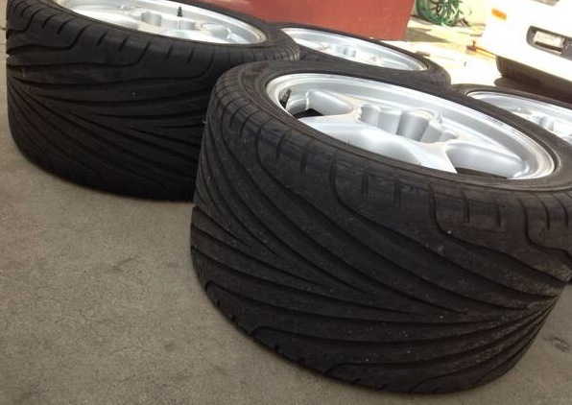
18 x 12.5 CCW Classic’s
345/30R18 (26.15 x 13.58) 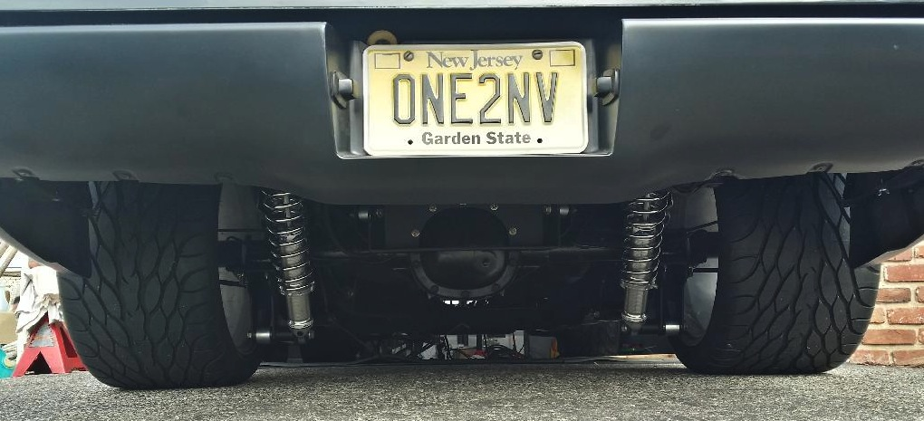
http://gnnorthwest.com/
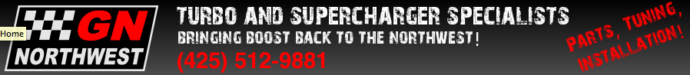
Jason McCartney
425 985-5331
jmac@theroot.org
jasond@theroot.org
My shop (where the truck is)
GN Northwest
9329 Evergreen Way
Everett, WA 98204
425-512-9881
jmac@gnnorthwest.com
My shop manager is Dan Miller - dan@gnnorthwest.com

For sale is my 1991 GMC Syclone. This is a rare, AWD factory turbocharged version of the S10 pickup truck that was made in limited quantities in 1991. The truck itself is very clean with 86K original miles - all OEM body panels and cladding - never wrecked with a clean original interior. Syclones came with a black paint scheme - this truck has been repainted a very cool deep red color to stand out from the pack and match a famous Syclone die cast toy car by Johnny Lightning. At 86K miles, the truck itself was in good shape, but certain parts were showing signs of getting tired, so the entire drivetrain has just been replaced and improved by a local shop (GN Northwest) that specializes in GMC Syclones and knows them as well as anyone. The engine was completely rebuilt to OEM specs, the transmission was rebuilt and hardened to racing specs, and the AWD drivetrain was freshened with new components. For all intents and purposes, the drivetrain of this truck is brand new and better than it rolled out of the factory. It runs and drives perfectly.

The truck has been extensively modified: the fuel system, turbocharger, intercooler, torque converter, transmission, intake, and exhaust have all been updated to street/strip racing specs. It is shod on all 4 corners with sticky race compound tires, has a full spread of aftermarket gauges, and can be shockingly quick. It will outrun almost any other car on the street at any price range in a stoplight race.
This truck would make an awesome street or track toy. I'm selling it because it sits around as a showpiece and never gets driven. That's not why I bought it - I bought it and restored it because I love these trucks and wanted to put another cool Syclone back in circulation. I want to sell it to someone who will drive it.

Turbo: it’s not a stock turbo - it’s bigger and flows better. I don’t know the specs. To find out, you pull it apart and measure the compressor and turbine wheels, then you can ID which turbo it is. Never did that - didn’t really matter unless I was running out of boost - never did that either. :)
Boost control: You’ll have to play with it. A good rule of thumb is that 1 full turn is 1-2psi of boost depending on your setup. That said, every combo is different, but it should be consistent once you figure it out.
Transmission: Yes it’s a standard 700 valve body, so you can shift it manually. That said, I wouldn’t. :) Keep the revs out of that stock motor as much as possible.
Engine: was rebuilt to OEM specs (cam/crank/rods/heads/etc). There were some upgrades just based on the fact that in some cases newer parts are better than older parts. I’ll see if I can find a build sheet somewhere.

The guy I bought it from in 2011 said he bought it in Vancouver, WA. He immediately went through it and started building it into his dream racing truck, but could never get it to run right, so he never had it at the track and it sat in his garage and didn’t move for several years. When I picked it up, it was sitting in his garage covered with dust but otherwise looking great. It didn’t run well enough to drive around when I bought it - not from being beat - it had a mis-installed fuel pump part. Regardless - the engine, trans, front diff, axle assemblies, fuel pump, wiring, etc. are all literally brand new - we just did all that work. They’re not even broken in yet.
once you get her broken in - go find a nice clear street, stop, press the brake to the floor, rev the engine in neutral a couple times to sink the vacuum brakes as deep as they'll go, shift to drive, keep the brakes locked in and stand on the gas - let her come up to 10-12psi boost, let go of the brake, and hold on for dear life! Front wheels will come off the pavement. :)

The GMC Syclone is a high-performance version of the GMC Sonoma pickup truck. Produced in 1991, the Syclone spawned the similarly powered 1992-1993 GMC Typhoon SUV. Another vehicle, the GMC Sonoma GT, offered less performance but was seen as a companion model.

At the time it was introduced, the Syclone was the quickest stock pickup truck being produced in the world. Auto magazines compared its acceleration favorably to a variety of sports cars including the Corvette and - in a memorable comparison test in Car and Driver magazine - a Ferrari.^{[2]} Featuring a turbocharged 6-cylinder engine, all wheel drive, and 4 wheel anti-lock brakes, the specifications had more in common with a Porsche than most other pickup trucks.

Both the Syclone and Typhoon trucks featured a Mitsubishi TD06-17C 8 cm² turbocharger^{[1]} and Garrett water/air intercooler attached to a 4.3 L LB4 V6 engine with unique pistons, main caps, head gaskets, intake manifolds, fuel system, exhaust manifolds, and a 48mm twin bore throttle body from the 5.7 L GM Small-Block engine. All Syclones and Typhoons had a GM 700R4 4-speed automatic transmission. A Borg Warner all wheel drive transfer case split torque with 35% forward and 65% to the rear wheels.^{[1]} Both trucks featured sport modifications to the standard suspensions. The Syclone was the first production truck to receive a 4 wheel anti-lock braking system. Output was 280 hp (209 kW) and 350 lb·ft (475 N·m).^{[1]} The Syclone, when new, was capable of accelerating from 0-60 mph in 4.3 seconds and could do a quarter-mile run in 13.6 seconds at 93 mph (150 km/h) according to Car & Driver's comparison test.

In 1991 Syclones were available in black only. 1992 models were to be offered in a wider range of colors before they were canceled. 2995 Syclones were built in 1991, and 3 in 1992. 113 (estimated 31 returned) were reported as Export Sales including a subset now referred to as the Saudi Syclones — a small number were delivered to Saudi Arabia and modified with a metric dash cluster, leaded fuel chip, and a resonator in
place of the catalytic converter.
The Syclone, Typhoon, and Sonoma GT were built for GMC by Production Automotive Services of Troy, Michigan and sold through dealerships.

The Syclone and Typhoon's gauge cluster is the one used in the Pontiac Sunbird Turbo, which was discontinued in 1990, one year before the Syclone was introduced.
In 2009, a GMC Syclone was scrapped under the Car Allowance Rebate System, despite being highly collectib

