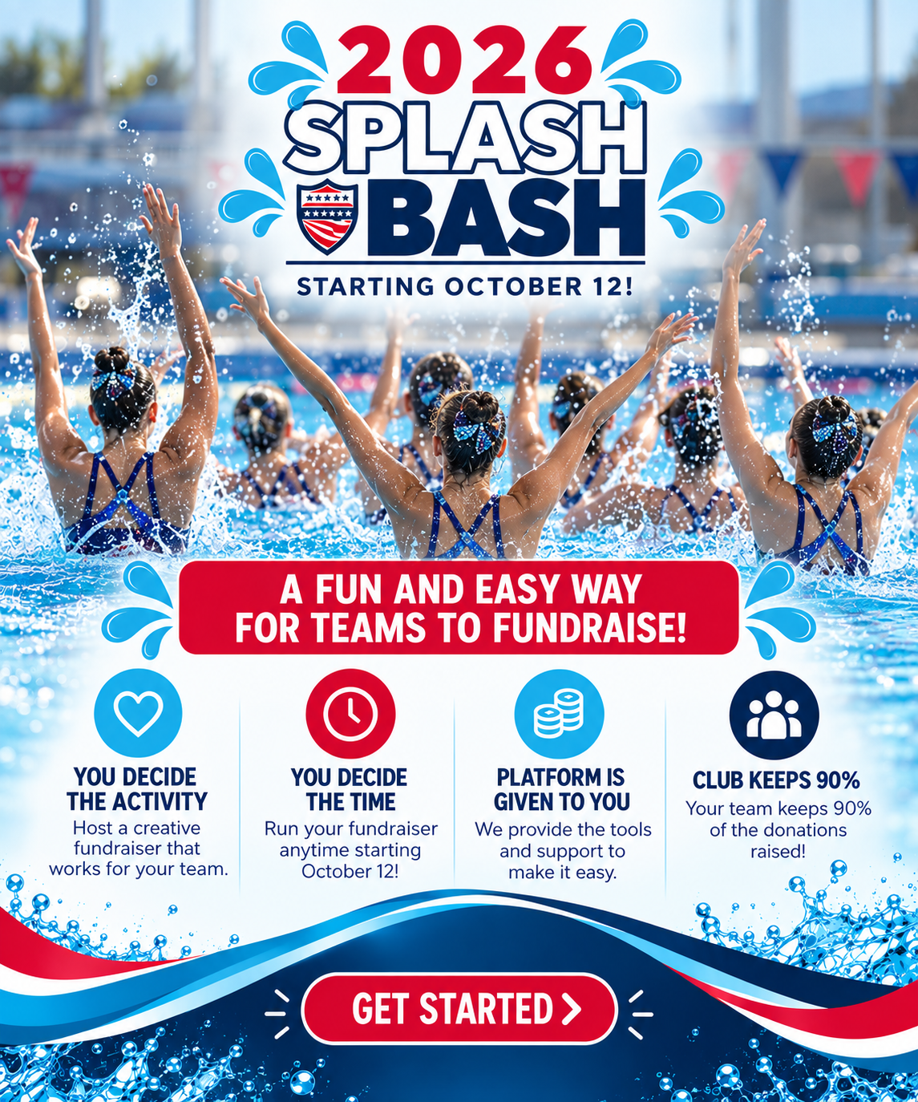

Join us for our Bi-Annual Splash Bash fundraiser and kick off the season with raising funds for your club. Starting October 12th through November 12th, USAASF and USAAS will be hosting a fundraising event for all clubs to participate (clubs don’t have to be a 501c3 to be eligible). Swim, Scull, Eggbeater or run your routine lap by lap or in full and earn money for every lap your athlete's swim. It's as easy as that. Pick a day, hold your practice and support your team. Splash Bash will be a fun, interactive way for individuals and teams to compete while raising funds for their club.

USAASF will provide all of the tools and the platform for fundraising, which will be all done through Qgiv. Clubs will get to keep 90% of what they raise from the event and the other 10% will be given to USAASF. Registration will open on October 12th, and you can join anytime during the fundraising event. Both teams and individuals can register and customize their own page. Instructions on how to update your page will be given once you make an account. This will be a fun way to personalize your fundraising and reach your own community. You can also share your page on social media and send a code for text fundraising! You won’t want to miss this opportunity to raise funds for your club! Follow our Instagram account: usaasfoundation for updates and reminders on the fundraising event.

Your club participation will count towards the USAAS Club Excellence program.

Here is what the Foundation will provide with registration:
- Toolkit for the event with fundraising strategies
- Event Logo
- Payment platform with link to website

What Clubs will provide:
- Tagging USAASF in all posts/ stories from the event
- Counters and an Accurate count of laps per participant

