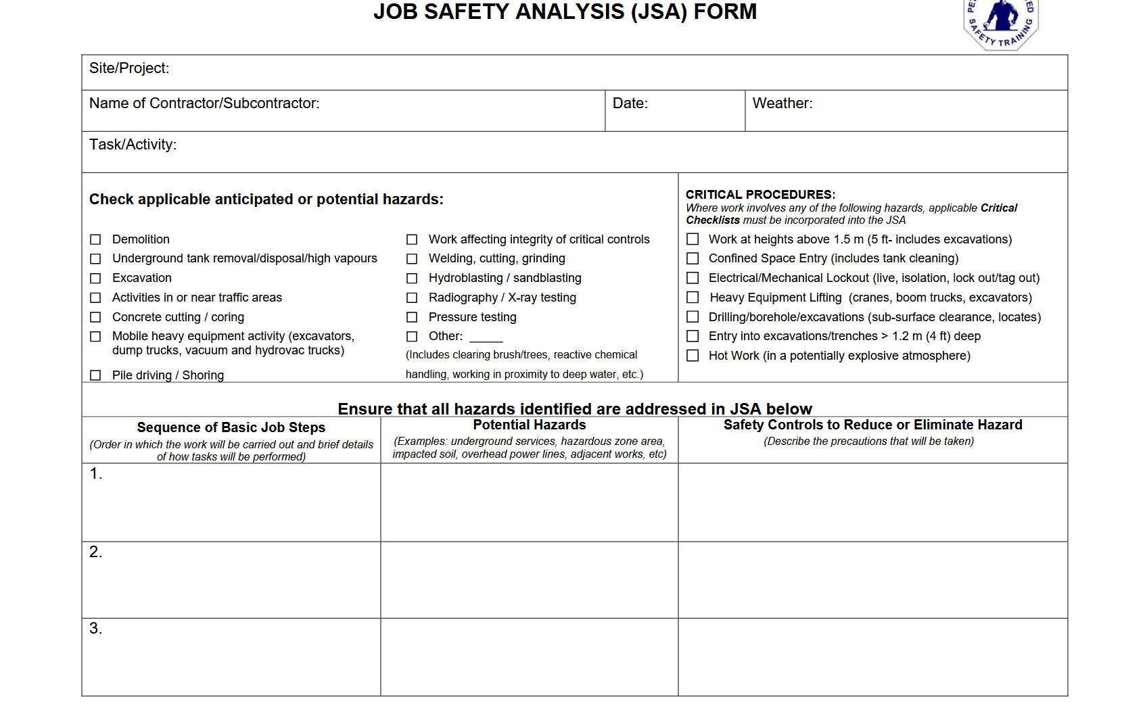Site Personnel

1)________________________________

2)________________________________

3)________________________________

4)________________________________

****­­­­­

5)________________________________

6)________________________________

7)________________________________

8)________________________________



Delta Backhaul Company (907) 310-3807 dhuntman@dbcalaska.net