Village Assets
Village |  | Date
Performed By |  | City/Tribe

Item | Condition | Owner | Cost | Location
Heavy Equipment
Light Equipment
Barge landing
Accommodations
Food prep area (stove, microwave, power, table)
Backhaul Staging Area (power?)
Pallets
Store
Number of people participating
Distance to landfill
Event distance to barge landing
Event distance to accommodations
Conex(s)
Gas Station
List additional equipment that can be used for backhaul activities -
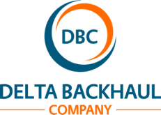
Protecting – Community & Environment

