ING.MARIO MASCOLO

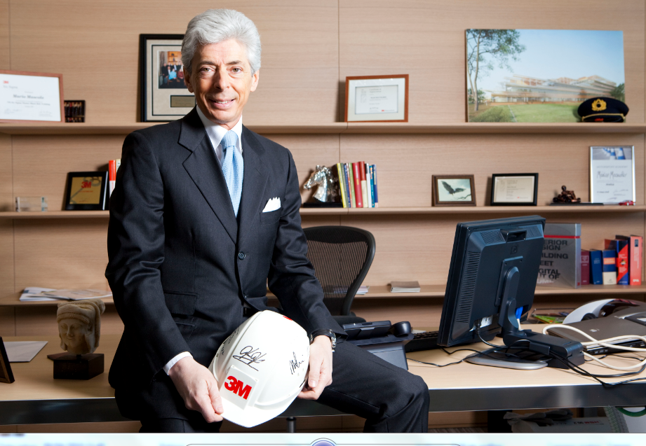
Personal Data

Date of birth: May 26, 1956
Place of birth: Iglesias (CI), Italy
Education: University of Rome, Italy, Degree – Mechanical Engineering
Address: Milan Italy
Phone : +39 3358763065

Career Location

Actual : CEO EMME CAPITAL srl Italy
https://www.emmecapital.com
Actual: Senior Advisor Green Energy Storage srl Italy
https://www.greenenergystorage.eu
Actual: Advisor Federico DeNora s.p.a. Italy

2016-2020 : Principal Expert The European House Ambrosetti Italy https://www.ambrosetti.eu/en/
2016-2019 : Senior Advisor FB & Associati Advocacy and Public Affairs Italy
https://www.fbassociati.it

2016-17 Vice President Business Transformation 3M EMEA Italy
(6 billion euros/ 20000 employees)
http://www.3m.com/
2012-16 President 3M EMEA GmbH Switzerland
(4.5 billion Swiss fr /15000 employees)
2007-12 President and Managing Director, 3M Italy Italy
2005-07 VP 3M Health Care Business, Europe/Middle East and Africa Germany
2003-05 3M Executive Director, Six Sigma, Europe /Middle East and Africa Belgium
2000-03 President and Managing Director, 3M Greece Greece
1997-00 Business Director, Industrial Markets and Integrated Solutions, 3M Italy Italy
1989-97 Business Manager, Abrasives Systems Department, 3M Italy Italy
1987-89 Marketing Manager, Abrasives Systems Department, 3M Italy Italy

1982-87 Exxon Mobil Italy Italy
http://corporate.exxonmobil.com/en/

Additional appointments: Professional and Civic Organizations

- Member, Ambrosetti The European House Club
- Vice President, AmCham (June 2010-2013)
- President Sustainability Committee AmCham (October 2011 – 2013)
- Member, Italy Aspen Institute (2009-2012)
- Member of the Foreign Investors Committee of Confindustria (National Companies Association) (October 2010 – 2013)
- Member of the Council Assolombarda (Association of Lombardy Region Companies) (June 2012 – 2013)
- Board Member, Green Economy Network - Assolombarda (2010-2013)

