

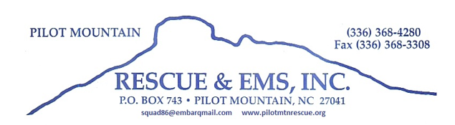

**DEADLINE FOR ALL ENTRIES: WEDNESDAY NOVEMBER 27th, 2019**

Please read ALL of the following information carefully.

1. **Overall Rules:**
2. **There will be only one Santa Claus in the parade**. He will be on the official Santa Claus Float arranged by parade officials. No other Santa suits are allowed.
3. Only Parade Entries will be allowed to enter the parking lot during lineup. Please have all items needed with you as you enter.
4. There should be an adult responsible for each parade entry. This adult should remain with the group or float throughout the duration of the event.
5. All vehicles shall be driven by a licensed driver. Careless driving or actions will not be tolerated.
6. No ATV’s Golf Carts or Dirt bikes will be allowed in the parade unless they are on a trailer or towing a float.
7. All entries must be properly registered for the event prior to the deadline and must present parade entry permit upon entry into the ESHS lot.
8. All entries must depict a Christmas theme.
9. All signage must be neat, legible and presented in a professional manner.
10. No vulgar or inappropriate actions, words or music will be tolerated.
11. No alcohol consumption, or possession will be tolerated.
12. Please turn off all daytime driving lights, wigwags, piercers, flashing headlights, or Roto Rays.
13. Sirens (electronic or wind up), air horns, or any loud audible warning devices are not tolerated, these are only to be used in case of an emergency. Any abuse of this rule will result in removal from the parade.
14. The parade will be held rain or shine, all registration fees as non-refundable unless the parade is canceled.
15. All disputes and/or decisions regarding parade issues will be the responsibility of the squad officers and all decisions are final.
16. **ONLY ONE APPARATUS PER DEPARTMENT**
17. **LIMIT 2 COMMERCIAL VEHICLES PER COMPANY**
18. **Safety Guidelines:**
19. All children should be seated during the parade.
20. When distributing candy please make sure the candy is thrown away from the entry to the curb.
21. Please remain in the middle of the street at all times while on the parade route, if you hear a siren please be aware of a possible emergency vehicle needing the right of way.
22. Drivers please be aware of your surroundings at all times, safety is our first priority.
23. The parade will end at the south intersection of town, please make arrangements to disperse after clearing the intersection as to not block the roadway.
24. Please keep moving during the parade as to limit open areas in the parade line.

**Line up time and Location**

Lineup will be held at East Surry High School main parking lot from 4pm- 5:30pm, please do not leave unattended vehicles or trailers before this time. Emergency vehicles will line up at Cox-Needham funeral home from 4p-5:30pm.

***THANK YOU FOR YOUR SUPPORT AND HAVE A VERY MERRY CHRISTMAS***