Body Blast Bootcamp with Kara  All Fitness Levels Welcome!  “It takes 4 weeks for you to see your body changing, 8 weeks for family & friends to notice, & 12 weeks for the world to notice. Give it 12 weeks. Don’t quit!”  Location: 333 Short Drive, Mountainside, NJ  Given By: Kara Fleming – Certified Personal Trainer & Group Fitness Instructor  When: Friday mornings beginning at 9:00 am (arrive 5 minutes early)  Fee: $20 per session  Why Choose Bootcamp?  - High Caloric Burn during and after workout  - Cardio & Strength workout in one  - Cost Effective  - Group Atmosphere is fun and motivating  “Kara is the perfect combination of strong and kind, and she works with the whole person -- Because of her, I am a different person…I can do things now I would have never dreamed of attempting before my journey with Kara.” ~Tara  - You will feel great and have more energy for the rest of the day!  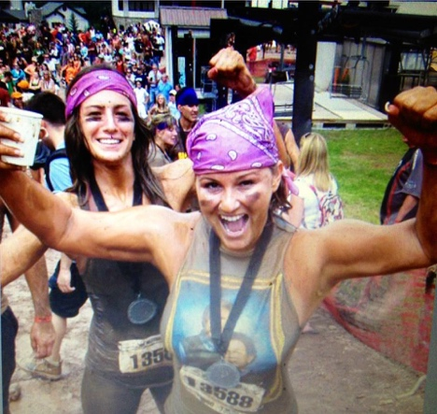  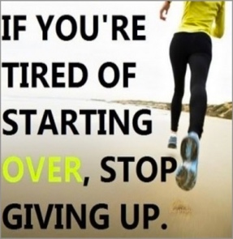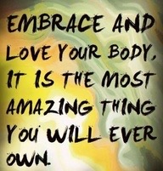 | Kara Fleming  (908) 578-7857  Kara Fleming  (908) 578-7857  Kara Fleming  (908) 578-7857  Kara Fleming  (908) 578-7857  Kara Fleming  (908) 578-7857  Kara Fleming  (908) 578-7857  Kara Fleming  (908) 578-7857  Kara Fleming  (908) 578-7857  Kara Fleming  (908) 578-7857  Kara Fleming  (908) 578-7857  Kara Fleming  (908) 578-7857  Kara Fleming  (908) 578-7857  Kara Fleming  (908) 578-7857  Kara Fleming  (908) 578-7857

