Walden Chapel United Methodist Church
2019 News Archives

Outreach Ministry
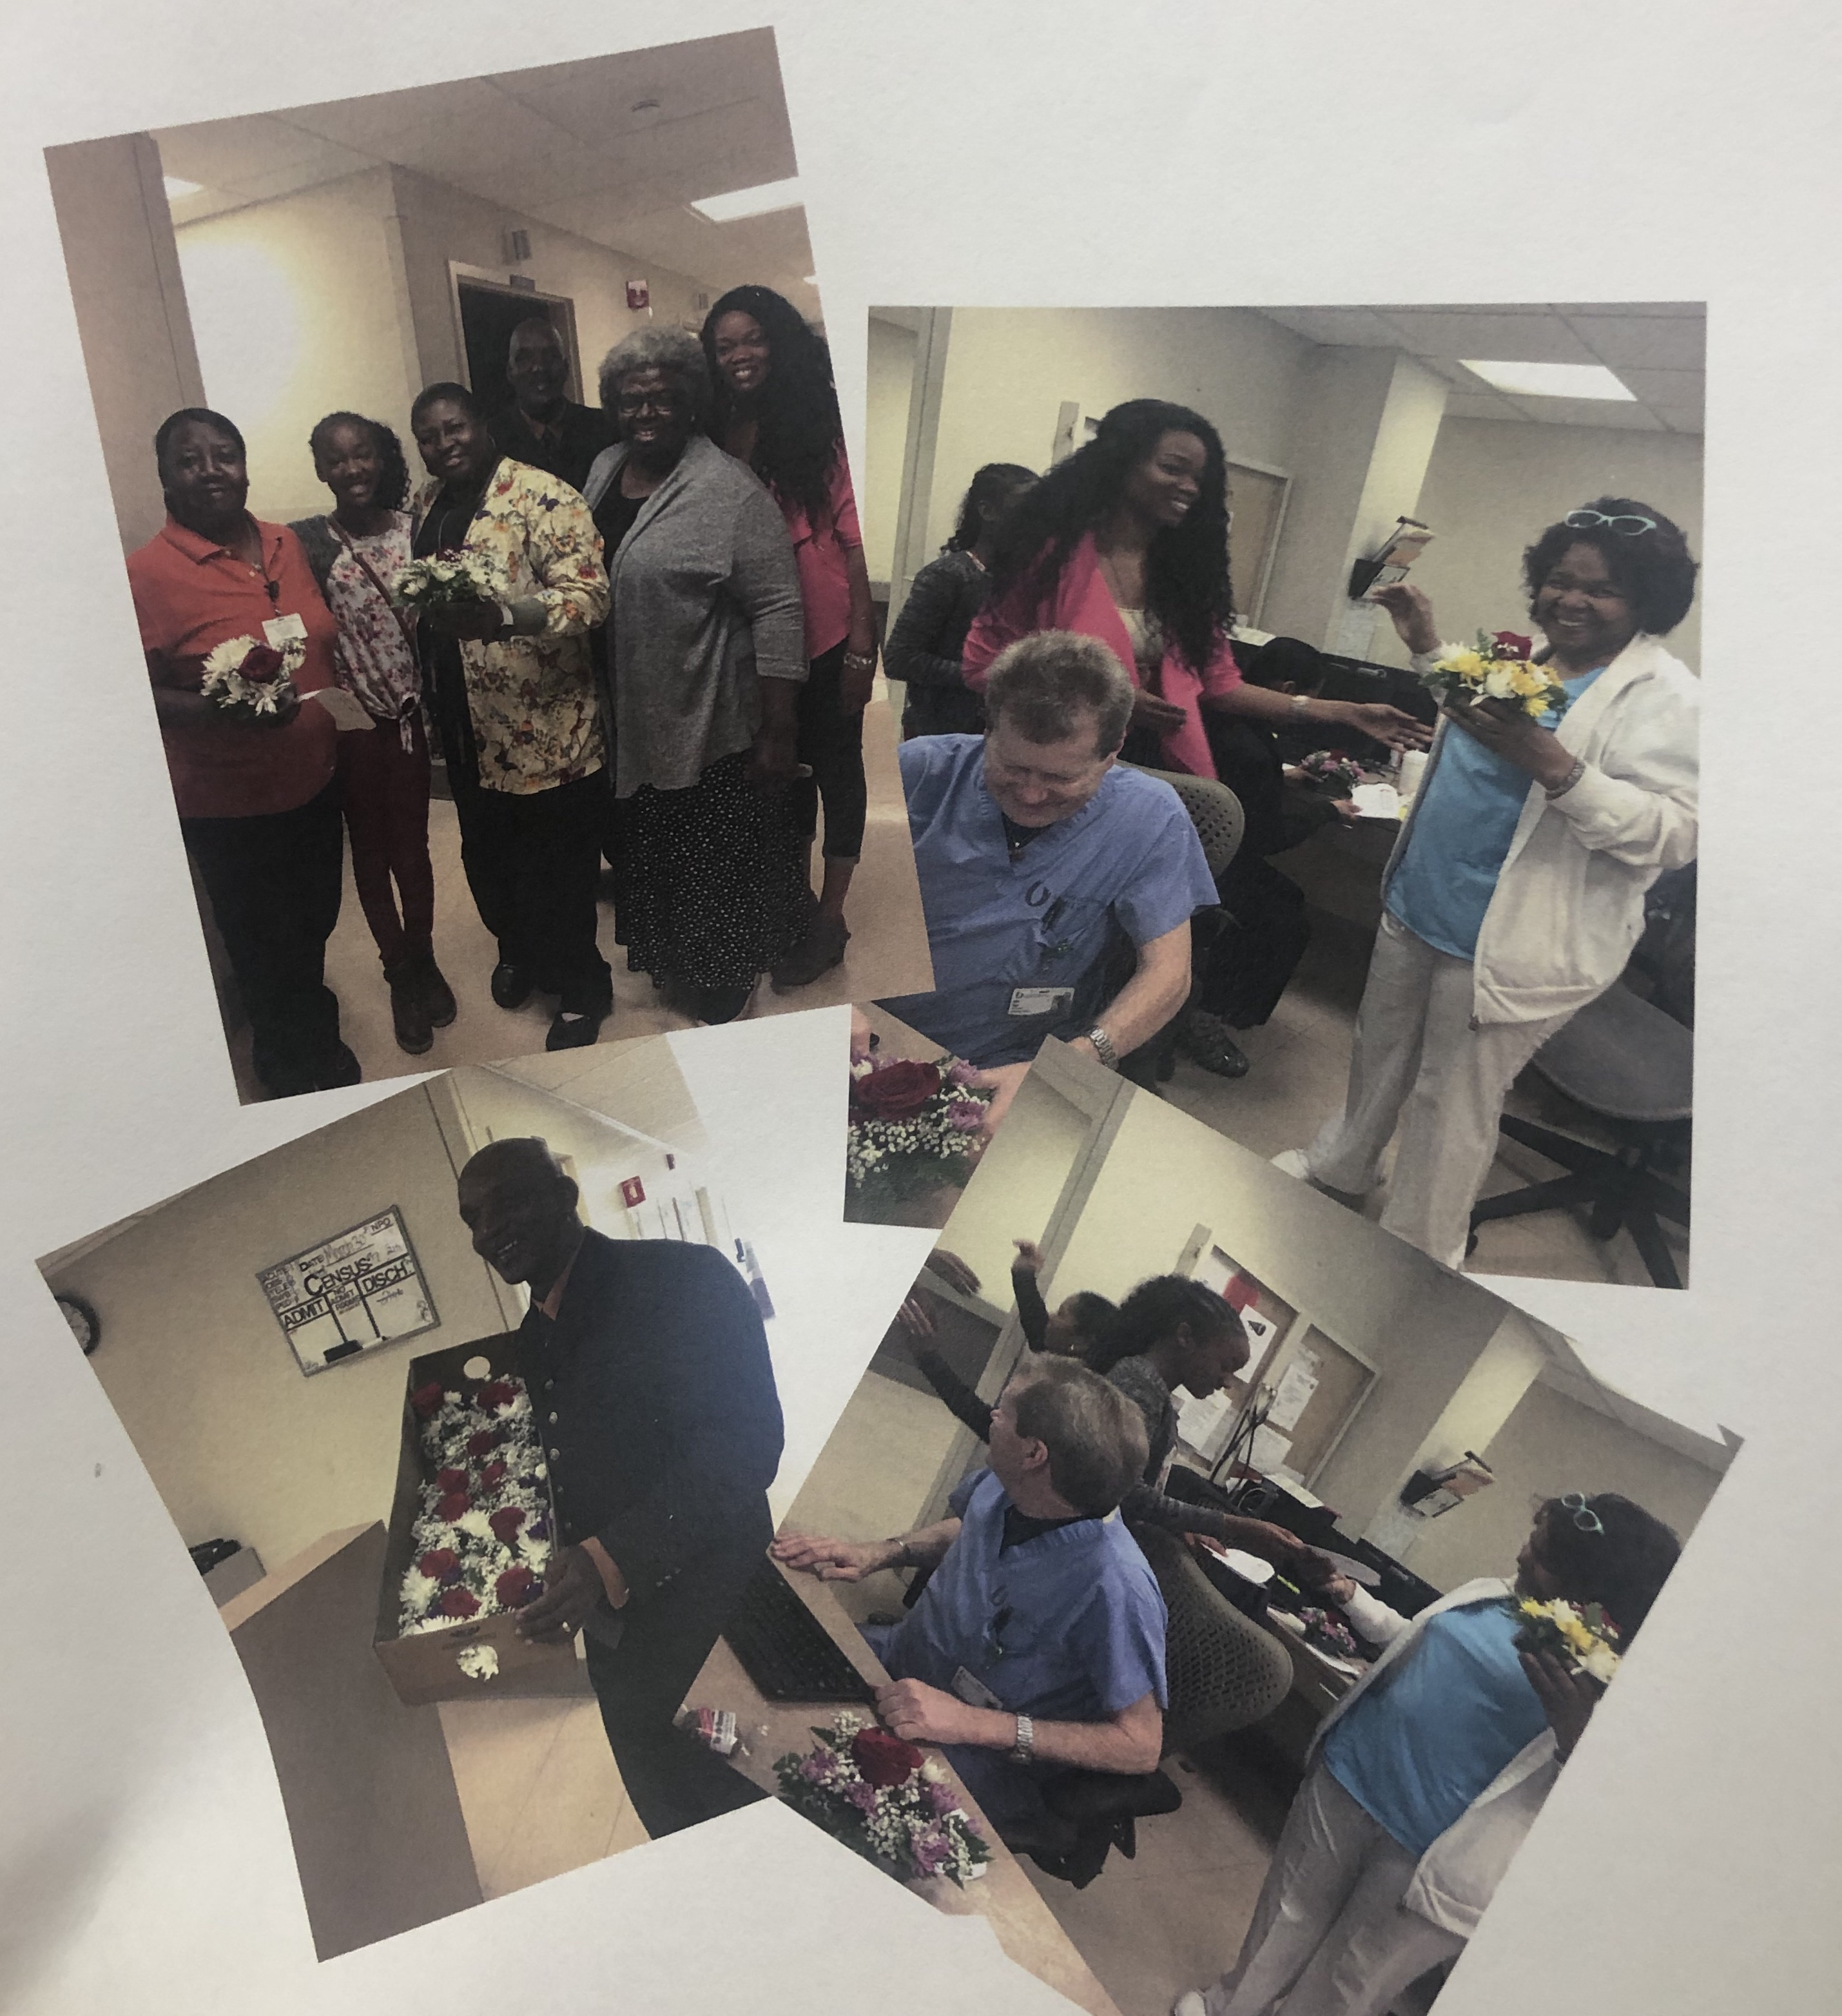
Small bouquets of flowers were given to the Lexington Hospital doctors, nurses, and patients as the outreach mission work for the month of March. The name of Walden Chapel was uplifted with scriptures for all.

2019 Graduates
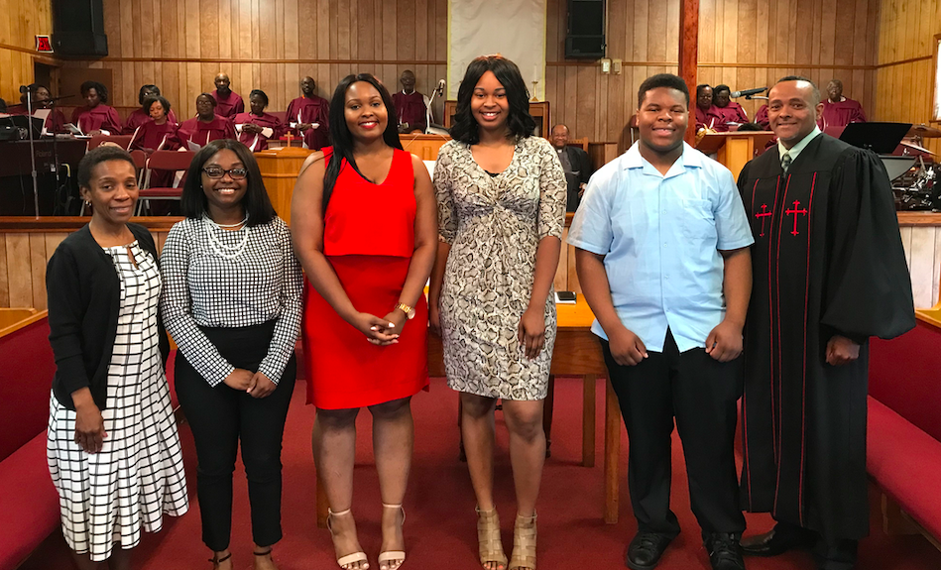
Our 2019 graduates received recognition during morning worship service. It is a blessing to accomplish your dreams and goals. Remember, you can do all things through Christ who strengthens you.
United Methodist Women Prayer Breakfast
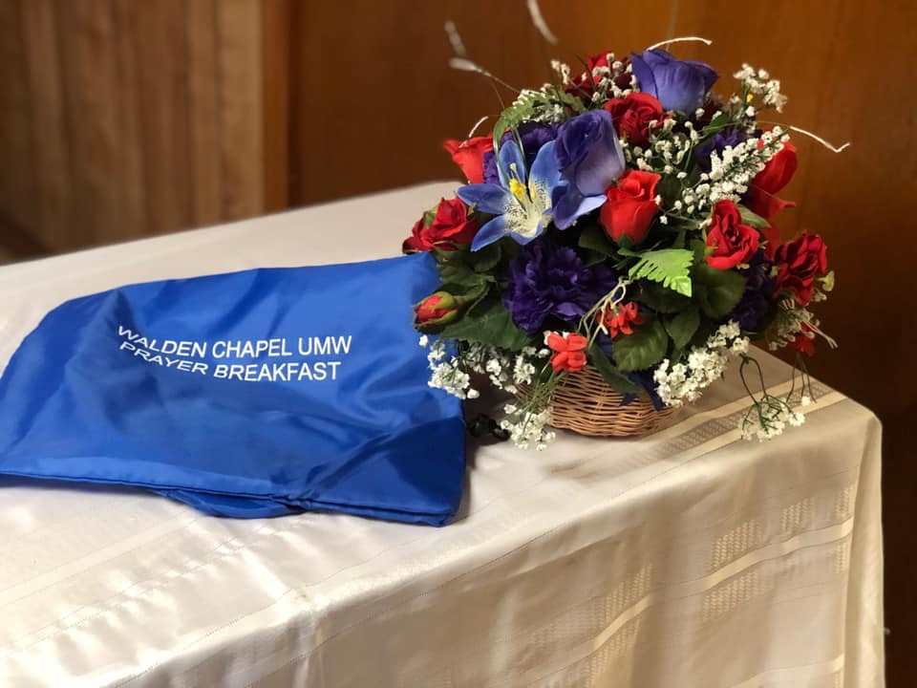
We appreciate everyone who came to our UMW Prayer breakfast. It was a great fellowship and powerful message brought by Sister Mary Howard Day.

