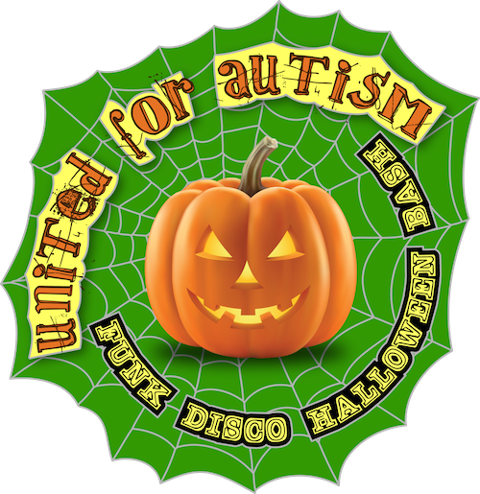

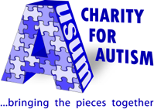

tel: 289-997-1612
toll free: 1-844-506-3974
e-mail: info@ausumcharity.org
website: www.ausumcharity.org
CRA No. 765947726RR0001

We warmly invite you to help us bring the pieces together for Autism!

Please consider partnering with Ausum Charity for Autism through sponsorship opportunities and engage us to see how we can further help recognize you!

Event Sponsorship Opportunities for:
United for Autism ~ Funk Disco Halloween Bash
Friday Oct 26, 2018 @ The Pilot (Stealth Lounge) ~ 22 Cumberland St. Toronto
Thank you from Ausum Charity!

>Invitation to speak at event
>Your logo goes onto our event flyer
>Your mentioned in our event press release
>Special mention by our president & emcee at event
>Your own event table for your brand and collateral
>Your logo represented via event signage / power pt.
>10 complimentary tickets & reserve table for 10
>Special acknowledgement on our website
Min $1000

(Tic)

(Please tic one box)
Thank you from Ausum Charity!

>Special website acknowledgement
>You’re mentioned in our press release
>Special mention by president at event
>6 complimentary tickets & reserve table
>Your logo represented via event signage
Min $500

(Tic)

Sponsorship Registration (please type in grey boxes)

Receipt Issued to:
Name / Company:
Address:
Phone:
Email:

Please either:

1 | Contact Yojna Gupta at info@ausumcharity.org or at 289-997-1612 for all inquires
Or  2 | Complete, print, and mail this form and cheque payable to:  Ausum Charity for Autism - 76 Bremen Lane – Mississauga, Ontario L5M2N5
Or  3 | Complete this fillable form and email it to info@ausumcharity.org and make the donation online at www.ausumcharity.org

We would love to hear from you. Thank you!

