Native Plants
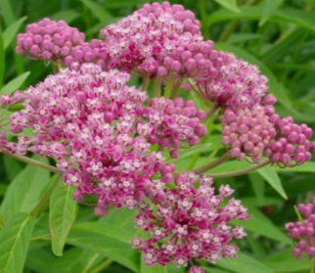  Swamp Milkweed | Asclepias incarnata  Upright with slender leaves; in summer plants are topped by rounded flower clusters  Suggested uses: Naturalize, Rain Garden  Attracts: Butterflies, Hummingbirds | Height: 4-5 feet  Spread: 2-3 feet  Bloom time: July to August  Sun: Full sun  Water: Medium to wet  Tolerates: Deer, wet soil  Monarch caterpillars  feed on them!
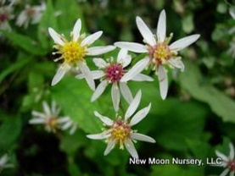  White Wood Aster | Eurybia divaricatus  Keystone species; low mounding perennial with oval leaves; late summer blooms with white daisies  Suggested uses: Groundcover, Border, Shade Garden  Attracts: Butterflies | Height: 2-3 feet  Spread: 3-4 feet  Bloom time: September to November  Sun: Partial to full shade Water: Moist to dry  Tolerates: Deer, rabbits
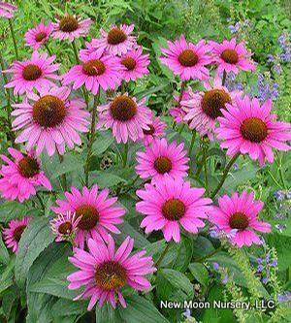  Purple Coneflower | Echinacea purpurea  Sturdy, upright plant with showy, daisy-like, purple flowers  Suggested uses: Wildlife Garden, Cut Flower Garden  Attracts: Butterflies, Goldfinches | Height: 2-5 feet  Spread: 2 feet  Bloom time: June to August  Sun: Full sun to partial shade Water: Moist to dry  Tolerates: Deer, drought, clay soil
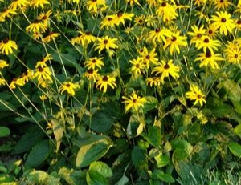  Black-eyed Susan | Rudbeckia fulgida  Keystone species; resilient wildflower with shiny deep green foliage, golden flowers with brown cones  Suggested uses: Naturalizing, Wildlife Garden, Cut Flower Garden  Attracts: Pollinators, Butterflies, Songbirds | Height: 2-3 feet  Spread: 1-2 feet  Bloom time: July to September  Sun: Full sun to partial shade  Water: Moist to dry  Tolerates: Deer, drought  Maryland’s state flower!

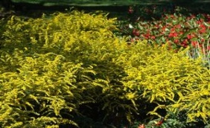  Wrinkle-leaf Goldenrod | Solidago rugosa Fireworks  Keystone species; mounding, clumping perennial with bright yellow flower sprays in late summer  Suggested uses: Wildlife Garden, Rain Garden, Perennial Borders  Attracts: Bees, Butterflies, Birds | Height: 3-4 feet  Spread: 2-3 feet  Bloom time: September to October  Sun: Full sun  Water: Moist  Tolerates: Deer, drought, clay soil
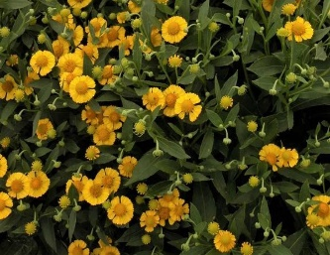  Sneezeweed | Helenium Autumnale 'Helena Gold'  Upright clumping perennial with bright green leaves and golden daisy-like flowers  Suggested uses: Wildlife Garden, Rain Garden  Attracts: Bees, Butterflies | Height: 3-4 feet  Spread: 1.5 to 3 feet  Bloom time: July to September  Sun: Full sun to partial shade Water: Moist to wet  Tolerates: Deer, clay soil
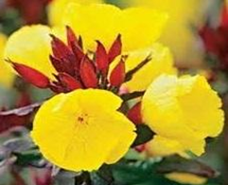  Narrowleaf Evening Primrose | Oenothera fruticosa ‘Fireworks’  Deep bronze foliage, red stems and buds with canary yellow blooms in late Spring and early Summer  Suggested uses: Perennial Border, Sunny slope, Rock Garden  Attracts: Pollinators, Butterflies | Height: 12-18 inches  Spread: 1-2 feet  Bloom time: May to June  Sun: Full sun to partial shade  Water: Moist to dry  Tolerates: Deer, drought
False Sunflower  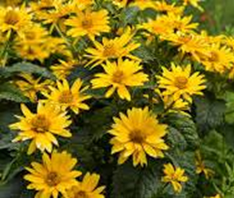  (Ox-eye Sunflower) | Heliopsis helianthoides  Keystone species; upright clumping perennial wildflower with clusters of yellow 2-3” daisies  Suggested uses: Naturalizing, Wildlife Garden, Cut flower Garden  Attracts: Pollinators, Butterflies, Songbirds | Height: 3-5 feet  Spread: 2-4 feet  Bloom time: June to August  Sun: Full sun  Water: Moist to dry  Tolerates: Deer, drought, dry soil, shallow rocky soil

